UNIT: 1 (SIZE SEPARATION)
CLASS:8
TOPIC: OBJECTIVES, APPLICATION & MECHANISM OF SIZE SEPARATION
SIZE SEPARATION
Size separation is a unit operation that involves the separation of a mixture of various sizes of particles into two or more portions by means of screening surfaces.
Size separation is also known as sieving, sifting, classifying or screening. This technique is based on physical differences between the particles such as size, shape and density.
Screening is a method of separating particles according to size alone. Particles can be separated into individual sizes using sieves. The final portion consists of a more uniform size. The material that remains on the given screening surface is known as oversize or plus material. The material passing through the screening surface is known as undersize or minus material. Size separation process (or sieves) can be used:
Applications of size separation
1. As a method to determine particle size and size distribution, which are useful in the production of tablets and capsules.
2. As a quality control tool for the analysis of raw materials such as griseofulvin and aspirin.
3. To test the efficiency of a size reduction equipment or process.
4. To optimise the process conditions such as method of agitation, time of screening, feed rate etc.
5. To recover valuable products or bye products.
6. To prevent environmental pollution.
Objectives of Size Separation
- Particle size determination is necessary for tablet and capsule production.
- Mixing powders should be improved.
- During production, particles should be made more solubilized and stable.
- During production, agitation, screening, and feed rate should be optimized.
- Raw materials are subject to quality control.
- Tablets, capsules, suspensions, emulsions, ophthalmic products, ointments, creams, etc. can be prepared with this product.
MECHANISM OF SIZE SEPARATION (OFFICIAL STANDARD)
Screening is a method of separating particles according to size alone. The basic technique involved is passing the particles through a series of sieves of uniform size. In this, the particles drop through the openings due to gravity. Coarse particles can drop easily through large openings, but it is difficult to screen the fine powders. This process can be hastened by inducing some type (mode) of motion (movement) to the particles. Size separation is basically assisted by three methods.
1. Agitation
2. Brushing
3. Centrifugal force
These modes of shaking help to shake the material so that sieving will be quick and entire sieving area can be utilised.
Agitation Method
Sieves are agitated in a number of ways.
Oscillation: The sieve is mounted in a frame that oscillates back and forth. i.e. reciprocal motion (Figure). It is a simple method, but the material may roll on the surface of the sieve. The motion is parallel to the plane of the sieve. The sieves can be slightly inclined. The reciprocating motion is induced by means of an ordinary eccentric on a rotating shaft.
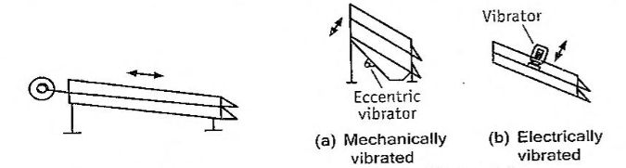
Motion of screen, shaking (oscillations). Motion of screens vibrating motion
Vibration: The sieve is vibrated at high speed by means of an eccentric device (Figure) either electrically or mechanically. Rapid vibration is imparted to the particles that helps the powder to pass through the sieve. Electrically vibrated screens are particularly useful in the chemical industry. Example is hummer screen. They handle light. fine and dry materials successfully. Inducing vibrations also prevents blinding of meshes.
Gyration: In this method. a system is made so that sieve is on rubber mounting and connected to an eccentric flywheel (Figure). This gives a rotary movement of small amplitude to the sieve, which in turn gives spinning motion to the particles that helps to pass them through the sieve.

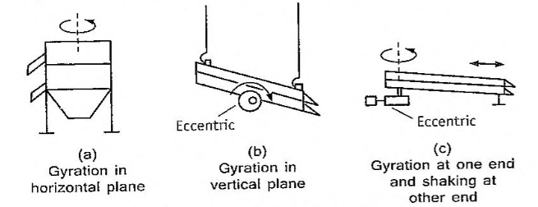
Gyratory motions of screens or sieves.
Gyratory screens are box like equipment, either round or square, with a series of screen cloths nested atop one another (Figure). Most gyratory screens have auxiliary vibrations caused by balls bouncing against the lower surface of the screen.
Agitation methods are not continuous methods. However, these can be made continuous by inclination of the sieves. Separate outlets are made for undersize and oversize particles. Normally, all the three modes of agitation are used simultaneously for an efficient size separation. Rotex screen works on this principle.
Advantages: (1) Agitation methods are inexpensive.
(2) Simple and rapid.
Disadvantages: (1) Agitation methods have lower limit of the particle size.
(2). If the powder is not dried. apertures become clogged with particles leading to improper sieving. (3) During agitation, attrition (particles colliding with each other) occurs causing size reduction.
Brushing Method
In this case, a brush is used to move the particles on the surface of the sieve and to keep the meshes clear. The brush is rotated in the middle in the case of a circular sieve. but spiral brush is rotated on the longitudinal axis in case of horizontal cylindrical sieve. One example is brush sifter (Figure). This is used for size separation of greasy or sticky powders such as waxes and soaps.
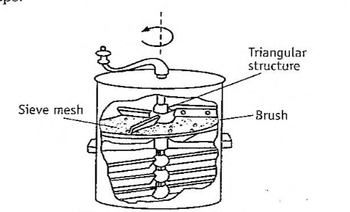
Brush sifter
Centrifugal Method
In this method. a high-speed rotor is fixed inside a vertical cylindrical sieve. so that on rotation the particles are thrown outwards by centrifugal force. The currents of air can be generated by means of a jet of air into the equipment, which helps in separating the particles. A few examples of equipment that work on this principle are cyclone separator and air separator.
Advantages (1) Centrifugal methods are extremely useful in cases where conventional sieving tends to block the sieves.
(2) Extremely useful for fine powder. because sieves have the limitation of mesh size.
Each question carry 2 marks
1. Compare the methods of sieving and classification in terms of their Utility.
Each question carry 5 marks
- Enumerate different modes of size separation.
- Write the advantages and disadvantages of size separation
- Write the application of size separation
MCQ Each carry 1 mark
