UNIT: 1 (SIZE REDUCTION)
CLASS:7
TOPIC: BALL MILL, FLUID ENERGY MILL, EDGE RUNNER MILL, END RUNNER MILL
BALL MILL OR PEBBLE MILL
These are also known as tumbling mills.
Principle: The ball mill works on the principle of impact between the rapidly moving balls and the powder material, both enclosed in a hollow cylinder. At low speeds, the balls roll over each other and attrition (rubbing action) will be the predominant mode of action. Thus, in the ball mill, impact or attrition or both are responsible for the size reduction.
Construction: The construction of a ball mill is shown in Figure. Ball mill consists of a hollow cylinder, which is mounted on a metallic frame in such a way that it can be rotated on its longitudinal axis. The length of the cylinder is slightly greater than its diameter. The cylinder is made of a metal and is usually lined with chrome. In pharmaceutical industry, sometimes the cylinder is lined with rubber or porcelain.
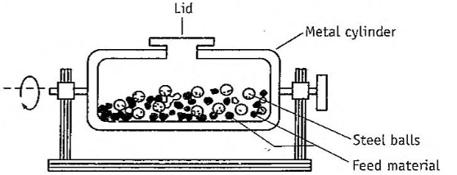
The construction of ball mill.
The cylinder contains balls that occupy 30 to 50% of the mill volume. The weight of the balls is kept constant. The ball size depends on the size of the feed and the diameter of the mill. Balls are made of steel, iron or stoneware. These act as the grinding medium.
Working: The drug to be ground is put into the cylinder of the mill in such a quantity that it is filled to about 60% of the volume (material to void ratio). A fixed number of balls are introduced and the cylinder is closed. The mill is allowed to rotate on its longitudinal axis.
The speed of rotation is very important. At low speeds, the balls roll over each other and attrition will be a predominant mode of stress (Figure A). The use of small balls (or glass pebbles) is recommended so that the surface is the greatest. This mode of attrition is used for wet grinding. It may be useful to add surface active agents to prevent agglomeration.
At correct speed, the centrifugal force just occurs, as a result the balls are picked up by the mill wall and carried nearly to the top, where they break contact with the wall and fall to the bottom to be picked up (Figure C). In this manner, impact stress will also be induced and the size reduction is made effective. At still higher speeds. the balls are thrown out to the wall by centrifugal force. Hence, grinding will not occur. The compression-by the balls against the wall will not be sufficient for effective comminution of the substance. (Figure B)
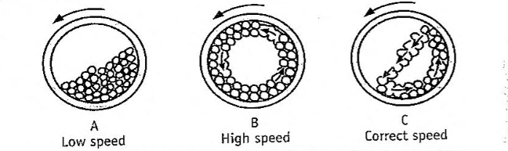
The modes of rolling of balls in the ball mill operations.
Uses: Fine grinding with a particle size of 100 to 5 be obtained, particularly for hard and abrasive materials 88/270 et balls are preferred in the production of ophthalmic and parenteras products, as there is a less chance of contamination due to wear. Ball mill at low speeds is used for milling dyes, pigments and insecticides.
Advantages: Ball mill offers several advantages and is widely used. These are:
(1) It can produce very fine powder.
(2) t is used for batch operation. It can be made continuous operation by including a chamber next to the cylinder. These are separated using a sieve.
(3) Ball mill is suitable for both wet and dry grinding processes.
(4) Toxic substances can be ground, as the cylinder is a closed system.
(5) Since the mill is a closed system, sterility can be achieved.
(6) Milling operation can be accomplished in an inert atmosphere, if oxygen sensitive substances are to be milled.
(7) Balls can be of various shapes and sizes. Rods or bars may be used instead of balls. Rod mill is particularly useful for milling of sticky materials.
(8) In ball mill, installation, operation and labour costs are low.
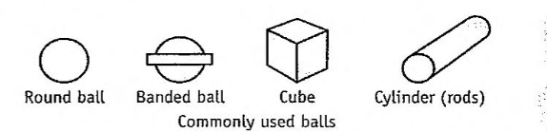
Disadvantages: Some of the disadvantages are
(1) The ball mill is a very noisy machine.
(2) Wear occurs from the balls as well as from the casing, which may result in contamination of the product.
(3) Ball milling is a slow process. The rate at which energy can be applied is limited, because it depends on the acceleration of the balls, which is influenced by the gravitational force.
(4) Soft, tacky, fibrous material cannot be milled by ball mill.
Variants (a) Hardinge mill (b) Continuous ball mills (c) Vibrating ball mills

FLUID ENERGY MILL OR JET MILL OR MICRONIZERS OR ULTRAFINE GRINDERS
Principle: Fluid energy mill operates on the principle of impact and attrition. In this equipment, the feedstock is suspended within a high velocity air stream. Milling takes place because of high velocity collisions between the suspended particles.
Construction: The construction of a fluid energy mill is shown in Figure. Fluid energy mill consists of an elliptical pipe, which has a height of about 2 metres and diameter may be ranging from 20 to 200 millimetres. The mill surface may be made of either soft stainless steel or tough ceramics. Usually, mills are constructed such that the contact surfaces are merely linings, which can be removed or replaced. If excessively eroded after use.
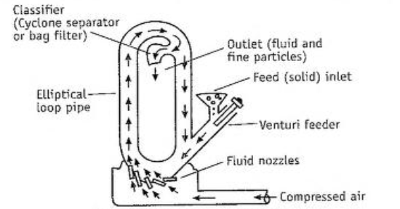
The construction of fluid energy mill.
Grinding nozzles (usually two to six)may be placed tangential and/or- opposed to the initial flow path of a powder. Normally, compressed air is used at 600 kilopascals to 1.0 megapascals. Inert gases are used to minimize or eliminate the oxidation of susceptible compounds.
Venturi feeder is provided in the path of the airflow. An outlet with a classifier (cyclone separator or bag filter) is fitted to allow the escape of air.
Working: Powder is introduced through the inlet of venturi. The air entering through the grinding nozzles transport the powder in the elliptical or circular track of the mill. In the turbulent stream of air, the suspended particles collide with each other and break. Thus, impact and attrition forces operate in size reduction. The resultant small particles (by entrapment of air) are carried to outlet and removed by cyclone or filters.
The coarser particles undergo re circulation in the chamber on ac count of its own weight. These re circulated particles collide again with new in-coming feed stock particles. The powder remains in the mill. until its size is reduced sufficiently. Later it leaves via the sieve Hence. fluid energy mill produces particles with narrow size distribution Some lines the particles, which are entrapped by the drag of gas, leave the mill and carried out to a cyclone separator or bag collector for size separation.
Uses: Fluid energy mill is used to reduce the particle size of most of the drugs such as antibiotics and vitamins. When strict quality courol is desirable for the purpose of better absorption (bioavailability), this mill is the preferred one. Ultrafine grinding can be achieved 'Moderately hard materials can be processed for size reduction.
Advantages: (1) It has no moving parts. hence, heat is not produced during milling. Therefore, heat-labile substances can be milled. Examples are sulphonamides, vitamins and antibiotics. Due to the expansion of gases under pressure cooling effect is produced during milling.
(2) It is a rapid and efficient method for reducing powders to 30 min or less.
(3) Since there is wear of the mill, contamination is not possible.
Disadvantages: (1) Fluid energy mill is not suitable for milling of soft, tacky; and fibrous materials.
(2) The equipment is expensive, because it needs additional accessories particularly fluid energy source and dust collection equipment.
Variants: Centrifugal-impact pulveriser
EDGE RUNNER MILL
Principle: The size reduction is done by crushing (compression) due to heavy weight of stones. Shearing force is also involved during the movement of the stones.
Construction: The construction of an edge runner mill is shown in Figure. It consists of two heavy rollers and may weigh several tons. The rollers move on a bed, which is made of stone or granite. Each roller has a central shaft and revolve on its axis. Further, the rollers are mounted on a horizontal shaft and move around the bed.
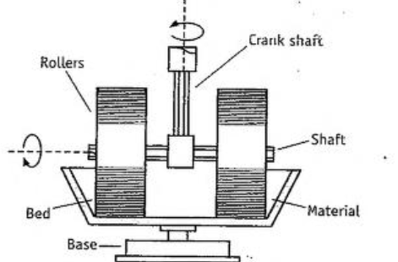
Construction of edge runner mill.
Working: The material to be ground is placed on the bed. help of a scrapper, it is kept in the path of the stone wheel. The stones revolve on its axis, and at the same time travel round the shallow stone bed. The outer part of the wheel has to travel a greater distance than the inner, so that size reduction is achieved by shearing as well as crushing. The material is ground for a definite period. The powder is collected and passed through a sieve to get powder of the required size. It is a batch process.
Uses: Edge runner mill is used for grinding tough materials to fine powder. It is still used for plant-based products, while more sophisticated mills are used for chemicals and drugs.
Advantages: Edge runner mill does not require attention during operation.
Disadvantages: (1) Edge runner mill occupies more space than other commonly used mills
(2) Contamination of the product with roller material is possible.
(3) The milling process is time consuming.
(4) It is not used for sticky materials.
(5) Energy consumption is quite high.
END RUNNER MILL
Principle: Size reduction is done by crushing (compression) due to heavy weight of steel pestle. Shearing stress is also involved during the movement of mortar and pestle.
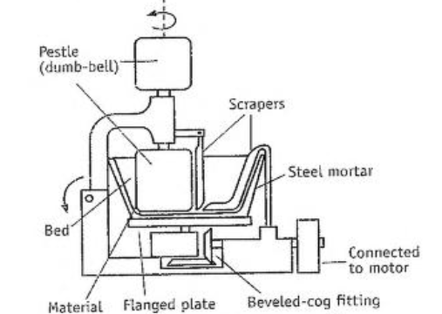
Construction of end runner mill.
Construction: The construction of an end runner mill is shown in Figure. It is considered as a mechanical mortar and pestle. It consists of a steel mortar, which is fixed to a flanged plate. Underneath the flanged plate, a bevelled cog fitting is attached to a horizontal shaft bearing a pulley. Hence, the plate with mortar can be rotated at a high speed.
The pestle is dumb-bell shaped so that balancing and efficient grind- ing by its weight can be achieved. The bottom of pestle is flat rather than round. The pestle carries an arm, which is hinged. By this arrangement, the pestle can be raised from the mortar to facilitate emptying and cleaning. The narrow central portion of the pestle is longer than the band of the arm around it. Hence, pestle can rise and fall over the material in the mortar.
Working: The material to be ground is placed in the mortar. The scraper puts the material in the path of the pestle. The mortar revolves at a high speed. The pestle is placed in the mortar. The revolving mortar causes the pestle to revolve. During this process, size reduction is achieved by shearing as well as crushing. The material is collected and passed through a sieve to get the powder of desired size. Uses: End runner mill is suitable for fine grinding. Now a days, this mill is replaced by more efficient and sophisticated milling equipment.
Disadvantage: End runner mill is not suitable for drugs, which are in unbroken or slightly broken conditions.

Some general characteristics of various types of mills are given in Table
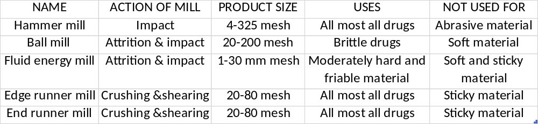
MCQ Each carry 1 mark
Fluid energy mill is based on the principle of_______.
Impact
Impact and Attrition
Attrition
Impact and compression
Edge Runner Mill works on the principle of___________.
Attrition and Impact
Attrition and Compression
Compression
Crushing and Shearing
For brittle materials, ___________ is the preferred.
Hammer Mill
Ball Mill
Fluid Energy Mill
Edge Runner Mill
In case of _________, air or inert gas is introduced with a very high pressure through the nozzles.
Hammer Mill
Ball Mill
Fluid Energy Mill
Edge Runner Mill
The efficiency of a ball mill is maximum at:
Low speed
High speed
2/3rd of speed
Very high speed
For heat sensitive materials, __________is used.
Ball Mill
Hammer Mill
Fluid Energy Mill
All of the above
Each carry 2 marks
The classical equipment mortar and pestle uses the mechanism of impact in size reduction. True or False. Explain.
Fluid energy mill is meant for wet grinding. True or false. Explain.
Size reduction mill can also he used as mixing or dispersion equipment. True or false. Explain
Each carry 5 marks
Explain with the help of a diagram the construction and working of a ball mill.
What is ultra-fine grinder? Explain the concept of ultra-fine grinding.
Describe micronizer. Describe aseptic grinding process of antibiotics.
Each carry 10 marks
Describe the construction. working, advantages and disadvantages of fluid energy mill.
Describe the milling equipment with the help of a neat diagram that uses the principle of shear and impact

