UNIT: 1 (SIZE REDUCTION)
CLASS:6
TOPIC: FACTORS EFFECTING SIZE REDUCTION, HAMMER MILL
Factors effecting size reduction
Factors Related to the Nature of Raw Materials
The properties of a solid determine its ability to resist size reduction and influence the choice of equipment used for milling. Some physical properties of the feed are as follows.
Hard materials: Iodine and pumice are hard and abrasive. In general, hard materials are most difficult to comminute. For iodine, hammer mill or fluid energy mill is used. Size reduction process of such materials can lead to abrasive wear of milling parts. which then cause contamination.
Fibrous materials: Glycyrrhiza, rauwolfia, ginger etc., are fibrous in nature and cannot be crushed by pressure or impact. Fibrous materials are tough in nature. They must be teared by a cutter. Nux vomica. and Ipecacuanha arc processed in two stages to get fine powders.
Friable materials: Sucrose and dried filter-cake are friable and tend fracture along well-defined planes. Brittle substances can be easily. converted to smaller particles. Such materials are milled by the mechanisms such as attrition, impact or pressure. For example, sugar is milled using hammer and fluid energy mills.
Elastic materials: Synthetic gums, waxes, and resins become soft and plastic during milling. These low-melting substances should be chilled before milling. Such materials are milled using hammer, colloid or fluid energy mill.
Hygroscopic materials: Substances such as potassium carbonate absorb moisture rapidly. This wet mass sticks and clogs the mill. They are prepared in a closed system such as porcelain ball mill.
Solvated materials: Sodium, sulphate (Na2SO4.10H2O) and other hydrates liberate water during milling and cause clogging of the mill.
Melting point: Solids with low melting points often become soft and melt owing to the heat generated during milling. Such materials are chilled before milling.
Thermolability: Certain substances undergo degradation reactions -such as hydrolysis and oxidation due to the presence of moisture and atmospheric oxygen. Such reactions proceed faster owing to the heat produced during milling. They should be milled in a closed system with an inert atmosphere of carbon dioxide or nitrogen. Vitamins and antibiotics are milled using fluid energy and ball mills.
Flammability: Almost any fine dust, such as dextrin, starch and sulphur, is, a potential explosive, mixture under certain conditions. All electrical switches should be explosive proof and the mill should be properly grounded (earthed).
Particle size of the feed: For a mill to operate satisfactorily. the feed should be of proper size. For example, pre-treatment of fibrous materials with high pressure rollers or cutters facilitates further comminution.
Moisture content: Presence of more than 5% water hinders the milling process and produces a sticky mass. The effect is more pronounced, when the concentration of water is more. In general, materials with moisture content below 5% are suitable for dry grinding and above 50% are suitable for wet grinding.

Pretreatment: For the mill to operate satisfactorily, the feed should be of a proper size and enter the equipment at a fairly uniform rate. Therefore, a pre treatment step should be included. For example, fibrous material should be treated with cutter or roller, which can facilitate further comminution.
Factors Related to the Nature of Finished Product
The nature of finished (milled) product also influences the selection of the equipment.
Particle size: If extreme size control is necessary, it may be essential to recycle the larger particles. This can be achieved by screening the discharge material and returning the over size particles for a second time milling. Moderately coarse or coarse powders with a minimum of fine powder are easily obtained by using a high-speed impact mill. For example, cascara, liquorice, belladonna leaves and roots are easily broken down by impact mill.
For example, particle size of griseofulvin is critical in the production. Similarly the particle size is also critical in the suspension of penicillin G procaine for intra-muscular injection due to its syringeability.
Ease of sterilisation: When preparations are intended for parenteral and ophthalmic uses. size reduction should be conducted in a sterile environment. The equipment should be sterilisable. Ball mills and fluid energy mills are suitable for this purpose.
Contamination of milled materials: In case of potent drugs and low dose products, contamination of the product should be avoided. Use of equipment that is free from wearing of mill parts is preferred. Fluid energy mill is suitable for this purpose.
In addition to the end use of a product, subsequent processing steps mainly determine the choice of wet or dry milling. In the preparation of colloidal dispersions, suspensions, emulsions and ointments, wet grinding offers advantages in terms of size reduction of materials. elimination of dust hazards. Thus, wet grinding has become an integral part of the processing of the above dosage forms. The same mill can also be used as mixing equipment. Examples are triple roller mill and colloid mill.
Factors Related to Safety
The factors related to safety are explosivity, irritability and toxicity. During milling, fine dust of drug arises which may become flammable under certain conditions. Explosion hazards of non-metallic materials, such as sulphur, starch and. wood floor, are often appreciable. Metal powders pose a hazard because of their flammability. The useful precautions are:
(a) isolate the mill.
(b) use of non-sparking material of construction.
Stainless steel has less sparking tendency than ordinary steel or forging,
Factors Related to the Economy
Cost. power consumption, space occupied and labour costs are some of the economic factors that determine the selection of a mill. Cost: Where the particle size control is not critical, the cost decides the type of equipment. In general, the cost of the size reduction increases, as the particle size decreases. Therefore, it is economically undesirable to reduce the particle size to a finer degree than necessary.

SIZE REDUCTION EQUIPMENT
General Parts of Size Reduction Equipment The milling or grinding equipment consists of three basic components.
(1) A structure for feeding material to the mill. It is called hopper.
(2) The milling chamber is the one in which actual size reduction takes place. It consists of a rotor and a stator.
(3) A discharge chute or receiver in which the milled product is collected.
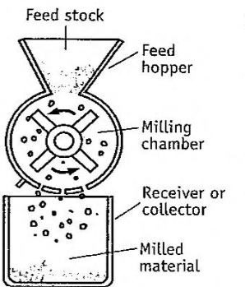
General parts of size, reduction equipment. Three basic components.
Other Accessories
(1) Sieves or screens are enclosed in the milling chamber to classify the particles by size.
(2) Cyclone separator or centrifugation equipment is fitted to the mills for separation of particles by their sizes.
(3) Dust collectors are employed in order to collect the fine powder and dust that may arise during milling process.
Special Features
(1) Cooling devices are fitted to the chamber to reduce the heat produced during milling.
(2) A closed environment is desirable for milling hygroscopic substances. For this purpose, dehumidified air is necessary.
(3) Closed system with inert atmosphere (nitrogen or carbon dioxide) is desirable for milling of drugs, which are oxidisable or combustible. Similarly, material to be used in the production of parenterals should be milled under sterile environment.
Though general parts of the equipment are identical, several modifications have been incorporated in order to make the process easy to handle and to provide desired discharge.

HAMMER MILL
Principle: The hammer mill operates on the principle of impact between rapidly moving hammers mounted on a rotor and the powder material.
Construction: The construction of a hammer mill is shown in Figure. The hammer mill can be either the horizontal or the vertical shaft type. Hammers are usually made of hardened steel, stainless steel with impact surface made of an extremely abrasive resistant material such as haystellite and carbaloy. Stainless steel hammers are sufficient for pharmaceutical purposes.
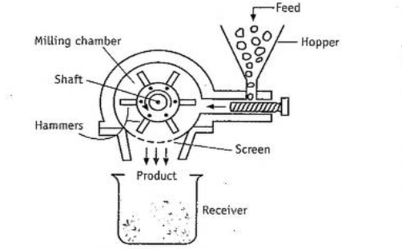
The construction of Hammer mill.
Hammers may take several shapes. Two basic shapes are the stirrup and the bar. Bar-shaped hammers are used extensively in tablet granulation. The hammer blades can be with flat edges or sharp edges or both on each side. Hammers, may be either rigid or swing-type. Free swinging type has an advantage that there will be increasing clearance 'between hammers and screen, if excessive build occurs in the mill. This unit is enclosed with a chamber containing a grid or removable screen through which the material must pass. These screens are not of woven type. Screens are prepared using metal sheet of varying thickness with perforated holes or slots.
Working The hammers are allowed to be in continuous motion (8000 to 15000 revolutions per minute). The feed material is placed into the hopper, which flows vertically down and then horizontally, while hammers are in continuous motion. These rotating hammers beat the material to yield smaller particles. Then, these pass through the screen. Due to the tangential exit, the size of the product is considerably smaller than the aperture of the screen as seen in Figure.
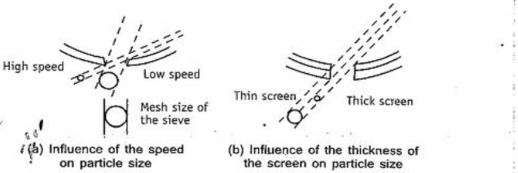
Size reduction modes in the hammer mill.
The screens are interchangeable, so that any grade of fineness can be achieved. The hammers act as a centrifugal fan, so that large amount of air is drawn through the mill. In most cases, this is sufficient to counteract the heat generated during milling.
The fineness of the product can be regulated by altering:
- Rotor speed,
- Feed rate,
- Clearance between hammers and grinding plates,
- Number and type of hammers,
- Size of the discharge opening (screen).
Uses: Fine to moderate grinding of powders may be obtained, depending on the speeds of the hammer. The expected particle size may vary from 10 to 400 mm. Non abrasive to moderately abrasive, brittle materials can be used as feed stock.
It is used to mill dry materials, wet filter press cakes, ointments, slurries etc. Brittle material is best fractured by impact from blunt hammers; fibrous material is best reduced in size by cutting edges. Advantages (1) Hammer mill is easy to setup (install), dismantle and clean up.
(2) Scale-up problems are minimal provided same type of mill is used.
(3) Various types of feed stock can be handled using screen of different sizes.
(4) Hammer mill occupies small space.
(5) It is versatile. i.e., speed and screen can be changed rapidly.
(6) As it is operated in a closed environment, dust can be reduced and explosion hazards can be prevented.
Disadvantages: (1) The screens may get clogged.
(2) Heat build-up during milling is more, therefore. product degradation is possible.
(3) Wearing of mill and screen is more with abrasive materials.
(4) Hammer mills cannot be employed to mill sticky. fibrous and hard materials.
Variants: The examples of hammer mills used in pharmaceutical industry are:
(a) Fitzpatrick comminuting machine (Fitz mill)
(b) Stokes tornado mill
Fitz mill is used for drugs, roots, herbs, glands, livers, soaps etc.

MCQ Each carry 1 mark
1. Hand mills are used for grinding small quantities of ____________ drug compound.
- Mineral origin
- Animal origin
- Vegetable origin
- Other
2. The process of levigation is known as:
- Wet crushing
- Shearing
- Wet grinding
- Both A and B
3. The material having _____moisture in case of wet grinding does not create any problem during size reduction.
- 10%
- 40%
- 50%
- 100%
4. To get a fine powder in a mill, it is required that a fairly ____________ feed size should be used.
- Small
- Large
- Medium
5. The output of size reduction of material in a machine depends on:
- Chemical nature
- Physical character
- Bulk density
- Material structure
6. A soft but tough material may present _______ in size reduction, than a hard but brittle substance.
- Less Problem
- More Problem
- No Problem
7. Importance of particles size reduction is
- Solubility increases
- Helps in the uniform mixing of ingredients
- Increases the rate of absorption of drugs
- All of the above

Each carry 2 marks
- It is difficult to obtain uniform sized product during milling without the use of sieves. Why?
- Size reduction of a material enhances the action of drugs. Explain
- How do you prevent the problems of sticking and clogging of sieves in the size reduction?
- List special precautions to be taken while thermolabile substances are subjected to size reduction process.
- The powder must contain fewer amounts of fines when it is meant for percolation process of extraction. Why?
- What are the advantages of swinging type of hammer compared to rigid hammers?
- Powders of same particle size that are obtained by different equipment have same physicochemical characteristics. True or false. Justify.
- How does stickiness effect the process of size reduction
- How does the presence of moisture interfere with the process of size reduction?
Each carry 5 marks
- Describe five factors that influence the selection of milling equipment for size reduction.
- Explain with the help of diagram the construction and working of a hammer mill.
Each carry 10 marks
- Describe the factors effecting size reduction
- Write a brief account about principle construction working uses advantages and disadvantages of hammer mill with a neat labelled diagram

