SUBJECT NAME & CODE: PHARMACEUTICAL ENGINEERING(BP304T)
UNIT: 1 (FLOW OF FLUIDS)
CLASS:4
TOPIC: PITOT TUBE & ROTAMETER
Pitot Tube
Principle: Pitot tube consists of a sensing clement with a small constriction compared to the size of the flow channel. When the sensing element is inserted at the centre of the stream, the velocity of flow is increased. This results in decreased pressure head. Tube at right angles to the flow measures pressure head only. The tube that pointed upstream measures pressure head and velocity head. The difference in the above readings indicates the velocity head.
Accordingly, to Bernoulli's equation, velocity head of the fluid may be obtained using equation (33).
ΔH_{P} = $\frac{u^{2}}{2g}$
Where, u = velocity of the flow at the point of insertion, m/s
ΔH_{P} = difference in head from manometer, m
Therefore. the reading (R) of the manometer measures the velocity head in metres.
Construction: The construction of a pitot tube is shown in Figure. Pitot tube is also known as insertion meter. The size of the sensing element is small compared to the size of the flow channel. The point of measurement may be at the centre of the channel. One tube is perpendicular to the flow direction and the other tube is connected parallel to the direction of flow. The two tubes are connected to the legs of a manometer or a suitable device.
Working: Two tubes are inserted into the pipe in the manner shown in Figure. Pitot tube is used to measure the velocity head of the flow. In this tube, the velocity of fluid is increased at the narrow constriction. This results in decreased pressure. Tube at right angles to the flow measures pressure head only. The tube that points upstream measures pressure head and velocity head. The difference in the above readings indicates velocity head. Therefore, the reading (R) of the manometer measures the velocity head.
As seen in the Bernoulli's equation, velocity head of the fluid (ΔH_{P}) may be obtained from an equation similar to equation (29), which can be represented as:
u² = 2g.ΔHp
This is the theoretical velocity. Actual velocity is given by:
u² = C_{V}$\sqrt{2g.ΔHp}$ (37)
where, C_{V} = coefficient of pitot tube.
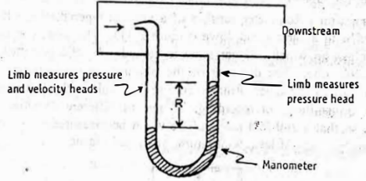
Construction and assembly of pitot tube.
Normally, pitot tube measures the velocity at one particular point, i.e., at the point of insertion. The average velocity (across the cross section of the pipe) may be obtained by either ways.
(a) Pitot tube may be inserted at the centre of the pipe and it measures the maximum velocity. Average velocity may be calculated from this maximum by means of calibrated charts.
(b) Adjustable pitot tube may be used to take readings from different points in the cross section. Mean velocity may be found by graphic integration. It is a difficult process.
Advantage: Pitot tube measures the velocity at one point only.
Disadvantages: (1) The pitot tubes themselves cause more disturbance. Eddies within the pressure tube disturb the readings.
(2) They do not give average velocity directly.
(3) For gases, the reading is extremely small. For gases working on low pressure, some form of multiplying gauges must be used.
Rotameter
Rotameter is a variable area meter, i.e., it measures the area of flow, so as to produce a constant head differential. Therefore, rotameters are known as area meters:
Principle: Rotameter consists of a vertical, tapered and transparent tube in which a plummet is placed. During the fluid flow through the tube, the plummet rises and falls because of variation in flow. As a result, the area of the annular space between the plummet and the tube varies. The head loss across the annulus is equal to the weight of the plummet. The upper edge of the plummet is used as an index to note the reading on the tapered tube. This value indicates the flow of the fluid.
Construction: Rotameter consists of a vertical tapered tube, which is mounted with a narrow end down (Figure). The tube is usually made of glass on which a linear scale is etched. A solid plummet is placed in the tube. The diameter of the plummet is smaller than the narrowest part of the tube.
Rotameters are available with electric and electronic transmitters for recording. Floats of different densities are available, so that a 200-fold range of flow can be measured accurately. Floats may be made of lead. aluminium, glass and plastic.
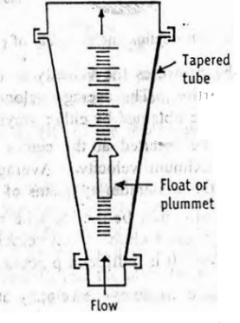
The Construction of a rotameter.
Working: As the flow is upward through a tapered tube, the flow of fluid varies. The plummet, which is surrounded by the fluid, rises and falls depending on the rate of flow. The greater the flow rate, the higher the plummet rises in the tube. In rotameters, the pressure drop is constant or nearly constant.
During the fluid flow, the area of the annular space between the plummet and the tube varies. Therefore, the head loss across the annulus is equal to the weight of the plummet. The flow may be read using the upper edge of the plummet as an index. The area is properly calibrated to the flow rate. The reading may be transmitted for recording, integrating and controlling.
Normally, manufacturers supply the necessary data and charts along with the meter while purchasing the instruments.
Uses: Rotameters are extensively used in chemical industries, such as bulk drugs. In the fermenters, the supply of air is controlled through rotameters. Rotameters are satisfactory both for gases and for liquids at high and low pressures.
Advantages: (1) Operator has a direct visual index of flow reading, It is satisfactory for manual control of processes for experimental work.
(2) It does not require the condition that straight pipes should run before and after the meter.
Direct Displacement Meter
Displacement meter is used for measuring domestic water supplies. This has the advantage that the total volume of liquid that has passed can be read directly.
Principle: Displacement meters are used for measuring the flow rate of fluids in small lines. In these meters, a stream of water enters the meter and strikes the moving member (disc as in disc meters or buckets as in current meters). The rate of rotation of the moving member is proportional to the velocity of water passing through the meter. The displacement of moving member is transmitted through a train of gears to the counting dial, which is present in the top of the member.
Advantages: The displacement meters have an advantage over venturi or orifice meters in the sense that the reading represents the total volume of fluid that has passed. This volume divided by a definite period gives the flow rate.

Each carry 2 marks
- List the advantages and disadvantages of rotameter
- List the advantages and disadvantages of pitot tube
Each carry 5 marks
Compare and contrast the advantages and disadvantages of pitot tube and rotameter.
Each carry 10 marks
Give a brief account of pitot tube
Write about rotameter with a neat diagram.

