SUBJECT NAME & CODE: PHARMACEUTICAL ENGINEERING(BP304T)
UNIT: 1 (FLOW OF FLUIDS)

CLASS:2

TOPIC: BERNOULLI'S THEOREM AND ITS APPLICATION , ENERGY LOSSES BERNOULLI'S THEOREM
When the principle of conservation of energy is applied to the flow of fluids, the resulting equation is called Bernoulli's theorem. Pumps generally supply energy for conveying liquids from one point to another. Consider such a pump working under isothermal conditions between points A and B, as shown in Figure
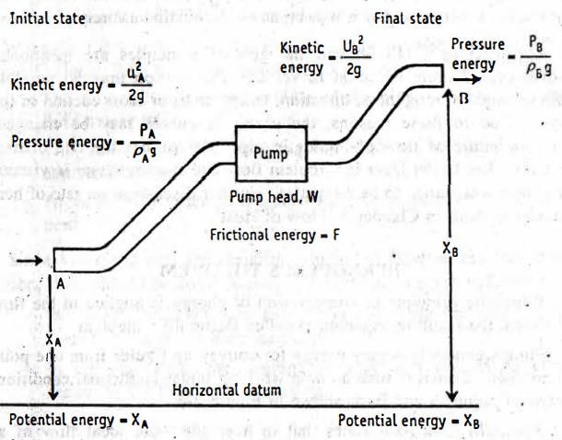
Bernoulli's theorem states that in a steady state, ideal flow of an incompressible fluid, the total energy per unit mass, which consists of pressure energy, kinetic energy and datum energy, at any point of the fluid is constant.
At point A, one kilogram (unit mass) of liquid is assumed to be entering. At this point, liquid experiences pressure energy, kinetic energy and potential energy, which are obtained as follows.
Since liquid is flowing through the pipe at certain pressure, pressure energy in joules may be written as:

P_{A} Pressure energy, =
𝑔𝜌𝐴
(14)

where P_{A} = Pressure at point A, Pa
g= acceleration due to gravity, m/s ρ_{A} = density of the liquid, kg/m³

Potential energy (datum energy) of a body is defined as the energy possessed by the body by virtue of its position or configuration. The point A is considered at a height of X metres above the horizontal datum plane. The potential energy for one kilogram of liquid may be written as:
Potential energy = X_{A} (15)
Kinetic energy of a body is defined as the energy possessed by the body by virtue of its motion. Since liquid is under motion, the velocity of liquid may be designated as u metre per second at point A. The kinetic energy may be expressed as:
𝑢2

Kinetic energy = ^{𝐴}
2𝑔
(16)

The total energy at point A may be summarised by combining equations (14), (15) and (16) as: Total energy = pressure energy+ potential energy + kinetic energy

Total energy at point A =
𝑃𝐴
𝑔𝜌𝐴
𝑢2
+ X_{A} +
𝐴
2𝑔
= constant. (17)

According to Bernoulli’s theorem the total energy at point A is constant.

Equation (17) is:

Total energy at point A =

𝑃𝐴
𝑔𝜌𝐴

𝑢2
+ X_{A} + = constant (18)
𝐴
2𝑔

After the system reaches the steady state, whenever one kilogram of liquid enters at point A, another kilogram of liquid leaves at point B. Therefore, energy content of one kilogram liquid that is being displaced at point B may be written (Bernoulli's theorem) as:

Total energy at point B =
𝑃𝐵
𝑔𝜌𝐵
𝑢2
+ X_{B} +
𝐵
2𝑔
(19)

where X_{B} = height from the datum to the pipe, m u_{B} = velocity at point B, m/s
P_{B} = pressure at point B, Pa Ρ_{B} = density at point B, kg/m³
If there is no gain or loss of energy, the principle of conservation of energy may be applied to the two points A and B.
INPUT = OUT PUT
Total energy at point A = Total energy at point B

𝑃𝐴
𝑔𝜌𝐴

𝑢2
+ X_{A} +
𝐴
2𝑔

= 𝑃𝐵
𝑔𝜌𝐵

𝑢2
+ X_{B} +
𝐵
2𝑔

(20)

Theoretically all kinds of energies involved in fluid flow should be accounted. In the transportation of fluid, the pump has added certain amount of energy, which can be written as:
Energy added by the pump = + w J (21)
During the transportation of liquid, some energy is converted to heat due to frictional forces and it is inevitable. The energy loss may be written as:

Loss of energy due to friction in the line = -F J (22)
The energy balance between points A and B can be accounted by including equations (21) and (22) in equation (20). This complete equation representing such energy may be written as:

𝑃𝐴
𝑔𝜌𝐴
𝑢2
+ X_{A} + – F + W =
𝐴
2𝑔

𝑃𝐵

𝑔𝜌𝐵
𝑢2
+ X_{B} +
𝐵
2𝑔
(23)

Equation (23) is called Bernoulli's equation. Bernoulli's theorem. although derived here over two ends of a system, it is applicable between any two points in a system.
Equation (23) is numerically correct. But it is not correct theoretically, since each of the terms in equation (23) is actually energy term and should be measured in the units of joules per unit mass. In practice, these terms are always referred as the heights and often measured in terms of height of a column of liquid.
Applications: (1) Bernoulli's theorem is applied in the measurement of the rate of fluid flow using orifice meter, venturi meter etc.
- Bernoulli's theorem is applied in the working of centrifugal pumps. In these pumps, the kinetic energy is converted into pressure head, which helps in pumping the liquids.
- It is easy to measure heights and apply them as energy terms, which is a contribution of Bernoulli's theorem.
ENERGY LOSSES
Bernoulli's equation includes the term 'loss of energy' in the pipe. According to law of conservation of energy, energy balances have to be properly accounted. Therefore, it is necessary to calculate the energy losses. Fluids experience energy losses in several ways while flowing through a pipe. Some of them are:
- Friction losses
- Losses in fittings
- Enlargement losses
- Contraction Losses
These are discussed in the following sections.

Friction Losses
During the flow of fluids, frictional forces cause a loss in pressure (ΔP_{f}/ pascals). The fluid flow can be either viscous or turbulent, which also influences the losses. In general, the pressure drop (ΔP_{f}) due to friction in a fluid is:
  - directly proportional to the velocity of the fluid (u), m/s
  - directly proportional to the density of the fluid (p), kg/m³
  - directly proportional to the length of the pipe (L), m
  - inversely proportional to the diameter of the pipe (D), m
These relationships are proposed in Fanning equation for calculating the friction losses, irrespective of the nature of flow (viscous or turbulent).

2
2𝑓
Fanning equation = ΔP = ^{𝑢} ^{𝐿𝜌}
(25)

f 𝐷
Where f = friction factor
ΔP= pressure drop, Pa
Equation (25) considers the friction losses when the fluid is passing through a straight pipe. The value of ƒ depends on:
  - Nature of flow of the fluid (turbulent or viscous).
  - Roughness of the inner surface of the pipe.
The roughness factors for some conditions of pipes are given below.

Condition of pipe | Roughness factor
Smooth brass, copperor lead pipe | 0.6
New steel or caste iron pipe | 1
Old steel pipe | 1.6
Badly rusted cast-iron pipe | 2.5
The numerical values reported in the above table give a rough estimate of the magnitude of the effect, which contributes to the friction factors. Frictional loss can be reduced by the addition of soluble, high molecular weight polymers in low concentrations.
In practice, fluids are rarely handled in viscous flow. For viscous flow. Hagen-Poiseuille equation could be employed for calculating the pressure drop due to friction.

Hagen-Poiseuille equation: ΔP = (viscous flow)
32𝐿𝑛ƞ
𝐷2 (26)

Where, ƞ = viscosity of the liquid, Pa's
ΔP_{f} = pressure drop, Pa
If the viscosity (ƞ) is known, Hagen-Poiseuille's equation permits the calculation of pressure drop due to friction. However, equation (26) is normally used to calculate the viscosity, by experimentally estimating ΔΡ.
Friction losses are permanent, since potential and kinetic energies are converted into heat.

Losses in Fittings
Normally, a large number of fittings are included in a pipeline (Figure). For a liquid passing through a straight pipe, Fanning equation is applicable for the losses. When fittings are introduced into a straight pipe, they cause disturbances in the flow, which results in additional loss of energy. It is difficult to specify the loss due to each type, because of varying types of fittings.
Losses in fittings may be due to
  - change in direction, for example elbow fittings,
  - change in the types of fittings, for example, coupling, union, valve or meter.
Losses in fittings, by convention, is expressed in terms of an equivalent length of straight pipe, which is given as a certain number of pipe diameters.

Equivalent lengths for a few screwed fittings are shown in Figure. For example, a globe valve is fitted in a pipeline having an internal diameter of 50 millimetres. Globe valve has an equivalent length of
300. Then,
Equivalent length of this fitting = 300 × 50 = 15000 mm or 15.0 m.
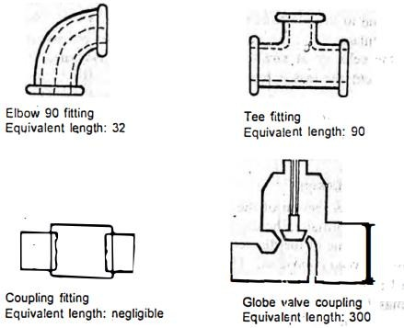
Friction losses in fittings of a new screwed pipe.
That means the contribution of a globe valve is equivalent to 15 metres of a straight pipe towards the losses. This length is added to the straight section of the pipe and substituted in the Fanning equation
(25) to obtain energy losses due to fittings.
Enlargement Losses
If the cross section of the pipe enlarges gradually, the fluid adapts itself to the changed section without any disturbance. Therefore, there is no loss of energy at this point.
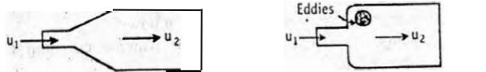
(a) Gradual enlargement No loss of energy (b) Sudden enlargement Loss of energy
If the cross section of the pipe changes suddenly, loss of energy is observed due to eddies. These are greater at this point than straight pipe. Due to these disturbances, the loss of head will be observed. In sudden enlargement, the velocity of flow at larger cross-section is less than the velocity at smaller cross-section, i.e., u₂ < u₁ . For sudden enlargement, the loss is represented by:

Sudden enlargement losses: ΔH_{e}
2
= (𝑢2− 𝑢1 )
2𝑔

(27)

Where, Δ He = loss of head due to sudden enlargement, m.

Contraction Losses
If the cross section of the pipe is reduced suddenly, the fluid flow is disturbed. Normally, the diameter of the fluid stream would be less than the initial value of the diameter. This point of minimum cross section is known as vena contracta. The velocity of fluid at smaller cross-section will be far greater than that at larger cross-section, i.e., u2> u. Then, u may be considered negligible. The losses due to additional eddying are observed. Such contraction losses can be expressed as:

𝐾𝑢2
2
Sudden contraction losses: ΔH_{c} =
2𝑔
Where, ΔH = loss in head due to sudden contraction, K = constant
U₂ = velocity, m/s
(28)

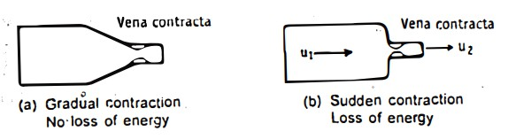
The constant K depends on the relative areas of two sections. For example, when the ratio of the areas is 0.5, K is equal to 0.3. For rounded entrance, K value for turbulent flow is about 0.04. For laminar flow, the loss is negligible.
MCQ each carry 1 mark
1 . In Bernoulli’s theorem the Potential energy is also known as ………..
- Resonance energy
- kinetic energy
- Thermal energy
- Datum energy
- ɳ in Poiseuilles equation is representing…………..
  - Velocity of fluids
  - Viscosity of fluids
  - Pressure of fluids
- According to Bernoulli’s equation velocity head of fluid of pitot tube obtained by which of the following equation
  - ∆HP=V2/ 2g
  - ∆HP = 2g/V
  - ∆HP= 2g/ V× u
  - ∆HP= V/2g
- Bernoulli’s theorem state that the pressure energy, kinetic energy, datum energy at any point of the fluids is………….
  - High
  - Constant

  - Low
  - Moderate

- The Bernoulli’s theorem is applied in measurement of……..
  - Rate of energy b) Rate of fluid c) Rate of velocity d) Rate of sedimentation
- The Bernoulli’s theorem is applied in working of …..……
  - Venturi pump
  - Orifice pump
  - Centrifugal pump
Each question carry 2 marks
Write the Fannings equation and explain the terms. What is its importance? Express the Hagen-Poiseuille's relationship. What is its importance?
Explain the term 'head'. List the different heads in the Bernoulli’s theorem. What is meant by equivalent pipe length? What are its applications?
Describe Vena contracta
What is a pressure head? How is it calculated
Each question carry 5 marks
Write Bernoulli's equation and explain the symbols used therein with a labelled diagram
How are losses of energy due to enlargement in cross section measured? Give relevant equation and explain the terms.
Each question carry 10 marks
Explain the energy losses that occur when a fluid flows through a pipe with relevant equations. Derive Bernoulli's equation stating the assumptions.
Write Bernoulli’s equation and explain the symbols used therein with a Labelled diagram.

