UNIT: II (HEAT TRANSFER)
CLASS:13
TOPIC: HEAT TRANSFER BY RADIATION, HEAT EXCHANGERS
RADIATION
Radiation is an energy transfer process in which heat is transferred through space by means of electromagnetic waves.
Thermal Radiation
Heat transfer by radiation is known as thermal radiation.
Radiation is effective across perfect vacuum and also through layers of air.
All solids radiate energy when their temperature is above the absolute zero. A solid surface emits radiant energy continuously and distributes over all wave length.
Heat transfer is predominant as the temp of the body increases. The amount and kind of thermal energy radiated increases rapidly with temperature.
Various Forms of Emitters
Various forms of emitters used for the supply of radiant energy are given below:
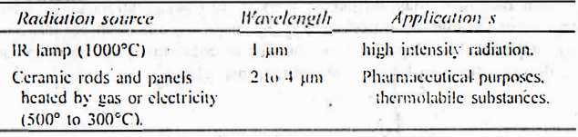
Advantages: The radiation source corresponding to wavelengths from 0.8 to 400 μm is used for the thermal radiation. For most cases of industrial interest. the range is narrowed from 0.8 to 25 μm. Radiant energy penetrates a short distance (1 to 2 μm) into materials. The heating effect occurs below the surface. For example, a film of solution can be dried by radiant heat. whereas surface skin retards the drying process in case of convection methods.
Fundamental Concepts
Thermal radiation obeys same laws of light, namely-
(a) it travels in a straight line
(b) it may be reflected from the surface
Suppose a cold substance is placed in the sight of a hot body inside an enclosed space. The cold body intercept the radiation emitted by the hot body. The fraction of radiations falling on the body may be reflected. which is known as reflectivity. p. The fraction that is absorbed is known as absorptivity. a. The fraction that is transmitted is known as transmissivity, $τ$. The sum of these fractions must be unity or:
α + ρ + $τ$ = 1
In practice, reflected and transmitted radiations usually fall on other absorptive bodies. The absorbed radiation is transformed into heat. This fraction is not available for the emission of radiation.

Black Body
All solid bodies radiate energy at a temperature above the absolute zero, however, not at the same rate. For the purpose of heat transfer, a theoretic substance is proposed and designated as black body.
Black body is defined as a body that radiates maximum possible amount of energy at a given temperature.
No physical substance is a perfect black body. The black matte surface approaches a black body, when visible light (rays) alone is considered. Light coloured substances deviate widely from it. Black surfaces are better emitters of heat radiation than polished surfaces. Further the term, 'black' is nothing to do with the colour of the body. Similarly it has nothing to do with the amount of energy it radiates.
In theory, a black body is considered to be an enclosed space with a small (negligible) opening. The temperature in the enclosed space should be constant and uniform, because the amount of energy escaping through a small opening is negligible. In practice, a convenient black body is made from a tube of carbon. Both the ends are plugged, with a small hole at the centre of one end. When viewed through this small hole, the inside enclosed space (furnace) is considered as a black body, provided the temperature is uniform. Similarly all objects within the furnace (enclosed space) can be considered as black bodies.
A good absorber of heat is a good emitter too. Conversely a poor absorber is a poor emitter.
Rate of Radiation
Normally, hot bodies emit radiation. Stefan-Boltzmann law gives the total amount of radiation emitted by a black body.
q = baT⁴ (37)
where q = energy radiated per second, W (or J/s)
A = area of radiating surface, m²
T = absolute temperature of the radiating surface, K
b = constant, W/m². K⁴
According to equation (37), the rate of heating depends upon the temperature and surface area of the emitter. At the same time, it also depends upon the absorption capacity of the material to be heated. For a black body, the value of b is 5.67x10⁻⁸ W/m².K⁴ . Actual bodies do not radiate as much as the black body. Therefore, equation (37) is modified for the actual bodies
q = εbAT⁴ (38)
where ε is equal to the emissivity of the actual body. Emissivity may be expressed at the same temperature as:
Emissivity, ε = $\frac{energy emitted by actual body}{energy emitted by black body}$ (39)
As per equation (39), emissivity is one for a black body. For actual bodies, & is less than one, because a fraction of the radiation is absorbed, which appears as heat. The fraction of energy absorbed is denoted by absorptivity; α (other fractions are either reflected or transmitted).
A good absorber of heat is also a good emitter at a given temperature. If emissivity is equal to absorptivity (ε = α), then a substance is considered as a black body. Since emissivity of a black body is 1. the absorptivity must be one. Therefore, the black body absorbs all the radiation falling on it.
Grey Body
Absorption of energy by a substance depends on its properties. Fairly high amount of energy will be absorbed by dark coloured, opaque and rough surface bodies. Least energy is absorbed by light coloured. transparent and smooth surfaced substances.
At a given temperature, the value of a varies somewhat with the wavelength of the radiation falling on it. This complicates the solving of problems in practice. Therefore, the concept of grey body has been introduced.
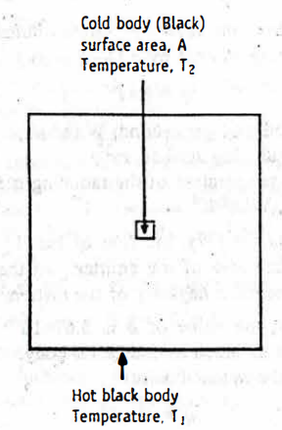
Heat transfer through radiation.
A grey body is defined as that body w whose absorptivity is constant at all wavelengths of radiation, at a given temperature.
Consider a small cold body with a surface area of A and temperature. of T₂ is completely surrounded by a hot black body at temperature T₁. The amount of heat transferred in such a process is expressed by the Stefan law, which may be written as:
q = bA ($T_{1}^{4}- T_{2}^{4} )$ (40)
Equation (40) assumes that all the heat radiated by a cooler body also falls on the hotter body.
EQUIPMENT
HEAT EXCHANGERS AND HEAT INTERCHANGERS
Most of the chemical and pharmaceutical industries employ a variety. of heat transfer equipment. The materials to be heated may be liquids or gases and occasionally solids (which is a separate case by itself). The heating media may be a hot fluid or condensed steam. Some of the processes. which involve the heat transfer encountered in pharmacy are:
- Preparation of starch paste (steam jacketed kettles) for granulation
- Crystallization
- Evaporation
- Distillation
In industrial processes, heat energy is transferred by various methods. The principles, construction and working of equipment used for the transfer of heat energy are as follows:
Heat exchangers: Heat exchangers are the devices used for transferring heat from one fluid (hot gas or steam) to another fluid (liquid) through a metal wall.
Heat interchangers: Heal interchangers are the devices used for transferring heat from one liquid to another or from one gas to another gas through a metal wall.
The classification given above is vague and many times used inter- changeably. Therefore, it is appropriate to call them as heat transfer equipment.
Some of them are discussed in the following sections.
Heaters or Heat Exchangers
Heat exchangers are the devices used for transferring heat from one fluid (hot gas or steam) to another fluid (liquid) through a metal wall.
Some heat transfer (or heaters) equipment are:
(1) tubular heater (shell-and-tube heater)
(2) multipass heater
(3) two pass floating head heater
In heat exchangers, the film coefficients on the steam side are usually much larger than the film coefficients on the cold liquid side. Therefore, the overall heat transfer coefficients will be nearer to the cold liquid side (because it is smaller of the two coefficients). Hence, heat transfer becomes less. The efficiency can be improved by passing the liquid at a high velocity. As a result, the thickness and resistance of the liquid film decrease. Normally, the space outside the tubes is large, but steam velocity is low. Still heat exchangers are useful, because of the high values of the steam film coefficients.
Tubular heater (Shell-and-tube heater): Shell-and-tube heater is the simplest form of a tubular heater. It is a single-pass tubular heater.
Construction: The construction of a simple tubular heater is shown in Figure.
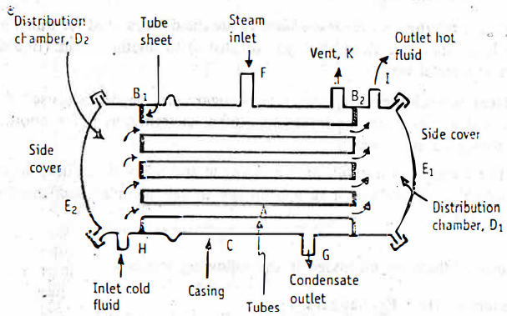
simple tubular heater
Tubular heater consists of a bundle of parallel tubes. which are relatively thin walled. The ends of these tubes are expanded into two tube sheets, B₁ and B₂. The bundle of tubes is enclosed in a cylindrical shell or casing, C, to which the tube-sheets are fitted. Many heaters have a cast iron shell.
Two distribution chambers, D₁ and D₂ are provided at each end of the casing C. Fluid inlet is provided to the distribution chamber D₂. The heated fluid outlet is provided to the distribution chamber D₁. Two covers. E₁ and E₂ are provided to close the distribution chambers from the sides. Steam or other vapour is introduced by a connection, F. Provisions are made for the escape of non-condensable vapour K and condensed vapour to drain at G.
Working: Steam or other vapour is introduced through a connection F into the space surrounding the tubes. The steam flows down the tubes. In this process, the tubes get heated. The condensed vapour is drained at G. Non-condensable gases, if any, escape through the vent K provided at the top of the casing.
The fluid to be heated is pumped through the connection H into distributing chamber D₂. The fluid flows through the tubes. The steam and fluid are physically separated, but are in thermal contact through the thin tube walls. The fluid in the tubes get heated due to heat transfer by conduction through the metal wall, followed by stagnant layer and finally by convection. The total heat transfer is effected by single pass of fluid. Thus, the heated fluid reaches the distributing chamber D₁ and leaves through the exit point, I
In the sheet-and-tube heater, the cross-sectional area of the tubes is larger. Hence, the velocity of the fluid inside the tubes is low.
Advantage: In single-pass tubular heater, large heating surface can be packed into a small volume.

Disadvantages: (1) The velocity of fluid flowing in these tubes is low, because of large cross-sectional area or larger surface.
(2) The expansion of the tubes and shell takes place due to differences in temperatures. This may lead to the loosening of the tube sheets or buckle the tubes.
Multipass heater: In a multi-pass heater, the velocity of fluid can be increased. As a result, heat transfer coefficient also increases. As the name indicates, the liquid to be heated is passed through the tubes several times before leaving the equipment. This facilitates the heat transfer. Therefore, multipass tubular heaters are superior to the single- pass shell-and-tube heaters.
Construction: The construction of a multipass heater is same as tubular heater mentioned above, however, with some modifications (Figure).
Tubular multipass heater consists of a bundle of parallel tubes. The ends of these tubes are expanded into two tube sheets. The tubes bundle is wrapped in a cylindrical casing. Two distribution chambers are provided at each end of the casing. Since the heater is multipass, the same liquid has to flow through several tubes back and forth. In order to facilitate this process, distribution chambers are partitioned by means of baffles and their arrangements are different in the two chambers (Figure). The entrance and exit points of the fluid are arranged in the same distribution chamber (right side).
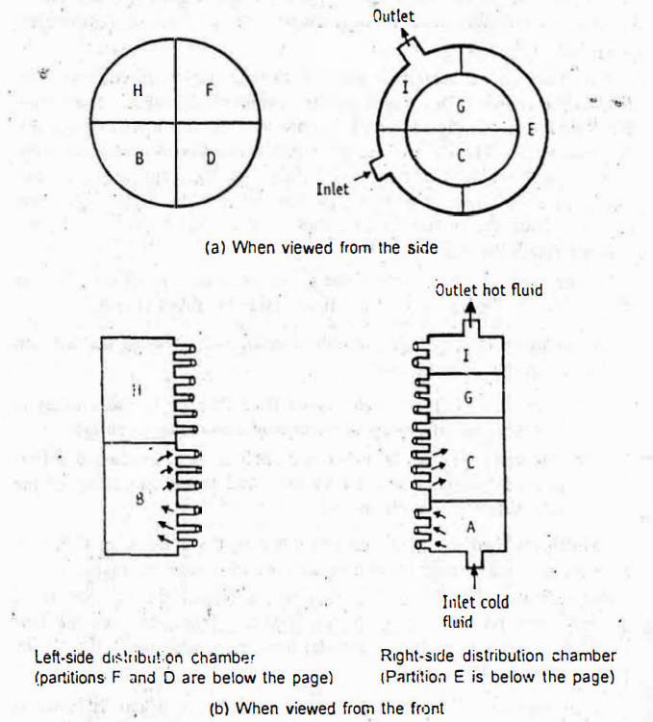
Construction of a multipass heater. In this figure. the modifications of distribution chambers and partitions are shown.
Working: Steam is introduced through the connection into the space surrounding the tubes. As the steam flows down, the tubes get heated. The condensed vapour is drained. Non-condensable gases, if any. escape through the vent provided at the top of the casing.
The fluid to be heated is pumped at high velocities into the right distribution chamber through the compartment. A. High velocity facilitates the effective heat transfer. In this construction, fluid is directed to enter only a fraction of the tubes by means of baffles placed in the distribution chamber.
The liquid enters compartment A and flows to the left into compartment B, back to the right to compartment, and so on in the same sequence of alphabetical order. During this process, fluid in the tubes get heated, due to heat transfer by conduction through the metal wall, followed by a stagnant layer and finally by convection. The net result is enhanced rate of heat transfer. Thus, the fluid passes back and forth through the several tubes and then leaves the equipment at I.
If the fluid is to be introduced at high velocities, pumping should be effective, which increases the cost of the power, though the cost of heater is low. Too low a velocity saves power for pumping, but needs a very large heater. Therefore, a balanced approach should be worked out based on economy.
Advantages: Multipass construction decreases the cross section of the fluid path, thereby increases the fluid velocity. Thus, multipass tubular heaters are superior to the single-pass shell-and-tube heaters.

Disadvantages: (1) The fabrication of a multipass heater is more complicated.
(2) The pressure-drop through the apparatus is increased, because of enhanced velocity of fluid flow. (3) More number of exit and entrance points increase the friction losses. This increases the cost of pumping of fluid.
Floating-head. two-pass heater: In floating-head two-pass heater, the ends of the tubes are structurally independent of the shell.
Construction: The construction of a two-pass floating head heater is shown in Figure. Its construction is the same as tubular heater with some modifications.
Two-pass floating head heater consists of a bundle of parallel tubes. These are enclosed in a shell (casing). The right-side of the distribution chamber is partitioned and fluid inlet and outlet are connected to the same chamber. The partition is such that both have equal number of tubes. On left-side, the distribution chamber is not connected to the casing. It is structurally independent, which is known as floating head. The other end of the tubes is embedded into the floating head. Steam or other vapour is introduced through inlet provided to the shell. Provisions are made for the escape of non-condensed vapour and an exit for the condensate.
Working: Steam is introduced through the inlet (Figure). As the steam flows down the tubes, they get heated. The condensed vapour escape through the bottom of the shell. Non-condensable gases, if any. escape through the vent at the top of the shell.
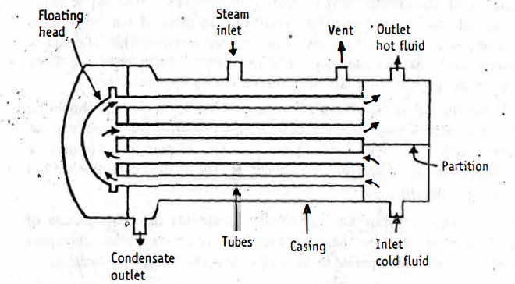
Construction of a two-pass floating head heater.
The fluid to be heated is introduced into the distribution chamber on right-side of the heater. The fluid flows through few tubes present in that part of the partition. The fluid reaches the floating head and changes direction. Now it passes back to the next part of the partition chamber on right-side. Therefore, the fluid flows twice through the tubes, i.e., two pass. During this process. fluid in the tubes get heated, due to heat transfer by conduction through the metal wall, followed by a stagnant layer and finally by convection. Then the fluid leaves the outlet provided in the shell.
Advantages: In a shell-and-tube heat exchanger, tubes and shell may get expanded due to differences in temperature. Similarly contractions are also possible when heater is switched off. It leads to loosening of tube sheets or buckles the tubes. Therefore, constructing the tubes independent of the shell can prevent these effects. Such an arrangement is floating head.
MCQ Each carry 1 mark
- In the heat interchanger, finned tubes are used for one of the following purposes.
  - Increasing the surface area
  - Introducing steam
  - Introducing the cold fluid
  - Reducing the size of apparatus
- In the microwave oven, the heat flows in one of the following mechanisms.
  - Conduction
  - Convection
  - Diffusion
  - Radiation
- Which of the following is an example of steady-state heat transfer?
    - Electric bulb cools down by the surrounding atmosphere
    - Chilling effect of cold wind on a warm body
    - Boilers and turbines
    - Cooling of I.C engine
- A person prefers to sit by a fire during the cold winter months. Which of the following heat transfer types gives him with the most heat?
    - Convection and radiation together
    - Radiation will provide quick warmth
    - If it is near the fire, convection sounds good
    - Conduction from the fire
- Radiation heat transfer is characterized by
    - Movement of discrete packets of energy as electromagnetic waves
    - Due to bulk fluid motion, there is a transport of energy
    - There is the circulation of fluid by buoyancy effects
    - Thermal energy transfer as vibrational energy in the lattice structure of the material
- Which of the following is the unit of coefficient of radiant heat transfer?
    - W/m2
    - W/m K
    - W/m2 K
    - W/K
Each carry 2 marks
- List the characteristics of heat transfer by radiation.
- What are Grey bodies? How do they radiate heat?
- Explain the terms 'Black body' and Grey body'.
- State and explain Stefen Bolzmann's law of heat radiation
Each carry 5 marks
- Draw a neat und labelled diagram of a shell-and-tube heat exchanger and explain its construction.
- Describe tinned tube heat exchanger and its specific advantages
- Explain the working of a heat exchanger with a labelled diagram.
Each carry 10 marks
- Describe the construction. operation, advantages and disadvantages of a multipass heater.

