UNIT: II (HEAT TRANSFER)
CLASS:12
TOPIC: HEAT TRANSFER BY CONVECTION
CONVECTION
When heat flow is achieved by actual mixing of warmer portions with cooler portions of the same material, the process is known as convection.
The heat transfer in fluid occurs on account of actual mixing of its layers.
Forced convection: Mixing of fluid may be obtained by the use of a stirrer or agitator or pumping the fluid for recirculation. Such a process in heat transfer is designated as forced convection. For example, in some types of tube evaporators, the evaporating liquid is forced through the tubes under pressure. Therefore forced convection is observed.
Natural convection: Mixing of fluid may be accomplished by the currents set up. when body of fluid is heated. Such a process is knowns as natural convection. For example, in pan evaporator. convection currents are set up in the evaporating liquid. In general, fluid flow may be described as either laminar or turbulent. These create problems in the estimations. Some of them are as follows.
When heat is passed through the tube, stagnant films are important in determining the rate of heat transfer.
- When fluid exhibits viscous flow, the velocity is zero at the actual surface of the wall. It means that the layer of fluid adjacent to the wall acts as a stagnant film.
- A comparatively stagnant film can be observed even in turbulent flow. At the centre. the fluid is in turbulent flow, while at the surface the fluid exhibits viscous flow. A film of buffer layer oscillates between these types of flow.
- Sometimes, scales are deposited on the surface of the metal wall and heat must be conducted through the scales.
- When steam gives up latent heat, water will condense on the surface of the vessel (or tube). again the heat must be con- ducted through this water film.
For heat transfer in a tube. heat must pass through the stagnant film by conduction. Hence, conductivity of these films is important. Normally, thermal conductivities of fluids are low. The conductivity of the stagnant film will be still less. For example, the thermal conductivity of water is less. A film of water has a resistance of about 500 times and that of air film is about 13.000 times greater than a copper sheet of the same thickness. Thus, the resistance offered by these films (though it is thin) is large for the heat flow. Beyond these films. the turbulence brings about rapid equalization of temperature.
Therefore, the resistance offered by the boundary film is of importance in the flow of heat, particularly in the evaporation process.
Forced Convection-Temperature Variation-Individual Heat Transfer Coefficients
Mixing of a fluid may be obtained by the use of a stirrer or agitator or pumping the fluid for recirculation. Such a process in heat transfer is designated as forced convection.
Forced convection is obtained in some types of tube evaporators. wherein the evaporating liquid is forced through the tubes under pressure.
In a heat transfer process, the overall coefficient depends upon many variables. It is necessary to break them into individual parts. The temperature distribution across a column of fluid that is being heated (or cooled) is related to the velocity distribution across the same column of fluid.
Consider a case of heat flowing from a hot fluid through a metal wall into a cold fluid. At a specific point, the variation of temperature on each side of the metal wall is depicted in Figure. Several important facts are evident from Figure, as listed below.
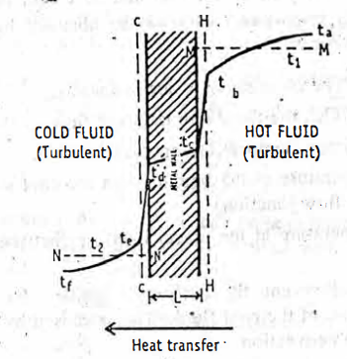
Temperature gradients in forced convection, while heat is flowing from a hot fluid to a cold fluid through a metal wall.
Metal wall: The characteristics are as follows.
- Dotted lines HH and CC represent the boundaries of the films in viscous flow on the hot and cold sides, respectively, on each side of the metal wall.
- The temperature gradient through the line t_{c} t_{d} is caused by the flow of heat purely by conduction through the metal whose thermal conductivity is known.
- Metal wall thickness is L.
Hot fluid side: The characteristics are as follows.
- To the right of HH, the fluid is in turbulent flow on the hot side.
- t_{a} is the maximum temperature in the hot fluid.
- t_{b} is the temperature at the boundary on the hot side (turbulent and viscous flow junction).
- t_{c} is the temperature at the actual interface (between fluid and solid surface).
- Curve t_{a} t_{b} t_{c} to the represents the temperature gradient from the bulk of the hot fluid to the metal wall. This is caused by the flow of heat in forced convection.
- t₁ is the average temperature on the hot fluid side represented by the line MM. In general, for heat transfer calculation. average temperature is important. This can be obtained by taking its temperature after mixing.
Cold fluid side: The characteristics are as follows.
- To the left of CC, the fluid is in turbulent flow on the cold side.
- t_{f} is the minimum temperature on the cold fluid.
- t_{e} is the temperature at the boundary on the cold side (viscous and turbulent flow junction).
- t_{d} is the temperature at the actual interface (between fluid and solid).
- Curve t_{d} t_{e} t_{f} represents the temperature gradient from the metal wall to the bulk of the cold fluid. This is caused by the flow of heat in forced convection.
- t₂ is the average temperature on the cold fluid side represented by the line NN. In general. for heat transfer calculation average temperature is important. This can be obtained by taking its temperature after mixing.
Surface or film coefficients: in forced convection, the stagnant films (HH and CC) are of great importance in determining the rate of heat transfer. Though these films are thin, the resistance offered by them is large. Beyond these films, the turbulence brings about rapid equalization of temperature.
Film coefficient is the quantity of heat flowing through unit area of the film for unit drop in temperature.
It is the conductive capacity of the stagnant film for the transfer of heat.
It is difficult to determine the thermal resistances of fluid films, since thicknesses of the films cannot be known precisely. The thickness of the film depends not only on viscosity of the fluid, but also on the fluid circulation level (forced convection). Hence, the resistance offered by these films cannot be individually calculated. Therefore, indirect method of computation of surface coefficients is employed.
Let q watt (joules per second) of heat is flowing from hot fluid. to cold one. Same heat must pass through stagnant fluid film on the hot side, through the metal wall and through the stagnant film on the cold side. Let the following be the characteristics.
Area of the metal wall on the hot side = A₁, m²
Area of the metal wall on the cold side = A₂, m²
Average area of the metal wall = A_{m} m2
Surface or film coefficient on the hot side: On the hot side, the surface coefficient, h₁ is defined as:
Film coefficient on
the hot side (W/m² .K) = $\frac{amount of heat flowing (W)}{area \left(m^{2}\right) × difference in temperature (K)}$
h₁ = $\frac{q}{A_{1\left(t_{1}- t_{c}\right)}}$ (20)
From equations (20) and (7), it can be seen that surface coefficient () is analogous to the term, K/L for a metal wall. Since L/kA is the resistance term for metal wall, the term:
And, $\frac{1}{h_{1}A_{1}}$ is known as thermal resistance on hot side.
The thermal resistance is due to the combined effect of the viscous film HH and the turbulent core. This resistance caused the difference in temperature, t_{a} – t_{b} .
Surface or film coefficient on the cold side: Film coefficient on the cold side can be written on similar lines as:
Film coefficient on the cold side = $\frac{amount of heat flowing}{area × difference in temperature}$
h₂ = $\frac{q}{A_{2\left(t_{d}- t_{2}\right)}}$ (21)
And. $\frac{1}{h_{2}A_{2}}$ is known as thermal resistance on cold side.
Overall coefficient: In the over all heat transfer, three resistance terms are involved in series.
$\frac{1}{h_{1}A_{1}}$is the resistance on the hot fluid side.
$\frac{L}{K A_{m }}$is the resistance of the metal wall.
$\frac{L}{h_{2}A_{2}}$is the resistance on the cold fluid side.
Applying the principle of compound resistance in series, the overall heat transfer may be written as:
q = $\frac{∆t}{ \frac{1}{h_{1}A_{1}}+ \frac{L}{K A_{m }}+ \frac{L}{h_{2}A_{2}} }$ (22)
If both numerator and denominator of the right side of equation (22) are multiplied by A₁, equation (23) is obtained.
q = $\frac{A_{1}∆t}{ \frac{1}{h_{1}}+ \frac{LA_{1}}{K A_{m }}+ \frac{A_{1}}{h_{2}A_{2}} }$ (23)
Then, the overall heat transfer coefficient U₁ (W/m²K) is defined by equation (24)
U₁ = $\frac{1}{ \frac{1}{h_{1}}+ \frac{LA_{1}}{K A_{m }}+ \frac{A_{1}}{h_{2}A_{2}} }$
If equation (24) is compared with equation (23), it is apparent that:
q = U₁ $∆t$ A₁ (25)
Equation (25) states that
Rate of heat transfer = overall heat transfer coefficient x
area of the heating surface ×
temperature drop (26)
For a tubular wall: The above derivation (equation (24)) is based on the metal wall of thickness, L. This relationship may be extended to a tubular metal wall. The heat coefficients may be written in terms of diameter (metre), since area is proportional to the corresponding tube diameter. The overall heat transfer coefficient for a tubular metal wall may be written as:
U₁ = $\frac{1}{ \frac{1}{h_{1}}+ \frac{LD_{1}}{K D_{m }}+ \frac{D_{1}}{h_{2}D_{2}} }$ (27)
In some cases, one particular area is more convenient than the other. Suppose, h₂ $≫$ h_{1,} the ($\frac{D_{1}}{h_{2}D_{2}}$) becomes small in comparison to (l/h₁). Similarly, resistance of the tube wall is also small in comparison with (1). Hence, ratios $(\frac{D_{1}}{ D_{m }})$ and ($\frac{D_{1}}{D_{2}}$) have very little significance and can be disregarded. Then, equation (27) becomes:
U₁ = $\frac{1}{ \frac{1}{h_{1}}+ \frac{L}{K }+ \frac{1}{h_{2}} }$ (28)
Equation (28) can be used in cases of:
(a) thin walled tubes with larger diameter
(b) thin walled plates
In these cases, area A can be used for A₁, A_{m} and A₂, since errors will be negligible. In such cases,
U₁ = U_{m} = U₂ (29)
When h₁ is very small compared to h₂ and (L/k). (1/h₁) will be larger. Therefore these two terms in the denominator are disregarded. Then
U₁ = h₁ (30)
Thus, rate of heat flow from one fluid to another through the retaining wall can be simplified. Hence, numerical value of surface coefficients can be predicted easily.
Factors influencing film coefficients: Several factors influence the surface film coefficients. However, the factors that are widely applied in practice are a few with reference to the processing conditions. These are:
- Thermal conductivity of the liquid
- Specific heat of the film
- Density of the liquid
- Turbulence of the fluid
- Thickness of the film
If the films are thin. their resistances will be reduced. This can be achieved by increasing the speed of the steam on one side and the speed of liquid on other side.
Fluids in Natural Convection
When a fluid is heated. the currents set up may cause mixing of fluid. Such a heat transfer process is known as natural convection.
The mechanism of natural convection is depicted in Figure. Consider a case of single horizontal cylinder. A large volume of fluid is. present surrounding the cylinder. When a fluid is in contact with a hot surface, the fluid that is immediately adjacent to the tube absorbs heat. The temperature of this part of the fluid increases, which in turn de- creases the density. As a result, the fluid rises from the surface and is replaced by the cold fluid. This process continues thereby effecting the mixing of hot and cold fluids.
Fluid circulation caused by changes in the densities due to temperature differences in the fluid is termed as natural convection
Fluid circulation also changes with:
- Geometry of the system, i.e., size, shape and arrangement heating surface,
- Shape of the vessel in which the fluid is enclosed.
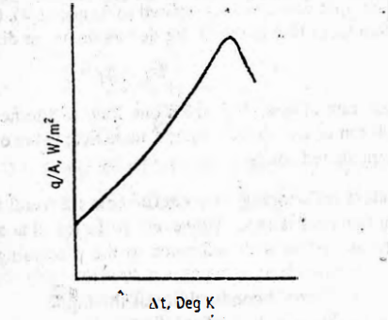
Mechanism of heat transfer in natural convection
The physical properties of the system are individually evaluated at the mean film temperature. Generally, hot bodies lose heat to their surroundings both by radiation and by convection. At lower temperature ranges. convection is more predominant, while radiation is important at higher temperature ranges. In practice, liquid film coefficients may vary from 10 to 200 depending on the arrangement of apparatus and the viscosity of the liquids.
Application: Natural convection is observed when extracts are evaporated in open pans.
Changes in Fluids during Heat Transfer
In heat transfer by convection, two liquids are involved. The hot liquid gives heat, while the cold liquid receives it. Each liquid under- goes changes during heat transfer. Steam condenses to give heat, while the cold liquid boils.
Hot liquid-Steam boiler: Steam is generated in a central boiler house at high pressure. The following are the advantages.
  - High pressure steam can be used to drive a turbine for generating electric power.
  - Low pressure exhaust steam is used for process heating.
  - Central generation is more economical.
  - More steam is stored in boiler if high pressure is applied.
  - High pressure steam means high temperature.
Characteristics of the steam:
- Steam should be as dry as possible. thereby heat losses can be minimized.
- Since the latent heat is the useful heat, steam should be used at the lowest pressure that will give a suitable temperature gradient.
- Steam should be pumped at its saturated temperature. Super -heated steam should not be used.
- Steam should be replaced continuously so that the process proceeds indefinitely.
Hot liquid-condensing of vapour: Steam gives its heat of vaporisation during condensation. This heat is transferred to the cold liquid through a metal wall.
In a heater, steam is passed through the tubes or outside the tubes. In each case. the metal surface of the tube gets heated up. While transmit- ting heat to a metal surface, the saturated vapour condenses into two distinct forms based on the nature of wetting of the metal surface. These are as follows.
Film type condensation: In this type, the condensed liquid wets the surface on which it is condensing and forms a continuous film of condensate.
If condensation is occurring on the outside surface of a horizontal metal tube (a very common case), this film of condensate drops off beneath the tube. If the tube is vertical, then it runs down the whole length and drops off from the edge. Generally, smooth and clean surfaces tend to form film type. For film type condensation the film coefficients are low. Equations have been proposed for heat transfer calculations.
Drop-wise condensation: In this type, the condensed liquid collects as drops that may range from microscopic size up to drops that are seen with the naked eye.
If the condensed liquid does not wet the surface, the drops grow and then fall off the surface, leaving an apparent bare area on which new drops form. Normally, oily or greasy surfaces tend to induce drop-wise condensation. The coefficients for drop-wise condensation may be double or more than double that of film type under identical conditions. It is difficult to estimate the coefficients of heat transfer for drop-wise condensation.
In general, the film coefficient between condensing vapour and metal wall increases with increasing temperature of vapour. Film coefficients decrease with increasing temperature drop. When steam is employed as a source of heat, it is necessary to remove non-condensable gases. Other- wise, they reduce the film coefficients, because of their accumulation.
Cold liquid-boiling of liquids: When heat is supplied to a liquid, it boils and the vapour pressure increases. This process continues until the vapour pressure is equal to the atmospheric pressure. At this stage, the temperature of the liquid remains constant, which is known as boiling point. Generally, heat is supplied to a liquid through a heater by passing steam.
Consider a horizontal tube, which is immersed in a pool of pure liquid. Steam is passed through the tube. The heat transfer depends on the differences in temperatures on each side of the tube wall. The relationship between temperature differences and heat transfer coefficients in liquids (boiling outside the horizontal tube) is shown in Figure. Δt may be defined as:
Δt = tube wall temperature-saturated temperature of liquid (= vapour pressure in spaces)
The following conclusions may be drawn from Figure.
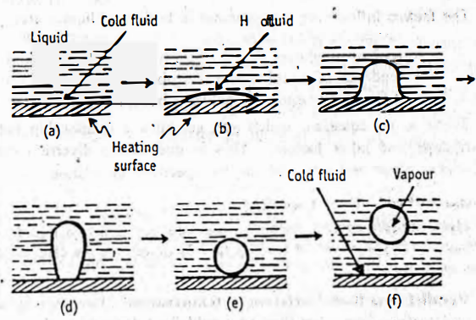
Effect of temperature difference on the behaviour of a liquid boiling outside the horizontal tube.

(1) If Δt is very small, the rate of heat transfer (q/A) is not much. Hence. liquid doesn't boil.
(2) If Δt is increased, the rate of heat transfer (q/A) will be increased, because heat transfer coefficient increases rapidly. The mechanism is as follows. The heated liquid at the wall forms bubbles of vapour and gets detached from the surface. These vapour bubbles rise through the liquid. This type of boiling is called nucleate boiling. The cold fluid now wets the tube, wall. Thus bubbles produce a series of currents, which have a stirring effect.
(3) If A is increased further, the surface temperature increases continuously up to a point, where the heat transfer coefficient reaches a maximum. This temperature is known as critical Δt. At this stage, the bubbles begin to coalesce into a continuous film of vapour, which insulates the tube.
(4) Beyond critical Δt, further increase in Δt leads to lowering of heat transfer coefficients rapidly. The continuous film of vapour insulates the tube, thereby the effective fails to increase. Thus rate of heat transfer is decreased.
For some organic liquids. the heat transfer coefficient may decrease rather slowly after critical Δt. Therefore, maximum heat flux may occur at higher Δt than the maximum coefficient.
The factors influencing heat transfer in boiling of liquids are:
- roughness of the tube
- type of roughness
- tendency of liquid to wet the tube
- difference in densities between bubble and liquid
There is no equation. which can establish a relationship between coefficient and other factors. This is due to the diverse nature of apparatus (shape and size) and varying speeds of circulation.
Modes of Feed-Heat Transfer
Heat transfer by convection is involved between two liquids. The differences in the modes of feeding largely determine the efficiency of a heat process.
Parallel heat flow-Variation in temperature: Heat transfer across a metal surface from a hot fluid to a cold fluid depends on the temperature gradient (Δt). Generally, it is assumed to be constant for all parts of heating surface.
When the hot fluid and the cold fluid enter the apparatus from the same end, the flow is parallel to each other. This arrangement is known as parallel flow.
Consider a heat interchanger. The temperature of the hot fluid inside a pipe decreases. from T₁ to T₂. by transferring heat to a cold fluid outside the pipe. As a result, the cold fluid temperature is increased
from t₁ to t₂ This condition is represented in Figure
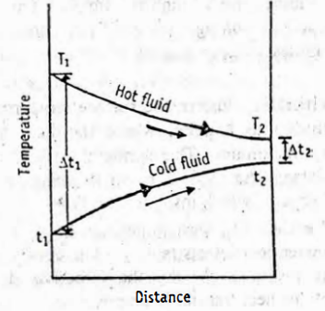
Temperature difference in parallel-current heat flow.
The temperature-drop at the left-end is much greater than at the right- end. It means that heat transfer is faster at left-side than that of the right-side. These changes, as occurring in a small section of the pipe, can be considered for the whole length of the pipe.
Mathematically, heat transfer in parallel flow of liquids can be written as:
dq = U . A . Δt (31)
Equation (31) is based on two assumptions.
(a) The overall coefficient (is considered constant throughout the equipment.
(b) The specific heat of each fluid is considered constant. Integrating equation (31) gives:
q = UaL$\frac{∆t_{1- ∆t_{2}}}{ln\frac{∆t_{1}}{∆t_{2}}}$ (32)
where L = length of pipe. M
a = area of the pipe, m²
Comparing equation (32) with the general equation of heat transfer (equation 25) gives:
$∆t_{m}$ = $\frac{∆t_{1- ∆t_{2}}}{ln\frac{∆t_{1}}{∆t_{2}}}$ (33)
Thus logarithmic mean temperature difference (Δt_{m}) is used. The total heating surface (A) is equal to aL. Heat transfer equation in parallel flow heat exchanger is:

q = UAΔt_{m} (34)
The logarithmic mean temperature difference is used to account varying temperature drop in parallel flow. If the temperature drop is. nearly equal (Δt₁$≅$Δt₂), then arithmetic average temperature (Δt_{m}) can be used, which is a general expression for heat transfer.
In parallel heat flow, the heating obtained per unit surface area is much less effective at the fluid exit point compared to it at the point of entrance of the apparatus.
Counter-current heat flow-temperature gradient: When the hot fluid is passed through one end of the apparatus while cold fluid is passed through the other end, fluids pass and by pass each other in the opposite directions. This arrangement is known as counter-current or counter-flow.
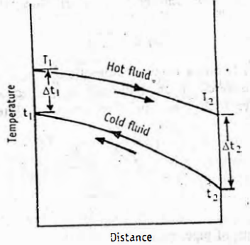
The temperature gradients for the counter-current flow are shown in Figure

Temperature difference in counter-current heat flow.
From the Figure, it can be concluded that the temperature drop along the length of the apparatus is nearly constant. In other words. amount of heat transfer per unit area is substantially same at both ends. The heating surface is nearly constant throughout the apparatus.
In counter-current heat flow, the exit temperature of the hot fluid is considerably less than the exit temperature of the cold fluid. Hence a large proportion of the heat content of the hot fluid can be extracted for a given entrance temperature of the cold fluid: If Δt₁$≅$Δt₂, temperature (Δt) can be taken as arithmetic average.
Δt_{ave} = $\frac{{∆t}_{1- ∆t_{2}}}{2}$ (35)
The heat transfer equation for counter-current heat flow can be written as:
q = UA. Δt_{ave} (36)
Consider a case, where steam is transferring its heat to a colder body. Let the pressure difference in steam be constant. The temperature difference when steam is in a heat exchanger is shown in Figure
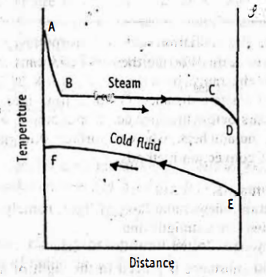
Temperature difference in counter current heat flow (steam as heating medium)
Initially steam cools down to condensing temp as indicated. Then condensation occurs at constant temperature and may further be allowed to cool
MCQ Each carry 1 mark
- In the convection process for a liquid in a tube, one of the following offers great resistance.
  - Central layer of liquid
  - Liquid layer adhered to the metal wall
  - Metal wall
  - Stagnant liquid layer between viscous and turbulent flow
- 9. On which of the following does convective heat transfer coefficient doesn’t depend?
    - Orientation of solid surface
    - Time
    - Surface area
    - Space
- In liquids and gases, heat transmission is primarily caused by
    - Convection
    - Radiation
    - Conduction
    - Conduction as well as convection
- The rate of heat transfer for a plane wall of homogenous material with constant thermal conductivity is given by which of the following equation?
    - Q = 2k/δ x
    - Q = 2kAδx
    - Q = kA (t1-t2)/δ
    - Q = 2kAx/ δ
- The convective heat transfer coefficient in the laminar flow over a flat plate __________
    - Decreases with increase in free stream velocity
    - Increases if a denser fluid is used
    - Increases with distance
    - Increases if a higher viscosity fluid is used
- What is the relation between the rate of convection heat transfer and the rate of mixing in turbulent fluid flow?
  - the rate of convection heat transfer decreases with increase in the rate of mixing in turbulent fluid flow
  - the rate of convection heat transfer increases with increase in the rate of mixing in turbulent fluid flow
  - the rate of convection heat transfer does not affected by the change in the rate of mixing in turbulent fluid flow
  - none of the above
Each carry 2 marks
- Differentiate between film coefficient and overall heat transfer coefficient.
- What is meant by overall heat transfer coefficient? What is its significance
- Define conductivity with a suitable example
- State the relationship between individual film coefficients and overall heat transfer coefficient.
Each carry 5 marks
- Compare and contrast heat transmission following counter-current and parallel current feed techniques with relevant equations.
- Write about fluids in natural convection
Each carry 10 marks
- With the help of a neat diagram, explain the concept of film and overall heat transfer coefficients in forced convection Deduce relevant mathematical equations.

