L-8
Preparationofamides:

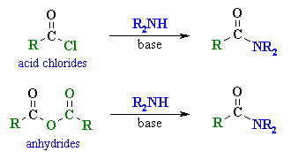
Reaction type: nucleophilic acyl substitution
Summary
Primary amines, r-nh₂ and secondary amines, r₂-nh undergo nucleophilic acyl substitution with carboxylic acid derivatives to give amides.
The most common examples are the reactions of acid chlorides and anhydrides, though esters do react with amines.
Hofmann elimination
Reaction type: elimination
Summary
Like alcohols, amines can undergo elimination reactions.
Quaternary ammonium salts undergo an e2 elimination when heated with silver oxide, ag₂o, in water.
Amines can readily be converted into quaternary ammonium iodides by treating them with excess methyl iodide.
Ag₂o / h₂o reacts giving the quaternary ammonium hydroxide, silver iodide precipitates.
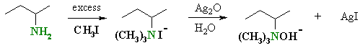
When heated the hydroxide induces a base promoted 1,2- or β-elimination giving an amine and alkene.
The regioselectivity is opposite to that predicted by zaitsevs rule in that it leads to the less highly substituted alkene.
The less highly substituted alkene is sometimes referred to as the hofmann product.
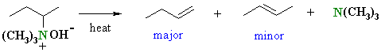
The outcome is dictated by steric effects of the large leaving group and the alkyl chain (more details ?)
Nh₂⁻ and nr₂⁻ are very poor leaving groups (both anionic), but nr₃ is much better (neutral)
Compare this with with -oh and h₂o in the dehydration of alcohols.
Related reactions
dehydration of alcohols
dehydrohalogenation of alkyl halides
Mechanism of the hofmann elimination
The initial steps are an example of the alkylation of an amine by methyl iodide. The mechanism of the elimination step is shown.  When heated, the hydroxide removes the more accessible proton, the π bond of the alkene c=c forms and the leaving group, a neutral amine departs. | 