L-2
Reactivity:
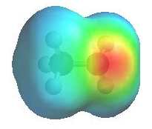 | The image shows the electrostatic potential for methylamine, ch₃nh₂. The more red an area is, the higher the electron density and the more blue an area is, the lower the electron density.  The amine n atom is a region of high electron density (red) due to the lone pair.  Amine n atoms are lewis bases, (alkyl ammonium pk_{a} ~ 10, aryl ammonium pka ~ 5)  Amines can react as either bases or nucleophiles at the nitrogen.  There is low electron density (blue) on h atom of the -nh group.  Removal of the proton generates the amide ion  (care : not to be confused with the carboxylic acid derivative rconh₂)  The -nh group is a very poor leaving group and needs to be converted to a better leaving group before substitution can occur.
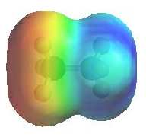 | The image shows the electrostatic potential for methylammonium, ch₃nh₃⁺. The more red an area is, the higher the electron density and the more blue an area is, the lower the electron density.  The ammonium n atom is a region of low electron density (blue) due to the positive charge.  Ammonium ions are not nucleophilic.  There is low electron density (blue) on h atom of the -nh₃ group.  Removal of the proton regenerates the amine.  The -nh₃ group is a potential leaving group.

