L-4
Reduction of azides
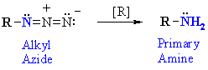
Reaction type : oxidation - reduction
Summary
Azides, r-n₃, can be reduced to primary amines, r-nh₂
Reagents : either lithium aluminum hydride (lialh₄) / ether solvent or catalytic hydrogenation (e.g. h₂/pd)
Alkyl azides are prepared by nucleophilic substitution (s_{n}2) by azide ion, n₃⁻, of primary or secondary alkyl halides.
Reduction of nitriles
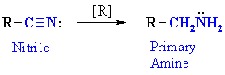
Reaction type : oxidation - reduction or nucleophilic addition
Summary
The nitrile, rc≡n, is reduced to the 1º amine by conversion of the c≡n to r-ch₂-nh₂
Reagents : either lithium aluminum hydride (lialh₄) / ether solvent or catalytic hydrogenation (e.g. h₂/pd).
Alkyl nitriles are prepared by nucleophilic substitution (s_{n}2) by cyanide ion, cn⁻, of primary or secondary alkyl halides.
Aryl nitriles can also be reduced to aryl amines.
Reduction of nitro compounds
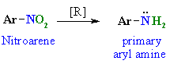
Reaction type : oxidation - reduction
Summary
Nitroarenes can be reduced to primary aryl amines (see scheme).
Typical reducing agents include, fe / h⁺, sn / h⁺ or catalytic hydrogenation (e.g. h₂ / pd)
Nitroarenes are prepared by the nitration of aromatics.
This is probably the most important method for the synthesis of anilines (ar-nh₂) and, therefore, accessing the chemistry of diazonium compounds (see later)

