L-2
General methods of preparation of aldehyde and ketone
Preparation of aldehydes
- Oxidation of primary alcohols:
primary alcohols on oxidation give aldehydes.
- In general, aldehydes are more easily oxidized than alcohols.
- Rcho → rcooh occurs more readily than rch 2oh → rcho.
- Therefore, very mild oxidizing agents must be used for the transformation rch 2oh → rcho.

Examples of mild oxidizing agents are:
(a) chromium trioxide-pyridine complex, cro 3.2py;
(b) manganese dioxide, mno 2

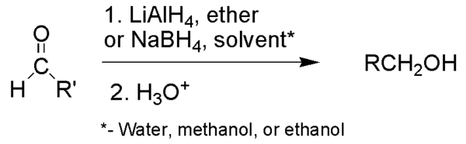
- Reduction of acyl chlorides
reduction of acyl chlorides: rcocl → rcho. Lithium trit-butoxyaluminum hydride is often used for this reduction.

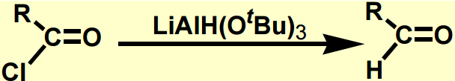
Preparation of ketones
- Preparation of ketones from acyl chlorides: acyl chlorides upon treatment with grignard reagent and a metal halide, yields ketones.
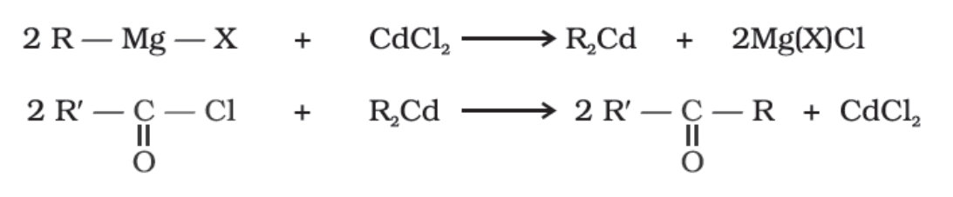
- preparation of ketones from nitriles: treatment of nitriles with grignard reagent upon further hydrolysis yields ketones.
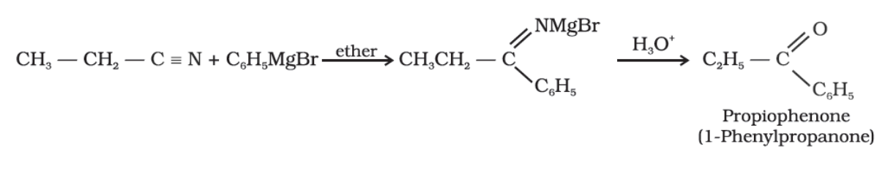
- Preparation of ketones from benzenes or substituted benzenes: electrophilic aromatic substitution of benzene ring with acid chlorides in the presence of a lewis acid such as, alcl₃ results in the formation of ketones. This reaction is popularly known as friedel craft’s acylation reaction.
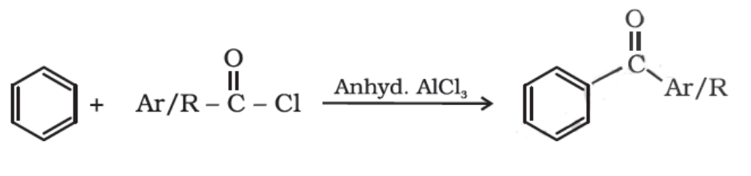
- Preparation of ketones by dehydrogenation of alcohols: dehydrogenation of alcohol is a reaction in which two hydrogen molecules are removed from an alcohol molecule upon oxidation. During oxidation of an alcohol both c-o and o-h bonds are broken for the formation of c=o bonds. Secondary alcohols in the presence of strong oxidizing agents undergo dehydrogenation to produce ketones
