UNIT-IV
ALDEHYDES & KETONES
Aldehydes and ketiones
L-1
Carbonyl compounds are molecules containing the carbonyl group, c=o. These include:
- Aldehyde
- Ketone

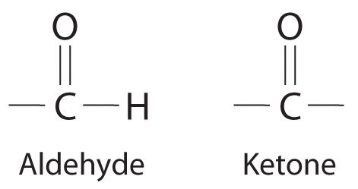
Carbonyl compounds also includes the following

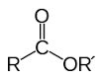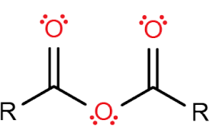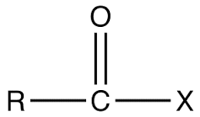
ester anhydride acid halide

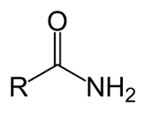
amide

Nomenclature of aldehydes and ketones
• common names are used for the simplest aldehydes and ketones:
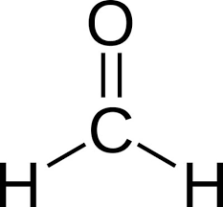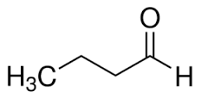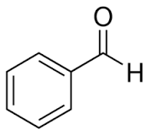
formaldehyde butyraldehyde benzaldehyde

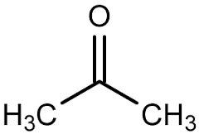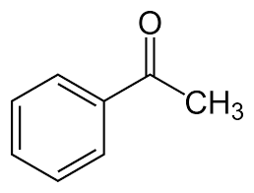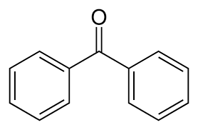
acetone acetophenone benzophenone

