L-9

Acidity of alpha hydrogens
The c-h bond on the alpha carbon of carbonyl compounds (aldehydes, ketones, acids, and acid derivatives) has modest acidity (pka 17-30) depending on the functional group. The carbonyl group is an electron-withdrawing group and is able to acidify the hydrogen on the alpha carbon. Strong bases will deprotonate the sp3 hydrogen on the alpha carbon generating an enolate ion. In the enolate ion the alpha carbon is sp2 hybridized. This anion is stabilized by delocalization of the negative charge into the carbonyl group placing the charge on the oxygen atom. Note that the sp2 orbital is in the proper orientation to overlap with the p orbitals of the carbonyl group. 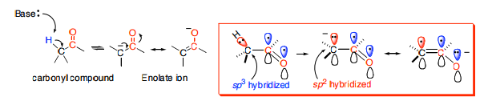
Compounds
- Formaldehyde:

Uses: a) it is used as solvating agent.
B) it is used for preparation of various organic compounds.
- Acetaldehyde:
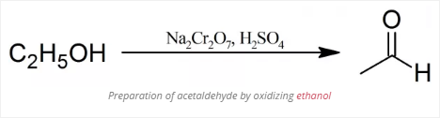
Uses: a) it is used for manufacturing of acetic acid, acetic anhydride, chloral etc.
B) it is also used in preparation of dyes.
- Paraldehyde:
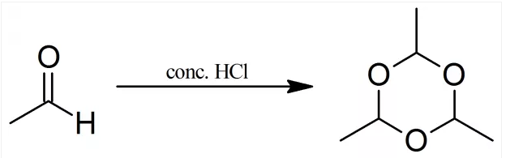
Uses: a) it is useful for regeneration of acetaldehyde on distillating with con. Sulphuric acid.
- Acetone:
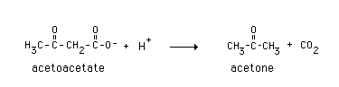
Uses: a) used as a solvent.
B) used as a laboratory cleaning agent.
C) used as artistic agent

