Unit : ii ; (alkanes)
L-1

Topic : introduction, nomenclature

Alkanes
- Alkanes are simplest organic compounds made of carbon and hydrogen only.
- They are represented by the general formula c_{n}h_{2n+2}
- Since carbon skeleton of alkanes is fully saturated with hydrogens they also called saturated hydrocarbons.
- Alkanes contain strong c-c and c-h covalent bonds therefore they are relatively chemically inert. They are sometimes referred as paraffins. (in Latin parum affinis= little affinity)
Structure:
Since carbon atom is attached to four other atoms it is sp³ hybridized and uses its sp ³ hybrid orbitals to form these bonds. Each c-h bond is result of overlap of sp³ orbital from carbon and s orbital of hydrogen.
Orbital structure of methane:
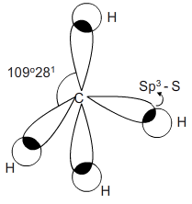
Nomenclature
First 4 members of the series are called by their common names, methane, ethane, propane and butane.the names of larger alkanes are derived from Greek prefixes that indicate the number of carbon atoms in the molecule.
Alkane | Structure
Methane | Ch₃
Ethane | Ch₃-ch₃
Propane | Ch₃-ch₂-ch₃
Butane | Ch₃-ch₂-ch₂-ch₃
Pentane | Ch₃-ch₂-ch₂-ch₂- ch₃

Isomerism: alkanes exhibit chain isomerism. The first three hydrocarbons do not exhibit chain isomerism. The various isomers are distinguished by their prefixes.
1) prefix n is used for those alkanes in which all the carbon atoms are in one continuous chain. Prefix n stand for normal.
ch₃-ch₂-ch₂-ch₂- ch₃ ch₃-ch₂-ch₂-ch₃
n-pentane n-butane
2) prefix iso is used for those alkanes which a methyl group attached to second last carbon atom of the continuous chain.
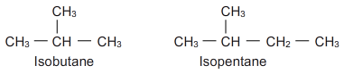
3) prefix neo used for those alkanes which two methyl groups attached to second last carbon atom of the continuous chain.
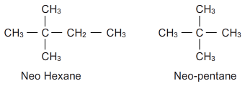
Primary, secondary and tertiary carbon atoms:
1) a carbon atom attached to one other carbon atom is called primary carbon atom
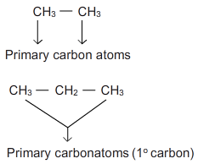
2) a carbon atom attached to two other carbon atom is called secondary carbon atom
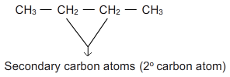
3) a carbon atom attached to three other carbon atom is called tertiary carbon atom
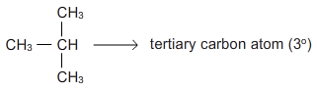
4) a carbon atom attached to four other carbon atom is called quaternary carbon atom
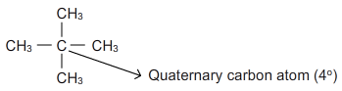
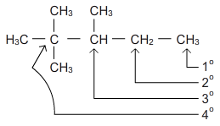
Alkyl groups:
An alkyl group is formed by removing one hydrogen from an alkane. They are named simply by dropping ane from the name of the corresponding alkane and replacing it by yl.(alkane-ane+yl= alkyl)
Parent alkane | Structure of parent alkane | Structure of alkyl group | Name of the alkyl group
Methane | CH₄ | CH | Methyl
Ethane | CH ₃-CH₃ | CH ₃-CH₂ | Ethyl
Propane | CH ₃-CH₂-CH₃ | CH ₃-CH₂-CH₂ | Propyl
N-butane | CH ₃-CH ₂-CH₃ | CH ₃-CH ₂-CH₂ | Butyl
Iso butane |  |  | Isobutyl

