UNIT-II
L-9
CONJUGATED DIENES

Allylic substitution and oxidation reactions and introduction to dienes
Ii. Substitution reactions: the alkyl group of alkenes undergoes substitution at high temperature. Chlorine or bromine replaces hydrogen of alpha carbon atom with respect to double bond without breaking double bond. This is called allylic substitution.
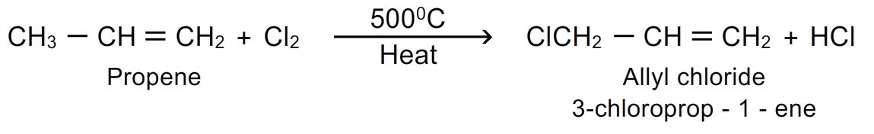
- The reaction proceeds by free radical mechanism. If the alkyl group contains more than one carbon atom, then the substitution occurs at α carbon.(allyl carbon atom)
- Mechanism of the reaction:
Step-1: chain initiation step:
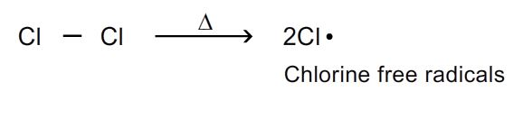
Step-2: chain propagation step:
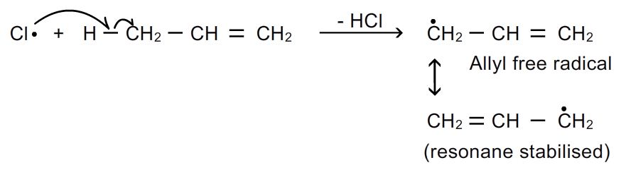
Step-3: chain termination step:
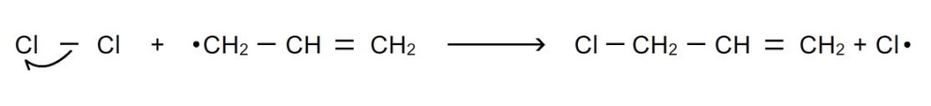
- Nbs (n-bromo succinimide) is a reagent used for specific purpose of brominating alkenes at allylic position.
Iii. Oxidation reactions: alkenes are readily oxidized. The oxidation products depend on the nature of oxidizing agent used.
- With cold dilute alkaline potassium permanganate: (hydroxylation): alkaline potassium permanganate is known as baeyer’s reagent. When alkenes are treated with alkaline potassium permanganate at low temperature, di hydroxy compounds are formed (glycols). The pink colour of kmno₄ disappears during the reaction.
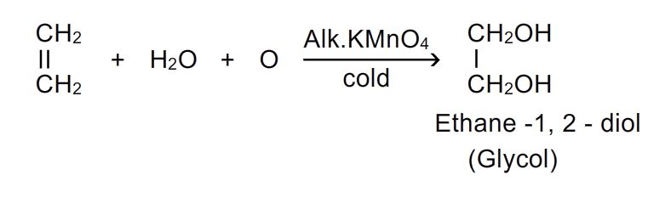
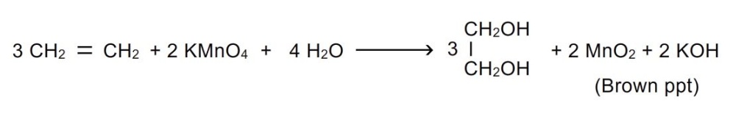

Thus, this reaction can be used as test of unsaturation.

- With acidic potassium permanganate or potassium dichromate: when alkenes are treated with acidic potassium permanganate, glycols are first formed which are oxidized to aldehydes , ketones or acids.
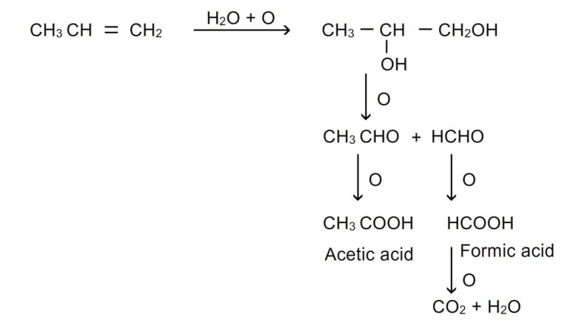
- Same products are also obtained when oxidation is done with periodic acid or lead tetra acetate or sodium periodate.
- Hydroxylation using peroxy acids: a mixture of h₂o₂ and formic acid on allowing to stand with alkenes yields glycol and the addition of two –oh groups occur in anti position.
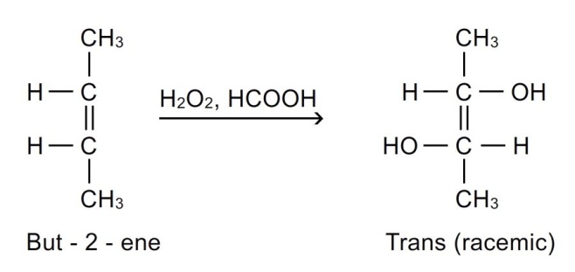
- Combustion reactions: when alkenes are burnt in air, they are oxidized to carbon dioxide and water.the reaction is exothermic and heat is evolved.
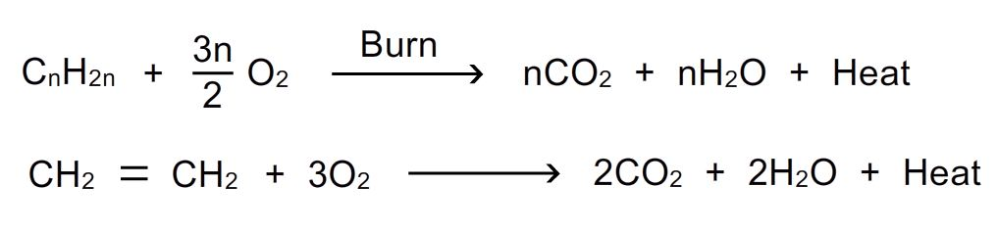
Dienes:
Hydrocarbons containing two carbon-carbon double bonds are called dienes. The general formula of dienes is c_{n}h_{2n-2}. Dienes are isomeric with alkynes.
They are of 3 types.
- Conjugated dienes: double bonds are separated by one single bond. These are important class of dienes. Their chemical properties differ from other alkenes.
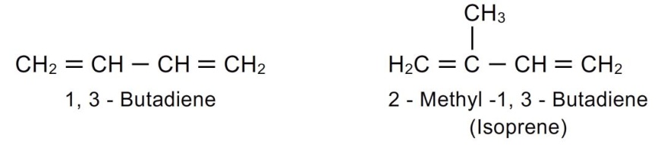
- Cumulative dienes: double bonds are adjacent to each other (double bonds between successive carbon atoms ). These are also known as allenes or cumulenes.
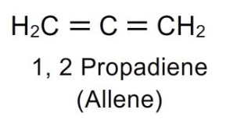
- Isolated dienes or non-conjugated dienes: double bonds are separated by more than one single bond.
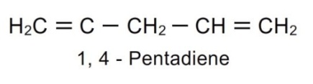
Stability of conjugated dienes:
Stability of conjugated dienes can be explained by resonance phenomenon
- It could be explained by taking the example of 1,3-butadiene, it is resonance hybrid of several contributing structures.
- Resonance structures of 1,3-butadiene:
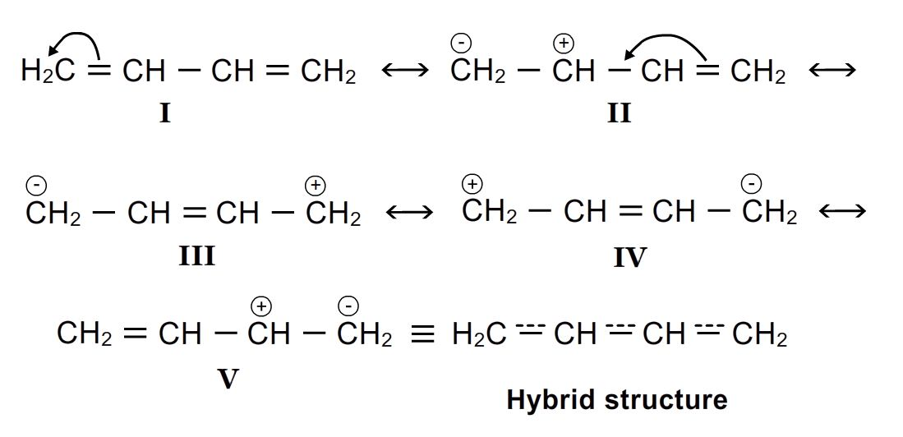
We know that greater the number of contributing structures greater will be the stability. That is why conjugated dienes show greater stability than simple alkenes or dienes with isolated double bonds.
The resonance energy can be calculated from heat of hydrogenation
The heat of hydrogenation of simple alkenes eg. 1-butene = 125.5kj/mol
The heat of hydrogenation of isolated diene eg.1,4 pentadiene = 250kj/mol
The heat of hydrogenation of conjugated dienes eg.1,3 butadiene = 238kj/mol
We can say the resonance energy of 1,3 butadiene is 12 kj/mol
Delocalisation of pi electrons: in 1,3-butadiene all carbon atoms are sp² hybridised i.e every carbon atom has empty p orbital and thus delocalization takes place over all 4 carbon atoms. This delocalization of pi electrons makes the molecule more stable.
Delocalization of pi electrons:
