L-8
Chemical reactions of alkenes:

The most important reactions of alkenes are addition reactions (π bond is broken and two σ bonds are formed). Alkenes are reactive due to presence of double bond, the π-electrons are loosely held and therefore are easily polarisable.
Addition occurs by two mechanisms:
1.ionic mechanism ( occurs at lower temperature)
2.free radical mechanism ( occurs at higher temperature)
Ionic mechanism
Mechanism involves three steps
1st step: the reagent e-nu ionizes to give an electrophile and nucleophile.
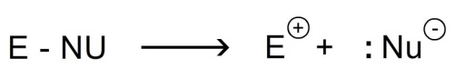
2nd step: the electrophile attacks the carbon-carbon double bond and forms a covalent bond with one of the carbon atom by utilizing the π- electrons. The other carbon atom acquires positive charge (carbocation)
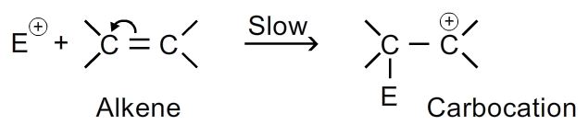
3rd step: the nucleophile now attacks the carbocation to form an addition product.
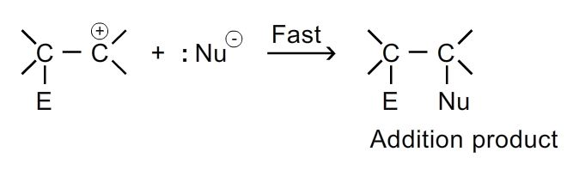
As the addition reaction is initiated by an electrophile these reactions are called electrophilic addition reactions.
the reactivity of alkenes follows the order:
R ₂C=CR ₂ < R ₂C=CHR < R ₂C=CH ₂ < RHC=CHR < RHC=C H ₂ < H₂C=C H ₂
less reactive more reactive

- The addition of electrophillic reagents relieves the strain of >c=c< (bond angle 120⁰) by changing it to >c-c< (bond angle 120⁰).

Important addition reactions are:

1.addition of hydrogens: alkenes react with hydrogen in the presence of catalyst at 200-300 ⁰c to form alkanes. Catalysts used are platinum, palladium, nickel etc. It is also called catalytic reduction. Also known as sabatiers senderens reaction.
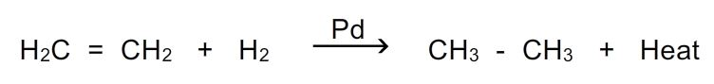
- When nickel is used as catalyst the reaction is carried at 200-300 ⁰c and in presence of pd or pt hydrogenation can even occur at room temperature.
- The lower the heat of hydrogenation the more stable the alkene.
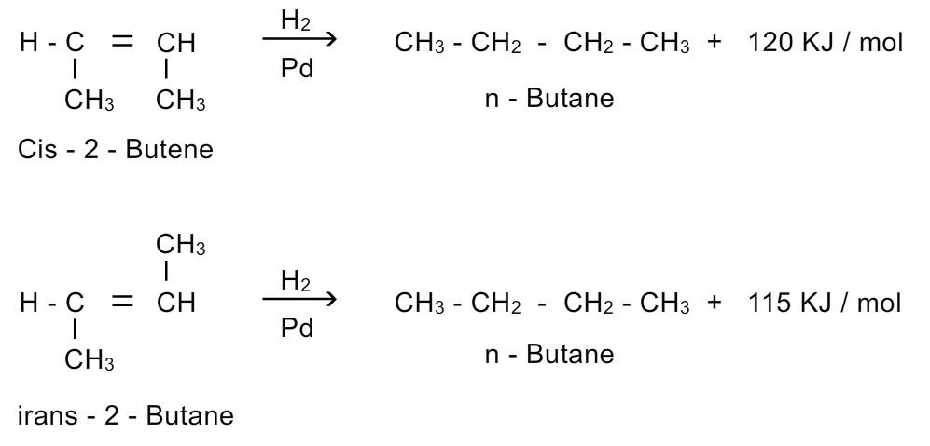
- Terminal double bond may be reduced by sodium in liquid ammonia in presence of alcohol. This is called birch reduction.
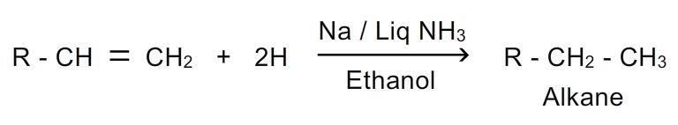
2. Addition of halogens: halogens chlorine , bromine only add at ordinary temperatures in presence of inert solvents to form vicinal alkyl halides.
Bromine water is decolourised by unsaturated hydrocarbons- this can be use as test of unsaturation. The brown colour of bromine gets disappeared as colourless dibromo derivative gets formed.
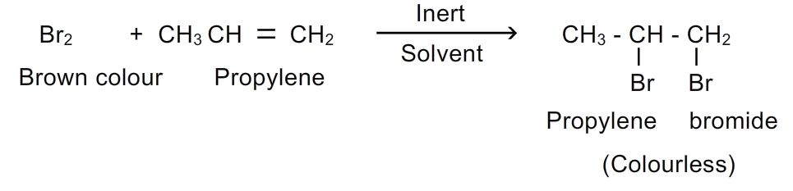
The reaction is stereospecific, anti-addition is observed.
Mechanism:
Step-1: the bromine molecule ionizes on interaction with π bond.
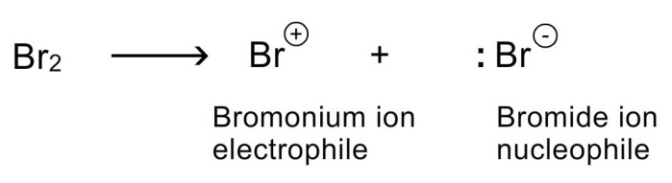
Step-2: bromonium ion attacks the double bond to form a carbocation.
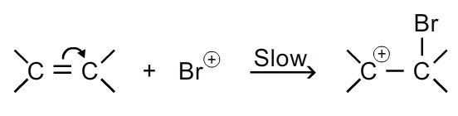
Step-3: nucleophile (br⁻) attacks the carbocation to form addition product.
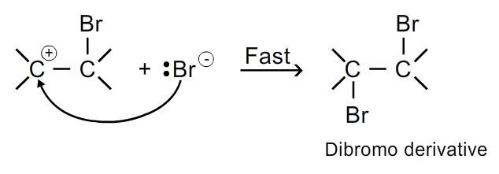
3. Addition of halogen acids: alkenes react with halogen acids (hcl, hbr, hi) to form alkyl halides.
A proton and a halogen add to the double bond of alkene to form an alkyl halide.
The addition of hydrogen halide to unsymmetrical alkene is highly regioselective as to be considered regiospecific. It follows markownikoff’s rule
Markownikoff’s rule: the addition of halogen acids to unsymmetrical alkenes takes place in such a manner that halogen attaches to that carbon atom which carries lesser number of hydrogen atoms.
- The modern version of rule is that electrophilic addition to carbon-carbon double bond involves the rearrangement (1,2-hydride or 1,2-methyl shift) leading to intermediate formation of more stable carbocation.
Example: addition of hbr to propene
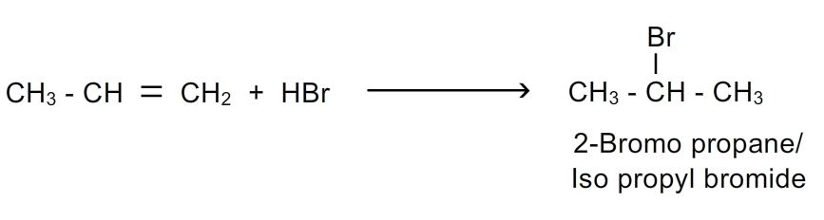
Mechanism:
1st step:hx ionizes

2nd step: electrophile (h+) attacks the double bond to form carbocation
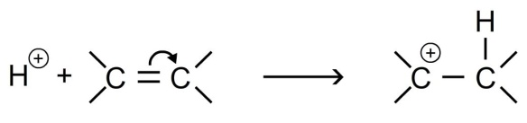
3rd step: nucleophile attacks the carbocation to form the alkyl halide
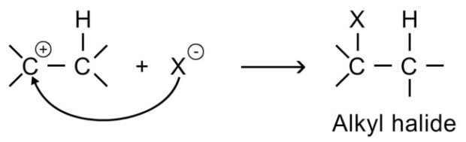
Peroxide effect: kharasch observed that the addition of hbr to unsymmetrical alkene in the presence of organic peroxides gives product opposite to markownikoff’s rule.
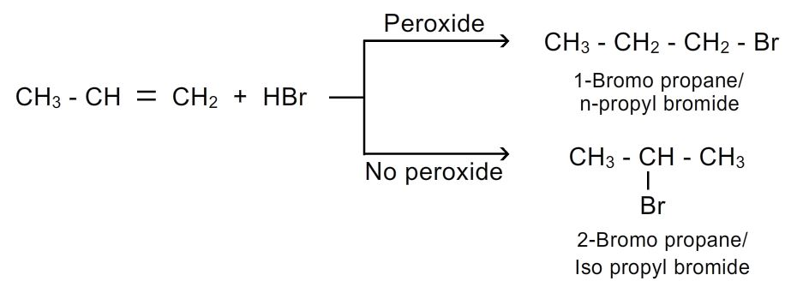
This is termed as anti markownikoff’s rule or peroxide effect.
Mechanism: in presence of peroxide (eg: benzyl peroxide) the reaction is free radical electrophillic addition reaction, in which the electrophile is bromine free radical.
Steps involved are
Step 1: peroxide undergoes fission to give free radicals(intitiation)
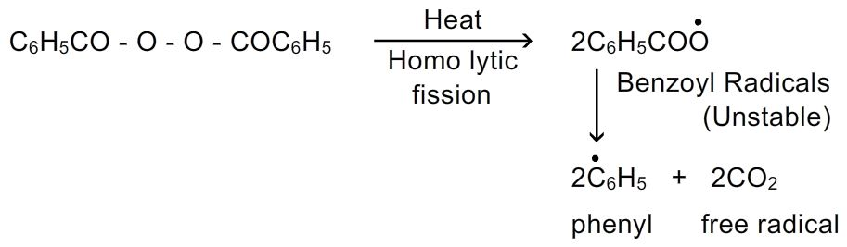
Step-2: hbr combines with free radicals to form bromine free radical
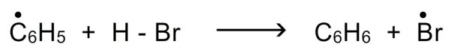
Step-3: ●br attacks the double bond of alkene to form more stable free radical.(propagation)
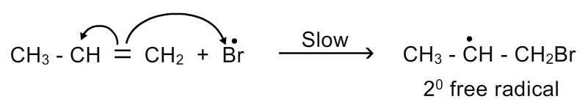
Step-4: more stable free radicals attacks the hbr (termination)
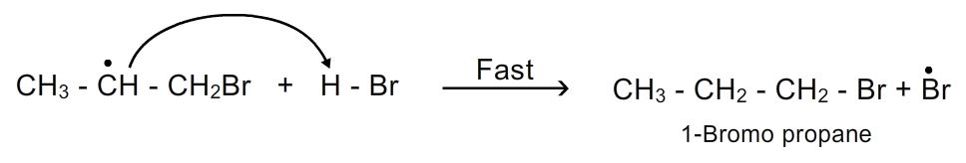
- This peroxide effect applies to the addition of hbr only and not to the addition of hcl or hi.

Topic: electrophilic addition reactions
8. Addition of oxygen: when mixed with oxygen or oxidation with peroxy acids or air and passed through a silver catalyst at high temperature (200-400⁰c) and pressure lower alkenes add an atom of oxygen to form epoxides (cyclic ethers). The reaction is stereo specific syn addition. These epoxides on hydrolysis form diols or glycols
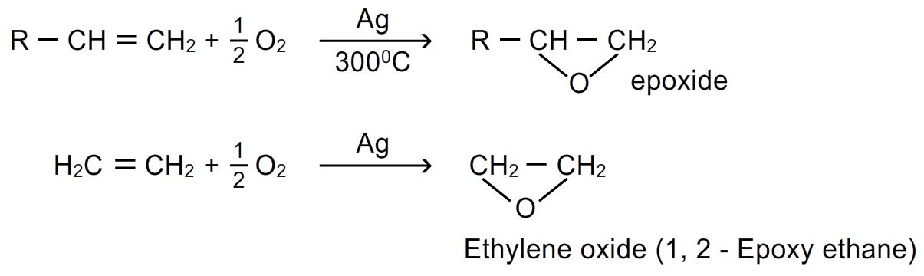
9. Addition of ozone(ozonolysis): when stream of ozone or ozonised oxygen is passed through a solution of alkene in an inert solvent ( ether, ccl₄, chloroform) at low temperature, the molecule adds up to form ozonide. Ozonide is unstable, explosive compound and easily decomposes either by reduction (zn/h₂o, zn/ch₃cooh, h₂/pd,) or hydrolysis( with h₂o₂ or ag₂o) and forms compounds having >c=o group(aldehydes and ketones). This process is called ozonolysis.
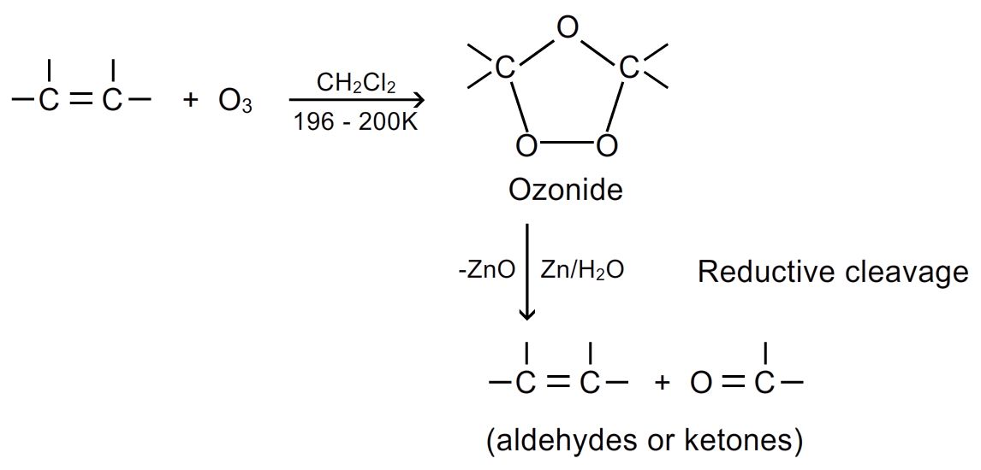
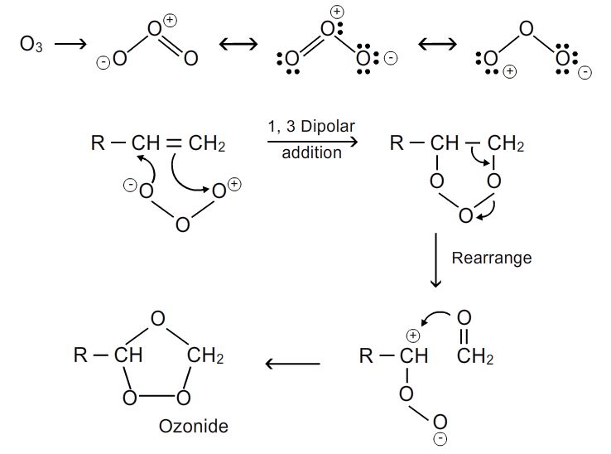
- Zinc dust is added to prevent the formation of h₂o₂ produced by the reaction of h₂o and o (therefore this reaction can be called as reductive ozonolysis)
- From the products formed, we can know the structure of original compounds.
- Ozonolysis of cycloalkene give only one molecule of dialdehyde.
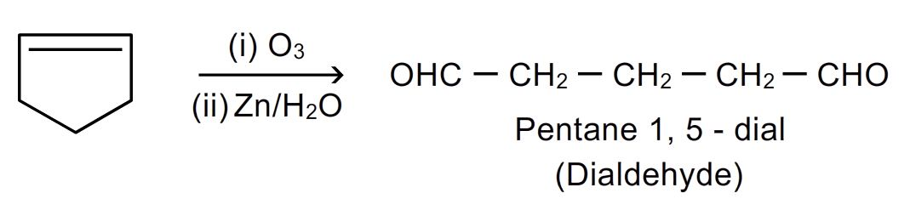
- Ozonolysis of cycloalkadiene gives two molecules of dialdehyde.
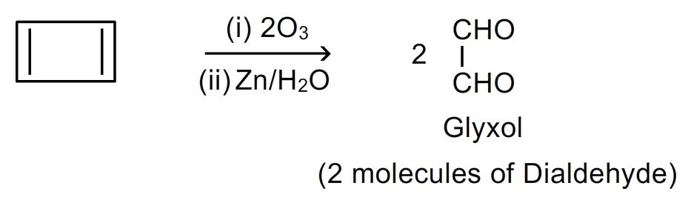
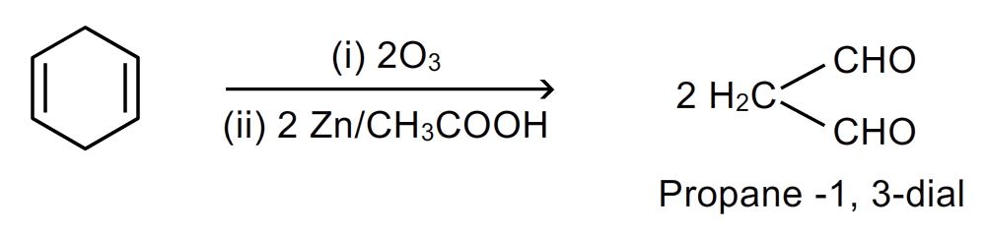
- While congujated diene and triene gives mainly glyoxal (dialdehyde) and formaldehyde.
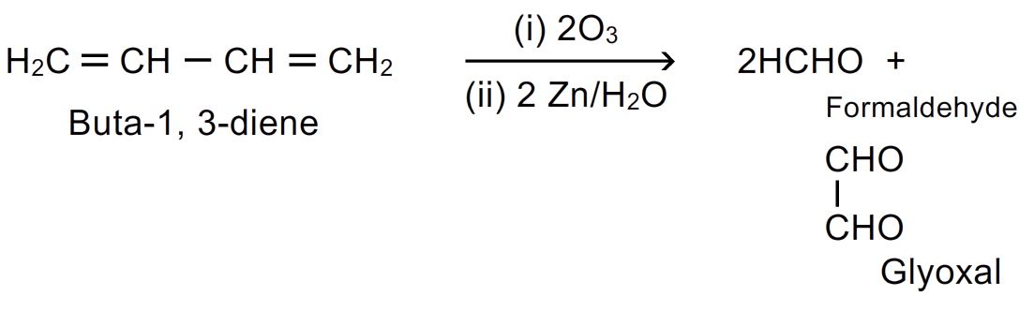
- Symmetrical alkenes give only one type of product. Substituted alkenes give ketones.
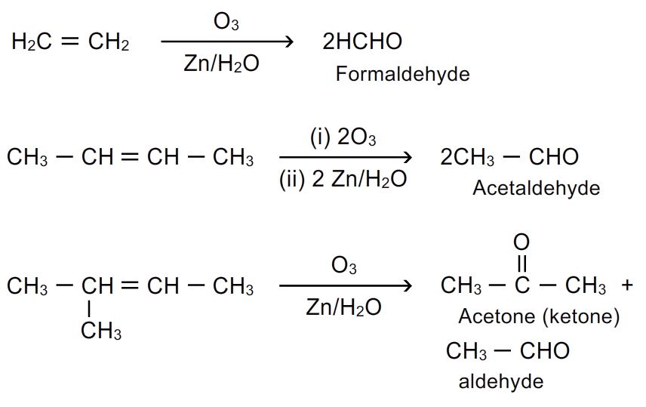
Type of alkene | Ozonolysis product
Ring containing one double bond | One molecule of dialdehyde
Ring containing two double bond | Two molecules of dialdehyde
Open chain 2 terminal double bonds | 2molecules of formaldehydeand 1 molecule of glyoxal
Rch=chr’ | Mixture of 2 aldehydes
R₂c=chr | Aldehyde + ketone
R₂c=cr’₂ | Mixture of two ketones
Ch₂=ch₂ | Only formaldehyde
2-butene | Only acetaldehyde

Based on the ozonolysis product we can know the type of alkene also the location of double bond.

10.addition of sulphuric acid: cold and concentrated sulphuric acid or fuming sulphuric acid adds alkenes to form alkyl hydrogen sulphate. In case of unsymmetrical alkenes, markownikoff’s rule is followed.
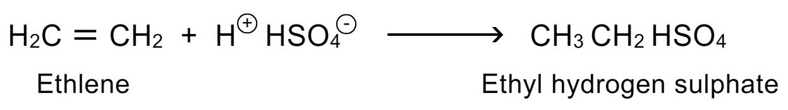
- Ethyl hydrogen sulphate on heating at 160-170⁰c yields ethylene. Hence this reaction can be useful in separation of ethylene or alkenes from mixture of alkenes and alkanes.
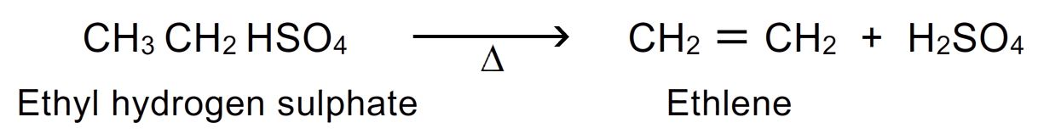
- Alkyl hydrogen sulphate when boiled with water ethanol is obtained. Hence this reaction is useful in the preparation of alcohols.
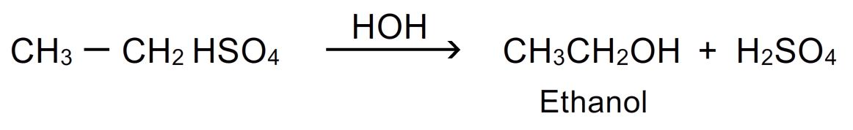

11. Self addition or polymerization: alkenes in the presence of acid catalyst at high temperature under pressure of 1500 atmospheres and in presence of oxygen undergo self addition. 2 or more molecules of alkene link together to form macro molecules or polymers. This process is called polymerization.
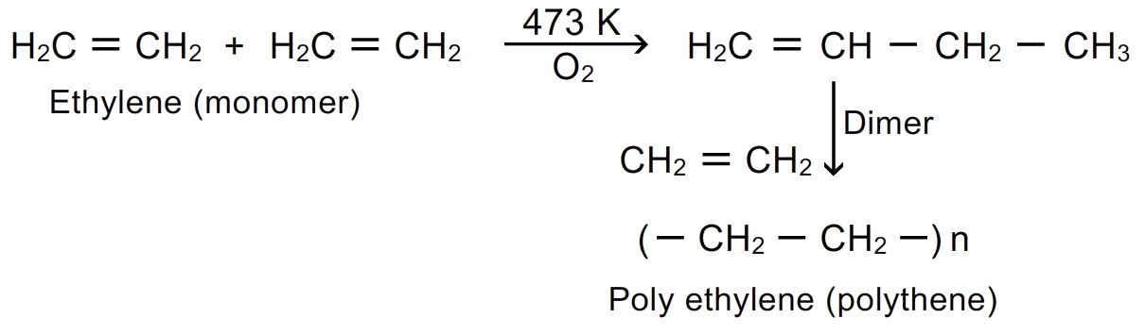

- Polythene, polypropene and polybutene are plastics of industrial importance. Polypropene is harder and stronger polymer and its fibres are used in carpets and automobile tyres.
- Cis- polyisopropene is natural rubber, pvc(poly vinyl chloride) used for making bottles, pipes, hand bags, tablemats.pan(poly acryl nitrile) is used in making orlon and acrilan fibres which are used in making clothes, carpets and blankets.

12. Addition of alkanes: highly branched alkanes add to alkenes in the presence of conc.h₂so₄ or hf.

