L-7
Methods of preparation of alkenes:
2.by dehydrohalogenation of alkylhalides: dehydrohalogenation involves removal of the halogen atom together with a hydrogen atom from a carbon adjacent to the carbon bearing the halogen atom.
Alkene is prepared by heating together the alkyl halide and a solution of potassium hydroxide in alcohol at a higher temperature.
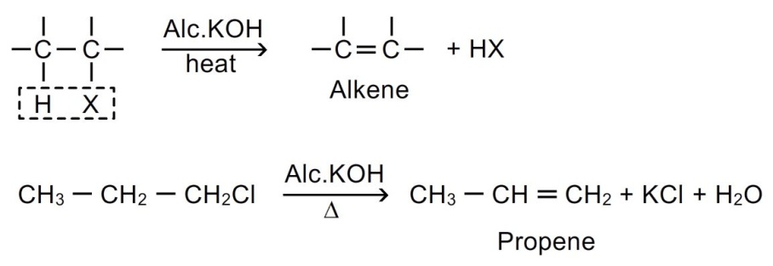
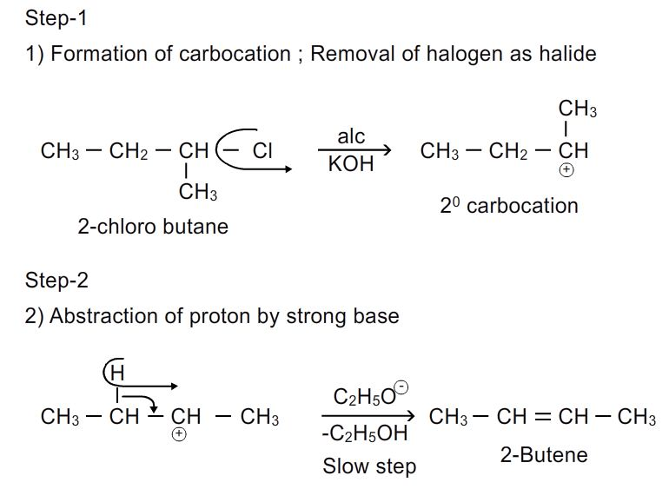
(discussed in detail in chapter alkyl halides)
3. Dehalogenation of vicinal dihalides: when vicinal dihalide is heated with zn/cu couple in methanolic solution, pure alkene is formed.
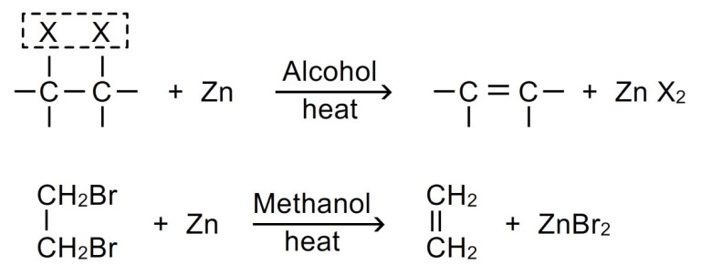
Gem dihalides also have been used in the preparation of alkenes.
I.when zinc metal is used
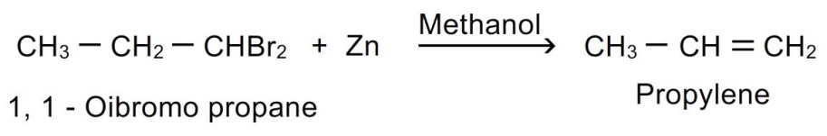
Ii.if sodium metal is used in place of zinc, then higher alkenes can be obtained.
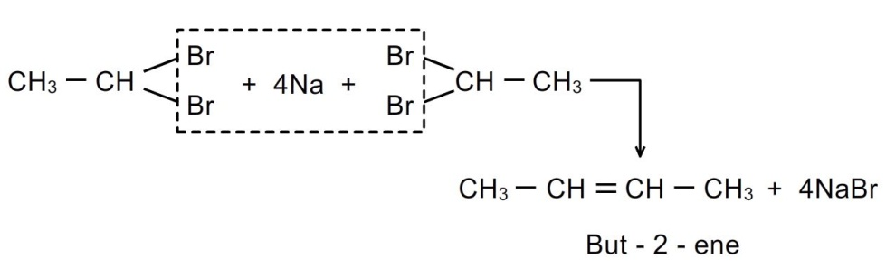
Stereoselectivity: elimination of halogen from dihalides give prominent trans- product.
4.electrolysis of salts of dicarboxylic acids: when sodium or potassium salt of saturated dicarboxylic acids are subjected to electrolysis in aqueous solution, alkenes are formed.
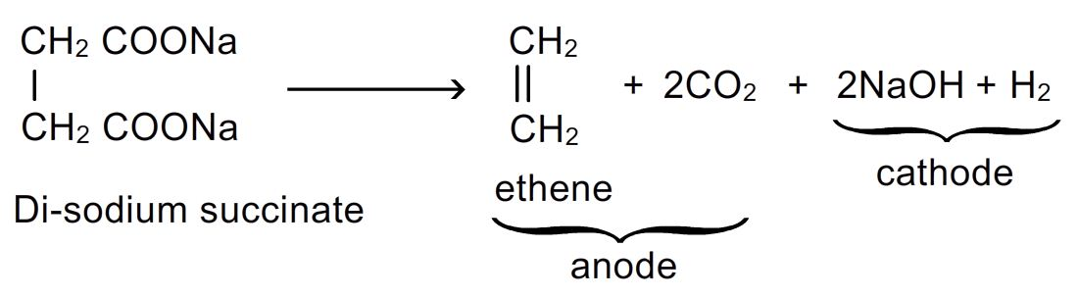
The method is extension of kolbe’s method.
5.controlled partial hydrogenation (reduction) of alkynes: controlled hydrogenation is essential because alkanes may be formed if hydrogenation is not controlled
Alkynes react with hydrogen when passed over heated catalyst
- Lindlar’s catalyst- palladium poisoned with caco₃ or (barium sulphate and quinoline) in equimolar ratio to form predominantly cis-alkenes
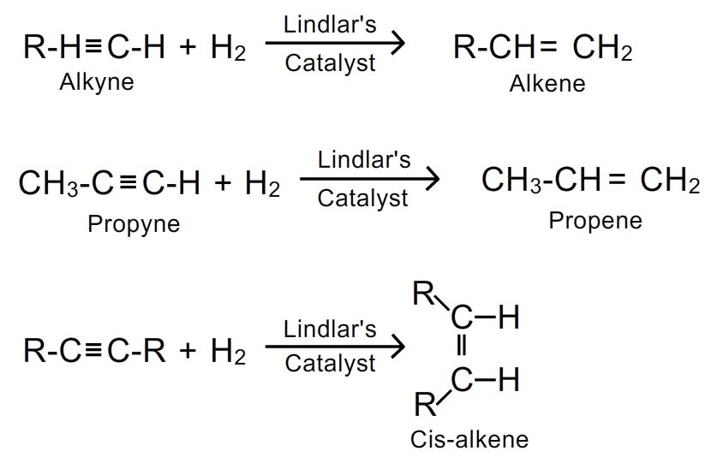
- Reduction of alkynes with lithium or sodium in liquid ammonia (birch reduction) yields predominantly trans-alkene.
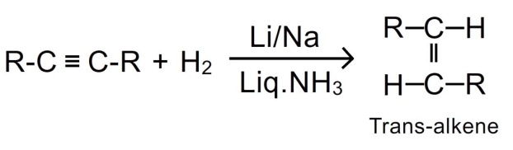
6. Pyrolysis or cracking: higher alkanes when heated at high temperature (500-700⁰c) decompose to produce a lower alkane and alkene (c-c fission)
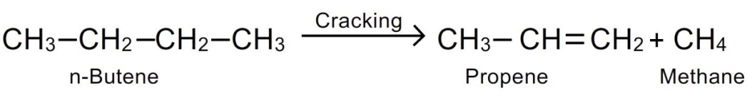
7.by grignard reagent: alkenes can be obtained by reacting grignard reagent with vinyl chloride.
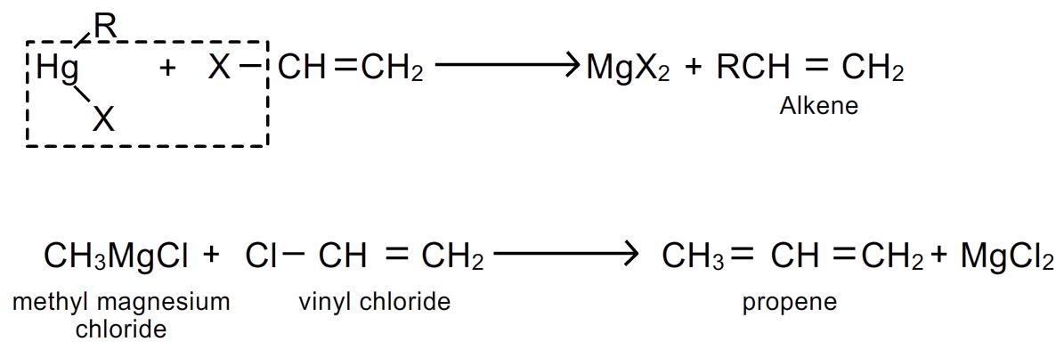
8.pyrolysis of quaternary ammonium compounds: many alkenes are conveniently prepared by heating quaternary ammonium compounds.
It is called hofmann elimination; in this an amine with smaller alkyl groups is formed.
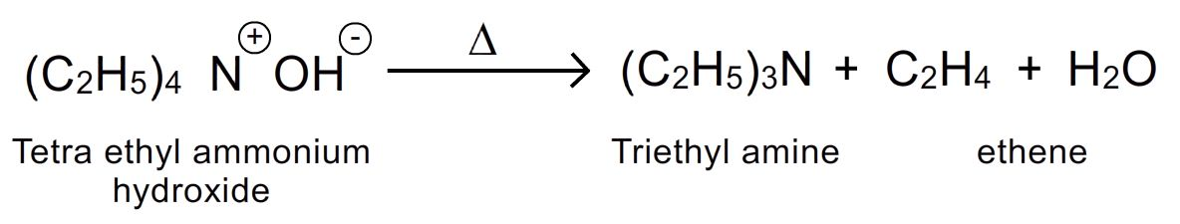
Physical properties:
1.state: first 3 members are gases, next 14 members are liquids while alkenes with more than 17 carbon atoms in the molecule are solids at room temperature.
2.odour: except ethane all are odour less. Ethane has pleasant odour. All are colourless.
3.solubility: alkenes are insoluble in water but freely dissolve in organic solvents.
4.boling points and melting points: their m.p , b.p and specific gravities show a gradual increase with the increase of molecular mass in homologous series.
They are less volatile than alkanes hence the melting and boiling points of alkenes are higher than alkanes.
Cis-isomer has higher boling point than trans isomer due to higher polarity.
However trans isomers have higher melting points than cis isomers. This is because trans isomers are more symmetrical and hence pack more closely in a crystal lattice. So larger amount of energy is required to break the lattice of trans isomer.
5.polarity: they are weakly polar. Trans-isomer have zero dipole moment and are non polar.

