L-6
Methods of preparation of alkenes:
- By dehydration of alcohols: alcohols are converted into alkenes by dehydration. I.e. elimination of water molecule.
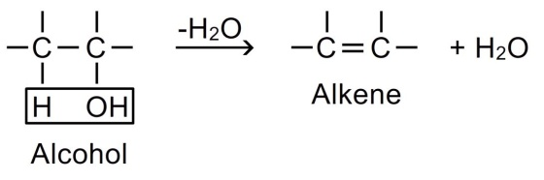
The dehydration is carried out in either two ways:
A.heating alcohol with acid catalyst like concentrated sulphuric acid or phosphoric acid or p₂o₅ to temperature 200⁰c.
B.passing the vapours of alcohol over alumina (al₂o₃) at 350-400⁰c.( al₂o₃ serves as lewis acid)
Mechanism of dehydration:
This involves formation of carbocation as an intermediate. The reaction occurs in 3 steps.
Step-1: due to presence of lone pair of electrons on oxygen atom, alcohols act as weak bases. Therefore they react with strong mineral acids (hcl or h₂so₄) to form protonated alcohol.
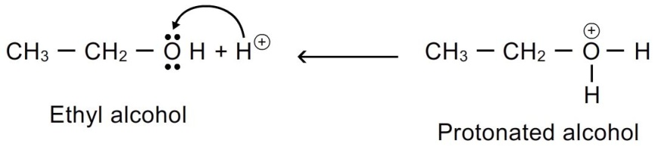
Step-2: the presence of positive charge on highly electronegative oxygen atom weakens c-o bond. As a result, the protonated ethanol breaks with the elimination of water molecule to form ethyl carbocation.
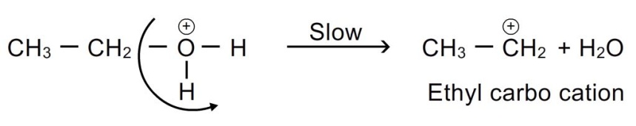
This step is slow and hence is the rate determining step of the reaction.
Step-3: the carbocation being unstable and a reactive chemical species, readily loses a hydrogen ion to yield an alkene.
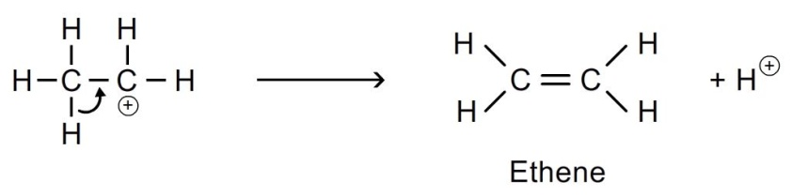
The ease of dehydration follows the following order:
Tertiary (3⁰) > secondary(2⁰) > primary(1⁰)

- Saytzeff’s rule : in the dehydration of secondary and tertiary alcohols, where there is possibility of formation of two isomers, the hydrogen atom is preferentially eliminated from the adjacent carbon atom with fewer number of hydrogen atoms.
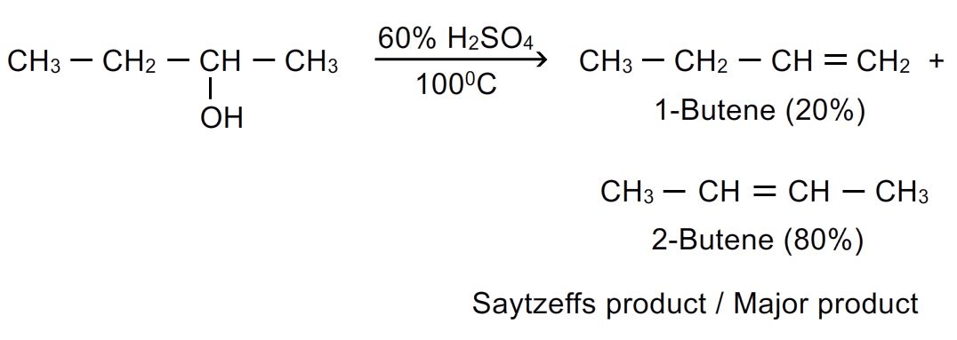
- Dehydration of alcohols is a stereoselective reaction:
The reaction may yield 2 or more stereoisomeric products and proceeds in such a way that more stable one is formed in greater amounts.
- Example: pentan-3-ol gives 74% trans pent-2-ene which is more stable and 25% cis-pent-2-ene.
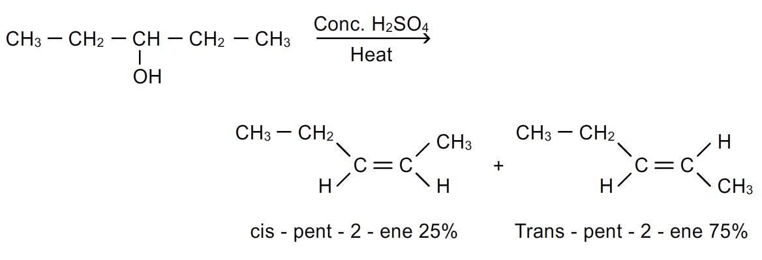
- Retropinacol rearrangement (wagner rearrangement): it is the rearrangement in open chain compounds in which shifting of c₆h₅; ch₃ and h takes place to form more stable carbocation and hence more stable products are formed.
- Shifting of these groups occur in following sequence:

C ₆H₅⁻(phenyl) > CH₃⁻ > H ⁻

