UNIT: II (ALKENES)
L-5

Topic: introduction, nomenclature, isomerism

The open chain compounds which contain lesser number of hydrogens than the corresponding alkanes are called unsaturated hydrocarbons.
unsaturated hydrocarbons

alkenes alkynes
Alkenes are un saturated compounds with general formula c_{n}h_{2n}. They contain contain two hydrogen atoms less than the corresponding alkane. They are also termed as olefins.
Alkenes containing two double bonds are called alkadienes or dienes.
Nomenclature:
1.iupac system: the name is obtained by dropping the suffix ane from the name and adding ene
Alkane-ane+ene = alkene

2.common system: the name is obtained by dropping the suffix ane from the name and adding ylene.
Greek letters are used to distinguish the isomers i.e. to indicate the double bond position.
CH₃-CH=CH-CH₃ CH₃-CH₂-CH=CH₂ CH₃-CH₂-CH₂-CH=CH₃
Α-butylene β-butylene α-amylene

3. As derivatives of ethylene: they are names as derivatives of ethylene.
CH₃-CH=CH-CH₃ CH₃-CH₂-CH=CH₂
Sym-dimethyl ethylene ethyl ethylene

Isomerism in alkenes:
They show the following type of isomerism.
- Position isomerism: this is due to position of double bond.
CH₃-CH=CH-CH₃ CH₃-CH₂-CH=CH₂
2-butene 1-butene
- Chain isomerism: this is due to difference in the nature of carbon skeleton.
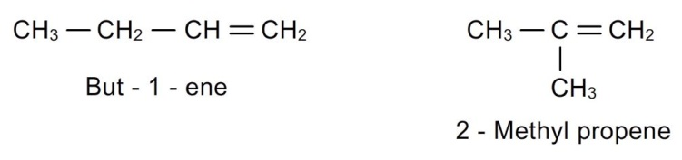
- Geometrical isomerism: due to restricted rotation around double bond, alkens show geometrical isomerism.
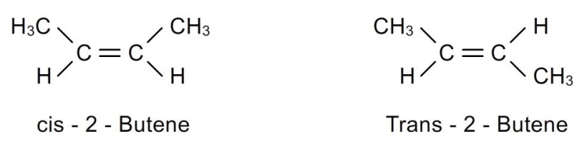
- Ring-chain isomerism: alkenes show ring-chain isomerism with cyclo alkanes.
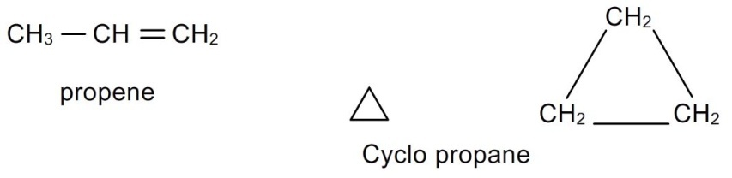
stability of alkenes:
- Propene is more stable than ethene. This can be explained based on hyperconjugation effect. Propene has greater number of contributing structures, hence greater the stability than ethene.
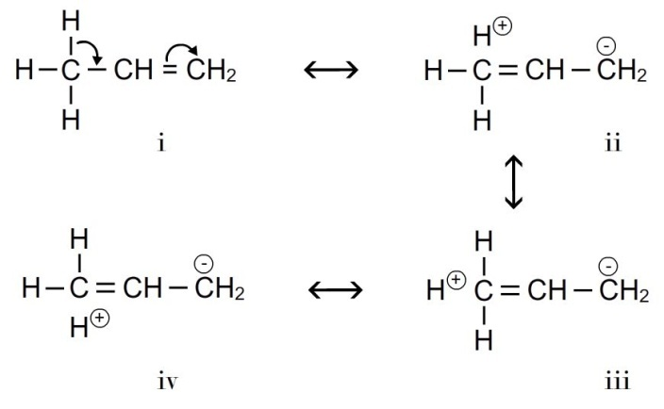
- Furthermore substituted alkenes are more stable thus larger the number of methyl groups attached to c-c double bond greater will be the hyper conjugation effect.
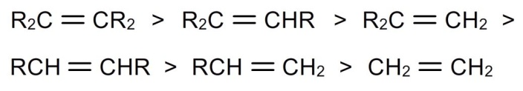
- So the stability of alkenes can be explained based on hyper conjugation effect. Greater the hyper conjugation effect, greater number of contributing structures, hence greater the stability.
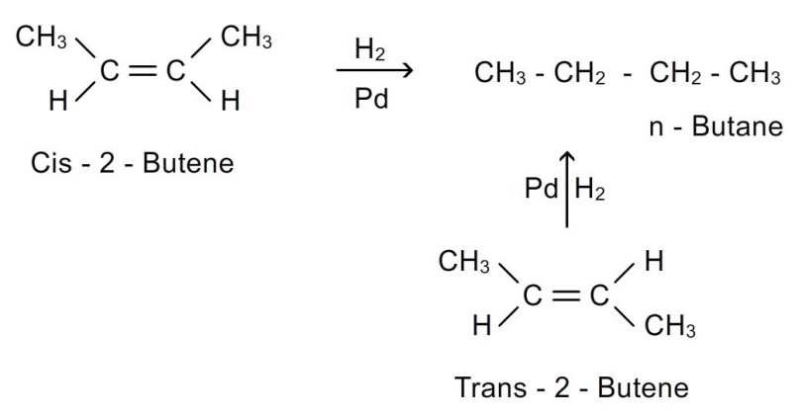
The relative stability of alkenes can be determined by comparing their enthalpies of hydrogenation.

- Cis –isomers are less stable than trans isomers.

- Enthalpy of hydrogenation of cis-isomer = 120.0 kj/mol
- Enthalpy of hydrogenation of trans-isomer = 115.0 kj/mol
- The trans isomer is stable than cis isomer by 5kj/mol.

