L-4
Chemical reactions:
2. Oxidation: oxidation of alkanes gives different products under different conditions
A) combustion or complete oxidation: alkanes when ignited in presence of excess oxygen or air burn to give carbon dioxide and water.
- Combustion of alkanes is an exothermic reaction; large quantity of heat is evolved. Heat of combustion increases with increase in molecular weight.
- It forms the basis for the use of alkanes as fuel and source of power.
eg: cooking gas lpg (mixture of propane and butane)
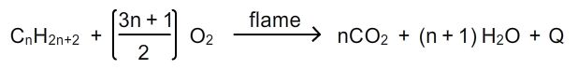
B) in complete oxidation of alkanes: when burnt in insufficient supply of oxygen, carbonmonodioxide or black carbon is formed.
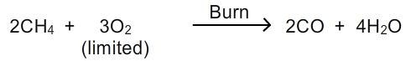
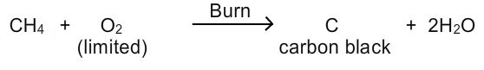
C) chemical oxidation: alkanes are usually not affected by oxidizing agents like kmno₄ however alkanes having tertiary hydrogen are oxidized by these oxidizing agents to corresponding alcohols.
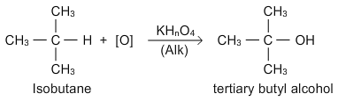
3. Thermal decomposition or fragmentation (pyrolysis/cracking):
- The decomposition of compound by heat is called pyrolysis. (greek: pyro=fire; lysis=loosening)
- When pyrolysis occurs in alkanes, the process is termed as cracking.
- Alkanes on heating at high temperature in absence of air broke down into lower alkanes, alkenes and hydrogen.
- During cracking of alkanes either rupture of c-c or c-h bonds take place resulting in formation of lower alkanes, alkenes and hydrogen.
- Pyrolysis generally requires high temperatures in the range of 500-800⁰c. However in the presence of catalyst (finely divided silica-alumina) reactions can be carried at less temperature. This is called catalytic cracking.
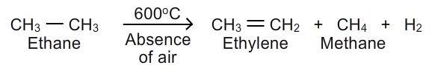
Mechanism:
- Chain –initiation step: ethane molecule decomposes to give two methyl free radicals.
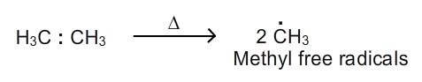
2. Chain propagation step:
A) methyl free radical attacks ethane to produce methane and ethyl free radical.
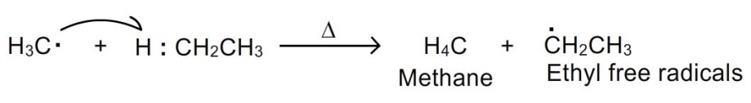
B) ethyl free radical gives ethylene and a hydrogen atom.
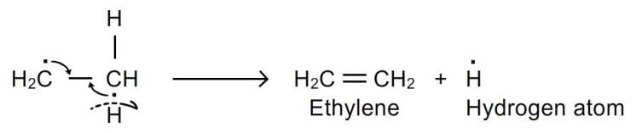
C) hydrogen atom attacks ethane to give ethyl free radical and hydrogen molecule.
Steps b, c are repeated over.
- Chain termination step: unreacted ethyl free radicals combine with hydrogen atoms to regenerate ethane which can further take part in reaction.
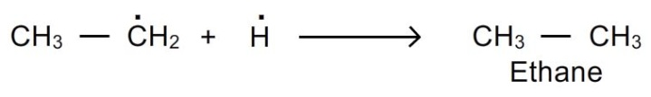
- Pyrolysis is of great importance to the petroleum industry because it provides means of making smaller, more volatile molecules from larger, less volatile hydrocarbons.
- Propane, when heated to 600⁰c in the absence of air, gives a complex mixture of propylene, ethylene,methane and hydrogen.
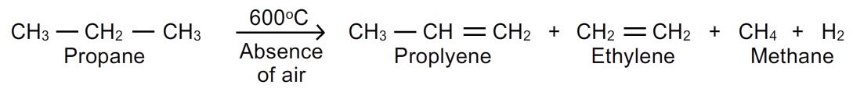
4.isomerisation: the process of conversion one isomer into another isomer is called isomerisation. Normal alkanes are converted to their branched-chain isomers in the presence of aluminium chloride and hcl at 25⁰c. The branched chain isomers have lower boiling point than the straight chain compounds.
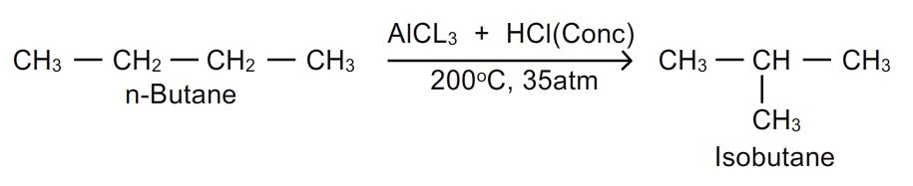
5. Aromatisation: the conversion of aliphatic compound into aromatic compound is called aromatization. Alkanes having 6-10 carbon atoms are converted into benzene or its homologous analogs at higher temperature in presence of a catalyst.
