L-3
Physical properties:
The physical properties of hydrocarbons depend upon the intermolecular forces of attraction. Since alkanes are almost non-polar and therefore, their molecules are held only by weak vanderwaals forces which depend upon the size (surface area)and structure of the molecule.

- State: due to weak forces the alkanes upto 4 carbon atoms i.e. methane, ethane, propane and butane are colorless gases, next 13 are colourless, odourless liquids. Alkanes from c₁₈ onwards are colourless, odourless solids.

- Density: the density of alkanes increase with increase in molecular mass until it becomes constant at about 0.8. Thus alkanes are lighter than water.

- Solubility: they are generally insoluble in polar solvents such as water but soluble in non-polar solvents like ether, carbon tetrachloride, benzene etc., the solubility decrease with increase in molecular mass.

- Boiling points: the boiling points of straight chain or n-alkanes increase regularly with increasing number of carbon atoms.

Alkane | Struture | Boiling point | Melting point
Methane | Ch₃ | -161.5 | -182.5
Ethane | Ch₃-ch₃ | -88.6 | -172.0
Propane | Ch₃-ch₂-ch₃ | -42.1 | -187.7
Butane | Ch₃-ch₂-ch₂-ch₃ | -0.5 | -138.4
Pentane | Ch₃-ch₂-ch₂-ch₂- ch₃ | 36.1 | -129.7

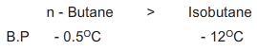

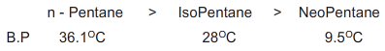

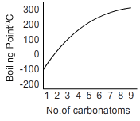

- In general the boiling point difference between two successive members of the series is about 20-30 ⁰c .
- Among the isomeric alkanes , the normal isomer has a higher boiling point than the branched chain isomer. The greater the branching of the chain, the lower is the boiling point.
- This can be explained in terms of inter molecular (dipole-dipole) forces of attraction .these forces act along the surface of the molecules and their magnitude increases with increase in surface area.
- The n-alkane has most extended structure and larger surface area in comparison with branched chain isomers that have compact structure. As the molecular size increases in the series, the surface area increases which increase the inter molecular forces and thus b.p also increases.

- Thus intermolecular forces are weaker in branched isomers so they have low boiling point.

5)melting points: the melting points of alkanes do not follow smooth gradation with increase in molecular size.
- Alkanes with even number of carbon atoms have higher melting point than the next lower and next higher alkanes having odd number of carbon atoms.
- Carbon atoms with odd number have their end-carbon atoms on the same of the molecule and even numbered carbon atoms alkanes have their end carbon atoms on the opposite sides of the molecule.
- Thus alkanes with even number of carbon atoms pack closely in such a manner as to permit greater intermolecular attraction and therefore have slightly higher melting point.

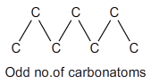

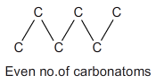

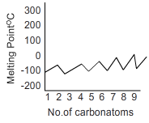

Chemical properties: alkanes are quite inert towards common reagents such as acids, alkalies, oxidizing and reducing agents at ordinary temperature.
The electronegativity difference between carbon and hydrogen is small and thus c-h bond is almost non polar. Therefore polar reagents (electrophiles and nucleophiles) do not find reaction sites on alkane molecules.
The c-c and c-h bonds are strong sigma and cannot break under ordinary temperatures, at high temperature energies of collision are sufficient to break c-h and c-c bonds resulting in the formation of free radicals.
However alkanes undergo some reactions under special conditions
- Substitution reactions
- Oxidation
- Thermal decomposition.
- Isomerisation
- Aromatization

Effect of activation energy on transition state:
For a reaction to occur, collision between reactant molecules is must.
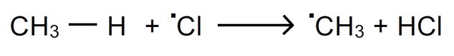
the above reaction takes place only if collisions between chlorine atom and methane take place. But all the collisions are not effective.
Activation energy(e_{act}):
- For the collisions to be effective, the reactant molecules must be associated with a certain minimum amount of energy called threshold energy.
- The molecules having the threshold energy are of only small fraction. Thus for the reaction to occur the energy of the molecules must be raised to a higher level. I.e. they must be activated before they react to form products.
- The additional amount of energy which the reactant molecules must acquire so that their collisions result in chemical energy is called activation energy(e_{act})
- For exothermic reactions the energy released appears to be sufficient but the bond breaking and bond making are not perfectly synchronized, the energy released through bond formation is not completely available for the bond breaking.
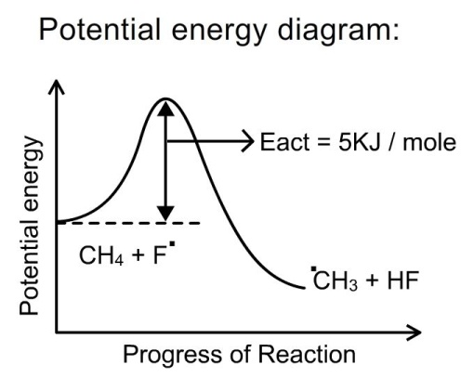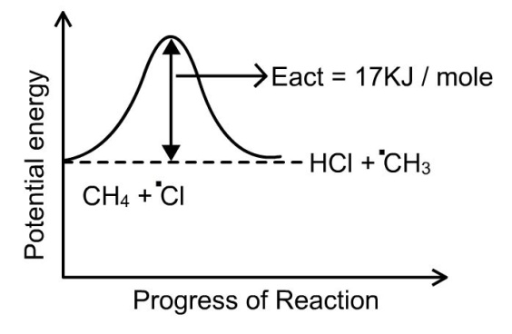
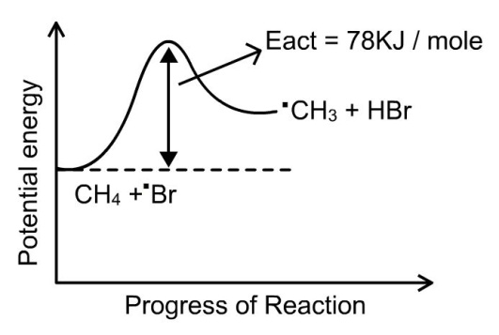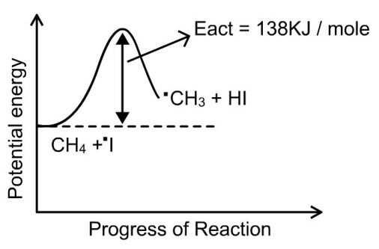
- The magnitude of e_{act} determines the rate of reaction. Reactions with low e_{act} proceed at faster rate than the one with high e_{act} at the same temperature.
The order of e_{act} for chain propagation step:
Iodination > Bromination > Chlorination > Fluorination

the order of halogenations :
Iodination < Bromination < Chlorination < Fluorination

Transition state(ts):
thus for a collision to be effective reactant must cross the energy barrier before the products are to be formed. The top of the energy hill represents an intermediate structure called transition state.
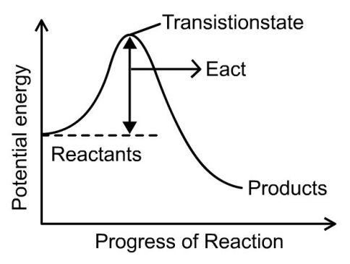
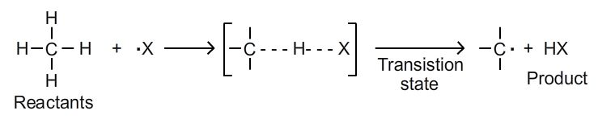
- Transition state can be defined as particular arrangements of atoms of reacting species as they are converted from reactants into products.
- It represents a configuration in which old bonds are partially broken and new bonds are partially formed. It is a state with highest potential energy. The transition state is unstable due to its high energy content and it cannot be isolated.
- In the transition state the c-h bonds are partly broken and h-x bond is partly formed.
Factors that influence the orientation of halogenations of alkanes:
- Collision frequency
- Probability factor
- Energy factor

Collision frequency: the collision frequency is same for both reactions.

Probability factor: since propane has 6 primary hydrogens and 2 secondary hydrogens, the ratio is 6:2 or 3:1

Energy factor: iso propyl free radicals are more easily formed than propyl radicals because they are more stable. Also the ease of formation can be related to the energy of activation of that radical.iso propyl free radical has smaller e_{act} than propyl free radical.

Study of chlorination of many alkanes has shown that the relative rate of abstraction of tertiary, secondary and primary hydrogens are in the ratio 5:3.8:1 with the help of these values we can predict the ratio of iso propyl halide and propyl halide.

