L-2
Methods of preparation of alkanes:
1)hydrogenation of alkenes or alkynes: alkenes or alkynes react with hydrogen in the presence of catalyst at 200-300 ⁰c to form alkanes. Catalysts used are platinum, palladium, nickel etc.
It is also called catalytic reduction. Also known as Sabatier’s senderens reaction.
General reaction:
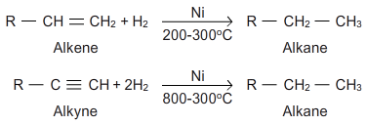
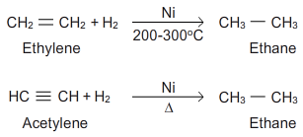

Alkenes consume one molecule of hydrogen whereas alkynes consume two molecules of hydrogens to form a saturated compound.
2)reduction of alkyl halides: alkyl halides undergo reduction with nascent hydrogen (just born/ just produced in the reaction) to form alkanes. The hydrogens required for the reduction may be obtained by using any of the following reducing agents,
A. Zn+ HCL
B. Zn+ CHCOOH
C.zn-cu couple in ethanol
D.red phosphorus +hi
- Also alkyl halides can be catalytically reduced using platinum, palladium, nickel.
- Primary and secondary halides can be reduced by Lilah and tertiary halides are reduced by nabh or tph
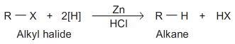
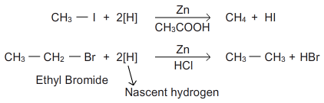
3)hydrolysis of Grignard’s reagent: alkyl magnesium halides are obtained by treating alkyl halides with magnesium in anhydrous ether. These on hydrolysis give alkanes.
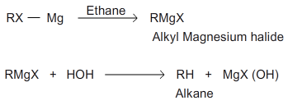
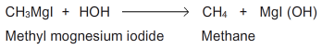

Preparation of alkanes: (continuation…)
4. Wurtz reaction:
This method was discovered by wurtz. This method was very useful in the preparation of high molecular mass alkanes.
An ether solution of alkyl halide is treated with sodium which removes the halogen of alkyl halide and the two alkyl radicals join together to form an alkane.
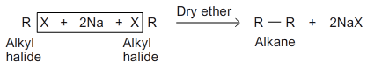
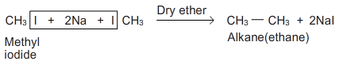
- Alkyl bromides and iodides are preferred in this reaction.

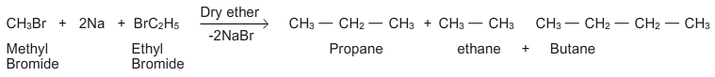

- When mixture of two different alkyl halides is used a mixture of three alkanes is obtained, the separation of the mixture into individual members is not easy process.
Thus wurtz reaction is not suitable for the synthesis of odd number of carbons.
Mechanism: the mechanism is not fully understood. 2 mechanisms were proposed.
- Intermediate formation of an organometallic compounds
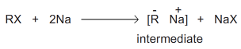
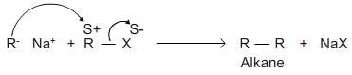

- Intermediate formation of free radicals
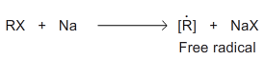
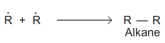
Limitations:
- Wurtz reaction is not suitable for the synthesis of odd number of carbons
- Methane cannot be prepared by this method
- The reaction fails with tertiary alkyl halides.

- By decarboxylation of carboxylic acid: when sodium salt of fatty acid is heated with sodalime (mixture of NAOH and CaO) a molecule of carbondioxide is eliminated as carbonate and as alkane is formed.

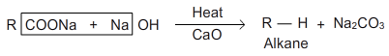
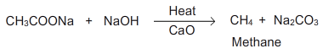

Since one molecule of carbon dioxide is eliminated this process is called decarboxylation.
- The alkane formed always contains one carbon atom less than the original acid. The yield is good in the case of lower members.

6. Kolbes electrolysis: electrolysis of concentrated aqueous solution of either sodium or potassium salts of saturated mono carboxylic acids yields higher alkanes at anode.
7.corey –house alkane synthesis: an alkyl halide is first converted to lithium alkyl which reacts with cuprous iodide to form lithiumdialkyl cuprate, it is then treated with alkyl halide to give an alkane.

