L-10

Topic: dienes- preparation & reactions of conjugated dienes
General methods of preparation of conjugated dienes:
- From acetylene: acetylene in presence of cu₂cl₂ and nh₄cl dimerise to form vinyl acetylene which on reduction with lindlar’s catalyst yields buta-1,3 diene.
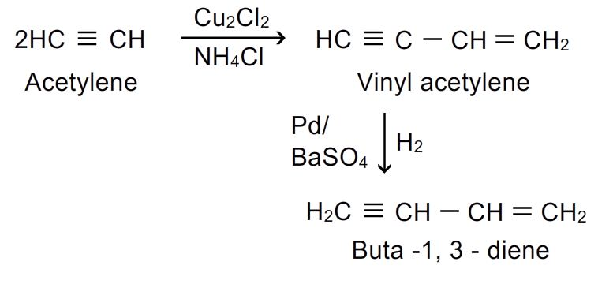
- From 1,4-dichlorobutane:1,4-dichlorobutane is heated with alcoholic koh when dehydrohalogenation occurs with formation of buta-1,3-diene
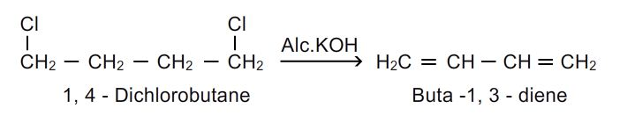
- From 1,4-butanediol: acid catalysed dehydration is done by heating 1,4 butanediol with conc.h₂so₄.
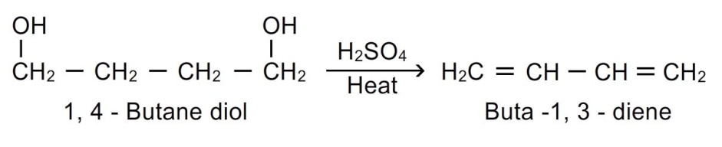
- By catalytic dehydrogenation of n-butane: buta-1,3-diene is obtained by passing the butane vapours over heated catalyst cr₂o₃ at 600 ⁰c
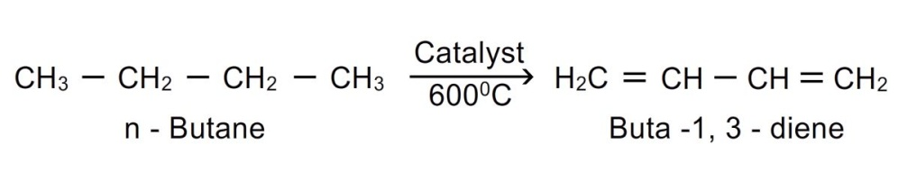
Reactions of conjugated dienes:
1.addition of halogens: buta-1,3-diene reacts with halogens in the presence of an inert solvent ccl₄ to yield a mixture of 1,2 and 1,4 addition products.
The mechanism of above reaction invoves following steps:
Step.1: the halogen molecule undergoes heterolytic fission.
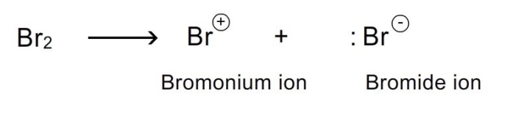
Step-2: the bromonium ion attacks the double bond to give a carbocation. The carbocation formed is allyl carbocation and it is resonance stabilized.
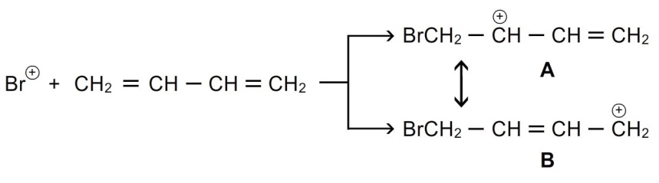
Step-3:the bromide ion combines with a to form 1,2 addition products.
it combines with b to form 1,4 addition products.
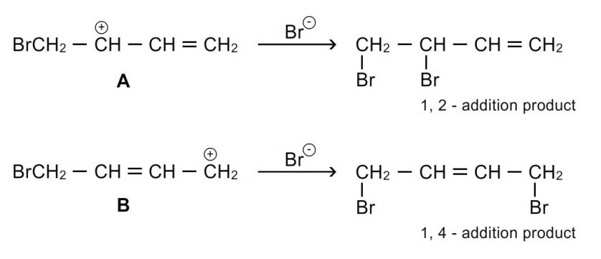
2.addition of halogen acids: a mixture of 2 compounds are formed when buta-1,3-diene reacts with halogen acids.
Effect of temperature on 1,2 and 1,4 additions to conjugated dienes: the proportions of 1,2 and 1,4 products formed in electrophilic addition to conjugated dienes depend on temperature at which the reaction is carried out.
From above reaction we can conclude that
1. 1,4 product is thermodynamically more stable.
2. The formation of 1,2 adduct/product in higher proportion at low temperature gives the information that e_{act} for 1,2 adduct is less i.e. kinetically favoured.
In electrophilic addition to conjugated dienes 1,2 adduct is formed preferentially at low temperature whereas 1,4 adduct is formed as major product at higher temperatures.

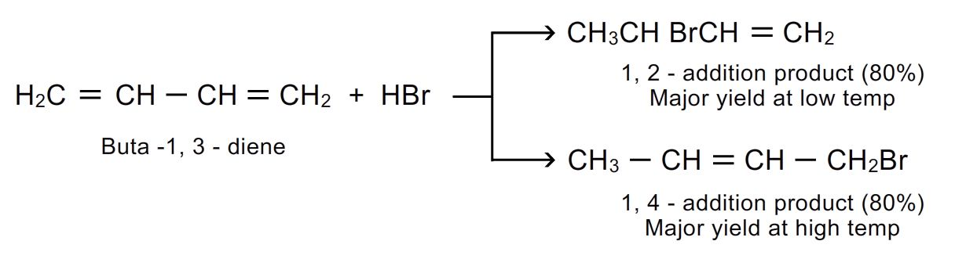
3. Addition of water: buta-1,3-diene reacts with water in the presence of sulphuric acid ro give mixture of 1,2 and 1,4 addition products.
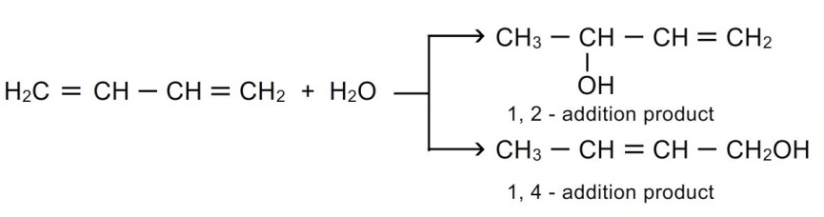
4. Addition of hydrogens: mixture of 1-butene and 2-butene are formed when buta-1,3 diene reacts with hydrogen in the presence of catalyst.
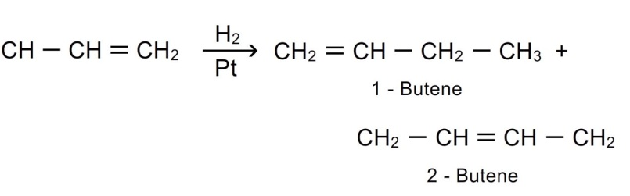
- Diels alder’s reaction: this reaction is between a conjugated diene and an alkene or alkyne called dienophile. It is a diene –dienophile addition reaction.
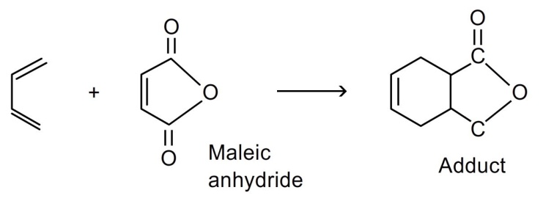
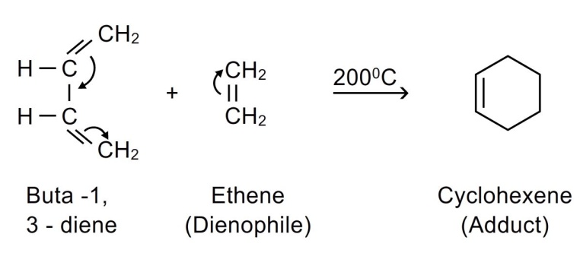
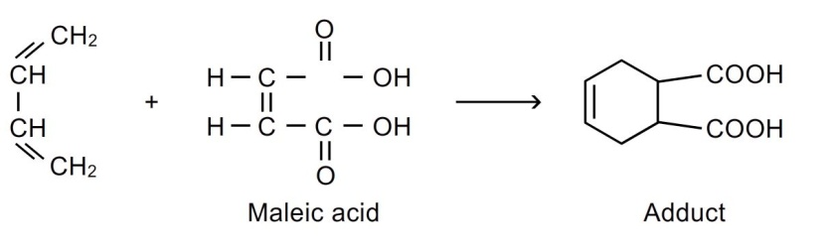
it forms cyclic compounds. Also called 4+2 addition reaction. The products are six membered cycloalkenes called adducts.
The presence of electron attracting groups such as –cn,-ch-,-cor,-cooh,-coor etc on dienophile facilitates the reaction.
This reaction is used in preparation of six membered rings.
6.ozonolysis: dienes undergo ozonolysis to give 3 molecules. Buta1,3-diene yields 2 molecules formaldehyde and glyoxal.
