L-7
Conformations of propane: the conformations of propane are similar to those of ethane except that one of the hydrogen is replaced by methyl group. The two extreme conformations of propane are shown below:
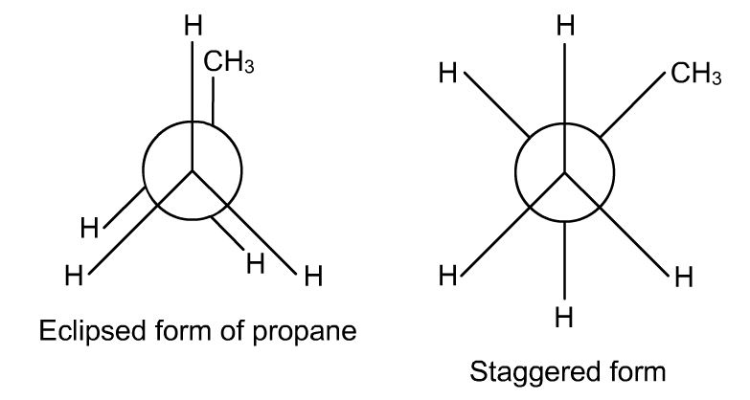
- The difference in the potential energy between these conformers is 14.2 kj/mol(3.4 kcal/mol). The energy is small and not enough to prevent rotation. Even at ordinary temperature, the energy barrier is overcome through collisions and thus, the conformations keep on changing from one to other.
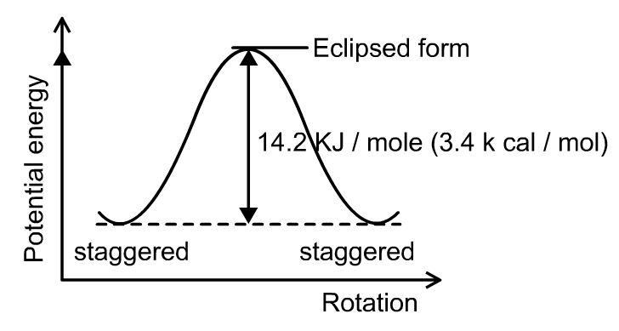
Conformations of butane: n-butane molecule can be represented as di-methyl derivative of ethane in which one h atom of each carbon is replaced by a methyl group.
Now one of central atom is fixed and other is rotated round the central bond through the angle of 60⁰ we get many conformations. Out of these only six are important.
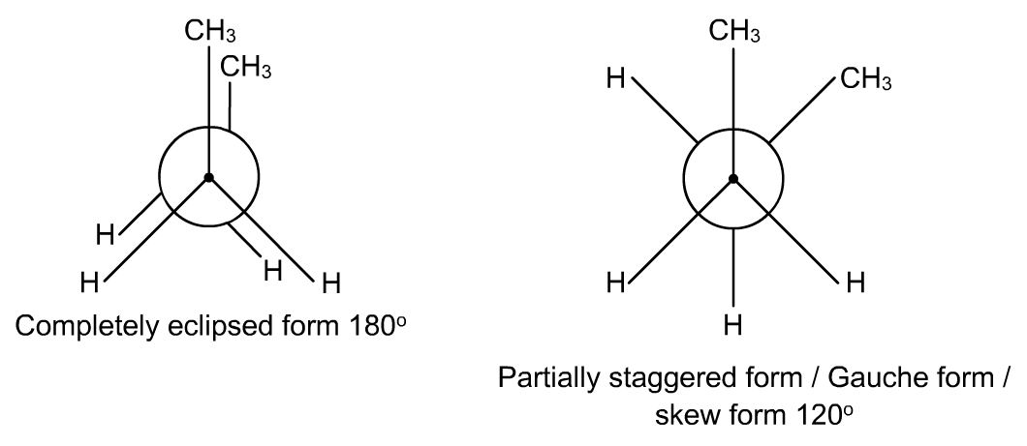
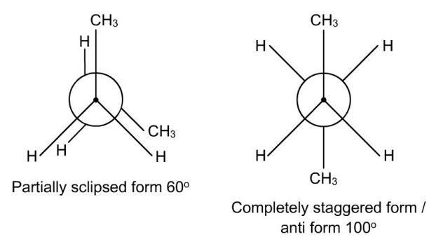
Staggered conformation: it is more stable in which the methyl groups are far apart, this is also called anti form.
Partially eclipsed conformation: the staggered conformation on rotation through 60⁰ gives eclipsed conformation (ii) in which methyl group on one carbon is overlapped by the hydrogen atom on the other carbon. Potential energy 14.6 kj/mol.
skew or gauche form :
Other conformation is be obtained by rotating through 60⁰ (iii); in this the methyl groups are close to each other that they repel each other. This repulsion cause gauche form to have 3.8kj/mol energy higher than antiform.
Fully eclipsed:
In conformation (iv) the steric strain is maximum; hence this conformation is most unstable and have potential energy 18.4 kj/mol. This is because of methyl groups which are very close together.
The order of stability of these conformations is:
Anti form > Skew or gauche form > Eclipsed Conformation > Fully eclipsed

The energy difference between various conformations is shown below:
