L-6

Topic : conformational isomerism
Isomerism: compounds having same molecular formula but exhibiting different physical and chemical properties are called isomers the phenomenon is called isomerism.
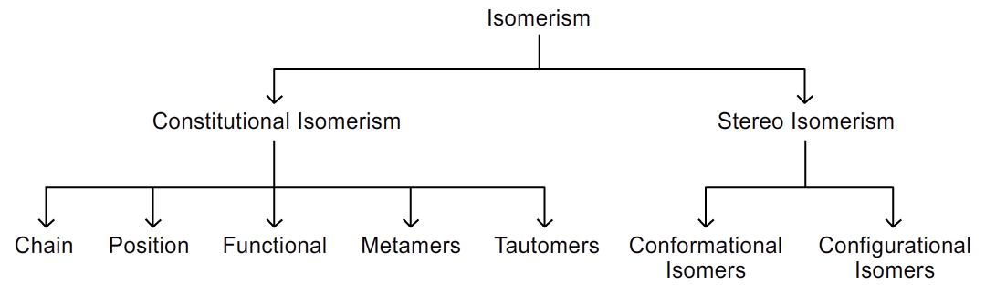
Conformational isomerism:
Conformations can be defined as different arrangements of atoms in space which can be converted into one another by rotation around single bonds.
- The different arrangements are known as conformational isomers/conformers/rotational isomers.
- The phenomenon is called conformational isomerism
- The study of properties of conformers is called conformational analysis.
Explanation:
Carbon-carbon single bond in alkanes is a sigma bond formed by overlapping of sp³ hybrid orbital; the electron distribution in such a bond is symmetrical around the axis; so that free rotation of one carbon against the other is possible without breaking the sigma covalent bond.
Consequently such compound can have different arrangements of atoms in space which can be converted into one another by rotation around single bonds.
Conformations of ethane:
In ethane two carbon atoms are linked by a single bond and each carbon atom is further linked to three hydrogen atoms. If one of the carbon atom is allowed to rotate about carbon-carbon single bond keeping the other carbon stationary an infinite number of arrangements are obtained.(bond lengths and bond angles are same.)
1. Newmann representation: this can be easily understood with the help of newman projection formulae. The molecule is viewed from front to back direction of carbon –carbon single bond.
The carbon nearer to the eye is represented by a point and the three hydrogens attached to it are shown by three longer lines at an angle of 120⁰ to one another.
The carbon away from the eye is represented by a circle and the three hydrogens attached to it are shown by three shorter lines at an angle of 120⁰ to one another.
Staggered conformation:
The conformation, in which the h atoms of two carbons are far apart as possible, is known as staggered conformation. This is the most stable conformer because it will have least torsional strain.
- The staggered conformation is most stable because the hydrogens and bonding pairs of electrons on adjacent carbon atoms are as far as possible. This causes minimum repulsion and this form is more abundant.
Conformations of ethane:
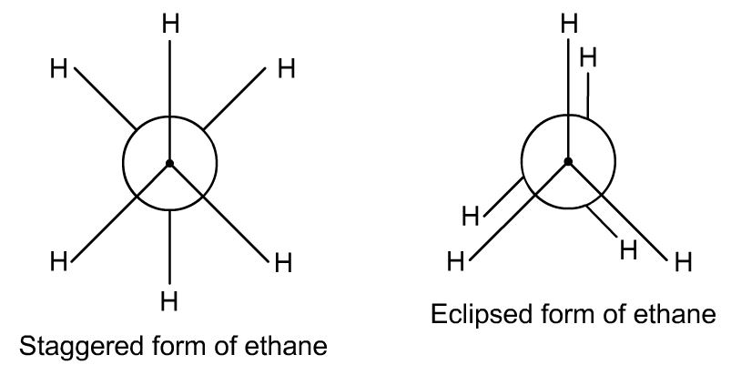
Eclipsed conformation:
The conformation in which the h atoms of back carbons are just behind those of front carbon is known as eclipsed conformation.
- The eclipsed conformation is least stable because the hydrogens and bonding pairs of electrons on adjacent carbon atoms are as near as possible. This causes repulsion and this form is less abundant.
Skew conformations:
The other conformations in between these two are called skew conformations. They can be converted into one another by rotation of single bond.
2. Sawhorse representation: in this molecule is visualized slightly from above and from the right and then projected on the paper. This bond between two carbons is drawn diagonally and is a bit longer for the sake of clarity. The lower left hand carbon is taken as front carbon and upper right hand carbon is taken as back carbon.
Conformations of ethane:
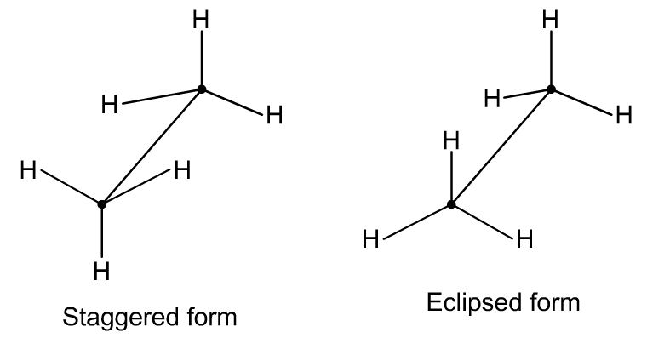
- It is found that the rotation is not completely free. Rather there exists a potential energy barrier which restricts the free rotations.this barrier is called torsional barrier.
- it means that molecule spend most of its time in most stable staggered conformation and spends least time in least stable eclipsed conformation.
- The difference in the potential energy is the energy required to rotate the molecule about carbon carbon bond is called rotational or torsional energy.

The energy is not large enough to prevent rotation. Even at ordinary temperature, the energy barrier is overcome through collisions and thus, the conformations keep on changing from one to other .
It is not possible to isolate the different conformations of ethane because they are constantly inter converting.

Rotational or torsional energy of ethane: 12.5 kj/mol (3 kcal/mol)
