Class-8
Topic- Structure and uses
ETHANOL-
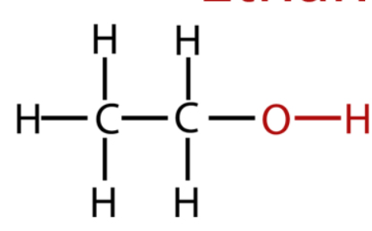
Uses - Use as a solvents.
As an antiseptics
Used as a motor fuels
METHANOL-

C
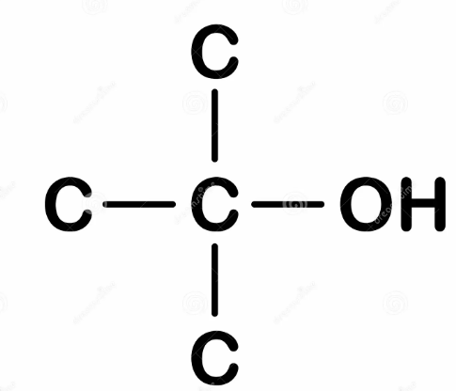
USES-
Methanol is primarily converted to formaldehyde, which is widely used in many areas, especially polymers. The conversion entails oxidation:
2 CH3OH + O2 → 2 CH2O + 2 H2O
Acetic acid can be produced from methanol.

CHLOROBUTANOL-
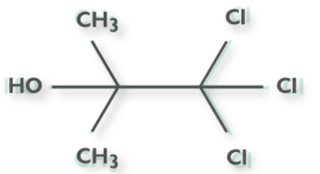
USES-
Chlorobutanol, or chlorbutol, is an alcohol-based preservative with no surfactant activity . It also elicits sedative-hypnotic and weak local anesthetic actions in addition to antibacterial and antifungal properties. Similar in nature to chloral hydrate, it is formed by the simple nucleophilic addition of chloroform and acetone.
CETOSTEARYL ALCOHOL
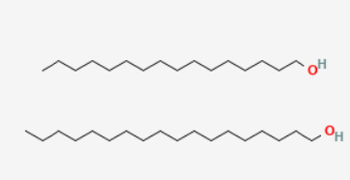
USES-
Cetostearyl alcohol, cetearyl alcohol or cetylstearyl alcohol^{[1]} is a mixture of fatty alcohols, consisting predominantly of cetyl (16 C) and stearyl alcohols (18 C) and is classified as a fatty alcohol. It is used as an emulsion stabilizer, opacifying agent, and foam boosting surfactant, as well as an aqueous and nonaqueous viscosity-increasing agent.
BENZYL ALCOHOL
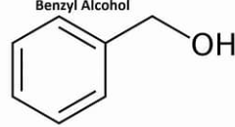
USES-
Used as local anaesthetics to reduce pain associated with lidocaine injection.
As a pharmaceutical aids
As a flavouring agents.

GLYCEROL
CH2-OH
CH2-OH
CH2-OH
USES- Used in cosmetics industry to enhance texture of lotions and cream
Used as a moisturizing agents.
PROPYLENE GLYCOL
OH
CH2
CH CH3
OH
USES-
As a solvent for food colors for oral topical formulation
Hand sanitizer and saline solutions

