Class-4
Topic- Nucleophilic Substitution Reactions

THE SN2 REACTION MECHANISM AND KINETICS
The reaction between methyl bromide and hydroxide ion to yield methanol follows second order kinetics; that is, the rate depends upon the concentration of both reactants (alkyl halides & nucleophile)
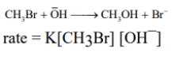
The simplest way to account for the kinetics is to assume that reaction requires a collision between a hydroxide ion and a methyl bromide molecule. In its attack, the hydroxide ion stays for away as possible from the bromine; i.e. it attacks the molecule from the rear and begins to overlap with the tail of the sp3 hybrid orbital holding Br. The reaction is believed to take place as shown:
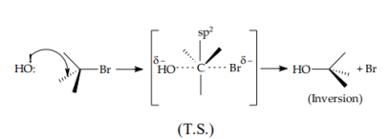
In the T.S. the carbon is partially bonded to both –OH and – Br; the C–OH bond is not completely formed, the C–Br bond is not yet completely broken. Hydroxide has a diminished – ve charge, since it has begun to share its electrons with carbon. Bromine has developed a partial negative charge, since it has partly removed a pair of electrons from carbon. At the same time, of course, ion dipole bonds between hydroxide ion and solvent are being broken and ion-dipole bonds between bromide ion and solvent are being formed. As the –OH becomes attached to C, 3 bonds are forced apart (120°) until they reach the spike arrangement of the T.S; then as bromide is expelled, they move on to the tetrahedral arrangement opposite to the original one.

STEREOCHEMISTRY
Both 2-bromo-octane and 2-octanol are chiral
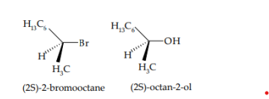
The (–) bromide and the (–) alcohol have similar configurations, i.e. –OH occupies the same relative position in the (–) alcohol as –Br does in the bromide. When (–)-2-bromooctane is allowed to react with sodium hydroxide under SN2 conditions, (+)-2-octanol is obtained.
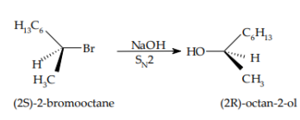
In Fisher projection the above reaction can be represented as follows
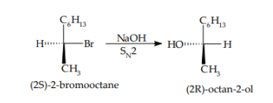
We see that – OH group has not taken the position previously occupied by –Br; the alcohol obtained has a configuration opposite to the bromide. A reaction that yields a product whose configuration is opposite to that of the reactant is said to proceed with inversion of configuration.
REACTIVITY
In SN2 reactions the order of reactivity of RX is CH3X > 1° > 2° > 3°.
Difference in rate between two SN2 reactions seem to be chiefly due to steric factors (bulk of the substituents) and not due to electronic factors i.e. ability to withdraw or release electrons. Relative Reactivity Towards I¯.

