Unit : ii ; (alkanes)

Topic : introduction, nomenclature, isomerism, preparation

Alkanes
- Alkanes are simplest organic compounds made of carbon and hydrogen only.
- They are represented by the general formula c_{n}h_{2n+2}
- Since carbon skeleton of alkanes is fully saturated with hydrogens they also called saturated hydrocarbons.
- Alkanes contain strong c-c and c-h covalent bonds therefore they are relatively chemically inert. They are sometimes referred as paraffins. (in Latin parum affinis= little affinity)
Structure:
Since carbon atom is attached to four other atoms it is sp³ hybridized and uses its sp ³ hybrid orbitals to form these bonds. Each c-h bond is result of overlap of sp³ orbital from carbon and s orbital of hydrogen.
Orbital structure of methane:
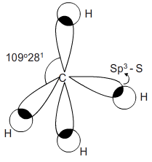
Nomenclature
First 4 members of the series are called by their common names, methane, ethane, propane and butane.the names of larger alkanes are derived from Greek prefixes that indicate the number of carbon atoms in the molecule.
Alkane | Structure
Methane | Ch₃
Ethane | Ch₃-ch₃
Propane | Ch₃-ch₂-ch₃
Butane | Ch₃-ch₂-ch₂-ch₃
Pentane | Ch₃-ch₂-ch₂-ch₂- ch₃

Isomerism: alkanes exhibit chain isomerism. The first three hydrocarbons do not exhibit chain isomerism. The various isomers are distinguished by their prefixes.
1) prefix n is used for those alkanes in which all the carbon atoms are in one continuous chain. Prefix n stand for normal.
ch₃-ch₂-ch₂-ch₂- ch₃ ch₃-ch₂-ch₂-ch₃
n-pentane n-butane
2) prefix iso is used for those alkanes which a methyl group attached to second last carbon atom of the continuous chain.
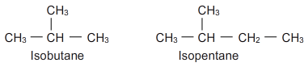
3) prefix neo used for those alkanes which two methyl groups attached to second last carbon atom of the continuous chain.
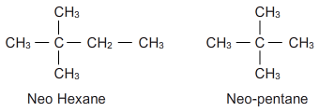
Primary, secondary and tertiary carbon atoms:
1) a carbon atom attached to one other carbon atom is called primary carbon atom
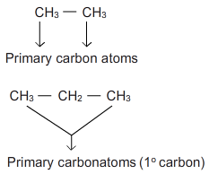
2) a carbon atom attached to two other carbon atom is called secondary carbon atom
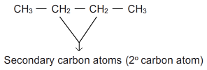
3) a carbon atom attached to three other carbon atom is called tertiary carbon atom
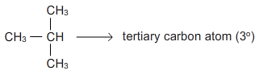
4) a carbon atom attached to four other carbon atom is called quaternary carbon atom
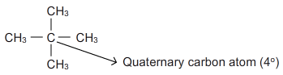
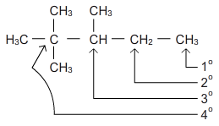
Alkyl groups:
An alkyl group is formed by removing one hydrogen from an alkane. They are named simply by dropping ane from the name of the corresponding alkane and replacing it by yl.(alkane-ane+yl= alkyl)
Parent alkane | Structure of parent alkane | Structure of alkyl group | Name of the alkyl group
Methane | CH₄ | CH | Methyl
Ethane | CH ₃-CH₃ | CH ₃-CH₂ | Ethyl
Propane | CH ₃-CH₂-CH₃ | CH ₃-CH₂-CH₂ | Propyl
N-butane | CH ₃-CH ₂-CH₃ | CH ₃-CH ₂-CH₂ | Butyl
Iso butane |  |  | Isobutyl

Methods of preparation of alkanes:
1)hydrogenation of alkenes or alkynes: alkenes or alkynes react with hydrogen in the presence of catalyst at 200-300 ⁰c to form alkanes. Catalysts used are platinum, palladium, nickel etc.
It is also called catalytic reduction. Also known as Sabatier’s senderens reaction.
General reaction:
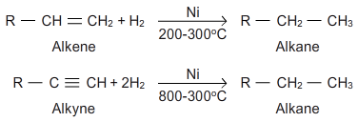
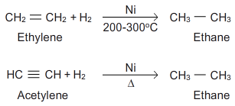

Alkenes consume one molecule of hydrogen whereas alkynes consume two molecules of hydrogens to form a saturated compound.
2)reduction of alkyl halides: alkyl halides undergo reduction with nascent hydrogen (just born/ just produced in the reaction) to form alkanes. The hydrogens required for the reduction may be obtained by using any of the following reducing agents,
A. Zn+HCL
B. Zn+CHCOOH
C.zn-cu couple in ethanol
D.red phosphorus +hi
- Also alkyl halides can be catalytically reduced using platinum, palladium, nickel.
- Primary and secondary halides can be reduced by Lilah and tertiary halides are reduced by nabh or tph
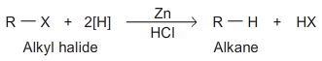
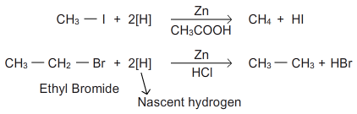
3)hydrolysis of Grignard’s reagent: alkyl magnesium halides are obtained by treating alkyl halides with magnesium in anhydrous ether. These on hydrolysis give alkanes.
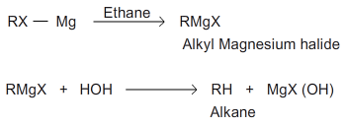
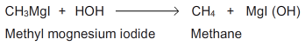

Preparation of alkanes: (continuation…)
4. Wurtz reaction:
This method was discovered by wurtz. This method was very useful in the preparation of high molecular mass alkanes.
An ether solution of alkyl halide is treated with sodium which removes the halogen of alkyl halide and the two alkyl radicals join together to form an alkane.
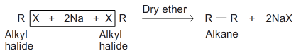
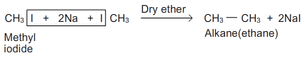
- Alkyl bromides and iodides are preferred in this reaction.

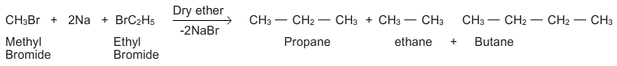

- When mixture of two different alkyl halides is used a mixture of three alkanes is obtained, the separation of the mixture into individual members is not easy process.
Thus wurtz reaction is not suitable for the synthesis of odd number of carbons.
Mechanism: the mechanism is not fully understood. 2 mechanisms were proposed.
- Intermediate formation of an organometallic compounds
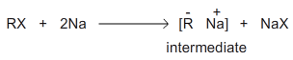
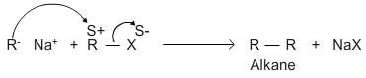

- Intermediate formation of free radicals
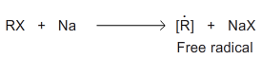
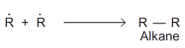
Limitations:
- Wurtz reaction is not suitable for the synthesis of odd number of carbons
- Methane cannot be prepared by this method
- The reaction fails with tertiary alkyl halides.

- By decarboxylation of carboxylic acid: when sodium salt of fatty acid is heated with sodalime (mixture of NAOH and CaO) a molecule of carbondioxide is eliminated as carbonate and as alkane is formed.

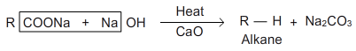
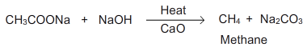

Since one molecule of carbon dioxide is eliminated this process is called decarboxylation.
- The alkane formed always contains one carbon atom less than the original acid. The yield is good in the case of lower members.

6. Kolbes electrolysis: electrolysis of concentrated aqueous solution of either sodium or potassium salts of saturated mono carboxylic acids yields higher alkanes at anode.
7.corey –house alkane synthesis: an alkyl halide is first converted to lithium alkyl which reacts with cuprous iodide to form lithiumdialkyl cuprate, it is then treated with alkyl halide to give an alkane.

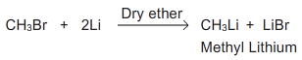

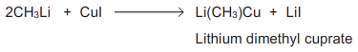

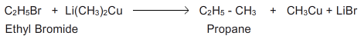
Physical properties:
The physical properties of hydrocarbons depend upon the intermolecular forces of attraction. Since alkanes are almost non-polar and therefore, their molecules are held only by weak vanderwaals forces which depend upon the size (surface area)and structure of the molecule.

- State: due to weak forces the alkanes upto 4 carbon atoms i.e. methane, ethane, propane and butane are colorless gases, next 13 are colourless, odourless liquids. Alkanes from c₁₈ onwards are colourless, odourless solids.

- Density: the density of alkanes increase with increase in molecular mass until it becomes constant at about 0.8. Thus alkanes are lighter than water.

- Solubility: they are generally insoluble in polar solvents such as water but soluble in non-polar solvents like ether, carbon tetrachloride, benzene etc., the solubility decrease with increase in molecular mass.

- Boiling points: the boiling points of straight chain or n-alkanes increase regularly with increasing number of carbon atoms.

Alkane | Struture | Boiling point | Melting point
Methane | Ch₃ | -161.5 | -182.5
Ethane | Ch₃-ch₃ | -88.6 | -172.0
Propane | Ch₃-ch₂-ch₃ | -42.1 | -187.7
Butane | Ch₃-ch₂-ch₂-ch₃ | -0.5 | -138.4
Pentane | Ch₃-ch₂-ch₂-ch₂- ch₃ | 36.1 | -129.7

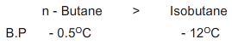

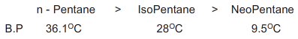

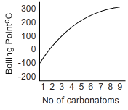

- In general the boiling point difference between two successive members of the series is about 20-30 ⁰c .
- Among the isomeric alkanes , the normal isomer has a higher boiling point than the branched chain isomer. The greater the branching of the chain, the lower is the boiling point.
- This can be explained in terms of inter molecular (dipole-dipole) forces of attraction .these forces act along the surface of the molecules and their magnitude increases with increase in surface area.
- The n-alkane has most extended structure and larger surface area in comparison with branched chain isomers that have compact structure. As the molecular size increases in the series, the surface area increases which increase the inter molecular forces and thus b.p also increases.

- Thus intermolecular forces are weaker in branched isomers so they have low boiling point.

5)melting points: the melting points of alkanes do not follow smooth gradation with increase in molecular size.
- Alkanes with even number of carbon atoms have higher melting point than the next lower and next higher alkanes having odd number of carbon atoms.
- Carbon atoms with odd number have their end-carbon atoms on the same of the molecule and even numbered carbon atoms alkanes have their end carbon atoms on the opposite sides of the molecule.
- Thus alkanes with even number of carbon atoms pack closely in such a manner as to permit greater intermolecular attraction and therefore have slightly higher melting point.

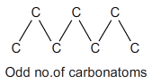

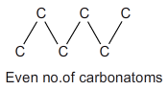

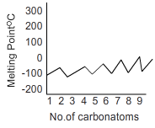

Chemical properties: alkanes are quite inert towards common reagents such as acids, alkalies, oxidizing and reducing agents at ordinary temperature.
The electronegativity difference between carbon and hydrogen is small and thus c-h bond is almost non polar. Therefore polar reagents (electrophiles and nucleophiles) do not find reaction sites on alkane molecules.
The c-c and c-h bonds are strong sigma and cannot break under ordinary temperatures, at high temperature energies of collision are sufficient to break c-h and c-c bonds resulting in the formation of free radicals.
However alkanes undergo some reactions under special conditions
- Substitution reactions
- Oxidation
- Thermal decomposition.
- Isomerisation
- Aromatization

Effect of activation energy on transition state:
For a reaction to occur, collision between reactant molecules is must.
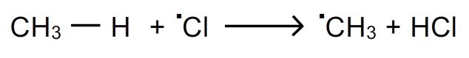
the above reaction takes place only if collisions between chlorine atom and methane take place. But all the collisions are not effective.
Activation energy(e_{act}):
- For the collisions to be effective, the reactant molecules must be associated with a certain minimum amount of energy called threshold energy.
- The molecules having the threshold energy are of only small fraction. Thus for the reaction to occur the energy of the molecules must be raised to a higher level. I.e. they must be activated before they react to form products.
- The additional amount of energy which the reactant molecules must acquire so that their collisions result in chemical energy is called activation energy(e_{act})
- For exothermic reactions the energy released appears to be sufficient but the bond breaking and bond making are not perfectly synchronized, the energy released through bond formation is not completely available for the bond breaking.
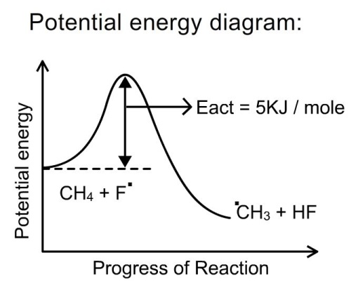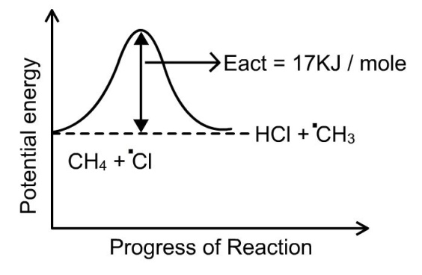
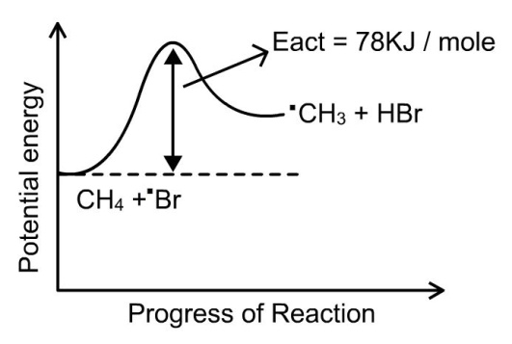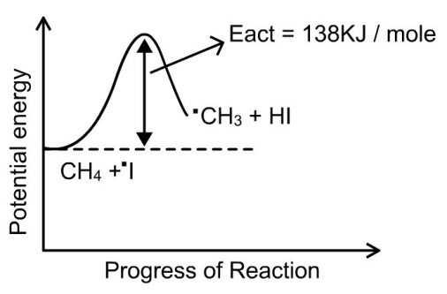
- The magnitude of e_{act} determines the rate of reaction. Reactions with low e_{act} proceed at faster rate than the one with high e_{act} at the same temperature.
The order of e_{act} for chain propagation step:
Iodination > Bromination > Chlorination > Fluorination

the order of halogenations :
Iodination < Bromination < Chlorination < Fluorination

Transition state(ts):
thus for a collision to be effective reactant must cross the energy barrier before the products are to be formed. The top of the energy hill represents an intermediate structure called transition state.
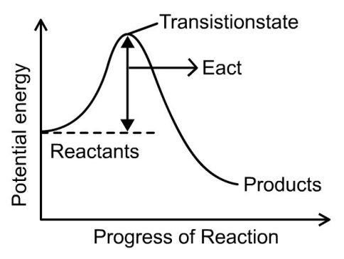
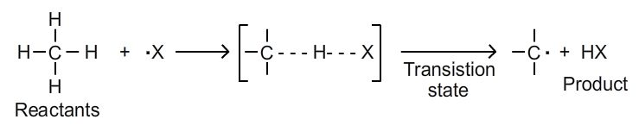
- Transition state can be defined as particular arrangements of atoms of reacting species as they are converted from reactants into products.
- It represents a configuration in which old bonds are partially broken and new bonds are partially formed. It is a state with highest potential energy. The transition state is unstable due to its high energy content and it cannot be isolated.
- In the transition state the c-h bonds are partly broken and h-x bond is partly formed.
Factors that influence the orientation of halogenations of alkanes:
- Collision frequency
- Probability factor
- Energy factor

Collision frequency: the collision frequency is same for both reactions.

Probability factor: since propane has 6 primary hydrogens and 2 secondary hydrogens, the ratio is 6:2 or 3:1

Energy factor: iso propyl free radicals are more easily formed than propyl radicals because they are more stable. Also the ease of formation can be related to the energy of activation of that radical.iso propyl free radical has smaller e_{act} than propyl free radical.

Study of chlorination of many alkanes has shown that the relative rate of abstraction of tertiary, secondary and primary hydrogens are in the ratio 5:3.8:1 with the help of these values we can predict the ratio of iso propyl halide and propyl halide.

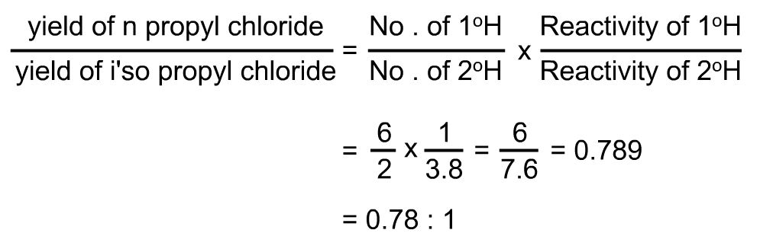
Chemical reactions:
2. Oxidation: oxidation of alkanes gives different products under different conditions
A) combustion or complete oxidation: alkanes when ignited in presence of excess oxygen or air burn to give carbon dioxide and water.
- Combustion of alkanes is an exothermic reaction; large quantity of heat is evolved. Heat of combustion increases with increase in molecular weight.
- It forms the basis for the use of alkanes as fuel and source of power.
eg: cooking gas lpg (mixture of propane and butane)
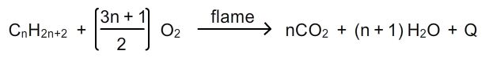
B) in complete oxidation of alkanes: when burnt in insufficient supply of oxygen, carbonmonodioxide or black carbon is formed.
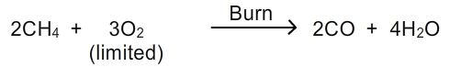
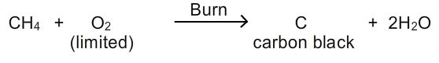
C) chemical oxidation: alkanes are usually not affected by oxidizing agents like kmno₄ however alkanes having tertiary hydrogen are oxidized by these oxidizing agents to corresponding alcohols.
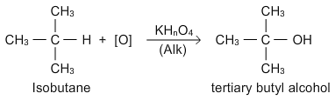
3. Thermal decomposition or fragmentation (pyrolysis/cracking):
- The decomposition of compound by heat is called pyrolysis. (greek: pyro=fire; lysis=loosening)
- When pyrolysis occurs in alkanes, the process is termed as cracking.
- Alkanes on heating at high temperature in absence of air broke down into lower alkanes, alkenes and hydrogen.
- During cracking of alkanes either rupture of c-c or c-h bonds take place resulting in formation of lower alkanes, alkenes and hydrogen.
- Pyrolysis generally requires high temperatures in the range of 500-800⁰c. However in the presence of catalyst (finely divided silica-alumina) reactions can be carried at less temperature. This is called catalytic cracking.
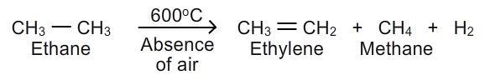
Mechanism:
- Chain –initiation step: ethane molecule decomposes to give two methyl free radicals.
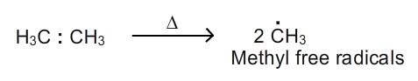
2. Chain propagation step:
A) methyl free radical attacks ethane to produce methane and ethyl free radical.
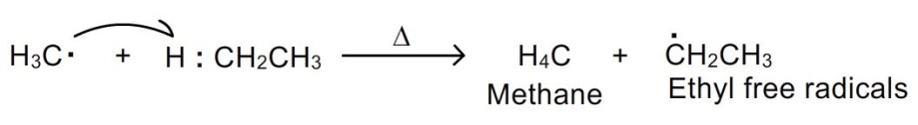
B) ethyl free radical gives ethylene and a hydrogen atom.
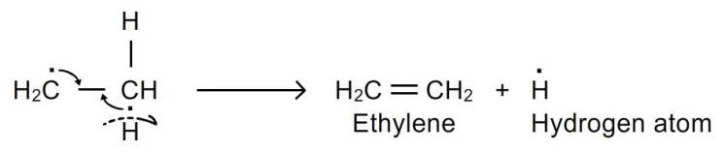
C) hydrogen atom attacks ethane to give ethyl free radical and hydrogen molecule.
Steps b, c are repeated over.
- Chain termination step: unreacted ethyl free radicals combine with hydrogen atoms to regenerate ethane which can further take part in reaction.
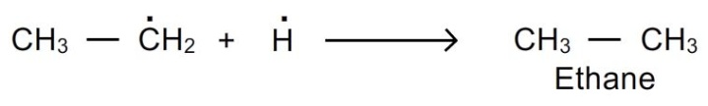
- Pyrolysis is of great importance to the petroleum industry because it provides means of making smaller, more volatile molecules from larger, less volatile hydrocarbons.
- Propane, when heated to 600⁰c in the absence of air, gives a complex mixture of propylene, ethylene,methane and hydrogen.
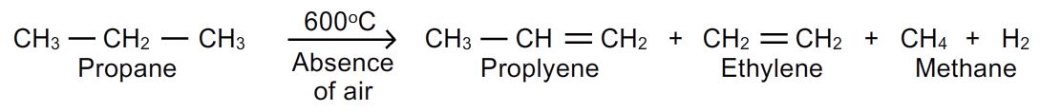
4.isomerisation: the process of conversion one isomer into another isomer is called isomerisation. Normal alkanes are converted to their branched-chain isomers in the presence of aluminium chloride and hcl at 25⁰c. The branched chain isomers have lower boiling point than the straight chain compounds.
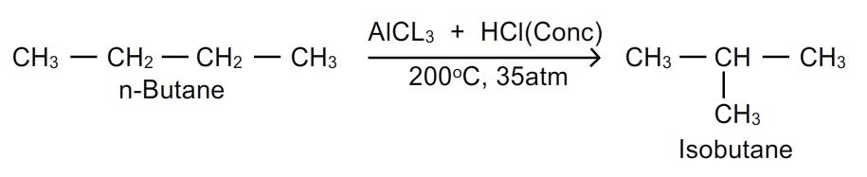
5. Aromatisation: the conversion of aliphatic compound into aromatic compound is called aromatization. Alkanes having 6-10 carbon atoms are converted into benzene or its homologous analogs at higher temperature in presence of a catalyst.
