UNIT -5 :
ALIPHATIC AMINES:

Amines (e.g. RNH₂) are organic derivatives of ammonia, nh₃ (i.e. replace the N-H with N-C bonds) and so they have certain similarities with ammonia (e.g. basicity, nucleophilicity).
Nitrogen containing compounds are biologically very important (examples) amines, amino acids, amides, proteins, vitamins etc.
The important organic reactions of amines (nucleophiles) are with the common electrophiles as we have already encountered:
Via nucleophilic substitution with alkyl halides
Via nucleophilic addition aldehydes or ketones
via nucleophilic acyl substitution with carboxylic acid derivatives, especially acid chlorides or anhydrides
Nomenclature:
functional group suffix = -amine
functional group prefix = amino
primary, secondary, tertiary or quaternary ? Amines are described as primary (1º), secondary (2º), tertiary (3º) or quaternary (4º) depending on how many alkyl substituents are attached to the n atom (note the difference compared with alcohols). Quaternary amines are also known as ammonium cations.
Ammonia | Ethyl amine | , dimethyl amine | , trimethyl amine | Tetramethyl ammonium
 | 1º | 2º | 3º | 4º

Physical properties:
The polar nature of the n-h bond (due to the electronegativity difference of the two atoms) results in the formation of hydrogen bonds with other amine molecules, see below, or other h-bonding systems (e.g. water). The implications of this are:
High melting and boiling points compared to analogous alkanes
High solubility in aqueous media

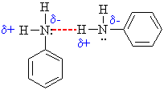
Intermolecular h-bonding in amines
Structure:
The amine functional group consists of an n atom bonded either to c or h atoms via σ bonds.
Both the c-n and the n-h bonds are polar due to the electronegativity of the n atom.
The trigonal pyramidal arrangement of bonds around nitrogen is shallower in aryl amines vs alkyl amines.
This is a result of resonance delocalisation of the lone pair into the aromatic π system
(such delocalisation is also responsible for the decreased basicity of aryl vs alkyl amines).
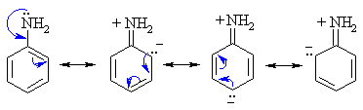
Reactivity:
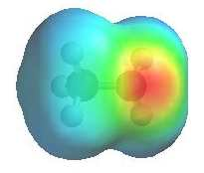 | The image shows the electrostatic potential for methylamine, ch₃nh₂. The more red an area is, the higher the electron density and the more blue an area is, the lower the electron density.  The amine n atom is a region of high electron density (red) due to the lone pair.  Amine n atoms are lewis bases, (alkyl ammonium pk_{a} ~ 10, aryl ammonium pka ~ 5)  Amines can react as either bases or nucleophiles at the nitrogen.  There is low electron density (blue) on h atom of the -nh group.  Removal of the proton generates the amide ion  (care : not to be confused with the carboxylic acid derivative rconh₂)  The -nh group is a very poor leaving group and needs to be converted to a better leaving group before substitution can occur.
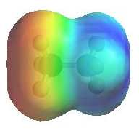 | The image shows the electrostatic potential for methylammonium, ch₃nh₃⁺. The more red an area is, the higher the electron density and the more blue an area is, the lower the electron density.  The ammonium n atom is a region of low electron density (blue) due to the positive charge.  Ammonium ions are not nucleophilic.  There is low electron density (blue) on h atom of the -nh₃ group.  Removal of the proton regenerates the amine.  The -nh₃ group is a potential leaving group.
Basicity:
Amines are more basic than analogous alcohols (r-nh₃⁺ pk_{a}~ 10, r-oh₂⁺ pk_{a}~ -3)
Factors (e.g. resonance, electronegativity) that affect the availabilty of the lone pair will affect the basicity.
N is less electronegative than o and therefore n is a better electron donor.
Alkyl and non-aromatic heterocyclic amines are slightly stronger bases than ammonia
Aryl amines are much weaker bases than ammonia, a result of the delocalisation of the lone pair into the π system of the ring.

The anion derived by the deprotonation of an amine is the amide ion, nh₂⁻
Amide ions are important bases in organic chemistry (example)
Amines react with na (or k) to give the amide ion.
The basicity of aryl amines is:
Increased by the presence of electron-donating substituents on the ring, by counter-acting the delocalisation of the lone pair into the π system of the ring.  Decreased by the presence of electron-withdrawing substituents which enhance the delocalisation of the lone pair into the π system of the ring (especially those ortho or para to the amine functional group, see right). | 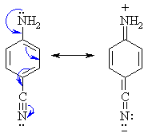

Inclusion of a heteroatom into an aromatic ring generally decreases basicity, unless protonation leads to an ion that can be stabilised by electron delocalisation:
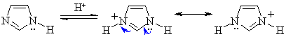
Alkylation of ammonia
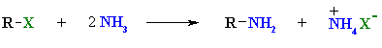
Reaction type: nucleophilic substitution
Summary
Ammonia reacts as a nucleophile with alkyl halides to give primary amines in a nucleophilic substitution reaction.
Yields are often poor as the product, a primary amine, rnh₂, is itself a nucleophile and can react with more alkyl halide.
The result are mixtures containing primary amines, secondary amines, tertiary amines and quaternary ammonium salts.
This can be avoided if a large excess of ammonia is used.
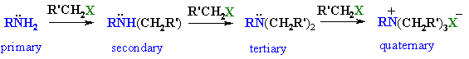
As aryl halides do not undergo simple nucleophilic substitution, they cannot be prepared using this method.
Mechanism of ammonia alkylation
Step 1:  the n in ammonia functions as the nucleophile and attacks the electrophilic c of the alkyl halide displacing the bromide and creating the new c-n bond. | 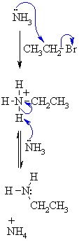
Step 2:
an acid/base reaction. The base (excess ammonia) deprotonates the positive n (ammonium) center creating the alkylation product, the primary amine.
Alkylation of phthalimide (gabriel synthesis of primary alkyl amines)
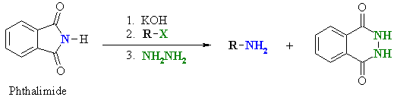
Reaction type: nucleophilic substitution then nucleophilic acyl substitution
Summary
The advantage of this method is that over alkylation is avoided (see previous page)
Reaction of phthalimide with koh removes the n-h proton giving an imide ion, a good nucleophile.
nucleophilic substitution by the imide ion on the alkyl halide generates an intermediate, n-alkyl phthalimide.
Hydrolysis or hydrazinolysis liberates a primary alkyl amine.
Aryl amines cannot be prepared via this method since aryl halides do not undergo simple nucleophilic substitution.
Reduction of azides
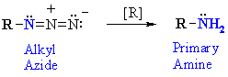
Reaction type : oxidation - reduction
Summary
Azides, r-n₃, can be reduced to primary amines, r-nh₂
Reagents : either lithium aluminum hydride (lialh₄) / ether solvent or catalytic hydrogenation (e.g. h₂/pd)
Alkyl azides are prepared by nucleophilic substitution (s_{n}2) by azide ion, n₃⁻, of primary or secondary alkyl halides.
Reduction of nitriles
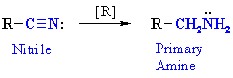
Reaction type : oxidation - reduction or nucleophilic addition
Summary
The nitrile, rc≡n, is reduced to the 1º amine by conversion of the c≡n to r-ch₂-nh₂
Reagents : either lithium aluminum hydride (lialh₄) / ether solvent or catalytic hydrogenation (e.g. h₂/pd).
Alkyl nitriles are prepared by nucleophilic substitution (s_{n}2) by cyanide ion, cn⁻, of primary or secondary alkyl halides.
Aryl nitriles can also be reduced to aryl amines.
Reduction of nitro compounds
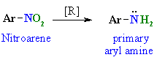
Reaction type : oxidation - reduction
Summary
Nitroarenes can be reduced to primary aryl amines (see scheme).
Typical reducing agents include, fe / h⁺, sn / h⁺ or catalytic hydrogenation (e.g. h₂ / pd)
Nitroarenes are prepared by the nitration of aromatics.
This is probably the most important method for the synthesis of anilines (ar-nh₂) and, therefore, accessing the chemistry of diazonium compounds (see later)
Reduction of amides
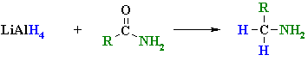
reactions usually in et₂o or thf followed by h₃o⁺ work-ups
Reaction type: nucleophilic acyl substitution then nucleophilic addition
Summary
Amides, rconr'₂, can be reduced to the amine, rch₂nr'₂ by conversion of the c=o to -ch₂-
Amides can be reduced by lialh₄ but not the less reactive nabh₄
Typical reagents : lialh₄ / ether solvent, followed by aqueous work-up.
Note that this reaction is different to that of other c=o compounds which reduce to alcohols (for example esters)
The nature of the amine obtained depends on the substituents present on the original amide.
Look at the n substituents in the following examples (those bonds don't change !)
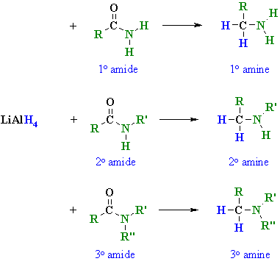
R, r' or r" may be either alkyl or aryl substituents.
In the potential mechanism shown below, note that it is an o system that leaves.
This is consistent with o systems being better leaving groups that the less electronegative n systems.

reduction of azides
reduction of nitriles
reduction of nitro compounds
reduction of carboxylic acids and esters

Reaction of lialh₄ with an amide
Step 1:  the nucleophilic h from the hydride reagent adds to the electrophilic c in the polar carbonyl group of the ester. Electrons from the c=o move to the electronegative o creating an intermediate metal alkoxide complex. | 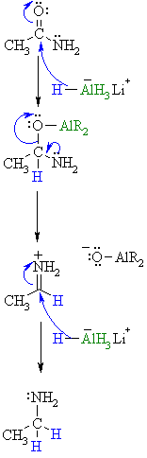
Step 2:
the tetrahedral intermediate collapses and displaces the o as part of a metal alkoxide leaving group, this produces a highly reactive iminium ion an intermediate.
Step 3:
rapid reduction by the nucleophilic h from the hydride reagent as it adds to the electrophilic c in the iminium system. Π electrons from the c=n move to the cationic n neutralising the charge creating the amine product.
Reductive amination via imines
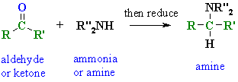
Reaction type : nucleophilic addition then oxidation - reduction
Summary
Aldehydes and ketones react (chapter 17) with 1º amines to give substituted imines and 2º amines to give enamines
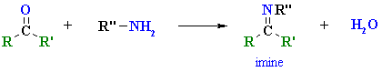
• these n species can then be reduced to amines.
• the method provides access to 1º, 2º, or 3º amines.
• typical reagents : step 1 : acidic buffer step 2 : most commonly catalytic hydrogenation (e.g. h₂/pd)
• sodium cyanoborohydride (nabh₃cn) (which is like nabh₄) can be used for smaller scale reductions.
• r, r' and r" may be either hydrogen, alkyl, or aryl.

Reactions of amines:
Alkylation of amines
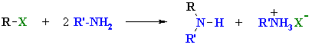
Reaction type : nucleophilic substitution
Summary
Amines can react as a nucleophiles with alkyl halides via substitution reactions (s_{n}2)
Yields are often poor as the product amines, are still nucleophilic and can react with more halide.
The result is often a mixture of amines in various states of alkylation.
Mechanism of amine alkylation
Step1:  the amine n functions as the nucleophile and attacks the electrophilic c of the alkyl halide displacing the bromide and creating the new C-H bond. | 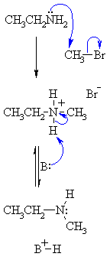
Step2:
an acid/base reaction. The base (excess amine) deprotonates the positive n (ammonium) center creating the alkylation product, here a secondary amine.
Reactions of primary amines with aldehydes and ketones
(review of chapter 17)
Reaction type: nucleophilic addition then elimination
Summary
Primary amines, R-NH₂ or ARNH₂, undergo nucleophilic addition with aldehydes or ketones to give carbinolamines which then dehydrate to give substituted imines.
The reactions are usually carried out in an acidic buffer to activate the c=o and facilitate dehydration but without inhibiting the nucleophile.
Systems of the general type Z-NH₂ undergo this type of reaction and can be used as derivatives to aid in the identification of aldehydes and ketones.
Nucleophilic addition of a primary amine giving an imine

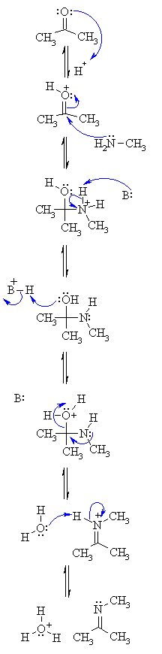

The above is the reaction mechanism:

Step1:
an acid/base reaction. Protonation of the carbonyl activates it and makes it more susceptible to attack by a neutral nucleophilic like the n of a primary amine.
Step2:
attack of the n nucleophile at the electrophilic c of the c=o group with the electrons from the π bond going to the +ve o.
Step3:
an acid/base reaction. Removal of the proton neutralises the +ve charge on the n and forms the carbinolamine intermediate.
Step4:
to form the imine we need to dehydrate. However, before -oh leaves it needs to be protonated, so a simple acid/base reaction.
Step5:
use the electrons of the n to help push out the leaving group, a neutral water molecule, this leaves us with an iminium ion.
Step6:
an acid/base reaction. Deprotonation of the iminium n reveals the imine product and regenerates the acid catalyst.

Preparationofamides:

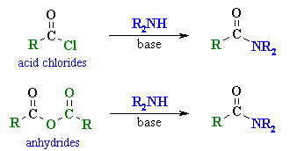
Reaction type: nucleophilic acyl substitution
Summary
Primary amines, r-nh₂ and secondary amines, r₂-nh undergo nucleophilic acyl substitution with carboxylic acid derivatives to give amides.
The most common examples are the reactions of acid chlorides and anhydrides, though esters do react with amines.
Hofmann elimination
Reaction type: elimination
Summary
Like alcohols, amines can undergo elimination reactions.
Quaternary ammonium salts undergo an e2 elimination when heated with silver oxide, ag₂o, in water.
Amines can readily be converted into quaternary ammonium iodides by treating them with excess methyl iodide.
Ag₂o / h₂o reacts giving the quaternary ammonium hydroxide, silver iodide precipitates.
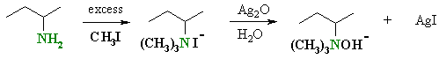
When heated the hydroxide induces a base promoted 1,2- or β-elimination giving an amine and alkene.
The regioselectivity is opposite to that predicted by zaitsevs rule in that it leads to the less highly substituted alkene.
The less highly substituted alkene is sometimes referred to as the hofmann product.
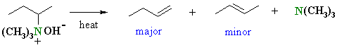
The outcome is dictated by steric effects of the large leaving group and the alkyl chain (more details ?)
Nh₂⁻ and nr₂⁻ are very poor leaving groups (both anionic), but nr₃ is much better (neutral)
Compare this with with -oh and h₂o in the dehydration of alcohols.
Related reactions
dehydration of alcohols
dehydrohalogenation of alkyl halides
Mechanism of the hofmann elimination
The initial steps are an example of the alkylation of an amine by methyl iodide. The mechanism of the elimination step is shown.  When heated, the hydroxide removes the more accessible proton, the π bond of the alkene c=c forms and the leaving group, a neutral amine departs. | 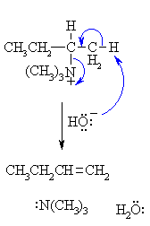
Electrophilic aromatic substitution of aryl amines
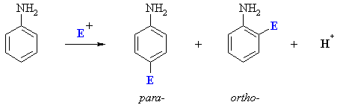
Summary
Arylamines are potentially very reactive towards electrophilic aromatic substitution
This is because -nh₂, -nhr2 and -nr2 are very strong activators and are ortho, para-directing.
However the basicity of the amino group means it is unsuitable for reactions with acids (e.g. h₂so₄ or alcl₃) such as nitration, sulfonation and friedel-crafts alkylation or acylation.
Polysubstitution can also be a problem. For example, bromination is very rapid, even in the absence of a catalyst, leading to bromination in all available ortho- and para- positions:
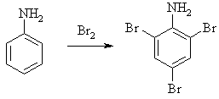
To avoid these problems, it is customary to "protect" aryl amines by converting them to their n-acyl derivatives i.e. amides.
The protecting group (an amide) can later be removed by either acid or base hydrolysis.
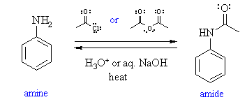
The amide is a less powerful activating group than the simple amino group, -nh₂ since resonance within the n-acetyl group of the amide (see below) competes with delocalisation of the n lone pair into the ring.
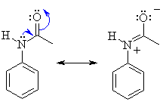
Steric effects in the amide also often lead to a decrease in the amount of the ortho-products.
In principle, the sequence protect - substitute - deprotect is equivalent to being able to substitute the aniline directly.
Nitrosation of amines
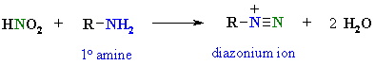
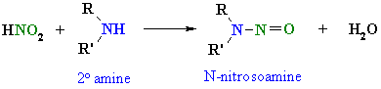
Summary
Typical reagents : sodium nitrite and aq. Hcl or h₂so₄ (this mixture yields nitrous acid, hno₂)
The most useful reactions are probably those of primary aryl amines, ar-nh₂, which give aryl diazonium salts, ar-n₂⁺ which can then be used to prepare substituted benzenes (see next page)
The actual nitrosation reagent is the nitrosyl cation, no⁺ which is formed in situ:
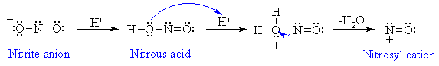
The nature of the product depends on the nature of the initial amine
Primary alkyl or aryl amines yield diazonium salts (hence the diazotisation reaction)
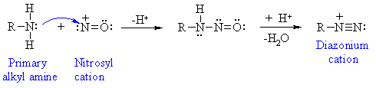
Alkyl diazonium salts are very unstable and yield carbocation-derived products by loss of the very good leaving group, n₂:

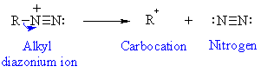
Secondary alkyl or aryl amines yield n-nitrosoamines:
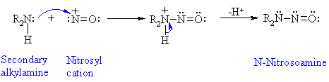
Tertiary alkyl amines do not react in a useful fashion.
Tertiary aryl amines undergo nitrosation of the ring (an electrophilic aromatic substitution reaction)
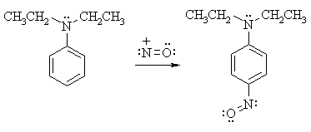

Synthetically useful transformations involving aryl diazonium ions
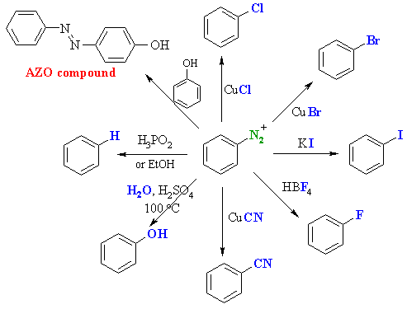
Aryl diazonium salts can be converted into a range of systems as shown above.
These reactions can be useful as the methodology can be complementary to other methods of introducing aromatic substitutents
Of particular note are the methods for introducing -f using hbf₄ (the schiemann reaction) and -oh using h₂o.
The reactions of copper salts (cucl, cubr and cucn) are known as the sandmeyer reactions.
Coupling with phenols gives azo-compounds which are important as yellow-red dyes or pigments.
Aryl diazonium salts are prepared from aryl amines (previous page) which in turn can be obtained by the reduction of nitrobenzene

