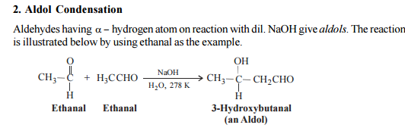
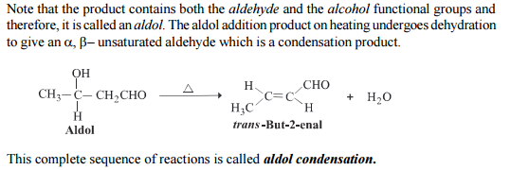
- Other reactions:
- cannizzaro reaction:
Aldehydes and ketones having no alpha hydrogen atom:
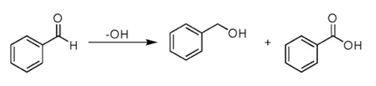
when two carbonyl groups are present within a molecule, think of intramolecular reaction.
Oh⁻ will attack more positively charged carbon. In this case, it is right >c=0 group.
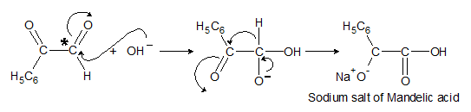
- Formation of keto esters
Esters having a-hydrogen on treatment with a strong base e.g. c₂h₅ona. Undergo self condensation to produce b-keto esters. This reaction is claisen condensation.
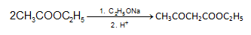
- reformatsky reaction
This is the reaction of a-haloester, usually an a-bromoester with an aldehyde or ketone in the presence of zinc metal to produce b-hydroxyester.
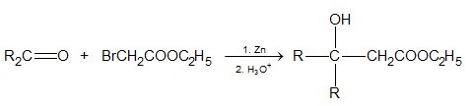
- pinacol-pinacolone rearrangement
The acid catalysed rearrangement of 1, 2 diols (vicinal diols) to aldehydes or ketones with the elimination of water is known as pinacol pinacolonerearrangement. 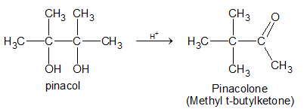

- wittig-ylide reaction
Aldehydes and ketones react with phosphorus ylides to yield alkenes and triphenyl phosphine oxide. An ylide is a neutral molecule having a negative carbon adjacent to a positive hetero atom. Phosphorus ylides are also called phosphoranes.
Preparation of ylides
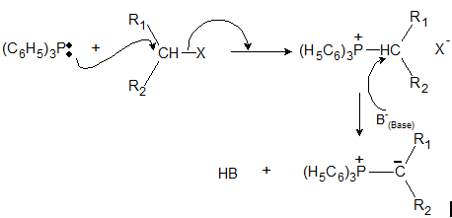

Acidity of alpha hydrogens
The c-h bond on the alpha carbon of carbonyl compounds (aldehydes, ketones, acids, and acid derivatives) has modest acidity (pka 17-30) depending on the functional group. The carbonyl group is an electron-withdrawing group and is able to acidify the hydrogen on the alpha carbon. Strong bases will deprotonate the sp3 hydrogen on the alpha carbon generating an enolate ion. In the enolate ion the alpha carbon is sp2 hybridized. This anion is stabilized by delocalization of the negative charge into the carbonyl group placing the charge on the oxygen atom. Note that the sp2 orbital is in the proper orientation to overlap with the p orbitals of the carbonyl group. 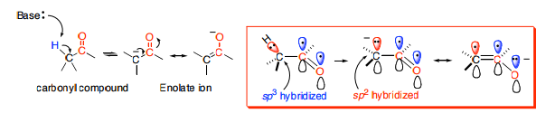
Compounds
- Formaldehyde:

Uses: a) it is used as solvating agent.
B) it is used for preparation of various organic compounds.
- Acetaldehyde:
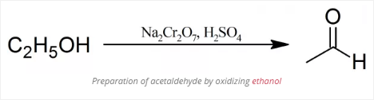
Uses: a) it is used for manufacturing of acetic acid, acetic anhydride, chloral etc.
B) it is also used in preparation of dyes.
- Paraldehyde:
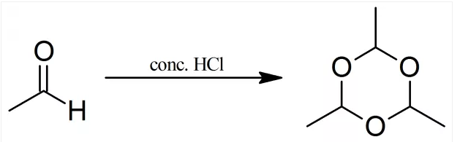
Uses: a) it is useful for regeneration of acetaldehyde on distillating with con. Sulphuric acid.
- Acetone:
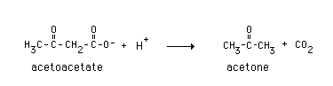
Uses: a) used as a solvent.
B) used as a laboratory cleaning agent.
C) used as artistic agent

5) chloral hydrate:

Uses: a) it is used in manufacturing of ddt, an important insecticide.
B) it has been used in medicine as a hypnotic.
- Benzaldehyde:
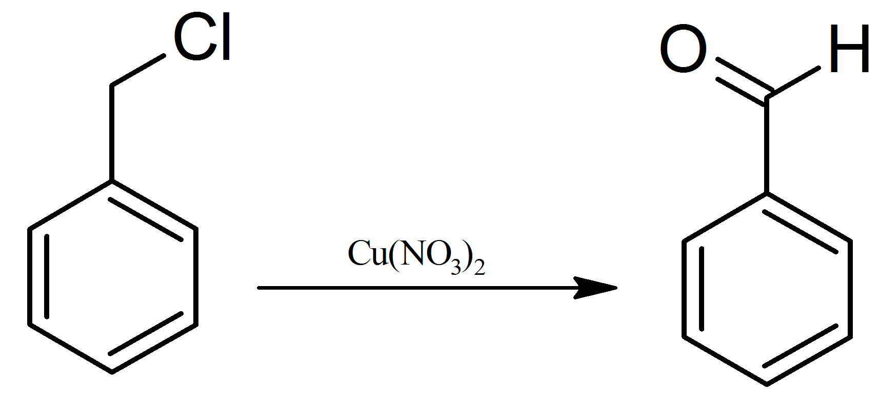
Benzyl chloride benzaldehyde
Uses: used in manufacturing of dyes, perfumes and flavouring agents.
- Cinnmaldehyde: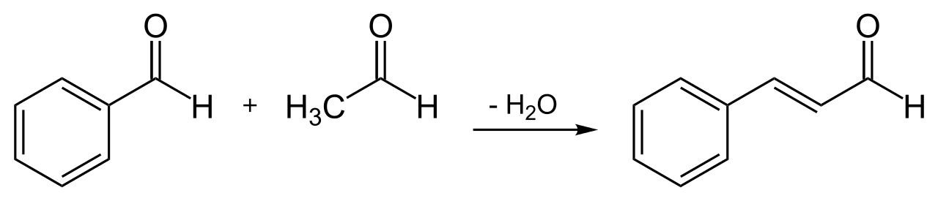
Benzaldehyde cinnmaldehyde
Uses: a) used as corrosion inhibitor of steel.
B) used as fungicide. C) used as flavouring agent in chewing gums.

