UNIT-IV
ALDEHYDES & KETONES
Aldehydes and ketiones

Carbonyl compounds are molecules containing the carbonyl group, c=o. These include:
- Aldehyde
- Ketone

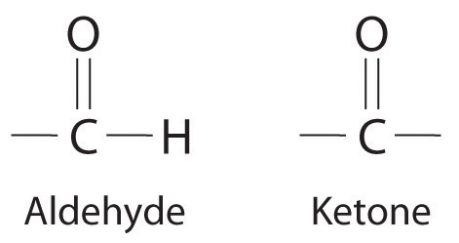
Carbonyl compounds also includes the following

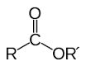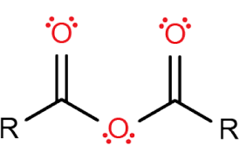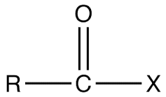
ester anhydride acid halide

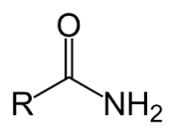 amide
Nomenclature of aldehydes and ketones
• common names are used for the simplest aldehydes and ketones:
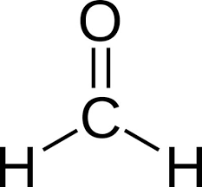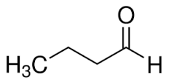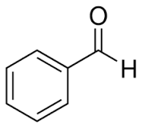
formaldehyde butyraldehyde benzaldehyde

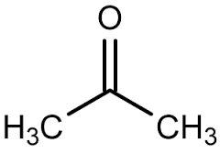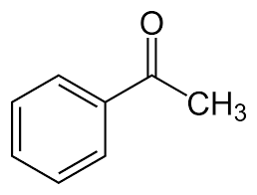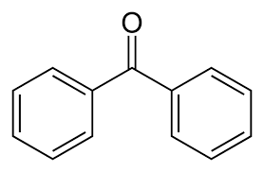
acetone acetophenone benzophenone

General methods of preparation of aldehyde and ketone
Preparation of aldehydes
- Oxidation of primary alcohols:
primary alcohols on oxidation give aldehydes.
- In general, aldehydes are more easily oxidized than alcohols.
- Rcho → rcooh occurs more readily than rch 2oh → rcho.
- Therefore, very mild oxidizing agents must be used for the transformation rch 2oh → rcho.

Examples of mild oxidizing agents are:
(a) chromium trioxide-pyridine complex, cro 3.2py;
(b) manganese dioxide, mno 2

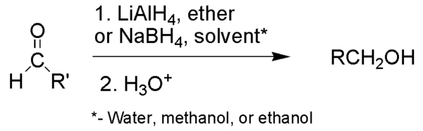
- Reduction of acyl chlorides
reduction of acyl chlorides: rcocl → rcho. Lithium trit-butoxyaluminum hydride is often used for this reduction.

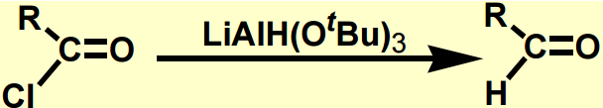
Preparation of ketones
- Preparation of ketones from acyl chlorides: acyl chlorides upon treatment with grignard reagent and a metal halide, yields ketones.
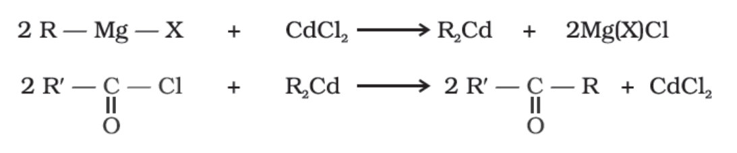
- preparation of ketones from nitriles: treatment of nitriles with grignard reagent upon further hydrolysis yields ketones.
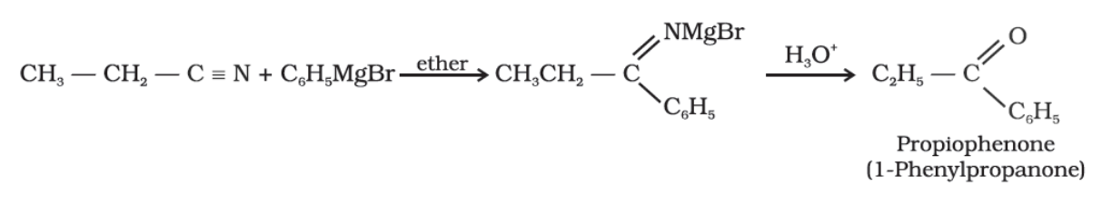
- Preparation of ketones from benzenes or substituted benzenes: electrophilic aromatic substitution of benzene ring with acid chlorides in the presence of a lewis acid such as, alcl₃ results in the formation of ketones. This reaction is popularly known as friedel craft’s acylation reaction.
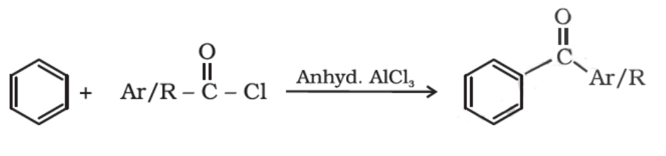
- Preparation of ketones by dehydrogenation of alcohols: dehydrogenation of alcohol is a reaction in which two hydrogen molecules are removed from an alcohol molecule upon oxidation. During oxidation of an alcohol both c-o and o-h bonds are broken for the formation of c=o bonds. Secondary alcohols in the presence of strong oxidizing agents undergo dehydrogenation to produce ketones
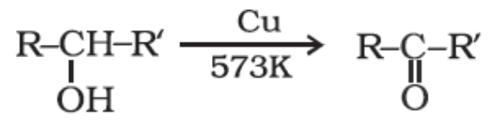
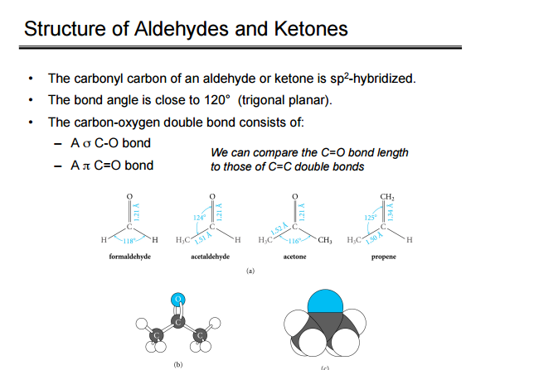

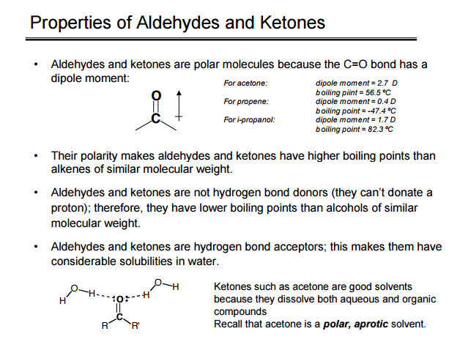
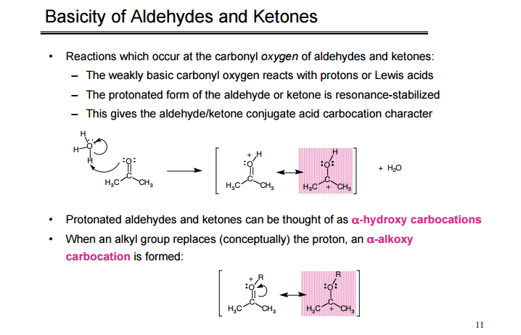

Chemical properties
- Nucleophilic addition reactions:
The carbonyl group of aldehydes and ketone is a highly polar group. It can be represented as:
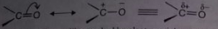
The mechanism involves two steps:
Step 1: the nucleophile attacks the positively charged carbonyl carbon to form a new bond.

Step 2: the electrophile attacks the negatively charged oxygen to form the addition product

The nucleophilic addition reactions may be catalysed either by acids or bases
- Addition under acidic condition:
This occurs in three steps:
- Protontion
- Addition
- Deprotonation

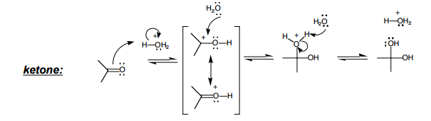
- Addition under basic condition:
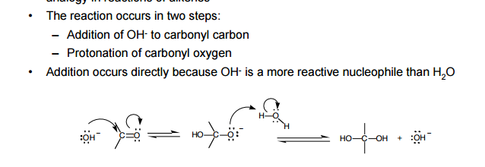
Reactions:
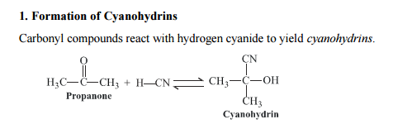
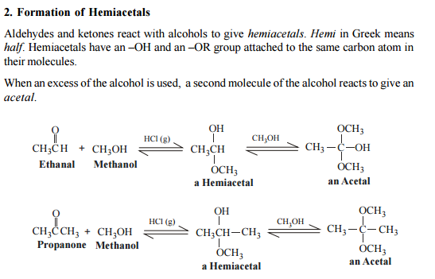
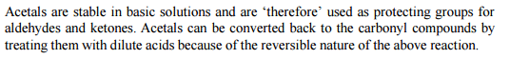
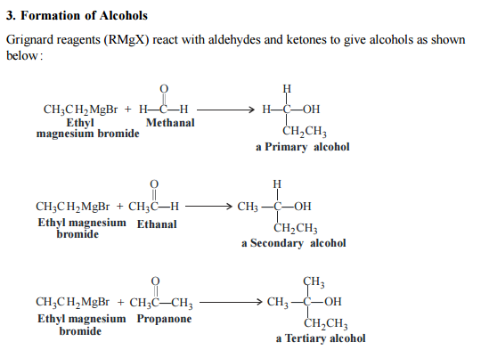
- Condensation reactions:
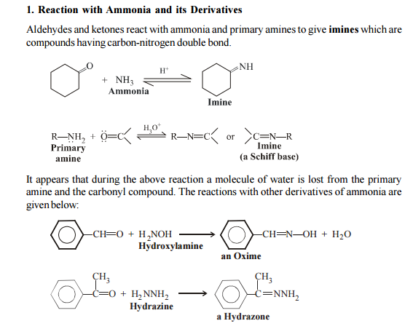

- Deoxygenationreaction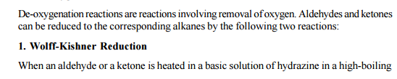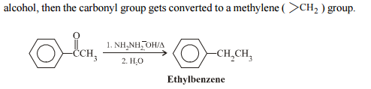
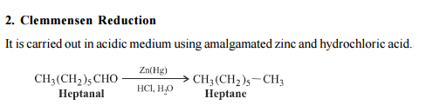
- Reactions at alpha carbon:
