The addition to unsymmetrical alkenes follow markownikoff’s rule.
Markownikoff’s rule: the addition of halogen acids to unsymmetrical alkenes takes place in such a manner that halogen attaches to that carbon atom which carries lesser number of hydrogen atoms.
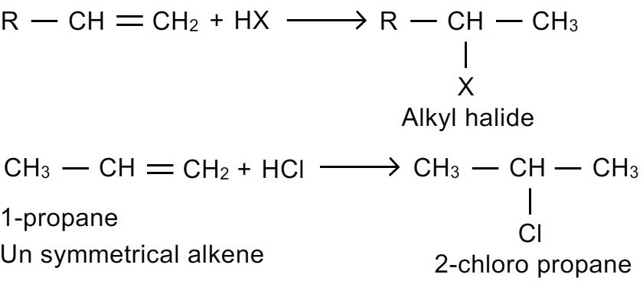
This is because the addition occur through the formation of carbocation.
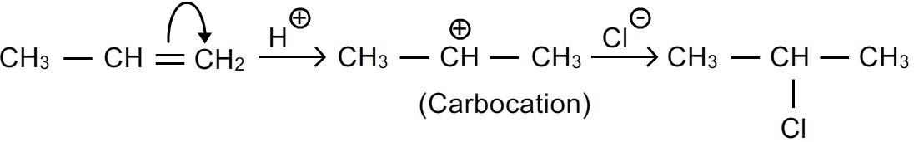
Anti-markownikoff’s addition: when hbr is added to an unsymmetrical alkene in the presence of per
Oxide it gives an addition product just reverse to one that is expected by markownikoff’s rule. This is because it follows a free radical mechanism.
- This peroxide effect applies to the addition of hbr in presence of peroxide only and not to the addition of hcl or hi.
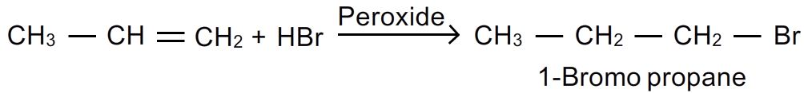
3.from alcohols: generally alkyl halides are prepared from alcohols by replacement of –oh by an halogen atom.
The replacement of –oh group can be done with variety of reagents.

I)by the action of halogen acids: alcohols react with halogen acids in the presence of dehydrating agent such as anhydrous zinc chloride or concentrated sulphuric acid.
The reactivity of halogen acids follows the order:
HI > HBr > HCl > HF

The reactivity of alcohols follow the order:
Allyl > 3⁰ alcohol > 2⁰alcohol > 1⁰alcohol
Mechanism: nucleophile attacks the protonated alcohol molecule with the elimination of water.
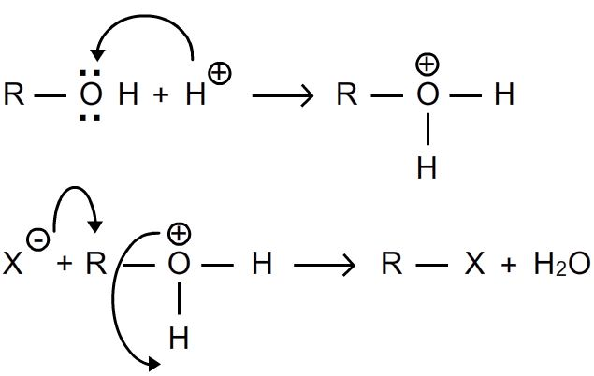
- Alkyl chlorides are obtained by passing hydrogen chloride through alcohol in presence of anhydrous zinc chloride.
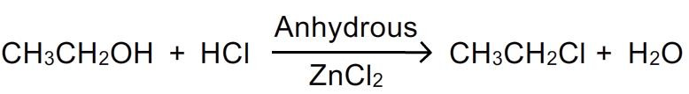
- This mixture of conc.hcl and anhydrous zncl ₂ is called lucas reagent.
- Alkyl bromides are obtained in a similar manner by refluxing alcohol with constant hbr in presence of little concentrated sulphuric acid.
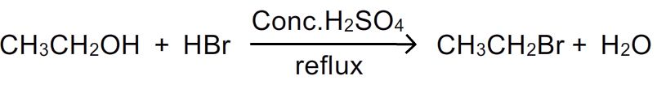
Ii) action of phosphorus halides: phosphorus halides readily convert alcohols into alkylhalides.
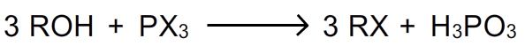
- The alkyl chlorides are formed by the action of pcl₃ or pcl₅
- In case of alkyl bromides and iodides pbr₃ or pi₃ required for the reaction is generally produced in situ by the action of red phosphorous on bromine or iodine.
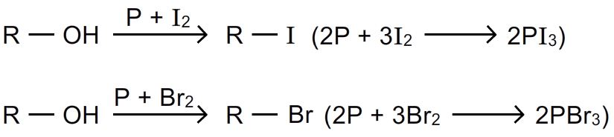

Iii) action of thionyl chloride: (darzen’s method): alkyl chlorides are prepared when thionyl chloride and alcohols are refluxed in presence of pyridine.
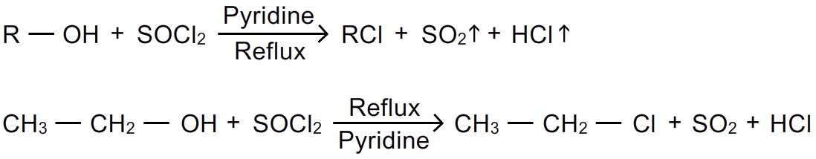
- This method has advantage over other methods because the byproducts sulphurdioxide and hydrogen chloride are gases which can be removed from the reaction mixture.
- Bromides and iodides are not prepared by` this method because thionyl chloride is unstable.

4.from silver salts of fatty acids: alkyl chlorides or alkyl bromides are prepared by the action of chlorine or bromine in ccl₄ on siver salt of the fatty acids. This reaction is called hunsdiecker reaction.
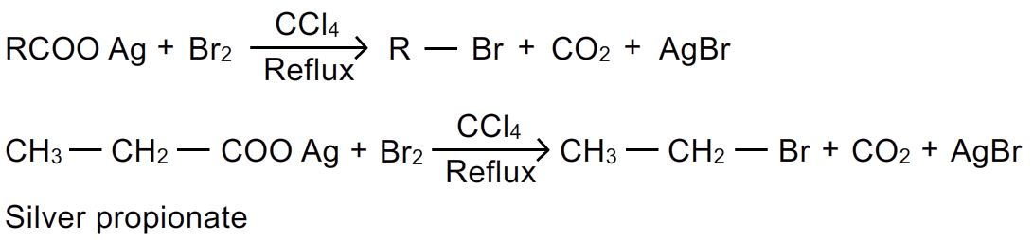
The reaction gives the product with one carbon less than the fatty acid .
5. By halide exchange method: this is a convenient method for the preparation of alkyl iodides. The corresponding alkyl bromides or chlorides are heated with a solution of sodium iodide in acetone or methanol.
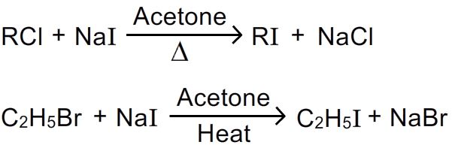
Alkyl fluorides which cannot be prepared by above methods can be obtained by the action of mercurous fluoride or antimony trifluoride.
