UNIT-III
ALKYL HALIDES:

Topic : introduction, nomenclature, classification, isomerism

Alkyl halides
Compounds derived from alkanes by the replacement of one or more hydrogen atoms by the corresponding number of halogen atoms are termed as halo-alkanes (iupac name)or alkyl halides.(common name)
They have the general formula rx, where r = alkyl group, x = f, cl, br, i.
Classification:
A. Depending on the number of halogen atoms present in the halogen derivative
1. Mono halogen derivatives: one halogen atom is attached to the carbon atom. These are termed as alkyl halides and the homologous series has general formula c_{n}h_{2n+1}x.
They are further classified based on the carbon atom to which halogen atom is attached.
- Primary alkyl halides:
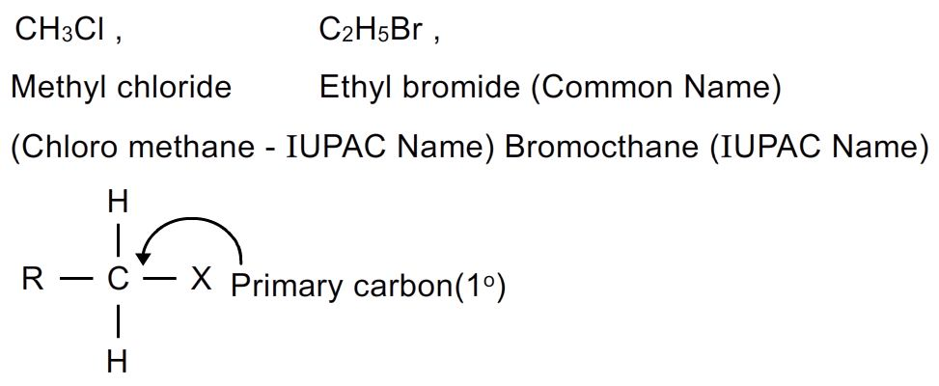
- Secondary alkyl halides:
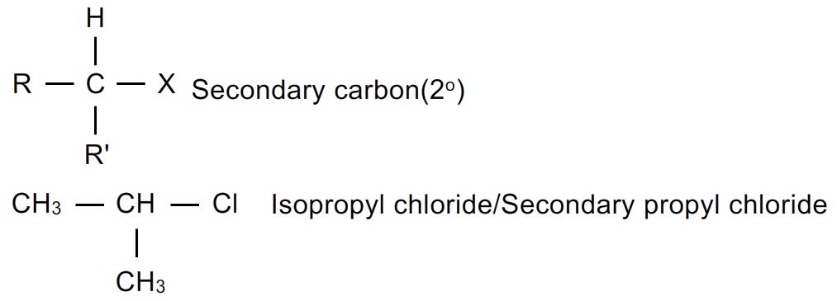

- Tertiary alkyl halides:
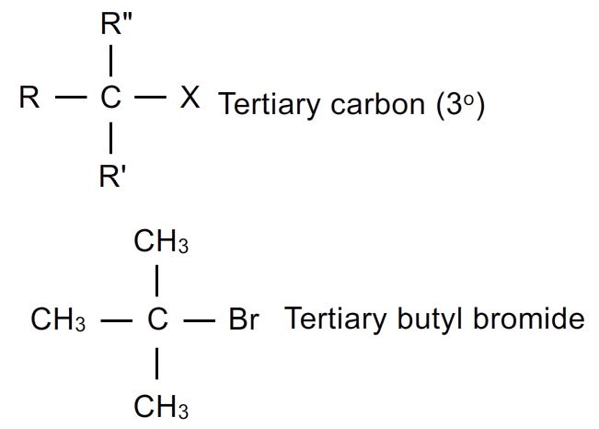
2.di halogen derivatives: they are derived by the replacement of two hydrogen atoms by two halogen atoms.
They are mainly three types:
1)gem-dihalides: in these derivatives both the halogen atoms are attached to same carbon atom. They are also called alkylidene halides ( geminal halides)
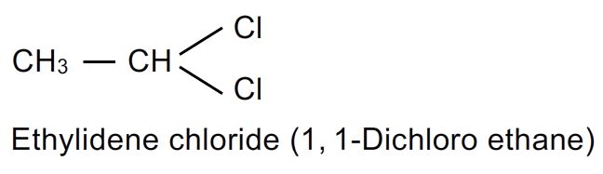
- Vic-dihalides: in these derivatives, the halogen atoms are attached to adjacent (vicinal) carbon atoms. They are also called alkylene halides (vicinal halides)
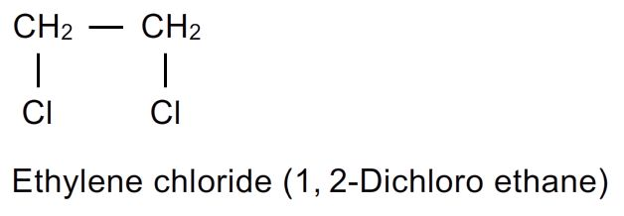
- Α-ω halides: : in these derivatives, the halogen atoms are attached to terminal carbon atoms. They are also called polymethylene halides.(terminal halides)
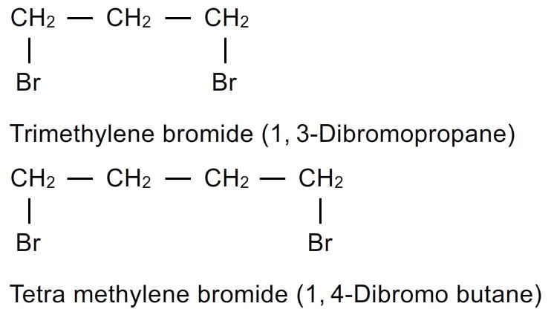
3.tri halogen derivatives: they are derived by the replacement of three hydrogens by three halogen atoms. The tri halogen derivatives of first alkane are termed as haloforms.

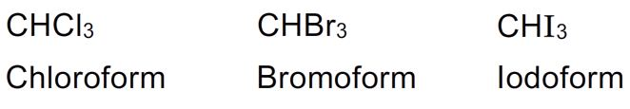

4.tetra halogen derivatives: they are derived by the replacement of four hydrogens by four halogen atoms.
- When four halogens attached to the same carbon in derivatives of methane.
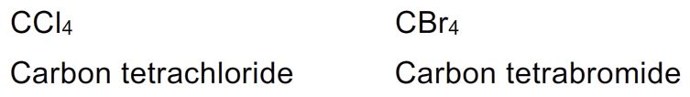
- When four halogens attached to different carbon atoms
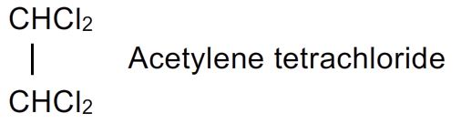

B. Based on the nature of c-x bond:

1.compounds containing c-x bond where carbon is sp ³ hybridized

I) alkyl halides or halo alkanes: derived from alkanes by the replacement of one or more hydrogen atoms by the corresponding number of halogen atoms.
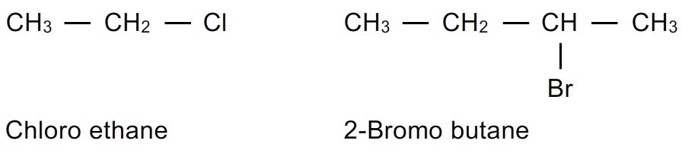

Ii)allylic halides: in these the halogen atom is attached to allylic carbon atom.( c=c-c-x) i.e. the carbon atom next to c=c.

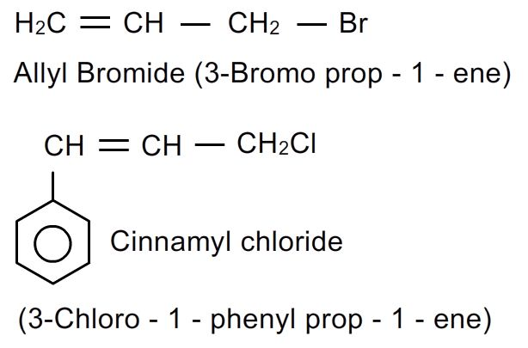

Iii)benzylic halides: : in these the halogen atom is attached to benzylic carbon atom. (c₆h₅ch₂- ) based on the number of halogen substituted they are named as:
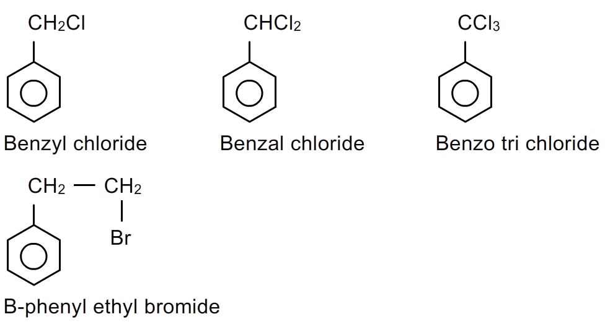

2.compounds containing c-x bond where carbon is sp² hybridized:

I) aryl halides: in these the halogen atom is attached to the carbon atom of aromatic ring.
These halides are also called haloarenes.
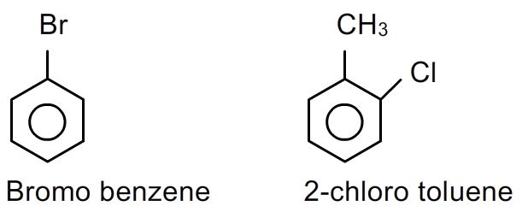

Ii)vinylic halides: in these the halogen atom is attached to vinylic carbon atom. (i.e to one of the c=c carbon atom)

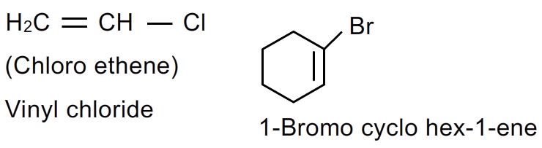

3.compounds containing c-x bond where carbon is sp hybridized:

In these the halogen atom is attached to one of the triple bonded carbon atom.
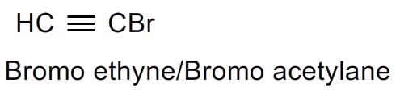
Isomerism in mono halogen derivatives:
1.chain isomerism: this is due to different arrangements of carbon atoms in the alkyl groups.
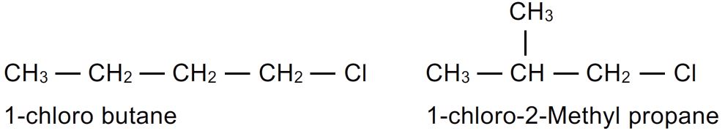
2.position isomerism: this is due to different positions of the halogen atom in the molecule.
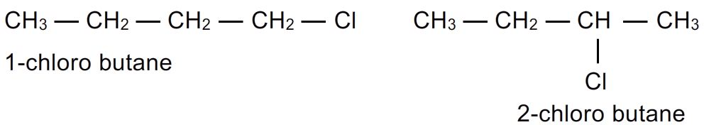
3.optical isomerism: this due to the presence of asymmetric carbon atom .
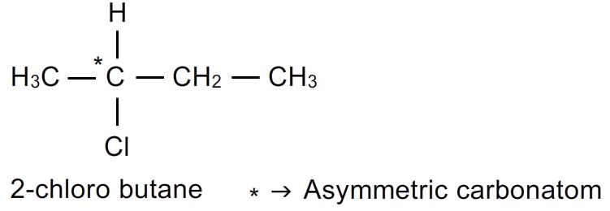
4.conformations: alkyl halides can also form conformers due to free rotation of c-c
Bond.

Methods of preparation:
1.from alkanes: direct halogenations of alkanes in presence of sunlight, heat or suitable catalyst yields alkyl halides.
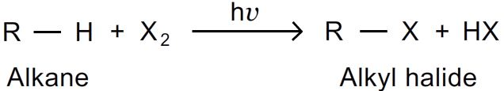
- Direct halogenations proceeds through free radical mechanism. In this mixture of poly halogen derivatives are obtained.
- This method is thus not used in laboratory because it is not easy to separate the individual members from the mixture.
- However it is the most important commercial method for obtaining alkyl halides. The ratio of halogen and alkane if well maintained we can suppress beyond mono substitution.
- Chlorination is fast; bromination is slow while iodination is carried out in presence of oxidizing agents like iodic acid.
- The reactivity of alkanes follows order

Tertiary alkane > secondary alkane > primary alkane

2.from alkenes: halogen acids react with alkenes to form alkyl halides. The order of reactivity of halogen acids is :
HI > HBr > HCl > HF

