TRANSCRIPTION

PREPARED BY:
T. PRIYANKA
Assistant Professor
Department of Pharmaceutical Analysis
Raghu College Of Pharmacy

TRANSCRIPTION:
- Transcription is a process in which ribonucleic acid (RNA) is synthesized from DNA.
- The word gene refers to the functional unit of the DNA that can be transcribed.
- Thus, the genetic information stored in DNA is expressed through RNA.
- For this purpose, one of the two strands of DNA serves as a template (non-coding strand or antisense strand) and produces working copies of RNA molecules.
- The other DNA strand which does not participate in transcription is referred to as coding strand or sense strand or non-template strand.
- (Coding strand commonly used since with the exception of T for U, primary mRNA contains codons with the same base sequence).
Transcription is selective
- The entire molecule of DNA is not expressed in transcription.
- RNAs are synthesized only for some selected regions of DNA.
- For certain other regions of DNA, there may not be any transcription at all.
- The exact reason for the selective transcription is not known. This may be due to some inbuilt signals in the DNA molecule.
- The product formed in transcription is referred to as primary transcript. Most often, the primary RNA transcripts are inactive.
- They undergo certain alterations (splicing, terminal additions, base modifications etc.) commonly known as post-transcriptional modifications, to produce functionally active RNA molecules.
TRANSCRIPTION IN PROKARYOTES:
A single enzyme—DNA dependent RNA polymerase or simply RNA polymerase— synthesizes all the RNAs in prokaryotes.
RNA polymerase of E. coli is a complex holoenzyme (mol wt. 465 kDa) with five polypeptide subunits—2$α$, 1$β$and 1$β$’ and one sigma(s) factor.
The enzyme without sigma factor is referred to as core enzyme ($2α,β,β$’).
Transcription involves three different stages—initiation, elongation and termination

Initiation:
- The binding of the enzyme RNA polymerase to DNA is the prerequisite for the transcription to start.
- The specific region on the DNA where the enzyme binds is known as promoter region.
- There are two base sequences on the coding DNA strand which the sigma factor of RNA polymerase can recognize for initiation of transcription.
1. Pribnow box (TATA box): This consists of 6 nucleotide bases (TATAAT), located on the left side about 10 bases away (upstream) from the starting point of transcription.
2. The ‘–35’ sequence: This is the second recognition site in the promoter region of DNA. It contains a base sequence TTGACA, which is located about 35 bases (upstream, hence –35) away on the left side from the site of transcription start.
Elongation:
- As the holoenzyme, RNA polymerase recognizes the promoter region, the sigma factor is released and transcription proceeds.
- RNA is synthesized from 5’ end to 3’ end (5’→3’) antiparallel to the DNA template.
- RNA polymerase utilizes ribonucleotide triphosphates (ATP, GTP, CTP and UTP) for the formation of RNA.
- For the addition of each nucleotide to the growing chain, a pyrophosphate moiety is released.
- The sequence of nucleotide bases in the mRNA is complementary to the template DNA strand.
- It is however, identical to that of coding strand except that RNA contains U in place of T in DNA.
- RNA polymerase differs from DNA polymerase in two aspects.
- No primer is required for RNA polymerase and, further, this enzyme does not possess endo- or exonuclease activity.
- Due to lack of the latter function (proof-reading activity), RNA polymerase has no ability to repair the mistakes in the RNA synthesized.
- This is in contrast to DNA replication which is carried out with high fidelity.
- It is, however, fortunate that mistakes in RNA synthesis are less dangerous, since they are not transmitted to the daughter cells.
- The double helical structure of DNA unwinds as the transcription goes on, resulting in supercoils.
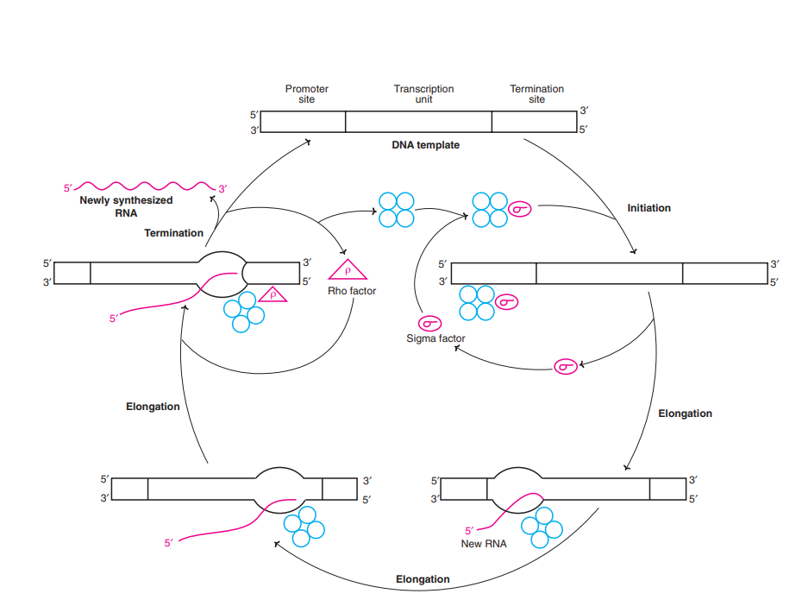
Termination:
The process of transcription stops by termination signals.
Two types of termination are identified.
1. Rho (U) dependent termination:
A specific protein, named U factor, binds to the growing RNA (and not to RNA polymerase) or weakly to DNA, and in the bound state it acts as ATPase and terminates transcription and releases RNA.
The U factor is also responsible for the dissociation of RNA polymerase from DNA.
2. Rho (U) independent termination:
The termination in this case is brought about by the formation of hairpins of newly synthesized RNA. This occurs due to the presence of palindromes.
A palindrome is a word that reads alike forward and backward e.g. madam, rotor.
The presence of palindromes in the base sequence of DNA template (same when read in opposite direction) in the termination region is known.
As a result of this, the newly synthesized RNA folds to form hairpins (due to complementary base pairing) that cause termination of transcription.

