TRANSLATION OR PROTEINS

PREPARED BY:

T. PRIYANKA
Assistant Professor
Department of Pharmaceutical Analysis
Raghu College Of Pharmacy

TRANSLATION OR PROTEIN SYNTHESIS AND INHIBITORS:
- The genetic information stored in DNA is passed on to RNA (through transcription), and ultimately expressed in the language of proteins.
- The biosynthesis of a protein or a polypeptide in a living cell is referred to as translation.
- The term translation is used to represent the biochemical translation of four-letter language information from nucleic acids (DNA and then RNA) to 20 letter language of proteins.
- The sequence of amino acids in the protein synthesized is determined by the nucleotide base sequence of mRNA.
Variability of cells in translation:
- There are wide variations in the cells with respect to the quality and quantity of proteins synthesized.
- This largely depends on the need and ability of the cells.
- Erythrocytes (red blood cells) lack the machinery for translation, and therefore cannot synthesize proteins.
- In general, the growing and dividing cells produce larger quantities of proteins. Some of the cells continuously synthesize proteins for export.
- For instance, liver cells produce albumin and blood clotting factors for export into the blood for circulation.
- The normal liver cells are very rich in the protein biosynthetic machinery, and thus the liver may be regarded as the protein factory in the human body.
PROTEIN SYNTHESIS:
The protein synthesis which involves the translation of nucleotide base sequence of mRNA into the language of amino acid sequence may be divided into the following stages for the convenience of understanding.
I. Requirement of the components
II. Activation of amino acids
III. Protein synthesis proper
IV. Chaperones and protein folding
V. Post-translational modifications.
I. REQUIREMENT OF THE COMPONENTS
The protein synthesis may be considered as a biochemical factory operating on the ribosomes.
As a factory is dependent on the supply of raw materials to give a final product, the protein synthesis also requires many components.
1. Amino acids:
- Proteins are polymers of amino acids. Of the 20 amino acids found in protein structure, half of them (10) can be synthesized by man.
- About 10 essential amino acids have to be provided through the diet.
- Protein synthesis can occur only when all the amino acids needed for a particular protein are available.
- If there is a deficiency in the dietary supply of any one of the essential amino acids, the translation stops.
- It is, therefore, necessary that a regular dietary supply of essential amino acids, in sufficient quantities, is maintained, as it is a prerequisite for protein synthesis.
- As regards prokaryotes, there is no requirement of amino acids, since all the 20 are synthesized from the inorganic components.
2. Ribosomes:
- The functionally active ribosomes are the centres or factories for protein synthesis.
- Ribosomes may also be considered as workbenches of translation.
- Ribosomes are huge complex structures (70S for prokaryotes and 80S for eukaryotes) of proteins and ribosomal RNAs.
- Each ribosome consists of two subunits—one big and one small.
- The functional ribosome has two sites—A site and P site. Each site covers both the subunits.
- A site is for binding of aminoacyl tRNA and P site is for binding peptidyl tRNA, during the course of translation.
- Some authors consider A site as acceptor site, and P site as donor site.
- In case of eukaryotes, there is another site called exit site or E site.
- Thus, eukaryotes contain three sites (A, P and E) on the ribosomes.
- The ribosomes are located in the cytosomal fraction of the cell.
- They are found in association with rough endoplasmic reticulum (RER) to form clusters RER—ribosomes, where the protein synthesis occurs.
- The term polyribosome (polysome) is used when several ribosomes simultaneously translate on a single mRNA.
3. Messenger RNA (mRNA):
- The specific information required for the synthesis of a given protein is present on the mRNA.
- The DNA has passed on the genetic information in the form of codons to mRNA to translate into a protein sequence.
4. Transfer RNAs (tRNAs):
- They carry the amino acids, and hand them over to the growing peptide chain.
- The amino acid is covalently bound to tRNA at the 3’-end.
- Each tRNA has a three nucleotide base sequence—the anticodon, which is responsible to recognize the codon (complementary bases) of mRNA for protein synthesis.
- In man, there are about 50 different tRNAs whereas in bacteria around 40 tRNAs are found.
- Some amino acids (particularly those with multiple codons) have more than one tRNA.
5. Energy sources:
- Both ATP and GTP are required for the supply of energy in protein synthesis.
- Some of the reactions involve the breakdown of ATP or GTP, respectively, to AMP and GMP with the liberation of pyrophosphate.
- Each one of these reactions consumes two high energy phosphates (equivalent to 2 ATP).
6. Protein factors:
- The process of translation involves a number of protein factors.
- These are needed for initiation, elongation and termination of protein synthesis.
- The protein factors are more complex in eukaryotes compared to prokaryotes.
II. ACTIVATION OF AMINO ACIDS
- Amino acids are activated and attached to tRNAs in a two step reaction.
- A group of enzymes—namely aminoacyl tRNA synthetases— are required for this process.
- These enzymes are highly specific for the amino acid and the corresponding tRNA.
- The amino acid is first attached to the enzyme utilizing ATP to form enzyme-AMP-amino acid complex.
- The amino acid is then transferred to the 3’ end of the tRNA to form aminoacyl tRNA.
III. PROTEIN SYNTHESIS PROPER
- The protein or polypeptide synthesis occurs on the ribosomes (rather polyribosomes).
- The mRNA is read in the 5`→3` direction and the polypeptide synthesis proceeds from N-terminal end to C-terminal end.
- Translation is directional and collinear with mRNA.
- The prokaryotic mRNAs are polycistronic, since a single mRNA has many coding regions that code for different polypeptides.
- In contrast, eukaryotic mRNA is monocistronic, since it codes for a single polypeptide.
- In case of prokaryotes, translation commences before the transcription of the gene is completed.
- Thus, simultaneous transcription and translation are possible.
- This is not so in case of eukaryotic organisms since transcription occurs in the nucleus whereas translation takes place in the cytosol.
- Further, the primary transcript (hnRNA) formed from DNA has to undergo several modifications to generate functional mRNA.
- Protein synthesis is comparatively simple in case of prokaryotes compared to eukaryotes.
Translation proper is divided into three stages—
- initiation,
- elongation
- termination
INITIATION OF TRANSLATION
The initiation of translation in eukaryotes is complex, involving at least ten eukaryotic initiation factors (eIFs).
Some of the eIFs contain multiple (3-8) subunits.
The process of translation initiation can be divided into four steps:
1. Ribosomal dissociation.
2. Formation of 43S preinitiation complex.
3. Formation of 48S initiation complex.
4. Formation of 80S initiation complex.
Ribosomal dissociation:
- The 80S ribosome dissociates to form 40S and 60S subunits.
- Two initiating factors namely eIF3 and eIF-1A bind to the newly formed 40S subunit, and thereby block its reassociation with 60S subunit.
- For this reason, some workers name eIF-3 as anti-association factor.
Formation of 43S preinitiation complex:
- A ternary complex containing met-tRNA and eIF-2 bound to GTP attaches to 40S ribosomal subunit to form 43S preinitiation complex.
- The presence of eIF-3 and eIF-1A stabilizes this complex (Note : Met-tRNA is specifically involved in binding to the initiation condon AUGs; hence the superscription is used in met tRNAi.
Formation of 48S initiation complex:
- The binding of mRNA to 43S preinitiation complex results in the formation of 48S initiation complex through the intermediate 43S initiation complex.
- This, however, involves certain interactions between some of the eIFs and activation of mRNA.
- eIF-4F complex is formed by the association of eIF-4G, eIF-4A with eIF-4E.
- The so formed eIF-4F (referred to as cap binding protein) binds to the cap of mRNA.
- Then elF-4A and elF-4B bind to mRNA and reduce its complex structure.
- This mRNA is then transferred to 43S complex.
- For the appropriate association of 43S preinitiation complex with mRNA, energy has to be supplied by ATP.
Recognition of initiation codon:
- The ribosomal initiation complex scans the mRNA for the identification of appropriate initiation codon.
- 5c-AUG is the initiation codon and its recognition is facilitated by a specific sequence of nucleotides surrounding it.
- This marker sequence for the identification of AUG is called as Kozak consensus sequences.
- In case of prokaryotes the recognition sequence of initiation codon is referred to as Shine- Dalgarno sequence.
Formation of 80S initiation complex:
- 48S initiation complex binds to 60S ribosomal subunit to form 80S initiation complex.
- The binding involves the hydrolysis of GTP (bound to eIF-2).
- This step is facilitated by the involvement of eIF-5.
- As the 80S complex is formed, the initiation factors bound to 48S initiation complex are released, and recycled.
- The activation of eIF-2 requires eIF-2B (also called as guanine nucleotide exchange factor) and GTP.
- The activated eIF-2 (i.e. bound to GTP) requires eIF2C to form the ternary complex.
Regulation of initiation:
- The eIF-4F, a complex formed by the assembly of three initiation factors controls initiation, and thus the translation process.
- eIF4E, a component of eIF-4F is primarily responsible for the recognition of mRNA cap. And this step is the rate-limiting in translation.
- eIF-2 which is involved in the formation of 43S preinitiation complex also controls protein biosynthesis to some extent.

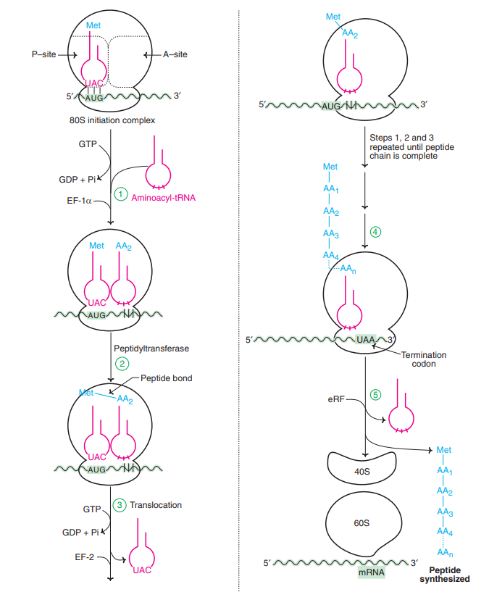
⸫PROTEIN BIOSYNTHESIS
Initiation of translation in prokaryotes:
The formation of translation initiation complex in prokaryotes is less complicated compared to eukaryotes.
The 30S ribosomal subunit is bound to initiation factor 3 (IF-3) and attached to ternary complex of IF-2, formyl met tRNA and GTP.
Another initiation factor namely IF-I also participates in the formation of preinitiation complex.
The recognition of initiation codon AUG is done through Shine-Dalgarno sequence.
A 50S ribosome unit is now bound with the 30S unit to produce 70S initiation complex in prokaryotes.
ELONGATION OF TRANSLATION
Ribosomes elongate the polypeptide chain by a sequential addition of amino acids.
The amino acid sequence is determined by the order of the codons in the specific mRNA. Elongation, a cyclic process involving certain elongation factors (EFs), may be divided into three steps
1. Binding of aminoacyl t-RNA to A-site.
2. Peptide bond formation.
3. Translocation.
Binding of aminoacyl—tRNA to A-site:
- The 80S initiation complex contains met tRNAi in the P-site, and the A-site is free.
- Another aminoacyl-tRNA is placed in the A-site.
- This requires proper codon recognition on the mRNA and the involvement of elongation factor 1a (EF-Ia) and supply of energy by GTP.
- As the aminoacyl-tRNA is placed in the A-site, EF-1D and GDP are recycled to bring another aminoacyl-tRNA.
Peptide bond formation:
- The enzyme peptidyltransferase catalyses the formation of peptide bond.
- The activity of this enzyme lies on 28S RNA of 60S ribosomal subunit.
- It is therefore the rRNA (and not protein) referred to as ribozyme that catalyses the peptide bond formation.
- As the amino acid in the aminoacyl-tRNA is already activated, no additional energy is required for peptide bond formation.
- The net result of peptide bond formation is the attachment of the growing peptide chain to the tRNA in the A-site.
Translocation:
- As the peptide bond formation occurs, the ribosome moves to the next codon of the mRNA (towards 3`-end).
- This process called translocation, basically involves the movement of growing peptide chain from A-site to P-site.
- Translocation requires EF-2 and GTP. GTP gets hydrolysed and supplies energy to move mRNA. EF-2 and GTP complex recycles for translocation.
- In recent years, another site namely exit site (E-site) has been identified in eukaryotes.
- The deacylated tRNA moves into the E-site, from where it leaves the ribosome.
- In case of prokaryotes, the elongation factors are different, and they are EF-Tu, EF-Ts (in place of EF-1a) and EF-G (instead of EF-2).
- Incorporation of amino acids It is estimated that about six amino acids per second are incorporated during the course of elongation of translation in eukaryotes.
- In case of prokaryotes, as many as 20 amino acids can be incorporated per second.
- Thus the process of protein/polypeptide synthesis in translation occurs with great speed and accuracy.
TERMINATION OF TRANSLATION:
- Termination is a simple process when compared to initiation and elongation.
- After several cycles of elongation, incorporating amino acids and the formation of the specific protein/ polypeptide molecule, one of the stop or termination signals (UAA, UAG and UCA) terminates the growing polypeptide.
- The termination codons which act as stop signals do not have specific tRNAs to bind.
- As the termination codon occupies the ribosomal A-site, the release factor namely eRF recognizes the stop signal.
- eRF-GTP complex, in association with the enzyme peptidyltransferase, cleaves the peptide bond between the polypeptide and the tRNA occupying P-site.
- In this reaction, a water molecule, instead of an amino acid is added. This hydrolysis releases the protein and tRNA from the P-site.
- The 80S ribosome dissociates to form 40S and 60S subunits which are recycled. The mRNA is also released.
INHIBITORS OF PROTEIN SYNTHESIS:
- Translation is a complex process and it has become a favourite target for inhibition by antibiotics.
- Antibiotics are the substances produced by bacteria or fungi which inhibit the growth of other organisms.
- Majority of the antibiotics interfere with the bacterial protein synthesis and are harmless to higher organisms.
- This is due to the fact that the process of translation sufficiently differs between prokaryotes and eukaryotes.
Streptomycin:
Initiation of protein synthesis is inhibited by streptomycin. It causes misreading of mRNA and interferes with the normal pairing between codons and anticodons.
Tetracycline:
It inhibits the binding of aminoacyl tRNA to the ribosomal complex. In fact, tetracycline can also block eukaryotic protein synthesis.
This, however, does not happen since eukaryotic cell membrane is not permeable to this drug.
Puromycin:
This has a structural resemblance to aminoacyl tRNA. Puromycin enters the A site and gets incorporated into the growing peptide chain and causes its release. This antibiotic prevents protein synthesis in both prokaryotes and eukaryotes.
Chloramphenicol:
It acts as a competitive inhibitor of the enzyme peptidyltransferase and thus interferes with elongation of peptide chain.
Erythromycin:
It inhibits translocation by binding with 50S subunit of bacterial ribosome.
Diphtheria toxin:
It prevents translocation in eukaryotic protein synthesis by inactivating elongation factor eEF2.
IV. CHAPERONES AND PROTEIN FOLDING:
- The three dimensional conformation of proteins is important for their biological functions.
- Some of the proteins can spontaneously generate the correct functionally active conformation e.g. denatured pancreatic ribonuclease.
- However, a vast majority of proteins can attain correct conformation, only through the assistance of certain proteins referred to as chaperones.
- Chaperones are heat shock proteins (originally discovered in response to heat shock).
- They facilitate and favour the interactions on the polypeptide surfaces to finally give the specific conformation of a protein.
- Chaperones can reversibly bind to hydrophobic regions of unfolded proteins and folding intermediates.
- They can stabilize intermediates, prevent formation of incorrect intermediates, and also prevent undesirable interactions with other proteins.
- All these activities of chaperones help the protein to attain compact and biologically active conformation.
Types of chaperones Chaperones are categorized into two major groups
1. Hsp70 system:
This mainly consists of Hsp70 (70-kDa heat shock protein) and Hsp40 (40-kDa Hsp). These proteins can bind individually to the substrate (protein) and help in the correct formation of protein folding.
2. Chaperonin system:
This is a large oligomeric assembly which forms a structure into which the folded proteins are inserted.
The chaperonin system mainly has Hsp60 and Hsp10 i.e. 60 kDa Hsp and 10 kDa Hsp.
Chaperonins are required at a later part of the protein folding process, and often work in association with Hsp70 system.
Protein misfolding and diseases:
- The failure of a protein to fold properly generally leads to its rapid degradation.
- Cystic fibrosis (CF) is a common autosomal recessive disease.
- Some cases of CF with mutations that result in altered protein (cystic fibrosis transmembrane conductance regulator or in short CFTR) have been reported.
- Mutated CFTR cannot fold properly, besides not being able to get glycosylated or transported.
- Therefore, CFTR gets degraded. Certain neurological diseases which are due to cellular accumulation of aggregates of misfolded proteins or their partially degraded products have been identified.
- The term prions (proteinous infectious agents) is used to collectively represent them.
- Prions exhibit the characteristics of viral or microbial pathogens and have been implicated in many diseases. e.g. mad cow disease, Creutzfeldt-Jacob disease, Alzheimer’s disease, Huntington’s disease.
V. POST-TRANSLATIONAL MODIFICATIONS OF PROTEINS:
- The proteins synthesized in translation are, as such, not functional.
- Many changes take place in the polypeptides after the initiation of their synthesis or, most frequently, after the protein synthesis is completed.
- These modifications include protein folding (described already), trimming by proteolytic degradation and covalent changes which are collectively known as post-translational modifications

