STRUCTURE OF DNA AND RNA

PREPARED BY:
T. PRIYANKA
Assistant Professor
Department of Pharmaceutical Analysis
Raghu College Of Pharmacy

STRUCTURE OF DNA:
DNA is a polymer of deoxyribonucleotides (or simply deoxynucleotides).
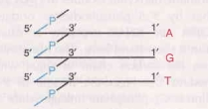
It is composed of monomeric units namely deoxyadenylate (dAMP), deoxyguanylate (dGMP), deoxycytidylate (dCMP) and deoxythymidylate (dTMP).
The monomeric deoxynucleotides in DNA are held together by 3`,5`-phosphodiester bridges.

DNA (or RNA) structure is often represented in a short-hand form. The horizontal line indicates the carbon chain of sugar with base attached to C1`.
Near the middle of the horizontal line is C3` phosphate linkage while at the other end of the line is C5` phosphate linkage.
Chargaff’s rule of DNA composition:
Erwin Chargaff in late 1940s quantitatively analysed the DNA hydrolysates from different species.
He observed that in all the species he studied, DNA had equal numbers of adenine and thymine residues (A = T) and equal numbers of guanine and cytosine residues (G = C).
This is known as Chargaff’s rule of molar equivalence between the purines and pyrimidines in DNA structure.
The significance of Chargaff’s rule was not immediately realised. The double helical structure of DNA derives its strength from Chargaff’s rule
Single-stranded DNA, and RNAs which are usually single-stranded, do not obey Chargaff’s rule.
However, double-stranded RNA which is the genetic material in certain viruses satisfies Chargaff’s rule.

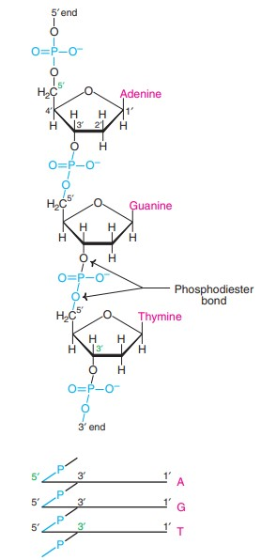
⸫Structure of polydeoxynucleotide held together by phosphodiester bonds
DNA DOUBLE HELIX
The double helical structure of DNA was proposed by James Watson and Francis Crick in 1953 (Nobel Prize, 1962).
The elucidation of DNA structure is considered as a milestone in the era of modern biology. The structure of DNA double helix is comparable to a twisted ladder.

The salient features of Watson-Crick model of DNA (now known as B-DNA) are described next
1. The DNA is a right handed double helix. It consists of two polydeoxyribonucleotide chains (strands) twisted around each other on a common axis.
2. The two strands are antiparallel, i.e., one strand runs in the 5` to 3` direction while the other in 3` to 5` direction. This is comparable to two parallel adjacent roads carrying traffic in opposite direction.
3. The width (or diameter) of a double helix is 20 A° (2 nm).
4. Each turn (pitch) of the helix is 34 A° (3.4 nm) with 10 pairs of nucleotides, each pair placed at a distance of about 3.4 A°.
5. Each strand of DNA has a hydrophilic deoxyribose phosphate backbone (3`-5` phosphodiester bonds) on the outside (periphery) of the molecule while the hydrophobic bases are stacked inside(core).
6. The two polynucleotide chains are not identical but complementary to each other due to base pairing.
7. The two strands are held together by hydrogen bonds formed by complementary base pairs.
The A-T pair has 2 hydrogen bonds while G-C pair has 3 hydrogen bonds. The G =C is stronger by about 50% than A = T.
8. The hydrogen bonds are formed between a purine and a pyrimidine only. If two purines face each other, they would not fit into the allowable space.
And two pyrimidines would be too far to form hydrogen bonds. The only base arrangement possible in DNA structure, from spatial considerations is A-T, T-A, G-C and C-G.

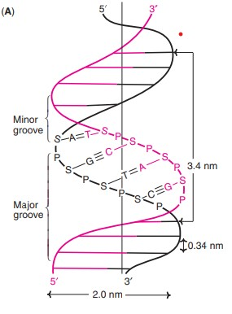
⸫Watson-Crick model of DNA helix
9. The complementary base pairing in DNA helix proves Chargaff’s rule. The content of adenine equals to that of thymine (A = T) and guanine equals to that of cytosine (G = C).
10. The genetic information resides on one of the two strands known as template strand or sense strand. The opposite strand is antisense strand.
The double helix has (wide) major grooves and (narrow) minor grooves along the phosphodiester backbone.
Proteins interact with DNA at these grooves, without disrupting the base pairs and double helix.
Conformations of DNA double helix Variation in the conformation of the nucleotides of DNA is associated with conformational variants of DNA.
The double helical structure of DNA exists in at least 6 different forms-A to E and Z. Among these, B, A and Z forms are important.
The B-form of DNA double helix, described by Watson and Crick is the most predominant form under physiological conditions.
Each turn of the B-form has 10 base pairs spanning a distance of 3.4 nm. The width of the double helix is 2 nm.
The A-form is also a right-handed helix. It contains 11 base pairs per turn. There is a tilting of the base pairs by 20° away from the central axis.
The Z-form (Z-DNA) is a left-handed helix and contains 12 base pairs per turn. The polynucleotide strands of DNA move in a somewhat ‘zig zag’ fashion, hence the name Z-DNA.
It is believed that transition between different helical forms of DNA plays a significant role in regulating gene expression.
OTHER TYPES OF DNA STRUCTURE
It is now recognized that besides double helical structure, DNA also exists in certain unusual structures.
It is believed that such structures are important for molecular recognition of DNA by proteins and enzymes.
This is in fact needed for the DNA to discharge its functions in an appropriate manner. Some selected unusual structures of DNA are :
Bent DNA
In general, adenine base containing DNA tracts are rigid and straight.
Bent conformation of DNA occurs when A-tracts are replaced by other bases or a collapse of the helix into the minor groove of A-tract.
Bending in DNA structure has also been reported due to photochemical damage or mispairing of bases.
Certain antitumor drugs (e.g. cisplatin) produce bent structure in DNA. Such changed structure can take up proteins that damage the DNA.
Triple-stranded DNA
Triple-stranded DNA formation may occur due to additional hydrogen bonds between the bases.
Thus, a thymine can selectively form two Hoogsteen hydrogen bonds to the adenine of A-T pair to form T-A-T.
Likewise, a protonated cytosine can also form two hydrogen bonds with guanine of G–C pairs that results in C–G–C.
Triple-helical structure is less stable than double helix. This is due to the fact that the three negatively charged backbone strands in triple helix results in an increased electrostatic repulsion.
Four-stranded DNA
Polynucleotides with very high contents of guanine can form a novel tetrameric structure called G-quartets.
These structures are planar and are connected by Hoogsteen hydrogen bonds.
Antiparallel four-stranded DNA structures, referred to as G-tetraplexes have also been reported.
The ends of eukaryotic chromosomes namely telomeres are rich in guanine, and therefore form G-tetraplexes.
STRUCTURE OF RNA:
RNA is a polymer of ribonucleotides held together by 3`,5`-phosphodiester bridges. Although RNA has certain similarities with DNA structure, they have specific differences
1. Pentose : The sugar in RNA is ribose in contrast to deoxyribose in DNA.
2. Pyrimidine : RNA contains the pyrimidine uracil in place of thymine (in DNA).
3. Single strand : RNA is usually a single stranded polynucleotide. However, this strand may fold at certain places to give a double stranded structure, if complementary base pairs are in close proximity.
4. Chargaff’s rule—not obeyed : Due to the single-stranded nature, there is no specific relation between purine and pyrimidine contents. Thus the guanine content is not equal to cytosine (as is the case in DNA).
5. Susceptibility to alkali hydrolysis : Alkali can hydrolyse RNA to 2`,3`-cyclic diesters. This is possible due to the presence of a hydroxyl group at 2` position. DNA cannot be subjected to alkali hydrolysis due to lack of this group.
6. Orcinol colour reaction : RNAs can be histologically identified by orcinol colour reaction due to the presence of ribose.
TYPES OF RNA:
The three major types of RNAs with their respective cellular composition are given below
1. Messenger RNA (mRNA) : 5–10%
2. Transfer RNA (tRNA) : 10–20%
3. Ribosomal RNA (rRNA) : 50–80%
Besides the three RNAs referred above, other RNAs are also present in the cells.
These include heterogeneous nuclear RNA (hnRNA), small nuclear RNA (snRNA), small nucleolar RNA (snoRNA) and small cytoplasmic RNA (scRNA).
Messenger RNA (mRNA):
- The mRNA is synthesized in the nucleus (in eukaryotes) as heterogeneous nuclear RNA (hnRNA).
- hnRNA, on processing, liberates the functional mRNA which enters the cytoplasm to participate in protein synthesis.
- mRNA has high molecular weight with a short half-life.
- In general, mRNA of eukaryotes is more stable with longer half-life, compared to prokaryotic mRNA.
- The eukaryotic mRNA is capped at the 5`-terminal end by 7-methylguanosine triphosphate.
- It is believed that this cap helps to prevent the hydrolysis of mRNA by 5`-exonucleases. Further, the cap may be also involved in the recognition of mRNA for protein synthesis.
- The 3c-terminal end of mRNA contains a polymer of adenylate residues (20-250 nucleotides) which is known as poly (A) tail.
This tail may provide stability to mRNA, besides preventing it from the attack of 3`-exonucleases.
mRNA molecules often contain certain modified bases such as 6-methyladenylates in the internal structure.
Transfer RNA (tRNA)
- Transfer RNA (soluble RNA) molecule contains 71-80 nucleotides (mostly 75) with a molecular weight of about 25,000.
- There are at least 20 species of tRNAs, corresponding to 20 amino acids present in protein structure.
- The structure of tRNA (for alanine) was first elucidated by Holley.
- The structure of tRNA resembles that of a clover leaf. tRNA contains mainly four arms, each arm with a base paired stem.
1. The acceptor arm : This arm is capped with a sequence CCA (5` to 3`). The amino acid is attached to the acceptor arm.
2. The anticodon arm : This arm, with the three specific nucleotide bases (anticodon), is responsible for the recognition of triplet codon of mRNA.
The codon and anticodon are complementary to each other.
3. The D arm : It is so named due to the presence of dihydrouridine.
4. The T Ѱ C arm : This arm contains a sequence of T, pseudouridine (represented by psi, Ѱ and C).
5. The variable arm : This arm is the most variable in tRNA.

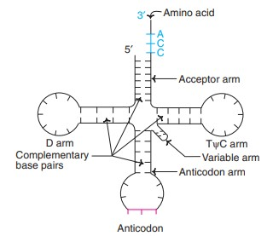
⸫Structure of tRNA

Based on this variability, tRNAs are classified into 2 categories :
(a) Class I tRNAs : The most predominant (about 75%) form with 3-5 base pairs length.
(b) Class II tRNAs : They contain 13-20 base pair long arm. Base pairs in tRNA : The structure of tRNA is maintained due to the complementary base pairing in the arms.
The four arms with their respective base pairs are given below
The acceptor arm – 7 bp
The TѰ C arm – 5 bp
The anticodon arm – 5 bp
The D arm – 4 bp
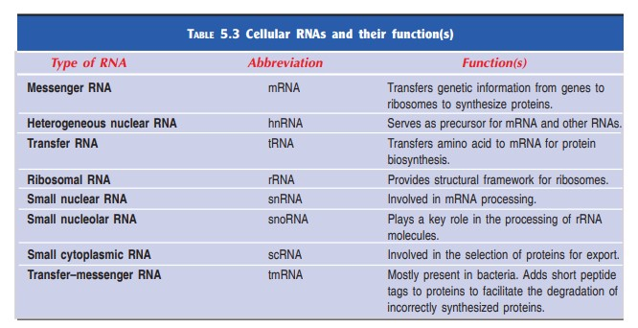
Ribosomal RNA (rRNA):
- The ribosomes are the factories of protein synthesis.
- The eukaryotic ribosomes are composed of two major nucleoprotein complexes–60S subunit and 40S subunit.
- The 60S subunit contains 28S rRNA, 5S rRNA and 5.8S rRNA while the 40S subunit contains 18S rRNA.
- The function of rRNAs in ribosomes is not clearly known.
- It is believed that they play a significant role in the binding of mRNA to ribosomes and protein synthesis.

