HEXOSE MONOPHOSPHATE SHUNT

PREPARED BY:
T. PRIYANKA
Assistant Professor
Department of Pharmaceutical Analysis
Raghu College Of Pharmacy

HEXOSE MONOPHOSPHATE SHUNT :
The hexose monophosphate (HMP) shunt, also known as the pentose phosphate pathway or phosphogluconate pathway, is a metabolic pathway that runs parallel to glycolysis. This pathway produces NADPH and intermediates required for the synthesis of nucleic acids and amino acids. Let us study the pathway in detail.

Features of the HMP Shunt
- It is an anabolic pathway that takes place in the cytosol for most organisms. However, in plants, it takes place in plastids.
- The pathway takes place in two distinct phases: oxidative and non-oxidative phases.
- The reactions of this pathway are enzyme catalysed.
- The products obtained from the pathway include NADPH, which is used in biosynthesis in cells, ribose-5-phosphate, which is used in the synthesis of nucleic acid and nucleotides, and erythrose-4-phosphate, which is used for the synthesis of aromatic amino acids.
- In humans, this pathway is most active in mammary glands, adrenal cortex, adipose tissue, erythrocytes, testes and liver.
- The HMP shunt is a tightly controlled metabolic pathway that is connected with other pathways, such as glycolysis and gluconeogenesis, depending upon the metabolic needs of the body.

Phases of the HMP Shunt

Oxidative Phase
In this phase, NADPH is produced by the reduction of two molecules of NADP⁺. The energy for this production is utilised by the conversion of glucose-6-phosphate to ribulose-5-phosphate. The three steps of the oxidative phase of the HMP shunt are:
- Glucose-6-phosphate is dehydrogenated to 6-phosphogluconolactone in the presence of glucose 6-phosphate dehydrogenase. In this reaction, one molecule of NADP⁺ is converted into NADPH.
- 6-phosphogluconolactone is hydrolysed into 6-phosphogluconate in the presence of 6-phosphogluconolactonase.
- 6-phosphogluconate is converted into ribulose 5-phosphate in the presence of 6-phosphogluconate dehydrogenase by oxidative decarboxylation.

Non-Oxidative Phase
The non-oxidative phase can be summarised in five steps:
- Ribulose-5-phosphate isomerises into ribose-5-phosphate in the presence of ribose-5-phosphate isomerase.
- Another enzyme, phosphopentose epimerase, isomerises ribulose-5-phosphate into xylulose 5-phosphate at the same time.
- Transketolase enzyme transfers a carbon group from ketose (xylulose-5-phosphate) to the aldose (ribose-5-phosphate), and the products obtained are glyceraldehyde 3-phosphate and sedoheptulose 7-phosphate.
- Transaldolase again transfers a carbon group from sedoheptulose 7-phosphate (ketose) to glyceraldehyde 3-phosphate (aldose), and the products obtained are erythrose 4-phosphate and fructose 6-phosphate.
- A carbon from xylulose 5-phosphate is transferred to erythrose 4-phosphate in the presence of transketolase to obtain glyceraldehyde 3-phosphate and fructose 6-phosphate.

Significance of HMP Shunt
HMP shunt is unique in generating two important products—pentoses and NADPH— needed for the biosynthetic reactions and other functions.

IMPORTANCE OF PENTOSES:
- In the HMP shunt, hexoses are converted into pentoses, the most important being ribose 5-phosphate. This pentose or its derivatives are useful for the synthesis of nucleic acids (RNA and DNA) and many nucleotides such as ATP, NAD+, FAD and CoA.
- Skeletal muscle is capable of synthesizing pentoses, although only the first few enzymes of HMP shunt are active. It, therefore, appears that the complete pathway of HMP shunt may not be required for the synthesis of pentoses.

IMPORTANCE OF NADPH:
- NADPH is required for the reductive biosynthesis of fatty acids and steroids, hence HMP shunt is more active in the tissues concerned with lipogenesis, e.g. adipose tissue, liver etc.
- NADPH is used in the synthesis of certain amino acids involving the enzyme glutamate dehydrogenase.
There is a continuous production of H2O2 in the living cells which can chemically damage unsaturated lipids, proteins and DNA. This is, however, prevented to a large extent through antioxidant (free radical scavenging) reactions involving NADPH. Gluta-thione mediated reduction of H2O2 is given in the next column.
Glutathione (reduced, GSH) detoxifies H2O2, peroxidase catalyses this reaction. NADPH is responsible for the regeneration of reduced glutathione from the oxidized one.
- Microsomal cytochrome P450 system (in liver) brings about the detoxification of drugs and foreign compounds by hydroxylation reactions involving NADPH.
- Phagocytosis is the engulfment of foreign particles, including microorganisms, carried out by white blood cells. The process requires the supply of NADPH.
- Special functions of NADPH in RBC : NADPH produced in erythrocytes has special functions to perform. It maintains the concentration of reduced glutathione (reaction explained in 3) which is essentially required to preserve the integrity of RBC membrane. NADPH is also necessary to keep the ferrous iron (Fe2+) of hemoglobin in the reduced state so that accumulation of methemoglobin (Fe3+) is prevented.
- High concentration of NADPH in lens of eyes is necessary to preserve the transparency of the lenses.

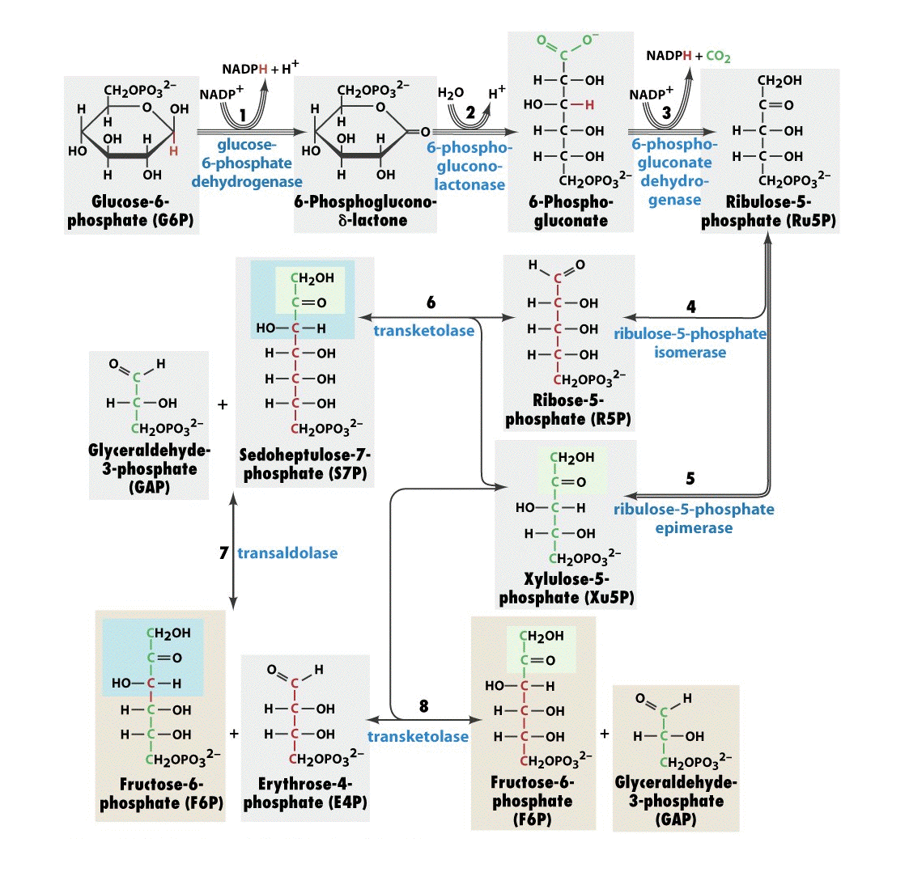

GLUCOSE 6-PHOSPHATE DEHYDROGENASE DEFICIENCY:
- G6PD deficiency is an inherited sex-linked trait. Although the deficiency occurs in all the cells of the affected individuals, it is more severe in RBC.
- HMP shunt is the only means of providing NADPH in the erythrocytes. Decreased activity of G6PD impairs the synthesis of NADPH in RBC. This results in the accumulation of methemoglobin and peroxides in erythrocytes leading to hemolysis.

Clinical manifestations in G6PD deficiency:
- Most of the patients with G6PD deficiency do not usually exhibit clinical symptoms.
- Some of them, however, develop hemolytic anemia if they are administered oxidant drugs or exposed to a severe infection.
- The drugs such as primaquine (antimalarial), acetanilide (antipyretic), sulfamethoxazole (antibiotic) or ingestion of fava beans (favism) produce hemolytic jaundice in these patients.
- Severe infection results in the generation of free radicals (in macrophages) which can enter RBC and cause hemolysis (due to decreased NADPH and reduced GSH).
G6PD deficiency and resistance to malaria :
- It is interesting to note that G6PD deficiency is associated with resistance to malaria (caused by Plasmodium falciparum).
- This is explained from the fact that the parasites that cause malaria are dependent on HMP shunt and reduced glutathione for their optimum growth in RBC.
- Therefore, G6PD deficiency—which is seen frequently in Africans—protects them from malaria, a common disease in this region.
- It is regarded as an adaptability of the people living in malaria-infected regions of the world.
- Biochemical diagnosis can be done by detecting reduced activity of G6PD in RBC.
- The management of G6PD deficiency includes avoiding oxidative stress and symptomatic treatment of hemolysis.

Wernicke-Korsakoff syndrome
- This is a genetic disorder associated with HMP shunt.
- An alteration in transketolase activity that reduces its affinity (by tenfold or so) with thiamine pyrophosphate is the biochemical lesion.
- The symptoms of Wernicke-Korsakoff syndrome include mental disorder, loss of memory and partial paralysis.
- The symptoms are manifested in vitamin-deficient alcoholics

