GLYCOLYSIS

PREPARED BY:
T. PRIYANKA
Assistant Professor
Department of Pharmaceutical Analysis
Raghu College Of Pharmacy

GLYCOLYSIS

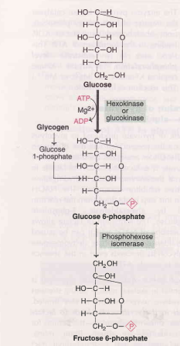
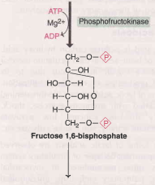
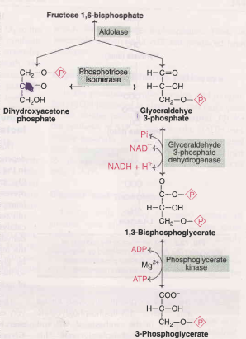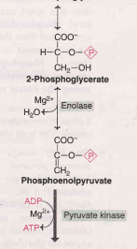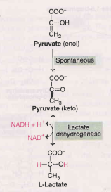
The pathway can be divided into three distinct phases:
  - Energy investment phase or priming stage
  - Splitting phase
  - Energy generation phase
I. Glucose is phosphorylated to glucose 6-phosphate by hexokinase or glucokinase (both are isoenzymes). This is an irreversible reaction, dependent on ATP and Mg²⁺.
- The enzyme hexokinase is present in almost all the tissues. It catalyses the phosphorylation of various hexoses (fructose, mannose etc.), has low K_{m} for substrates and is inhibited by glucose6-phosphate.
- Glucose-6-phosphate is impermeable to the cell membrane. It is a central molecule with a variety of metabolic fates- glycolysis, glycogenesis, gluconeogenesis and pentose phosphate pathway
- II. Glucose6-phosphate undergoes isomerization to give fructose-6-phosphate in the presence of the enzyme phospho-hexose isomerase and Mg²⁺ .
- III. Fructose6-phosphate is phosphorylated to fructose1,6- bisphosphate by phospho fructokinase (PFK). This is an irreversible and a regulatory step in glycolysis.
VI. Glyceraldehyde-3-phosphate dehydrogenase converts glyceraldehyde 3-phosphate to 1,3-bisphosphoglycerate.
- This step is important as it is involved in the formation of NADH + H⁺ and a high energy compound 1,3-bisphosphoglycerate.
- In aerobic condition, NADH passes through the electron transport chain and 6 ATP (2 x 3 ATP) are synthesized by oxidative phosphorylation.
VII. The enzyme phosphoglycerate kinase acts on 1,3-bisphosphoglycerate resulting in the synthesis of ATP and formation of 3- phosphoglycerate.
- This step is a good example of substrate level phosphorylation, since ATP is synthesized from the substrate without the involvement of electron transport chain.
- VIII. 3-Phosphoglycerate is converted to 2-phosphoglycerate by phosphoglycerate mutase. This is an isomerization reaction.
- IX. The high energy compound phosphoenol pyruvate is generated from 2-phosphoglycerate by the enzyme
enolase. This enzyme requires Mg²⁺ or Mn²⁺ .
- X. The enzyme pyruvatekinase catalyses the transfer of high energy phosphate from phosphoenol pyruvate to ADP leading to the formation of ATP. This step also is a substrate level phosphorylation.

Generation of ATP in glycolysis
