Class-5
Topic- REARRANGEMENTS OF CARBOCATION

REARRANGEMENTS OF CARBOCATION-
Carbocation rearrangement can be defined as the movement of carbocation from an unstable state to a more stable state by making use of different structural shift within the molecules.
CARBOCATION-
Carbocation also known as carbonium ion. Chemical species carrying a +ve charge on C-atom are called carbocation. Have electron deficient & possess six electrons on it.
C+

Order of stability of carbocation-

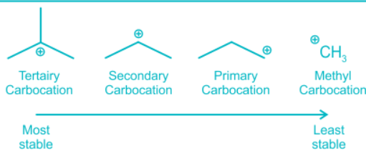
- HYDRIDE SHIFTING (H SHIFT)
+ +
CH₃-CH₂-CH₂ CH₃-CH-CH₃

- METHYL SHIFTING (CH3 SHIFT)
CH₃
+
CH₃ C CH₂+ CH₃ C CH₃

CH₃ CH₃

- PHENYL SHIFTING (C₆H₅)

C₆H₅
+
C₆H₅ C C₆H₅+ C₆H₅ C C₆H₅

C₆H₅ C₆H₅

