Class-3
Topic- Nucleophilic Substitution Reactions

Nucleophilic Substitution Reactions (SN1 and SN2)

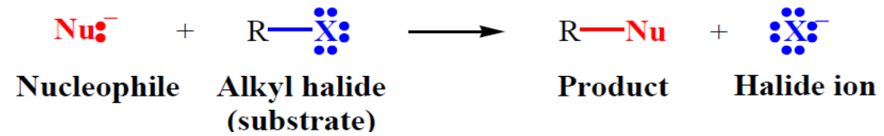

A nucleophile, a species with an unshared electron pair (lone-pair electrons), reacts with an alkyl halide (substrate) by replacing the halogen substituent (leaving group).
In nucleophilic substitution reactions, the C–X bond of the substrate undergoes heterolysis, and the lone-pair electrons of the nucleophile is used to form a new bond to the carbon atom.
A nucleophile is any negative ion or any neutral molecule that has at least one unshared electron pair-General Reaction for Nucleophilic Substitution of an Alkyl Halide by Hydroxide Ion.
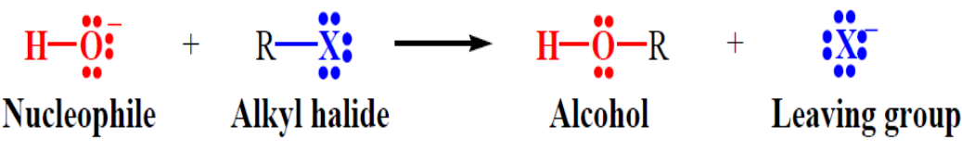
To be a good leaving group the substituent must be able to leave as a relatively stable, weakly basic molecule or ion.
In alkyl halides the leaving group is the halogen substituent –– it leaves as a halide ion.
Because halide ions are relatively stable and very weak bases, they are good leaving groups.
THE SN1 REACTION MECHANISM AND KINETICS
The reaction between tert-butyl and hydroxide ion to yield tert-butyl alcohol follows first order kinetics; i.e., the rate depends upon the concentration of only one reactant, tertbutyl bromide.
SN1 reaction follows first order kinetics
C(CH₃)₃Br + OH⁻ C(CH₃)₃OH + Br –
^{Tert-butyl bromide}
^{Rate=} K[C(CH₃)₃Br]
Mechanism-
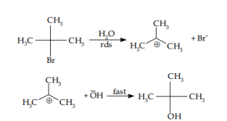
STEREOCHEMISTRY
When (–)-2-bromo octane is converted into alcohol under conditions where first-order kinetics are followed, partial racemization is observed. The optically active bromide ionizes to form bromide ion and the flat carbocation. The nucleophilic reagent then attaches itself to carbonium ion from either face of the flat ion. If the attack were purely random, we would expect equal amounts of two isomers; i.e. we would expect only the racemic modification. But the product is not completely racemized, for the inverted product exceeds its enantiomer.

We can say in contrast SN2 reaction, which proceeds with complete inversion; an SN1 reaction proceeds with racemization though may not be complete.

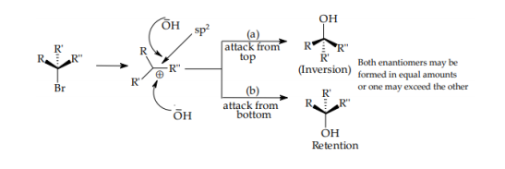

Reactivity of an alkyl halide depends upon the stable carbonium ion it can form. In SN1 reactions the order of reactivity of alkyl halides is 3° > 2° > 1° > CH3X.
Some of the important nucleophilic substitution reactions of alkyl halides are described below:
1.Reaction with aqueous KOH:
Alkyl halides react with aqueous potassium hydroxide to form alcohols. The halogen atom is substituted by -OH group.
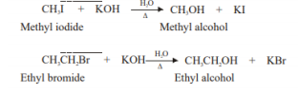
MECHANISM:
In the above reaction OH¯ is the nucleophile
