UNIT-II
CONJUGATED DIENES

Allylic substitution and oxidation reactions and introduction to dienes
Ii. Substitution reactions: the alkyl group of alkenes undergoes substitution at high temperature. Chlorine or bromine replaces hydrogen of alpha carbon atom with respect to double bond without breaking double bond. This is called allylic substitution.
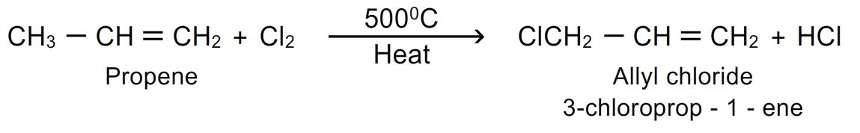
- The reaction proceeds by free radical mechanism. If the alkyl group contains more than one carbon atom, then the substitution occurs at α carbon.(allyl carbon atom)
- Mechanism of the reaction:
Step-1: chain initiation step:
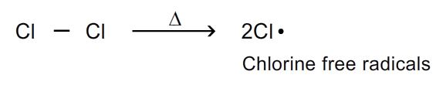
Step-2: chain propagation step:
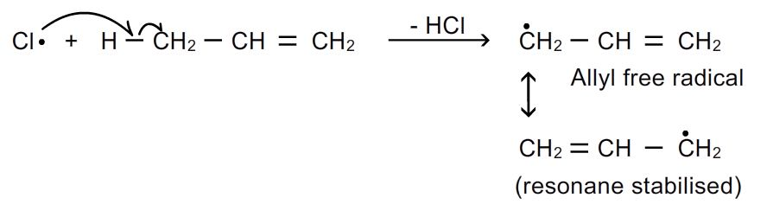
Step-3: chain termination step:
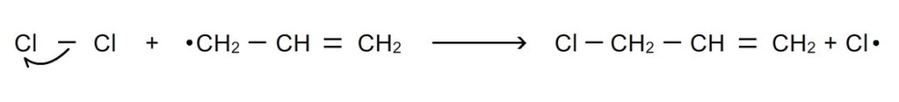
- Nbs (n-bromo succinimide) is a reagent used for specific purpose of brominating alkenes at allylic position.
Iii. Oxidation reactions: alkenes are readily oxidized. The oxidation products depend on the nature of oxidizing agent used.
- With cold dilute alkaline potassium permanganate: (hydroxylation): alkaline potassium permanganate is known as baeyer’s reagent. When alkenes are treated with alkaline potassium permanganate at low temperature, di hydroxy compounds are formed (glycols). The pink colour of kmno₄ disappears during the reaction.
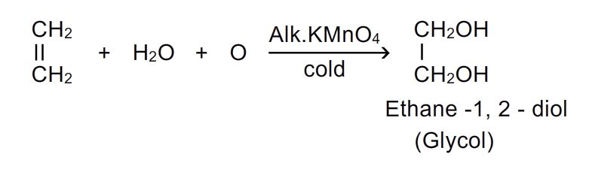
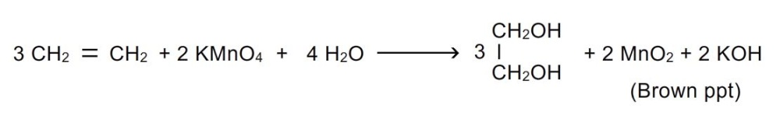

Thus, this reaction can be used as test of unsaturation.

- With acidic potassium permanganate or potassium dichromate: when alkenes are treated with acidic potassium permanganate, glycols are first formed which are oxidized to aldehydes , ketones or acids.
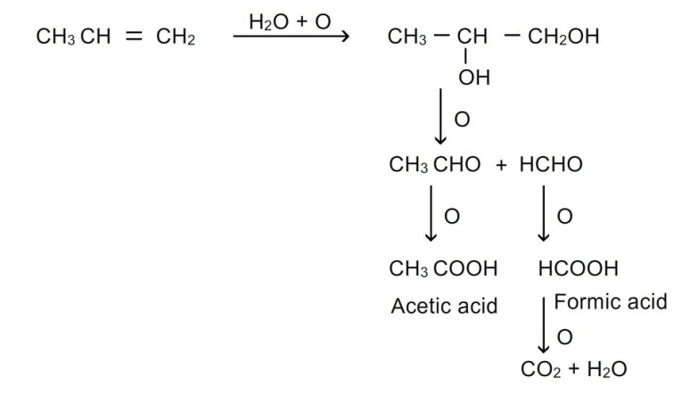
- Same products are also obtained when oxidation is done with periodic acid or lead tetra acetate or sodium periodate.
- Hydroxylation using peroxy acids: a mixture of h₂o₂ and formic acid on allowing to stand with alkenes yields glycol and the addition of two –oh groups occur in anti position.
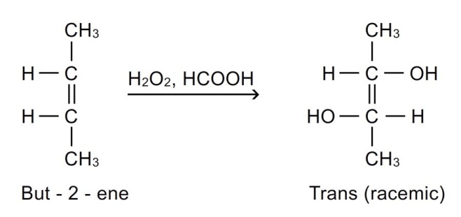
- Combustion reactions: when alkenes are burnt in air, they are oxidized to carbon dioxide and water.the reaction is exothermic and heat is evolved.
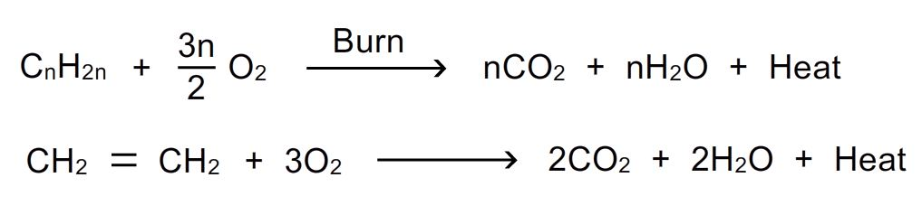
Dienes:
Hydrocarbons containing two carbon-carbon double bonds are called dienes. The general formula of dienes is c_{n}h_{2n-2}. Dienes are isomeric with alkynes.
They are of 3 types.
- Conjugated dienes: double bonds are separated by one single bond. These are important class of dienes. Their chemical properties differ from other alkenes.
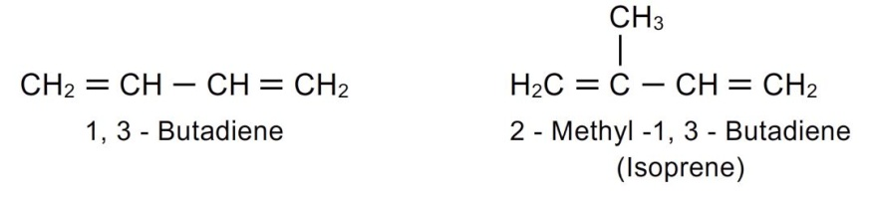
- Cumulative dienes: double bonds are adjacent to each other (double bonds between successive carbon atoms ). These are also known as allenes or cumulenes.
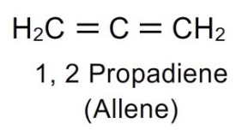
- Isolated dienes or non-conjugated dienes: double bonds are separated by more than one single bond.
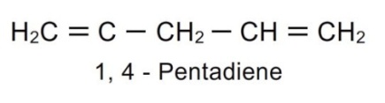
Stability of conjugated dienes:
Stability of conjugated dienes can be explained by resonance phenomenon
- It could be explained by taking the example of 1,3-butadiene, it is resonance hybrid of several contributing structures.
- Resonance structures of 1,3-butadiene:
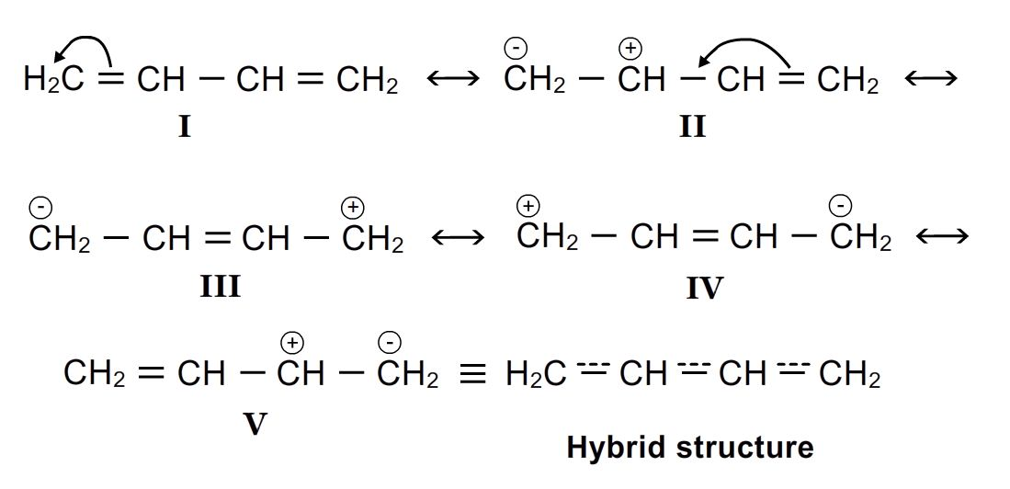
We know that greater the number of contributing structures greater will be the stability. That is why conjugated dienes show greater stability than simple alkenes or dienes with isolated double bonds.
The resonance energy can be calculated from heat of hydrogenation
The heat of hydrogenation of simple alkenes eg. 1-butene = 125.5kj/mol
The heat of hydrogenation of isolated diene eg.1,4 pentadiene = 250kj/mol
The heat of hydrogenation of conjugated dienes eg.1,3 butadiene = 238kj/mol
We can say the resonance energy of 1,3 butadiene is 12 kj/mol
Delocalisation of pi electrons: in 1,3-butadiene all carbon atoms are sp² hybridised i.e every carbon atom has empty p orbital and thus delocalization takes place over all 4 carbon atoms. This delocalization of pi electrons makes the molecule more stable.
Delocalization of pi electrons:
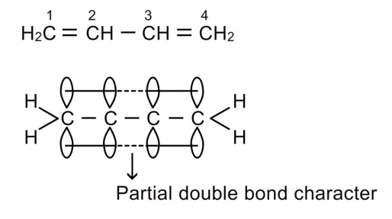

Topic: dienes- preparation & reactions of conjugated dienes
General methods of preparation of conjugated dienes:
- From acetylene: acetylene in presence of cu₂cl₂ and nh₄cl dimerise to form vinyl acetylene which on reduction with lindlar’s catalyst yields buta-1,3 diene.
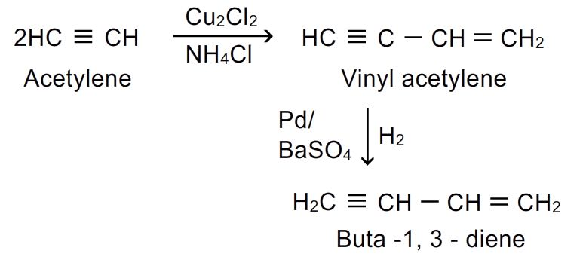
- From 1,4-dichlorobutane:1,4-dichlorobutane is heated with alcoholic koh when dehydrohalogenation occurs with formation of buta-1,3-diene
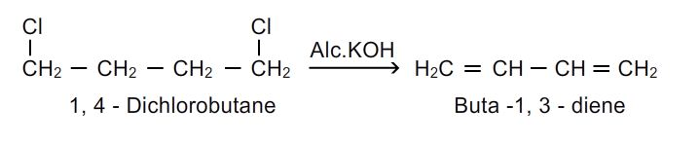
- From 1,4-butanediol: acid catalysed dehydration is done by heating 1,4 butanediol with conc.h₂so₄.
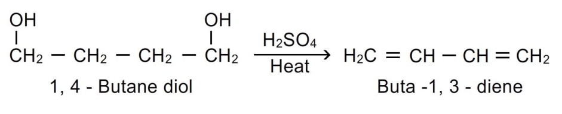
- By catalytic dehydrogenation of n-butane: buta-1,3-diene is obtained by passing the butane vapours over heated catalyst cr₂o₃ at 600 ⁰c
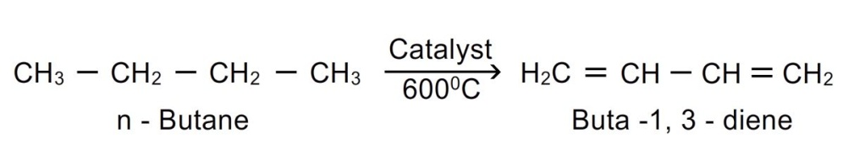
Reactions of conjugated dienes:
1.addition of halogens: buta-1,3-diene reacts with halogens in the presence of an inert solvent ccl₄ to yield a mixture of 1,2 and 1,4 addition products.
The mechanism of above reaction invoves following steps:
Step.1: the halogen molecule undergoes heterolytic fission.
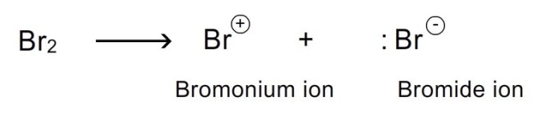
Step-2: the bromonium ion attacks the double bond to give a carbocation. The carbocation formed is allyl carbocation and it is resonance stabilized.
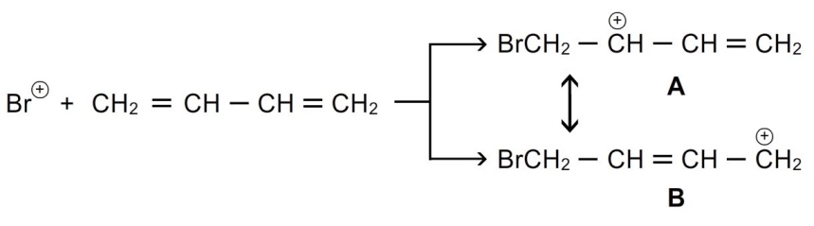
Step-3:the bromide ion combines with a to form 1,2 addition products.
it combines with b to form 1,4 addition products.
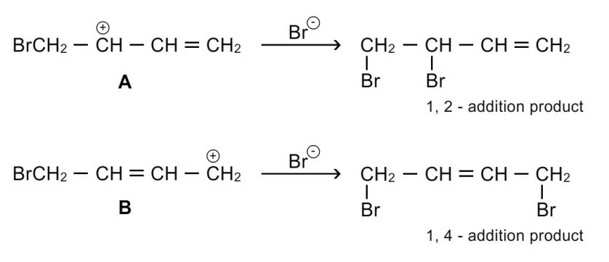
2.addition of halogen acids: a mixture of 2 compounds are formed when buta-1,3-diene reacts with halogen acids.
Effect of temperature on 1,2 and 1,4 additions to conjugated dienes: the proportions of 1,2 and 1,4 products formed in electrophilic addition to conjugated dienes depend on temperature at which the reaction is carried out.
From above reaction we can conclude that
1. 1,4 product is thermodynamically more stable.
2. The formation of 1,2 adduct/product in higher proportion at low temperature gives the information that e_{act} for 1,2 adduct is less i.e. kinetically favoured.
In electrophilic addition to conjugated dienes 1,2 adduct is formed preferentially at low temperature whereas 1,4 adduct is formed as major product at higher temperatures.

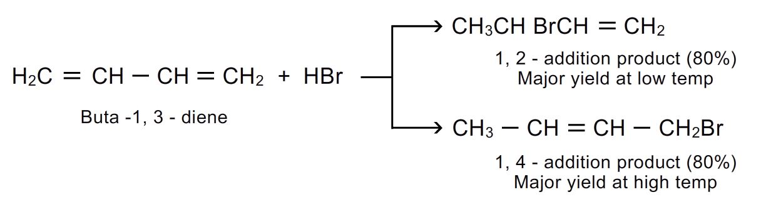
3. Addition of water: buta-1,3-diene reacts with water in the presence of sulphuric acid ro give mixture of 1,2 and 1,4 addition products.
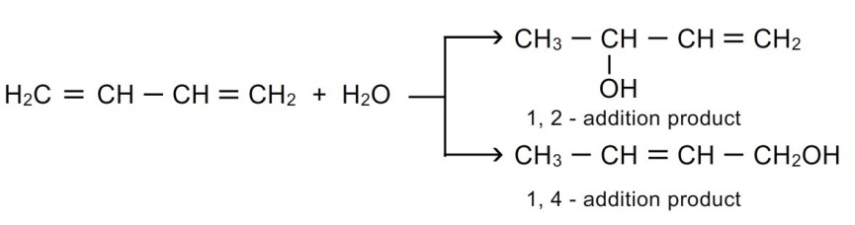
4. Addition of hydrogens: mixture of 1-butene and 2-butene are formed when buta-1,3 diene reacts with hydrogen in the presence of catalyst.
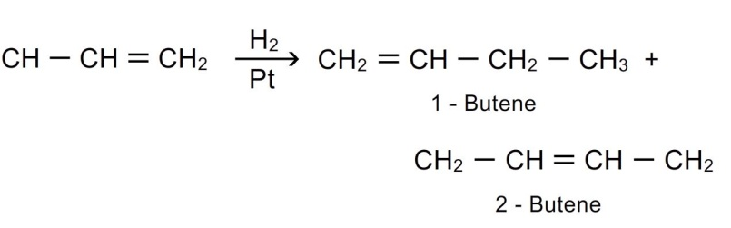
- Diels alder’s reaction: this reaction is between a conjugated diene and an alkene or alkyne called dienophile. It is a diene –dienophile addition reaction.
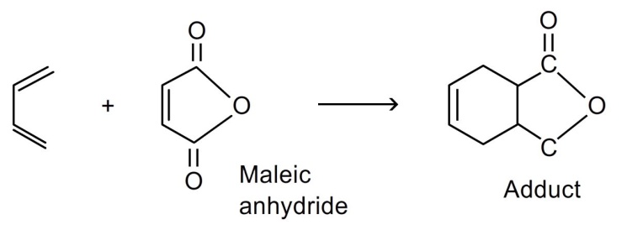
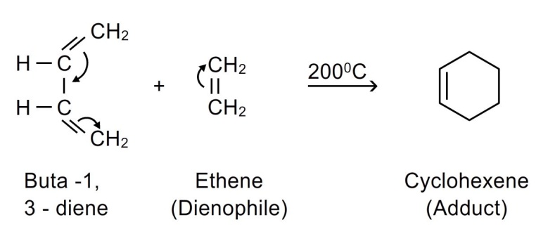
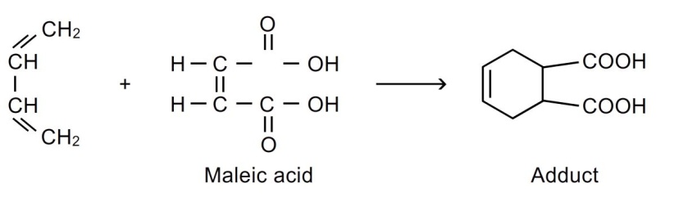
it forms cyclic compounds. Also called 4+2 addition reaction. The products are six membered cycloalkenes called adducts.
The presence of electron attracting groups such as –cn,-ch-,-cor,-cooh,-coor etc on dienophile facilitates the reaction.
This reaction is used in preparation of six membered rings.
6.ozonolysis: dienes undergo ozonolysis to give 3 molecules. Buta1,3-diene yields 2 molecules formaldehyde and glyoxal.
