CITRIC ACID CYCLE

PREPARED BY:
T. PRIYANKA
Assistant Professor
Department Of Pharmaceutical Analysis
Raghu College Of Pharmacy

CITRIC ACID CYCLE:
- The citric acid cycle (Krebs cycle or tricarboxylic acid-TCA cycle) is the most important metabolic pathway for the energy
supply to the body. About 65-70% of the ATP is
synthesized in Krebs cycle.
- Citric acid cycle essentially involves the oxidation of acetyl CoA to CO₂ and H₂O. This cycle utilizes about two thirds of total oxygen consumed by the body.
- The name TCA cycle is used, since, at the outset of the cycle, tricarboxylic acids (citrate, cis-aconitate and iso-citrate) partcipate.
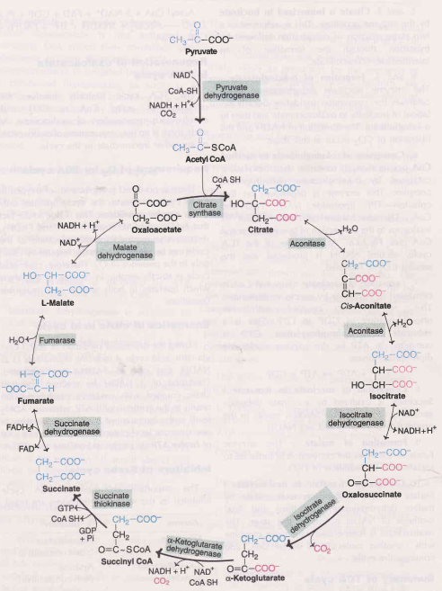

REACTIONS OF CITRIC ACID CYCLE :
- Oxidative decarboxylation of pyruvate to acetyl-coA by pyruvate dehydrogenase complex.
- This step is a connecting link between glycolysis and TCA cycle.
  - Formation of Citrate
  - Citrate is isomerised to iso-citrate
  - Isocitrate formation
  - Formation of α-keto glutarate
  - Conversion of α-keto glutarate to succinyl coA
  - Formation of succinate
  - Conversion of succinate to fumerate
  - Formation of malate
  - Conversion of malate to oxaloacetate

SIGNIFICANCE OF KREBS CYCLE:
- Krebs cycle or Citric acid cycle is the final pathway of oxidation of glucose, fats and amino acids
- Many animals are dependent on nutrients other than glucose as an energy source
- Amino acids (metabolic product of proteins) are deaminated and get converted to pyruvate and other intermediates of the Krebs cycle. They enter the cycle and get metabolised.
- e.g. alanine is converted to pyruvate, glutamate to 𝝰-ketoglutarate, aspartate to oxaloacetate on deamination
- Fatty acids undergo 𝞫-oxidation to form acetyl CoA, which enters the Krebs cycle
- It is the major source of ATP production in the cells. A large amount of energy is produced after complete oxidation of nutrients
- It plays an important role in gluconeogenesis and lipogenesis and interconversion of amino acids
- Many intermediate compounds are used in the synthesis of amino acids, nucleotides, cytochromes and chlorophylls, etc.
- Vitamins play an important role in the citric acid cycle. Riboflavin, niacin, thiamin and pantothenic acid as a part of various enzymes cofactors (FAD, NAD) and coenzyme A
- Regulation of Krebs cycle depends on the supply of NAD⁺ and utilization of ATP in physical and chemical work
- The genetic defects of the Krebs cycle enzymes are associated with neural damage.

