BIOSYNTHESIS OF PYRIMIDINES

PREPARED BY:
T. PRIYANKA
Assistant Professor
Department of Pharmaceutical Analysis
Raghu College Of Pharmacy

BIOSYNTHESIS OF PYRIMIDINES:
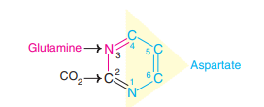
The synthesis of pyrimidines is a much simpler process compared to that of purines.
Aspartate, glutamine (amide group) and CO2 contribute to atoms in the formation of pyrimidine ring.
Pyrimidine ring is first synthesized and then attached to ribose 5-phosphate.
This is in contrast to purine nucleotide synthesis wherein purine ring is built upon a pre-existing ribose 5-phosphate.
The pathway of pyrimidine synthesis is depicted in Fig.17.12, and the salient features are described below.
- Glutamine transfers its amido nitrogen to CO2 to produce carbamoyl phosphate.
- This reaction is ATP-dependent and is catalysed by cytosomal enzyme carbamoyl phosphate synthetase II (CPS II).
- CPS II is activated by ATP and PRPP and inhibited by UTP.
- Carbamoyl phosphate synthetase I (CPS I) is a mitochondrial enzyme which synthesizes carbamoyl phosphate from ammonia and CO2 and, in turn urea.
- Prokaryotes have only one carbamoyl phosphate synthetase which is responsible for the biosynthesis of arginine and pyrimidines.
- Carbamoyl phosphate condenses with aspartate to form carbamoyl aspartate.
- This reaction is catalysed by aspartate transcarbamoylase.
- Dihydroorotase catalyses the pyrimidine ring closure with a loss of H2O.
- The three enzymes—CPS II, aspartate transcarbamoylase and dihydroorotase are the domains (functional units) of the same protein.
- This is a good example of a multifunctional enzyme.
- The next step in pyrimidine synthesis is an NAD+ dependent dehydrogenation, leading to the formation of orotate.
- Ribose 5-phosphate is now added to orotate to produce orotidine monophosphate (OMP).
- This reaction is catalysed by orotate phosphoribosyltransferase, an enzyme comparable with HGPRT in its function.
- OMP undergoes decarboxylation to uridine mono-phosphate (UMP).
- Orotate phosphoribosyltransferase and OMP decarboxylase are domains of a single protein.
- A defect in this bifunctional enzyme causes orotic aciduria (details given later).
- By an ATP-dependent kinase reaction, UMP is converted to UDP which serves as a precursor for the synthesis of dUMP, dTMP, UTP and CTP.
- Ribonucleotide reductase converts UDP to dUDP by a thioredoxin-dependent reaction.
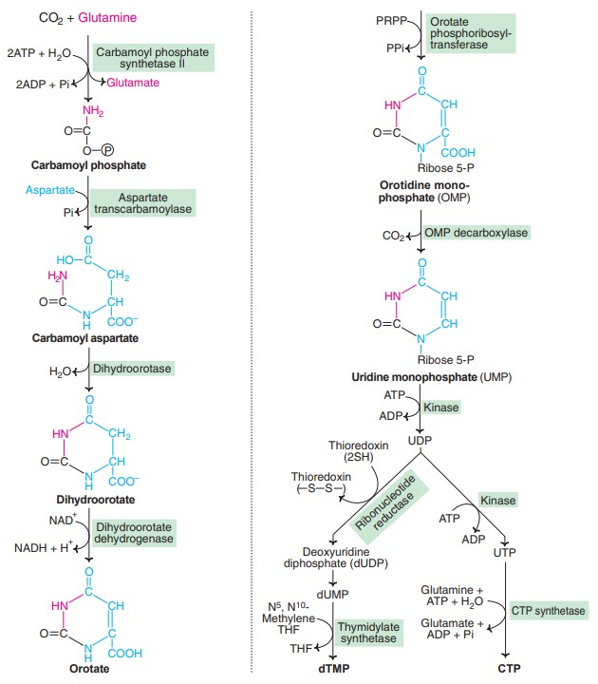
- Thymidylate synthetase catalyses the transfer of a methyl group from N5, N10-methylene tetrahydrofolate to produce deoxythymidine monophosphate (dTMP).
- UDP undergoes an ATP-dependent kinase reaction to produce UTP.
- Cytidine triphosphate (CTP) is synthesized from UTP by amination.
- CTP synthetase is the enzyme and glutamine provides the nitrogen.
Regulation of pyrimidine synthesis
- In bacteria, aspartate transcarbamoylase (ATCase) catalyses a committed step in pyrimidine biosynthesis.
- ATCase is a good example of an enzyme controlled by feedback mechanism by the end product CTP. In certain bacteria, UTP also inhibits ATCase.
- ATP, however, stimulates ATCase activity.
- Carbamoyl phosphate synthetase II (CPS II) is the regulatory enzyme of pyrimidine synthesis in animals.
- It is activated by PRPP and ATP and inhibited by UDP and UTP.
- OMP decarboxylase, inhibited by UMP and CMP, also controls pyrimidine formation.
Degradation of pyrimidine nucleotides
The pyrimidine nucleotides undergo similar reactions (dephosphorylation, deamination and cleavage of glycosidic bond) like that of purine nucleotides to liberate the nitrogenous bases— cytosine, uracil and thymine.
The bases are then degraded to highly soluble products—`-alanine and `-aminoisobutyrate.
These are the amino acids which undergo transamination and other reactions to finally produce acetyl CoA and succinyl CoA.
Salvage pathway
The pyrimidines (like purines) can also serve as precursors in the salvage pathway to be converted to the respective nucleotides.
This reaction is catalysed by pyrimidine phosphoribosyltransferase which utilizes PRPP as the source of ribose 5-phosphate.
Disorders of pyrimidine metabolism
Orotic aciduria:
- This is a rare metabolic disorder characterized by the excretion of orotic acid in urine, severe anemia and retarded growth.
- It is due to the deficiency of the enzymes orotate phosphoribosyl transferase and OMP decarboxylase of pyrimidine synthesis.
- Both these enzyme activities are present on a single protein as domains (bifunctional enzyme).
- Feeding diet rich in uridine and/or cytidine is an effective treatment for orotic aciduria.
- These compounds provide (through phosphorylation) pyrimidine nucleotides required for DNA and RNA synthesis.
- Besides this, UTP inhibits carbamoyl phosphate synthetase II and blocks synthesis of orotic acid.
Reye’s syndrome:
- This is considered as a secondary orotic aciduria.
- It is believed that a defect in ornithine transcarbamoylase (of urea cycle) causes the accumulation of carbamoyl phosphate.
- This is then diverted for the increased synthesis and excretion of orotic acid.

