(ALKENES)

Topic: introduction, nomenclature,isomerism

The open chain compounds which contain lesser number of hydrogens than the corresponding alkanes are called unsaturated hydrocarbons.
unsaturated hydrocarbons

alkenes alkynes
Alkenes are un saturated compounds with general formula c_{n}h_{2n}. They contain contain two hydrogen atoms less than the corresponding alkane. They are also termed as olefins.
Alkenes containing two double bonds are called alkadienes or dienes.
Nomenclature:
1.iupac system: the name is obtained by dropping the suffix ane from the name and adding ene
Alkane-ane+ene = alkene

2.common system: the name is obtained by dropping the suffix ane from the name and adding ylene.
Greek letters are used to distinguish the isomers i.e. to indicate the double bond position.
CH₃-CH=CH-CH₃ CH₃-CH₂-CH=CH₂ CH₃-CH₂-CH₂-CH=CH₃
Α-butylene β-butylene α-amylene

3. As derivatives of ethylene: they are names as derivatives of ethylene.
CH₃-CH=CH-CH₃ CH₃-CH₂-CH=CH₂
Sym-dimethyl ethylene ethyl ethylene

Isomerism in alkenes:
They show the following type of isomerism.
- Position isomerism: this is due to position of double bond.
CH₃-CH=CH-CH₃ CH₃-CH₂-CH=CH₂
2-butene 1-butene
Chain isomerism: this is due to difference in the nature
- ature of carbon skeleton.
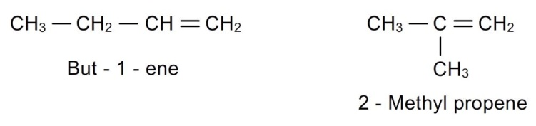
- Geometrical isomerism: due to restricted rotation around double bond, alkens show geometrical isomerism.
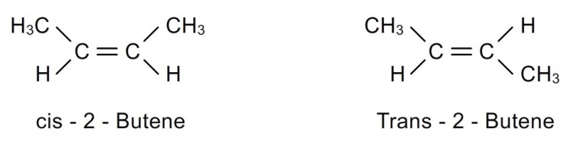
- Ring-chain isomerism: alkenes show ring-chain isomerism with cyclo alkanes.
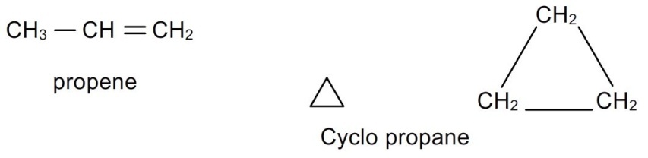
stability of alkenes:
- Propene is more stable than ethene. This can be explained based on hyperconjugation effect. Propene has greater number of contributing structures, hence greater the stability than ethene.
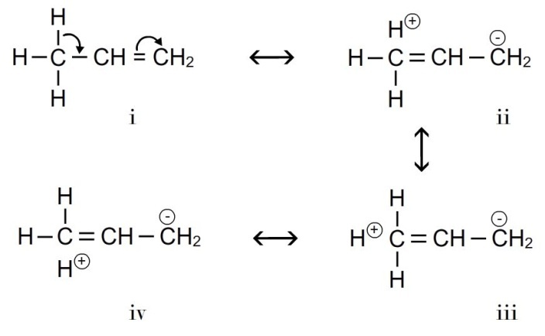
- Furthermore substituted alkenes are more stable thus larger the number of methyl groups attached to c-c double bond greater will be the hyper conjugation effect.
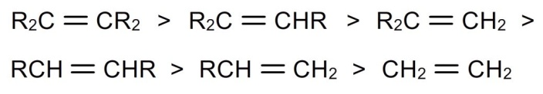
- So the stability of alkenes can be explained based on hyper conjugation effect. Greater the hyper conjugation effect, greater number of contributing structures, hence greater the stability.
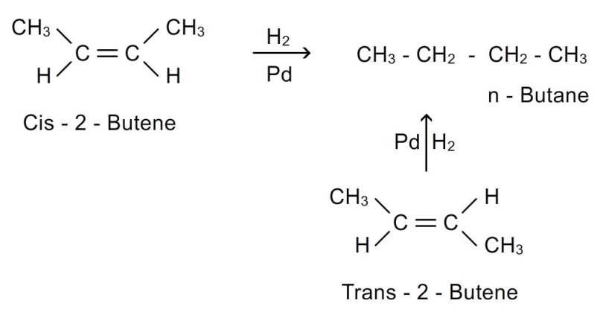
The relative stability of alkenes can be determined by comparing their enthalpies of hydrogenation.

- Cis –isomers are less stable than trans isomers.

- Enthalpy of hydrogenation of cis-isomer = 120.0 kj/mol
- Enthalpy of hydrogenation of trans-isomer = 115.0 kj/mol
- The trans isomer is stable than cis isomer by 5kj/mol.
Methods of preparation of alkenes:
- By dehydration of alcohols: alcohols are converted into alkenes by dehydration. I.e. elimination of water molecule.
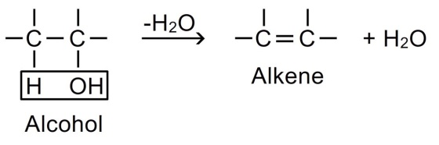
The dehydration is carried out in either two ways:
A.heating alcohol with acid catalyst like concentrated sulphuric acid or phosphoric acid or p₂o₅ to temperature 200⁰c.
B.passing the vapours of alcohol over alumina (al₂o₃) at 350-400⁰c.( al₂o₃ serves as lewis acid)
Mechanism of dehydration:
This involves formation of carbocation as an intermediate. The reaction occurs in 3 steps.
Step-1: due to presence of lone pair of electrons on oxygen atom, alcohols act as weak bases. Therefore they react with strong mineral acids (hcl or h₂so₄) to form protonated alcohol.
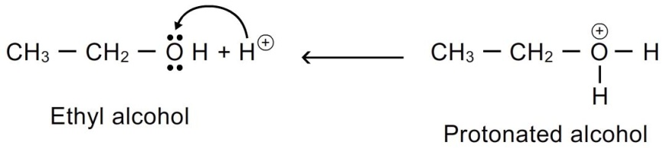
Step-2: the presence of positive charge on highly electronegative oxygen atom weakens c-o bond. As a result, the protonated ethanol breaks with the elimination of water molecule to form ethyl carbocation.
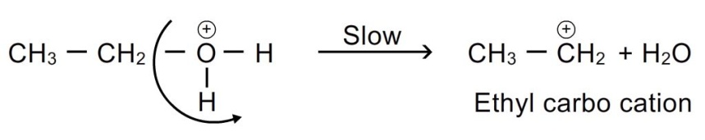
This step is slow and hence is the rate determining step of the reaction.
Step-3: the carbocation being unstable and a reactive chemical species, readily loses a hydrogen ion to yield an alkene.
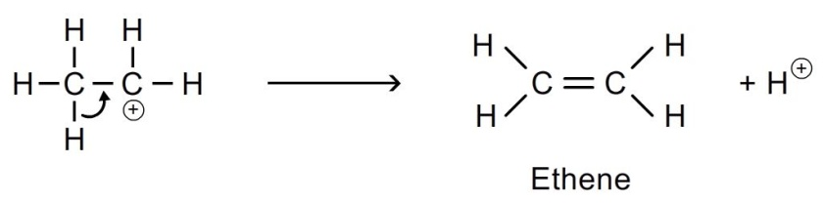
The ease of dehydration follows the following order:
Tertiary (3⁰) > secondary(2⁰) > primary(1⁰)

- Saytzeff’s rule : in the dehydration of secondary and tertiary alcohols, where there is possibility of formation of two isomers, the hydrogen atom is preferentially eliminated from the adjacent carbon atom with fewer number of hydrogen atoms.
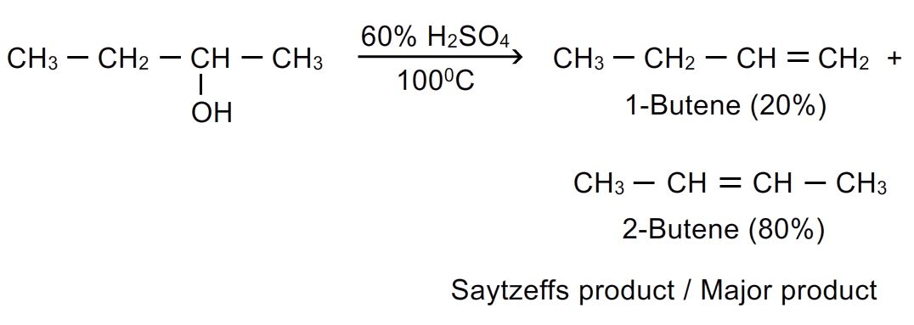
- Dehydration of alcohols is a stereoselective reaction:
The reaction may yield 2 or more stereoisomeric products and proceeds in such a way that more stable one is formed in greater amounts.
- Example: pentan-3-ol gives 74% trans pent-2-ene which is more stable and 25% cis-pent-2-ene.
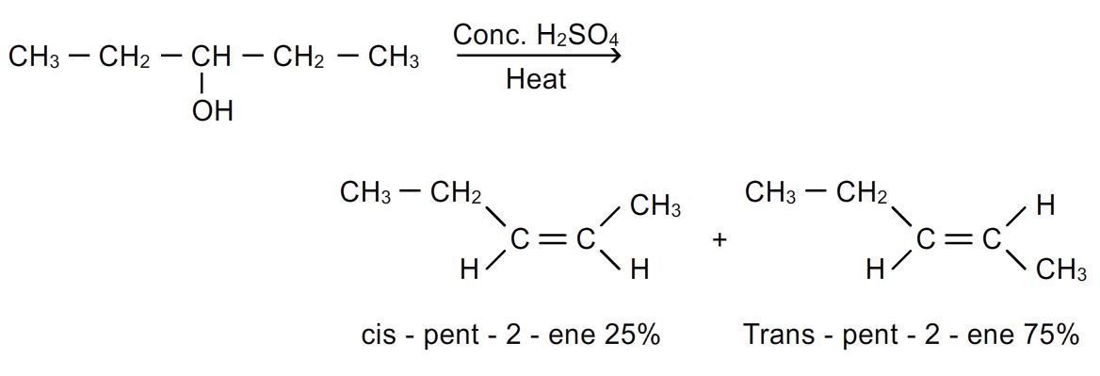
- Retropinacol rearrangement (wagner rearrangement): it is the rearrangement in open chain compounds in which shifting of c₆h₅; ch₃ and h takes place to form more stable carbocation and hence more stable products are formed.
- Shifting of these groups occur in following sequence:

C ₆H₅⁻(phenyl) > CH₃⁻ > H ⁻

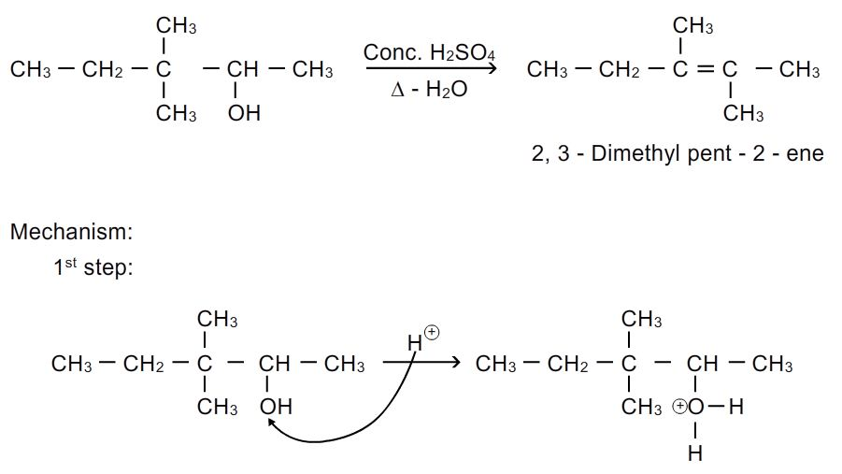
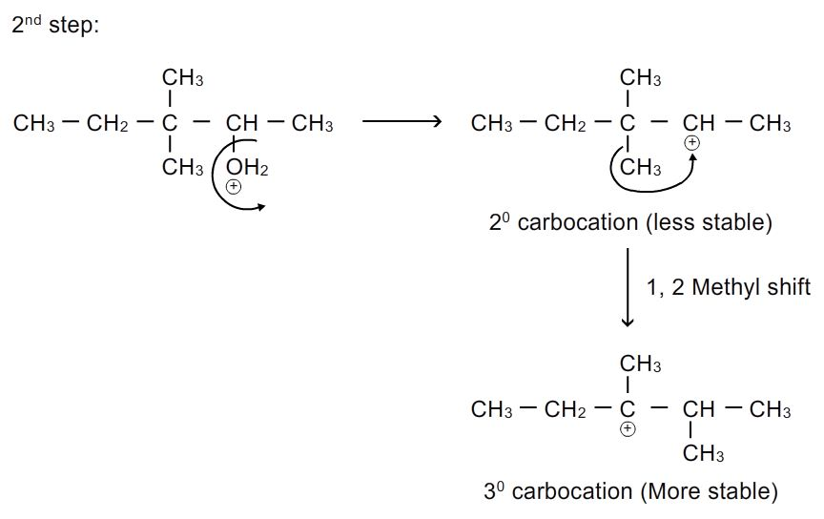
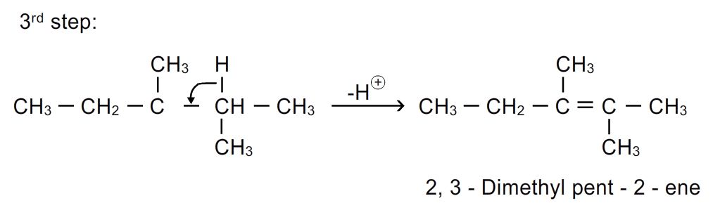
Methods of preparation of alkenes:
2.by dehydrohalogenation of alkylhalides: dehydrohalogenation involves removal of the halogen atom together with a hydrogen atom from a carbon adjacent to the carbon bearing the halogen atom.
Alkene is prepared by heating together the alkyl halide and a solution of potassium hydroxide in alcohol at a higher temperature.
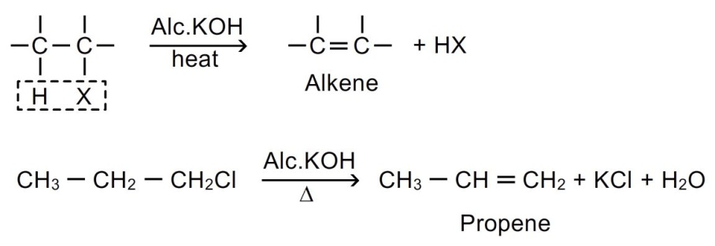
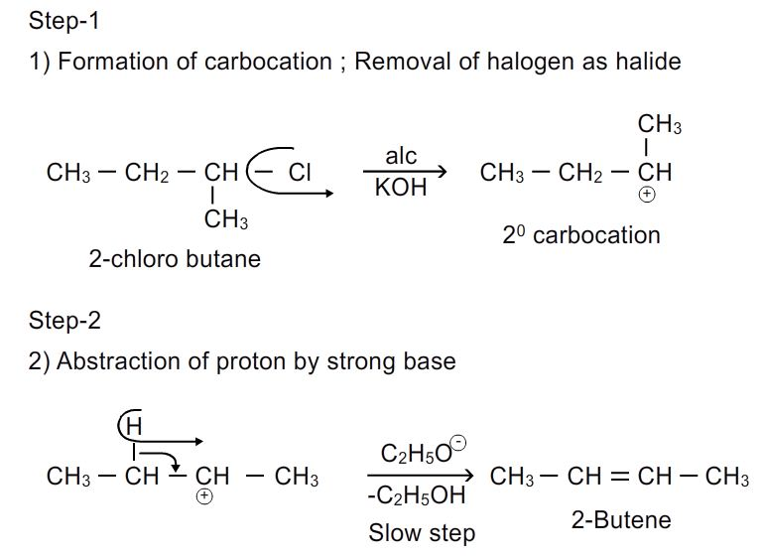
(discussed in detail in chapter alkyl halides)
3. Dehalogenation of vicinal dihalides: when vicinal dihalide is heated with zn/cu couple in methanolic solution, pure alkene is formed.
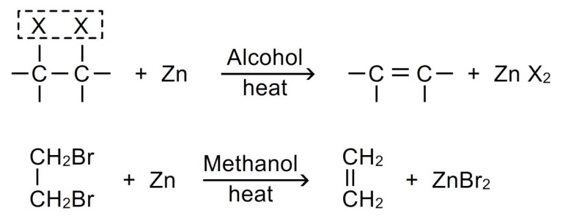
Gem dihalides also have been used in the preparation of alkenes.
I.when zinc metal is used
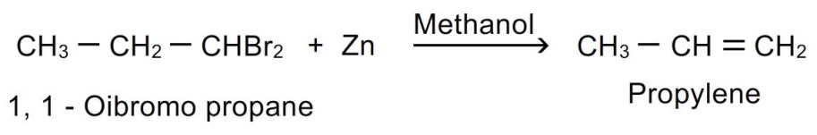
Ii.if sodium metal is used in place of zinc, then higher alkenes can be obtained.
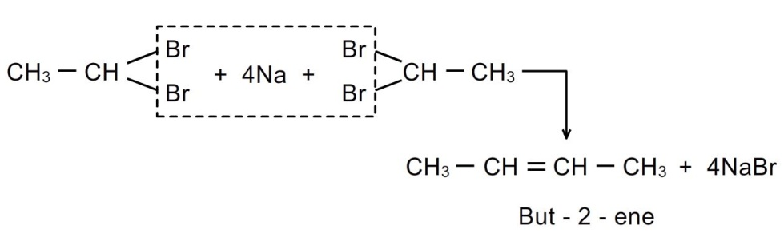
Stereoselectivity: elimination of halogen from dihalides give prominent trans- product.
4.electrolysis of salts of dicarboxylic acids: when sodium or potassium salt of saturated dicarboxylic acids are subjected to electrolysis in aqueous solution, alkenes are formed.
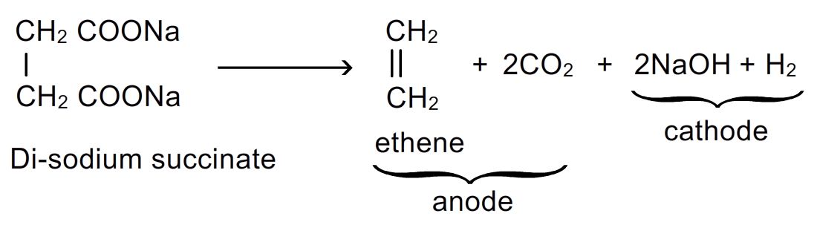
The method is extension of kolbe’s method.
5.controlled partial hydrogenation (reduction) of alkynes: controlled hydrogenation is essential because alkanes may be formed if hydrogenation is not controlled
Alkynes react with hydrogen when passed over heated catalyst
- Lindlar’s catalyst- palladium poisoned with caco₃ or (barium sulphate and quinoline) in equimolar ratio to form predominantly cis-alkenes
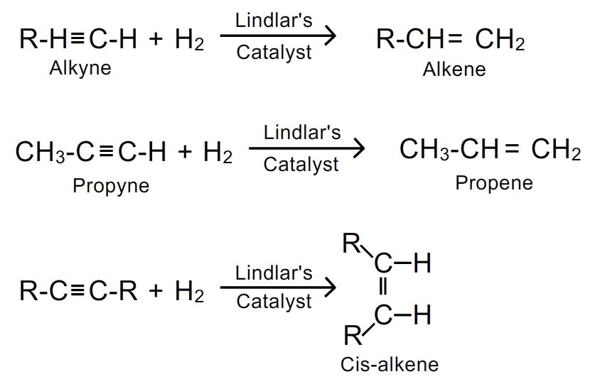
- Reduction of alkynes with lithium or sodium in liquid ammonia (birch reduction) yields predominantly trans-alkene.
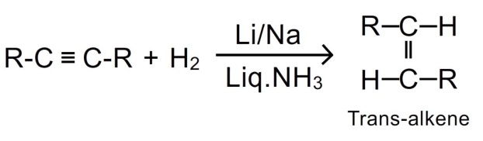
6. Pyrolysis or cracking: higher alkanes when heated at high temperature (500-700⁰c) decompose to produce a lower alkane and alkene (c-c fission)
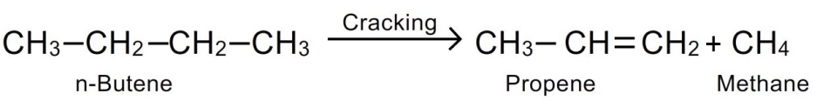
7.by grignard reagent: alkenes can be obtained by reacting grignard reagent with vinyl chloride.
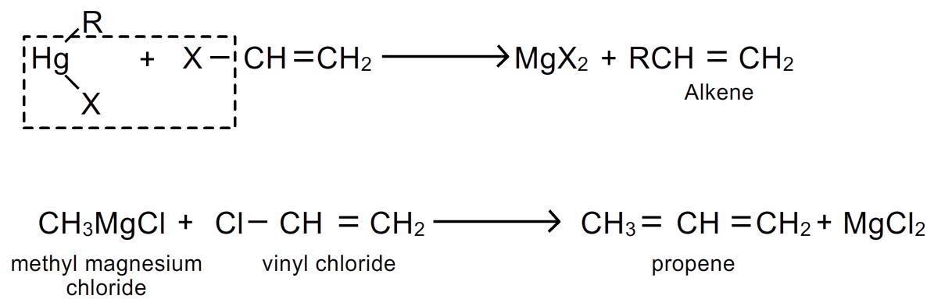
8.pyrolysis of quaternary ammonium compounds: many alkenes are conveniently prepared by heating quaternary ammonium compounds.
It is called hofmann elimination; in this an amine with smaller alkyl groups is formed.
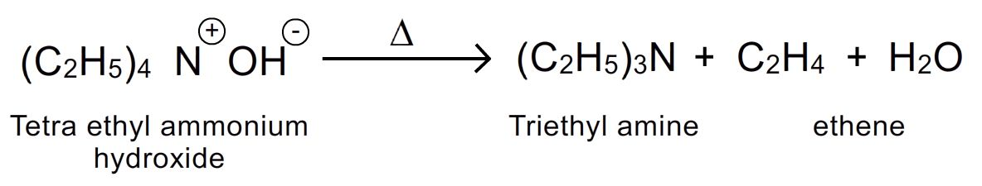
Physical properties:
1.state: first 3 members are gases, next 14 members are liquids while alkenes with more than 17 carbon atoms in the molecule are solids at room temperature.
2.odour: except ethane all are odour less. Ethane has pleasant odour. All are colourless.
3.solubility: alkenes are insoluble in water but freely dissolve in organic solvents.
4.boling points and melting points: their m.p , b.p and specific gravities show a gradual increase with the increase of molecular mass in homologous series.
They are less volatile than alkanes hence the melting and boiling points of alkenes are higher than alkanes.
Cis-isomer has higher boling point than trans isomer due to higher polarity.
However trans isomers have higher melting points than cis isomers. This is because trans isomers are more symmetrical and hence pack more closely in a crystal lattice. So larger amount of energy is required to break the lattice of trans isomer.
5.polarity: they are weakly polar. Trans-isomer have zero dipole moment and are non polar.
Chemical reactions of alkenes:
The most important reactions of alkenes are addition reactions (π bond is broken and two σ bonds are formed). Alkenes are reactive due to presence of double bond, the π-electrons are loosely held and therefore are easily polarisable.
Addition occurs by two mechanisms:
1.ionic mechanism ( occurs at lower temperature)
2.free radical mechanism ( occurs at higher temperature)
Ionic mechanism
Mechanism involves three steps
1st step: the reagent e-nu ionizes to give an electrophile and nucleophile.
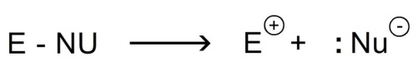
2nd step: the electrophile attacks the carbon-carbon double bond and forms a covalent bond with one of the carbon atom by utilizing the π- electrons. The other carbon atom acquires positive charge (carbocation)
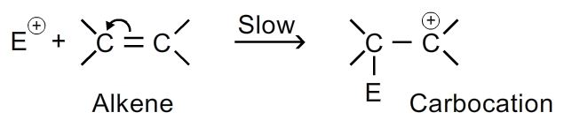
3rd step: the nucleophile now attacks the carbocation to form an addition product.
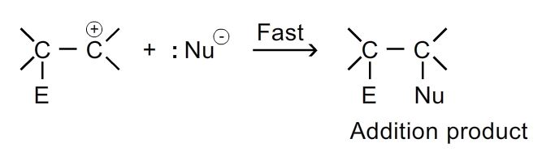
As the addition reaction is initiated by an electrophile these reactions are called electrophilic addition reactions.
the reactivity of alkenes follows the order:
R ₂C=CR ₂ < R ₂C=CHR < R ₂C=CH ₂ < RHC=CHR < RHC=C H ₂ < H₂C=C H ₂
less reactive more reactive

- The addition of electrophillic reagents relieves the strain of >c=c< (bond angle 120⁰) by changing it to >c-c< (bond angle 120⁰).

Important addition reactions are:

1.addition of hydrogens: alkenes react with hydrogen in the presence of catalyst at 200-300 ⁰c to form alkanes. Catalysts used are platinum, palladium, nickel etc. It is also called catalytic reduction. Also known as sabatiers senderens reaction.
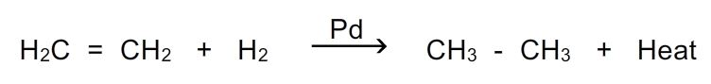
- When nickel is used as catalyst the reaction is carried at 200-300 ⁰c and in presence of pd or pt hydrogenation can even occur at room temperature.
- The lower the heat of hydrogenation the more stable the alkene.
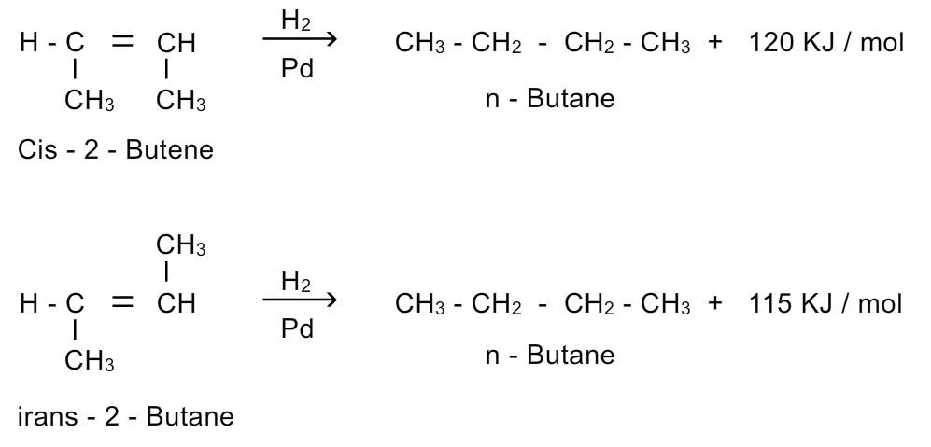
- Terminal double bond may be reduced by sodium in liquid ammonia in presence of alcohol. This is called birch reduction.
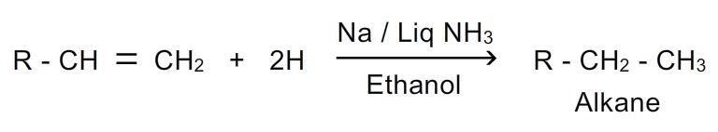
2. Addition of halogens: halogens chlorine , bromine only add at ordinary temperatures in presence of inert solvents to form vicinal alkyl halides.
Bromine water is decolourised by unsaturated hydrocarbons- this can be use as test of unsaturation. The brown colour of bromine gets disappeared as colourless dibromo derivative gets formed.
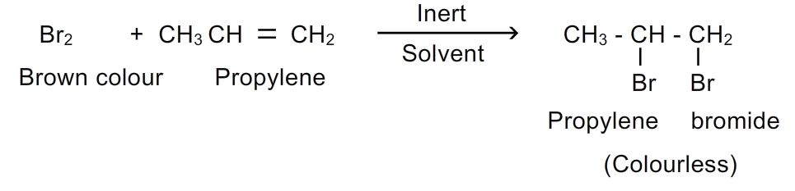
The reaction is stereospecific, anti-addition is observed.
Mechanism:
Step-1: the bromine molecule ionizes on interaction with π bond.
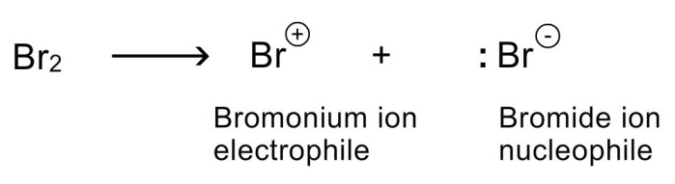
Step-2: bromonium ion attacks the double bond to form a carbocation.
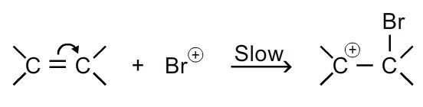
Step-3: nucleophile (br⁻) attacks the carbocation to form addition product.
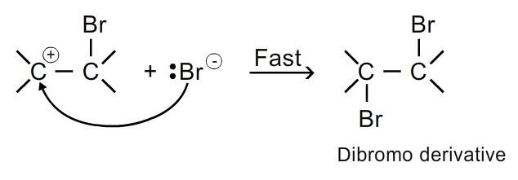
3. Addition of halogen acids: alkenes react with halogen acids (hcl, hbr, hi) to form alkyl halides.
A proton and a halogen add to the double bond of alkene to form an alkyl halide.
The addition of hydrogen halide to unsymmetrical alkene is highly regioselective as to be considered regiospecific. It follows markownikoff’s rule
Markownikoff’s rule: the addition of halogen acids to unsymmetrical alkenes takes place in such a manner that halogen attaches to that carbon atom which carries lesser number of hydrogen atoms.
- The modern version of rule is that electrophilic addition to carbon-carbon double bond involves the rearrangement (1,2-hydride or 1,2-methyl shift) leading to intermediate formation of more stable carbocation.
Example: addition of hbr to propene
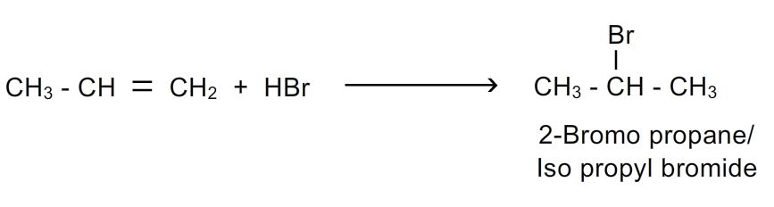
Mechanism:
1st step:hx ionizes

2nd step: electrophile (h+) attacks the double bond to form carbocation
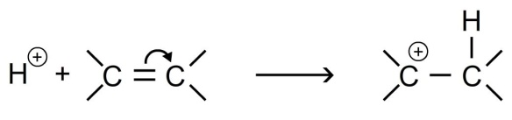
3rd step: nucleophile attacks the carbocation to form the alkyl halide
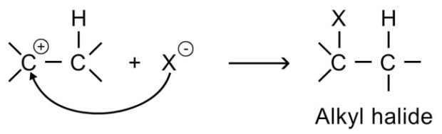
Peroxide effect: kharasch observed that the addition of hbr to unsymmetrical alkene in the presence of organic peroxides gives product opposite to markownikoff’s rule.
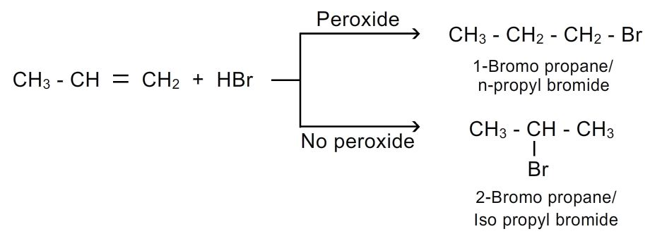
This is termed as anti markownikoff’s rule or peroxide effect.
Mechanism: in presence of peroxide (eg: benzyl peroxide) the reaction is free radical electrophillic addition reaction, in which the electrophile is bromine free radical.
Steps involved are
Step 1: peroxide undergoes fission to give free radicals(intitiation)
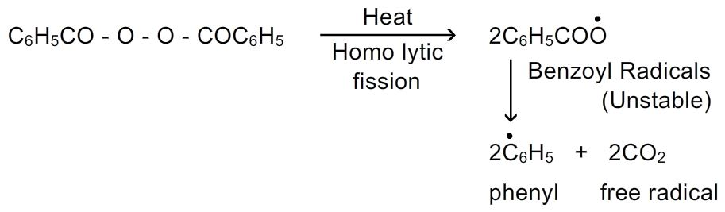
Step-2: hbr combines with free radicals to form bromine free radical
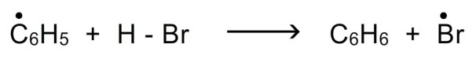
Step-3: ●br attacks the double bond of alkene to form more stable free radical.(propagation)
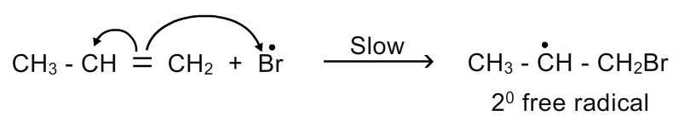
Step-4: more stable free radicals attacks the hbr (termination)
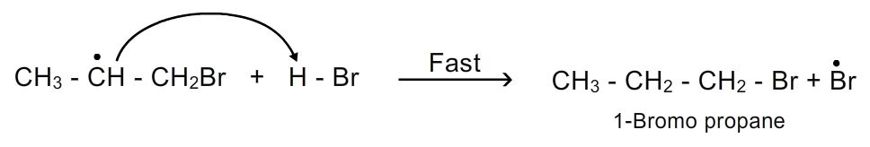
- This peroxide effect applies to the addition of hbr only and not to the addition of hcl or hi.

Topic: electrophilic addition reactions
8. Addition of oxygen: when mixed with oxygen or oxidation with peroxy acids or air and passed through a silver catalyst at high temperature (200-400⁰c) and pressure lower alkenes add an atom of oxygen to form epoxides (cyclic ethers). The reaction is stereo specific syn addition. These epoxides on hydrolysis form diols or glycols
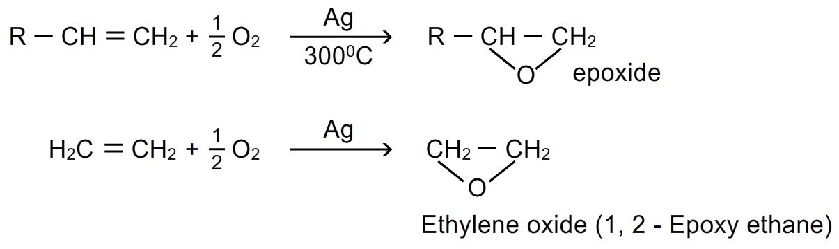
9. Addition of ozone(ozonolysis): when stream of ozone or ozonised oxygen is passed through a solution of alkene in an inert solvent ( ether, ccl₄, chloroform) at low temperature, the molecule adds up to form ozonide. Ozonide is unstable, explosive compound and easily decomposes either by reduction (zn/h₂o, zn/ch₃cooh, h₂/pd,) or hydrolysis( with h₂o₂ or ag₂o) and forms compounds having >c=o group(aldehydes and ketones). This process is called ozonolysis.
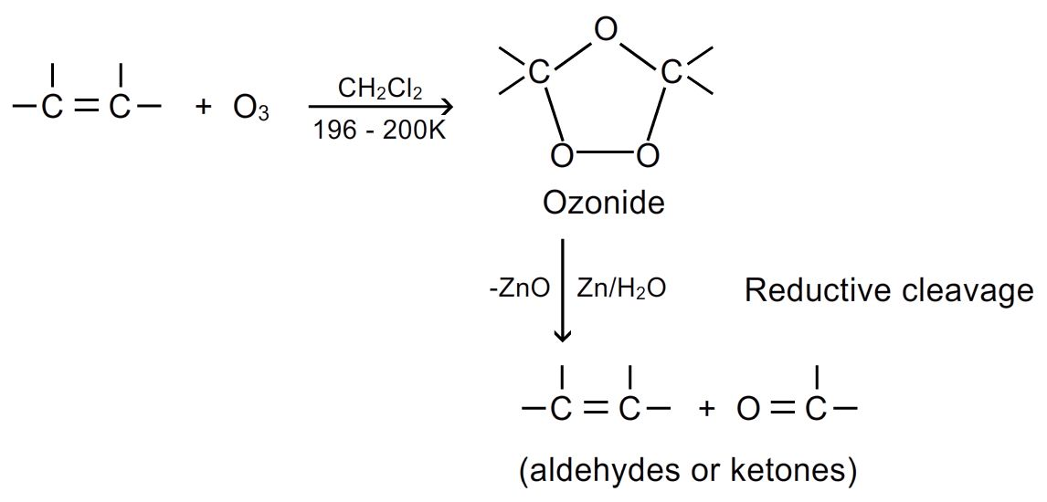
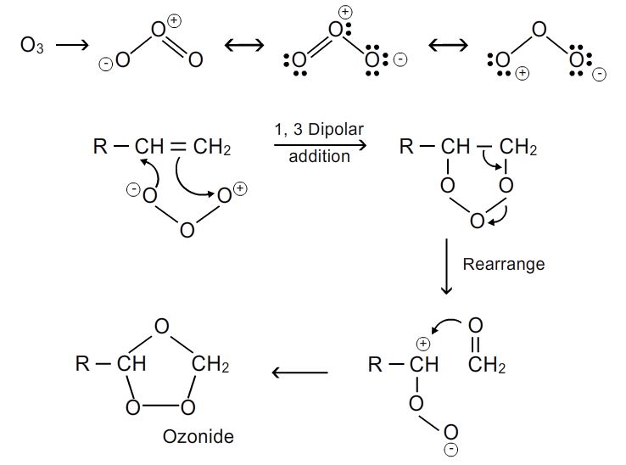
- Zinc dust is added to prevent the formation of h₂o₂ produced by the reaction of h₂o and o (therefore this reaction can be called as reductive ozonolysis)
- From the products formed, we can know the structure of original compounds.
- Ozonolysis of cycloalkene give only one molecule of dialdehyde.
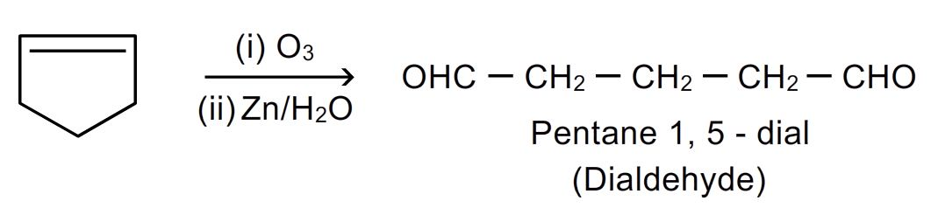
- Ozonolysis of cycloalkadiene gives two molecules of dialdehyde.
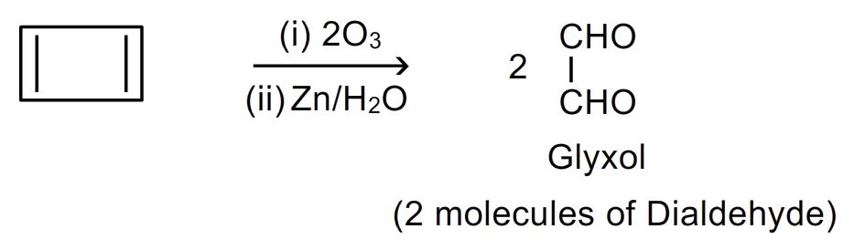
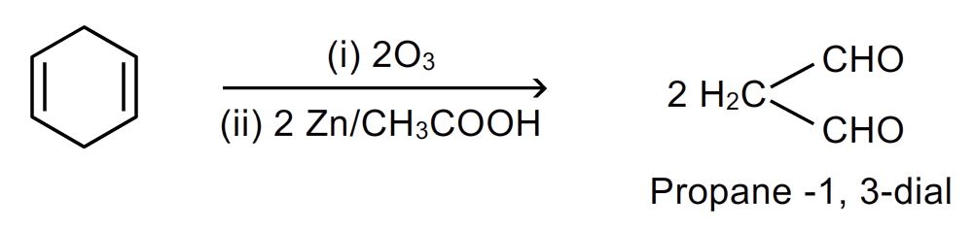
- While congujated diene and triene gives mainly glyoxal (dialdehyde) and formaldehyde.
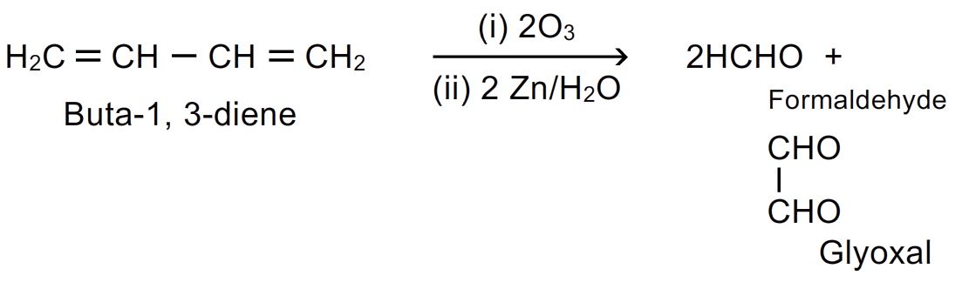
- Symmetrical alkenes give only one type of product. Substituted alkenes give ketones.
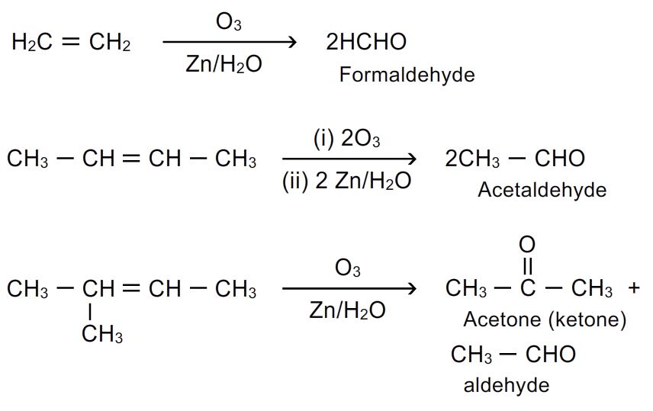
Type of alkene | Ozonolysis product
Ring containing one double bond | One molecule of dialdehyde
Ring containing two double bond | Two molecules of dialdehyde
Open chain 2 terminal double bonds | 2molecules of formaldehydeand 1 molecule of glyoxal
Rch=chr’ | Mixture of 2 aldehydes
R₂c=chr | Aldehyde + ketone
R₂c=cr’₂ | Mixture of two ketones
Ch₂=ch₂ | Only formaldehyde
2-butene | Only acetaldehyde

Based on the ozonolysis product we can know the type of alkene also the location of double bond.

10.addition of sulphuric acid: cold and concentrated sulphuric acid or fuming sulphuric acid adds alkenes to form alkyl hydrogen sulphate. In case of unsymmetrical alkenes, markownikoff’s rule is followed.
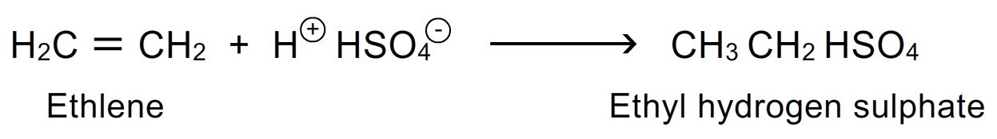
- Ethyl hydrogen sulphate on heating at 160-170⁰c yields ethylene. Hence this reaction can be useful in separation of ethylene or alkenes from mixture of alkenes and alkanes.
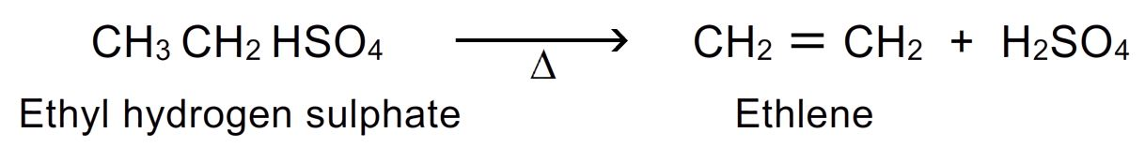
- Alkyl hydrogen sulphate when boiled with water ethanol is obtained. Hence this reaction is useful in the preparation of alcohols.
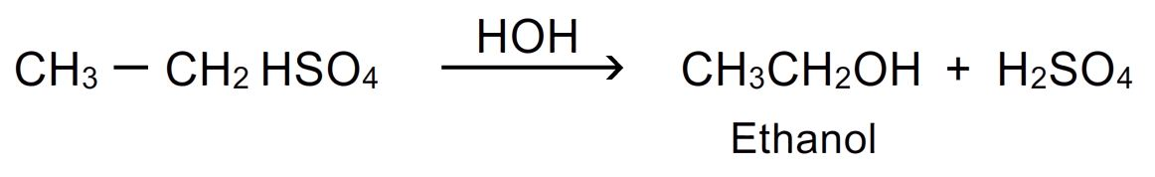

11. Self addition or polymerization: alkenes in the presence of acid catalyst at high temperature under pressure of 1500 atmospheres and in presence of oxygen undergo self addition. 2 or more molecules of alkene link together to form macro molecules or polymers. This process is called polymerization.
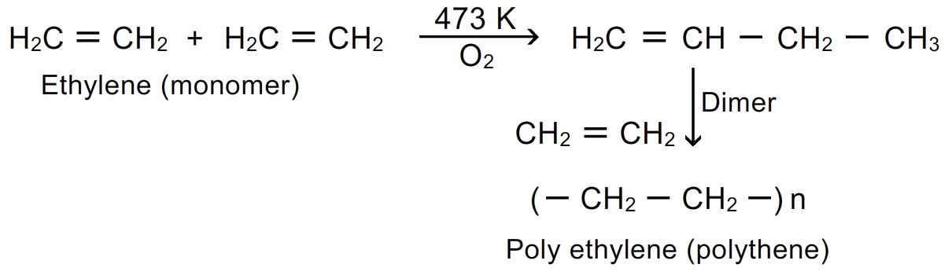

- Polythene, polypropene and polybutene are plastics of industrial importance. Polypropene is harder and stronger polymer and its fibres are used in carpets and automobile tyres.
- Cis- polyisopropene is natural rubber, pvc(poly vinyl chloride) used for making bottles, pipes, hand bags, tablemats.pan(poly acryl nitrile) is used in making orlon and acrilan fibres which are used in making clothes, carpets and blankets.

12. Addition of alkanes: highly branched alkanes add to alkenes in the presence of conc.h₂so₄ or hf.

