PHARMACEUTICAL ANALYSIS – BP102T

UNIT: III REDOX TITRATIONS
CLASS:
TOIPC: Titration with potassium iodate

Titration with potassium iodate:
Principle:
potassium iodate is a strong oxidizing agent in moderate acidic conditions where iodides/ Arsenic oxidizes are converted into iodine.
That liberated iodine is titrated with sodium Thio sulphate
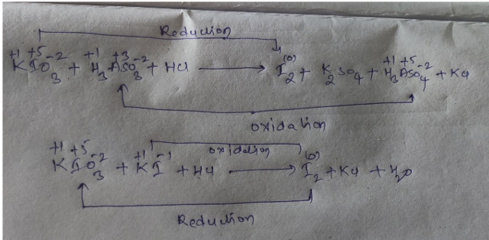

Applications:
It is used for the determinations of arsenic
It is used for the determination of hydrazine sulphate
It is used to determine copper compounds

