PHARMACEUTICAL ANALYSIS – BP102T

UNIT: III REDOX TITRATIONS
CLASS:
TOIPC: INTRODUCTION OF REDOX TITRATIONS

Oxidation:
It is a part of oxidation and reduction,
when electron is lost or the oxidation state will be increased the combination of a substance with oxygen.
A reaction in which the atoms of an element lose electrons and the valence of the element is correspondingly increased.
A substance is oxidized if it gains oxygen, loses hydrogen, or loses electrons.
A chemical reaction involving loss of electrons. In the human body, oxidation occurs when breathed-in oxygen combines with molecules in food to produce energy, water, and carbon dioxide.
Reduction:
It is a part of oxidation -reduction reaction, where electron is gained as the oxidation state, the valency will be decreased.
Oxidizing agents:
These are substances containing the elements that accept electrons, allowing other elements to oxidized by accepting electrons.
it is a substance which oxidizes other substances and itself it undergoes reduction.
Example: KMnO4, KBrO3, KIO3, Iodine.

Reducing agents:
These are substances which reduces other substances and itself it undergoes oxidation Example: FeSO4, Oxalic acid, Ferric ammonium sulphate
Reducing agents are substances containing the elements that donate electrons, allowing other elements to be reduced
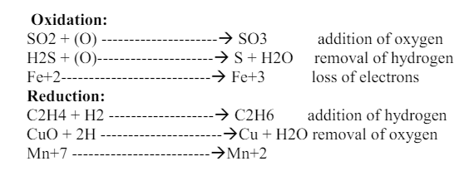

Very Short Answer Questions
1.Define oxidation and reduction reactions
2.What are redox titrations
3.Write the difference between oxidation and reduction
4.Define Oxidising and reducing agents with examples
5.Write Redox Potential

