PHARMACEUTICAL ANALYSIS – BP102T

UNIT: V ELECTRO ANALYTICAL METHOD OF ANALYSIS

CLASS:

TOPIC: POLAROGRAPHY

Polarography:

Polarography is a voltametric measurement whose response is determined by only diffusion mass transport.
The simple principle of polarography is the study of solutions or of electrode processes by means of electrolysis with two electrodes, one polarizable and one unpolarizable, the former formed by mercury regularly dropping from a capillary tube. Polarography is a specific type of measurement that falls into the general category of linear-sweep voltammetry where the electrode potential is altered in a linear fashion from the initial potential to the final potential. As a linear sweep method controlled by convection/diffusion mass transport, the current vs. potential response of a polarographic experiment has the typical sigmoidal shape. What makes polarography different from other linear sweep voltammetry measurements is that polarography makes use of the dropping mercury electrode (DME) or the static mercury drop electrode.
A plot of the current vs. potential in a polarography experiment shows the current oscillations corresponding to the drops of Hg falling from the capillary. If one connected the maximum current of each drop, a sigmoidal shape would result. The limiting current (the plateau on the sigmoid), called the diffusion current because diffusion is the principal contribution to the flux of

Ilkovic equation:
The Ilkovic equation is a relation used in polarography relating the diffusion current (Id) and the concentration of the depolarizer (c), which is the substance reduced or oxidized at the dropping mercury electrode. The Ilkovic equation has the form or id = 607 n D1/2 C m2/3 t1/6 where k is a constant which includes π and the density of mercury, and with the Faraday constant F has been evaluated at 708 for maximal current and 607 for average current, Dis the diffusion coefficient of the depolarizer in the medium (cm2 /s), n is the number of electrons exchanged in the electrode reaction, m is the mass flow rate of Hg through the capillary (mg/s), t is the drop lifetime in seconds, and c is depolarizer concentration in mol/cm3 .

Dropping mercury electrode
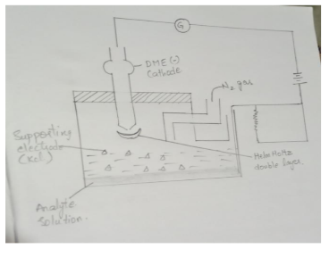
Construction:
It is acting as cathode and sometimes acting as anode. It consists of long capillary tube of 15-20cm long and 20-50mm internal diameter and that capillary tube is connected with Mercury reservoir. 2-12 seconds takes the time to form a mercury droplet. 20-30 droplets can be formed in a minute and all the mercury droplets form mercury pool at the bottom and acting as counter electrode. The potential can be applied for DME is +0.4 to -1.8 volts.
Working:
1. The sample analyte is taken in a beaker along with 50-100 times of supporting electrolyte i.e.,Kcl. 2. Nitrogen gas is introduced into the beaker to remove the dissolved oxygen. 3. Dropping mercury electrode and mercury pool are connected to battery and external potential is applied. 4. The sample analyte is taken in a beaker along with 50-100 times of supporting electrolyte i.e., Kcl. 5. Nitrogen gas is introduced into the beaker to remove the dissolved oxygen. 6. Dropping mercury electrode and mercury pool are connected to battery and external potential is applied
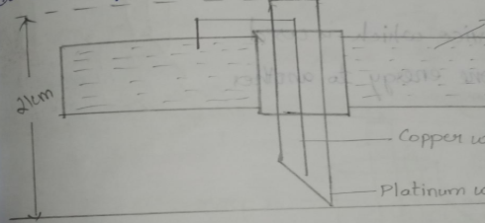
The potassium cation reaches to cathode that is DME and form Helm Holtz double layer after that the sample Pb+2 reaches to the cathode surface by passing through potassium double layer and reduced them
Due to the potential difference current is produced because of diffusion of ions which is directly proportional to concentration of analyte.

Rotating platinum electrode
This is used when more positive potential is applied
Steady electrode if we use, we get slow diffusion current .so that we use rotating platinum electrode which gives sharp and accurate result. it consists of 21cm long mercury platinum wire consists of 5-6 mm length and 0.5mmdiameter. The total electrode is covered with glass tube which rotated 600 rpm speed. It is acting as a indicated electrode. Polarography graph is known as polarogram
Application:
1.It is used for determination of quantitative analysis.
2.It is used for determination of qualitative analysis.
3.It is used for determination of dissolved oxygen.
4.It is used for determination of organic and inorganic compounds

Very Short Answer Questions:
1.Define Polarography
2.Write different currents used in polarography
Short Answer Questions:
1.Eplain in detail about Dropping mercuric Electrode
2.Writr in detail about platinum Electrode

