PHARMACEUTICAL ANALYSIS – BP102T

UNIT: V ELECTRO ANALYTICAL METHOD OF ANALYSIS

CLASS:
TOPIC: CLASSIFICATION OF CONDUCTOMETRIC TITRATIONS

Titrations:
Acid-base titrations
Strong acid vs strong base:
HCl is strong acid and it completely dissociates into H+ and Cl
HCl --------------- H+ + Cl-
H+ ions move to cathode and Cl- ions move to anode and the conductivity is more at initial stage and this is known as initial conductivity
When NaOH is added from burette, OH- of NaOH reacts with H + of HCl and convert into water so that the conductivity gradually decreased.
Once the total available H+ ions are converted into water indicates completion of reaction or end point.
Further addition of NaOH causes increase in the conductivity because of Na+, OH- move to electrodes and increase the conductivity. Therefore, we get V shaped graph, where two lines joined is the end point.
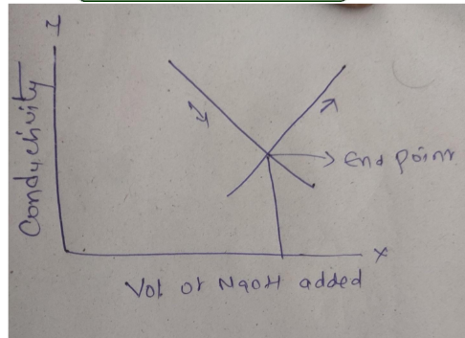

Strong acid vs weak base:
HCl is completely dissociates and we get maximum conductivity.
Once NaOH is added the conductivity is decreased by conversion of H+ from HCl and OH- from NH4OHto water.
Once the end point reaches, further addition of NH4OH it is not completely dissociates and conductivity will be neither decreased or increased.
So that we get the graph like below
NH4OH …………………> NH4+ + OH
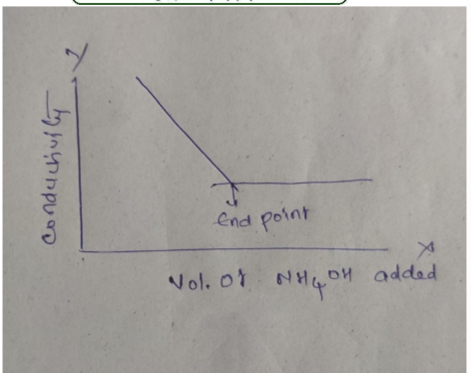
Weak acid vs strong base:
Acetic acid is weak acid and it is partially ionised to acetate and H+ ions.
Being a weak acid, conductivity is less so that we get plateau or straight line.
Once the end point reaches excess of sodium hydroxide is ionized to Na+ and OH- ions.
Because of more conductance of OH- ion,
The conductivity will be increased so that if we plot the graph we get as below
CH3COOH ------------------ CH3COO- + H+
CH3COOH + NaOH ------------- CH3COONa + H2O
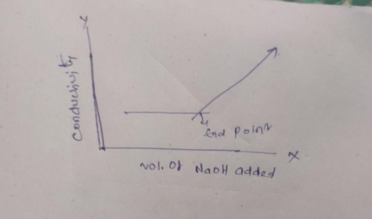

Weak acid vs weak base:
The titration between weak acid like acetic acid and wea base like NH4OH takes place and we get ammonium acetate which is having good conductance hence conductivity is increased.
Once the end point reaches further addition of ammonium hydroxide will not change the conductivity, so that we get straight line
CH3COOH+ NH4OH ---------------- CH3COONH4 +H2O
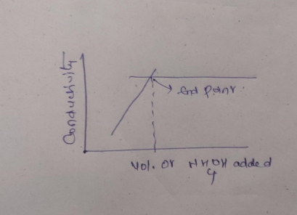

Long Answer Questions:
1.define conductometry and conductive cell and explain in briefly about conductometric titrations.

