PHARMACEUTICAL ANALYSIS – BP102T

UNIT: III REDOX TITRATIONS
CLASS:
TOIPC: PERMANGANOMETRY

Types of redox titrations:
1. Permanganometry titration
2. Dichrometry titration
3. Cerimetry titration
4. Iodo/iodimetry titration
5. Bromatometry titration
6. Titrations with potassium iodate.
1.Permanganometry titration:
Such type of reactions where we use KMnO4 such type of reactions is known as permanganometry titrations.
The KMnO4 should be standardized with primary standard like Oxalic acid
Principle:
KMnO4 is strong oxidizing agent.
In the presence of acidic medium, it reduces itself and oxidizes other substances. It is acting as a self-indicator because of intense colour
Standardization of 0.1M KMnO4
Take 20 ml of 0.1N oxalic acid in a conical flask and add 5 ml of 1N H2SO4 and heat upto70°and then titrates with KMnO4 which is taken in burette until permanent pink colour appears
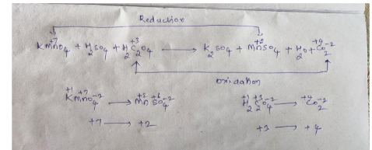

Limitations:
KMnO4 is not available in pure form and it contains manganese dioxide as an impurity if we use ordinary water and that manganese dioxide is responsible for decomposition of KMnO4
Remedy:
KMnO4 is prepared and heated for 1 hour and transfer to amber coloured bottle and keep asidefor2 days.

Very Short Answer Questions
1.Define Permanganometry
2.write the limitations of Permanganometry
Short Answer Questions
1.Explain in detail about Permanganometry and its applications.

