PHARMACEUTICAL ANALYSIS – BP102T

UNIT : II ACID-BASE TITRATIONS AND NON-AQUEOUS TITRATIONS
CLASS:4

TOPIC: THEORIES OF INDICATORS
Theories of indicators: An indicator is a substance which show characteristic change in its colour when comes in contact with acid or base and thus it is used to determine dictators the degree of acidity or basicity of any solution. For example, litmus solution or litmus paper.
Role of indicators in chemistry is very important. They are used are also used to find out the end point in a titration.
In acid-base titrations, organic substances (weak acids or weak bases) are generally used as indicators.
Indicators change their colour within a certain pH range.The colour change and the pH range of some common indicators used are tabulated below:

Indicator | pH Range | Colour of Acidic Solution | Colour of Basic Solution
Methyl Orange | 3.2-4.5 | Orange | Yellow
Methyl Red | 4.4 – 6.5 | Red | Yellow
Bromothymol blue | 6.0 -7.8 | Yellow | Blue
Phenolphthalein | 8.3- 10.0 | Colourless | Pink
Alizarin Yellow | 10.1 – 12.1 | Yellow | Red
Litmus | 5.5-7.5 | Red | Blue
Phenol red | 6.8-8.4 | Yellow | Red

There are two theories which explain the change of colour indicators with change in pH.

Ostwald's Theory
According to Ostwald’s theory
- The colour change of any indicator is due to its ionisation. The unionised form of indicator has different colour than its ionised form.
- An indicator is either a weak acid or base, so its ionisation is highly affected in acids and bases. If an indicator is a weak acid, its ionisation would be very much low in acids due to common H⁺ ions while it is fairly ionised in alkalies. In the same way, if the indicator is a weak base, its ionisation is large in acids and low in alkalies due to common OH- ions.
Let’s take examples of two important indicators phenolphthalein which is a weak acid and methyl orange which is a weak base.
- Phenolphthalein
It is represented as HPh. This indicator being a weak acid ionises in solution to a small extent as follows:

HPh H⁺ + Ph⁻
Colourless Pink
HInd is a weak organic acid indicator and in aqueous solution it is well dissociated as :
HInd → H⁺ + In⁻ (Poorly dissociated)
Undissociated Dissociated
Indicator Indicator
In above reaction,
HInd → H⁺ + In⁻
HA → H⁺ + A⁻
Common ion effect
HIn is a weak acid therefore it poorly dissociates and due to common ion effect its dissociation further decreased. The equilibrium is shifts towards the left hand side. Therefore in the presence acid the dissociation of HIn is most negligible and indicator is mostly in undissociated form that show undissociated indicator colour.
If same indicator is added in an alkali solution of base BOH the dissociation of HIn will be increased.
HInd → H⁺ + In⁻ ( Dissociation increased)
BOH → OH⁻ + B⁺
Water
Applying law of mass action, we get K = [H+][Ph-]/[HPh]
The undissociated molecules of phenolphthalein are colourless while the Ph- ions are pink in colour. In presence of an acid , ionisation of HPh is practically negligible as the equilibrium shifts to left hand side due to high concentration of H+ ions. Thus, the solution would remain colourless. On addition of alkali, hydrogen ions are removed by OH- ions in the form of water molecules and the equilibrium shifts to right hand side. Thus, the concentration of Ph- ions increases in solution and they impart pink colour to the solution.

equilibrium shifts to right hand side. Thus, sufficient Me+ ions are produced which impart red colour to the solution. On addition of alkali, the concentration of OH- ions increases in the solution and the equilibrium shifts to left hand side, i.e., the ionisation of MeOH is practically negligible. Thus, the solution acquires the colour of unionised methyl orange molecules, i.e., yellow.

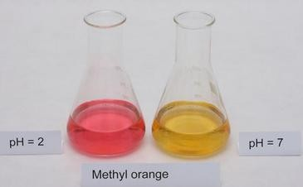

This theory also explains the reason why phenolphthalein is not a suitable indicator for titrating a weak base against strong acid. The OH- ions furnished by a weak base are not sufficient to shift the equilibrium towards right hand side considerably, i.e., pH is not reached to 8.3. Thus, the solution does not attain pink colour. Similarly, it can be explained why methyl orange is not a suitable indicator for the titration of weak acid with strong base.

Quinonoid theory
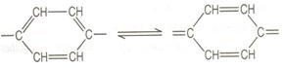
According to quinonoid theory, an acid-base indicator exists in two tautomeric forms having different structures which are in equilibrium. One form is termed benzenoid form and the other quinonoid form.
The two forms have different colours. The colour change is due to the interconversion of one tautomeric form into other. One form mainly exists in acidic medium and the other in alkaline medium.
Thus, during titration the medium changes from acidic to alkaline or vice-versa. The change in pH converts one tautomeric form into other and thus, the colour change occurs.

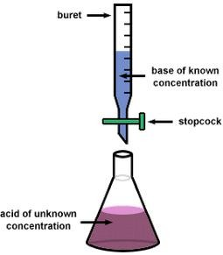

Phenolphthalein has benzenoid form in acidic medium and thus, it is colourless while it has quinonoid f
orm in alkaline medium which has pink colour.
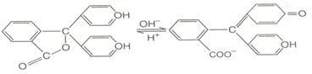

Methyl orange has quinonoid form in acidic solution and benzenoid form in alkaline solution. The colour of benzenoid form is yellow while that of quinonoid form is red.

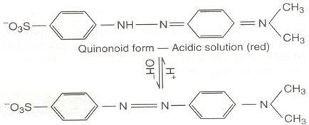

Very Short Answer Questions:
1.Define Indicator and give its Examples.
2.When phenolphthalein indicator is used and wish type of titrations.

Short Answer Questions:
1.Explain in detail about theories of Indicators

